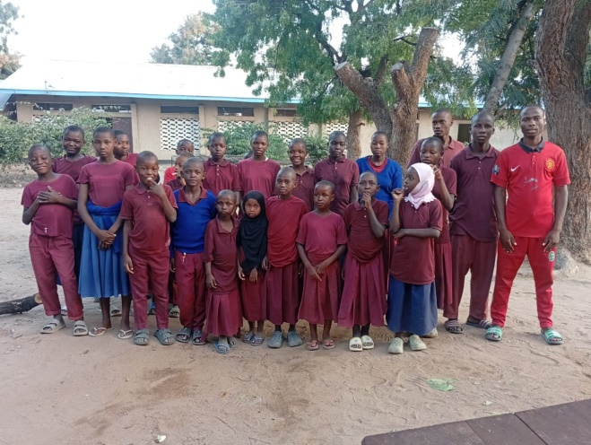

The primary school students have returned to school this week after the June break.

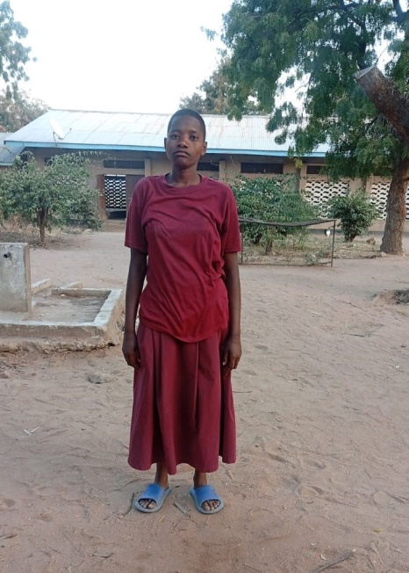
Here is Sesilia Sogoyi from Solowu village , Chamwino district Dodoma. We discovered her during the search for deaf people in the region. She started at Kigwe deaf school 7 years ago and she is now in class 5.
In the past she was unable to communicate - even her name . She can now sign in Tanzanian Sign Language (TSL) so she has friends to make stories and share more things with. She is now happy and her ambition is to be a teacher to teach her fellow deaf.
She is doing well academically. Her parents are old and cannot take care of her . TDT through partnership with DCT is helping her to reach her goals.

In May, 35 students completed their 1-year course at Matumulu Vocational Training College. Just under half of these had been supported at Kigwe Primary School. Funds are being raised to enable more Kigwe graduates and other deaf young people gain practical and business skills so they can support themselves in the future.

