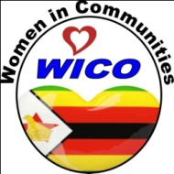

ORGANISATION PROFILE

WOMEN IN COMMUNITIES ZIMBABWE
(WICO ZIMBABWE)

BACKGROUND
Women In Communities Zimbabwe (WICO ZIMBABWE) is a women-led organization whose mandate is to uphold women’s rights, health and livelihoods and it is a registered Trust (# MA0000427/15) that was established in 2009. The organisation is guided by its philosophy of “Women’s rights are Human Rights” and that sustainable development can be attained if, and only if, women and PWDs (who are the most marginalized population groups) are empowered and included in socio-economic, environmental, and political development. The organisation mainly focuses on rural women and girls and PWDs to build resilient communities - through promoting climate-smart agricultural systems, health education and empowerment of women.

GOVERNANCE & LEADERSHIP TEAM

WICO ZIMBABWE has a 9-member board of trustees, with 78% of the members being women, governed by a registered constitution which oversees the organization through the Executive Director. The Board chairperson is a woman and former general manager of an international organization, a woman activist, and sits on several development boards. The other members include a legal practitioner, a school head, a banker, an entrepreneur, an auditor, a human rights activist, and a medical doctor. Th Executive Director is responsible for the day-to-day operations guided by a 5-year Strategic Plan (2021-2025). The board meets quarterly to deliberate on strategic issues and it has a Finance and Administration Committee responsible for guiding the secretariat on all financial and administrative matters. Currently, WICO ZIMBABWE employees 5 full time employees. The Executive Director, Rebecca Tendai Chirenga, is an experienced lecturer in Business and Entrepreneurship, and export marketing and training. The Programs Officer, Mrs Dorcas Marumani, has worked on catchment planning and management, protection of water bodies, community development work, and health. Mrs Tendai Madzokere is responsible for Finance and Administration. Clemence Mutegeri, a graduate in Economics, is the Monitoring and Evaluation Officer.

VISION
A world in which women play decisive roles in agriculture; health; governance; and natural resources management for sustainable livelihoods and development.

MISSION
To promote the recognition of local initiatives and strengthening of women’s capacities to adjust to changing conditions, in collaboration with relevant partners and stakeholders.

OBJECTIVES
- To inculcate a culture of self-worth and independence in women and girls through economic empowerment.
- To promote and create a safe space for participation in governance issues.
- To advocate for behavioral change among women – especially marginalized rural women – who fear taking leadership positions because of cultural and patriarchal norms.
- To encourage healthy living standards and improved livelihoods for women and girls.
- To raise awareness of, and advocate for, human rights and constitutional rights - especially women’s rights.
- To create resilient communities free from poverty.

PROGRAMS
- Promotion of human rights, women’s rights, and the rights of the child and PWDs;
- Civic Participation, Governance, Constitutional rights, and voter education;
- Awareness of maternal and child health rights – Prevention of Mother-to-child Transmission (PMTCT), Sexual Reproductive Health and Rights (SRHR);
- Promotion of HIV / TB Prevention and Management;
- Supporting Cervical Cancer Screening (VIAC);
- Gender-Based Violence awareness, mitigation and psychosocial support;
- Sustainable Forest Management (SFM), Sustainable Land Management (SLM), Sustainable Water Management (SWM), and climate change adaptation through ecosystem based adaptation (EBA);
- Community nutrition gardening, apiculture, and value addition of produce;
- Water, Sanitation and Hygiene (WASH);
- Entrepreneurship skills development;
- Pandemics and Disaster Risk Management mitigation.

STRATEGIES TO ACHIEVE ORGANISATION PURPOSE OR MISSION
- Human Rights-Based Approach
WICO ZIMBABWE generally adopts the Human-Rights Based Approach in all its programming as a strategy to achieve organizational purpose or mission. The Human Rights-Based approach focuses on the beneficiaries as rights holders in socio-economic and environmental issues.

- Gender Intentional Approach
Research has it that socio-economic, environmental, and political crises will deepen gender inequalities and roll back the progress on women’s and girls’ rights. On this backdrop, WICO ZIMBABWE adopts the Gender Intentional Approach in program design and implementation. Since women and girls make up more than half of the population, the gender intentional approach will contribute to reduced inequalities, zero poverty, no hunger, and inclusive climate action in line with the United Nations’ Sustainable Development Goals.

- Gender Transformative Approach
Women’s decision-making processes are dependent on their spouses on account of the patriarchal nature of the society. To achieve its purpose or mission, and address gender inequalities, WICO ZIMBABWE facilitates a change in existing values and norms, structures, and systems, as well as gender relations.

- Community Approach
WICO ZIMBABWE holds to the philosophy that local communities are better placed to solve their problems if they are fully and meaningfully involved in needs assessments, solution development, project design and implementation, and project monitoring and evaluation. Thus, the organisation shares an inspired vision which reflects the needs and voices of local communities. This ensures that the host communities own the projects as means to the end of promoting sustainability of the positive outcomes and impacts of projects.

- Integrated Approach
Due to the multi-faceted nature of socio-economic and environmental problems in Zimbabwe, WICO ZIMBABWE adopted an Integrated Approach to address issues that include poverty and climate change, among others.

PAST PROJECTS AND ACHIEVEMENTS
WICO ZIMBABWE has had a long history of advancing women’s and girls’ empowerment and promotion of health awareness on issues of Prevention of Mother to Child Transmission (PMTCT), HIV/TB, Sexual Reproductive Health and Rights (SRHR), Violence against Women and Girls (VAWG) and VIAC.
HIV - PREVENTION OF MOTHER-TO-CHILD TRANSMISSION (PMTCT)
In the area of PMTCT, and (in year 2010) under the funding of the Canadian Embassy, WICO ZIMBABWE successfully built a 30-bed dormitory, (Waiting mothers’ home) with running water and electricity, in Shurugwi, Midlands province, at the Zvamabande rural hospital. It was handed over to the Ministry of Health in September 2014.
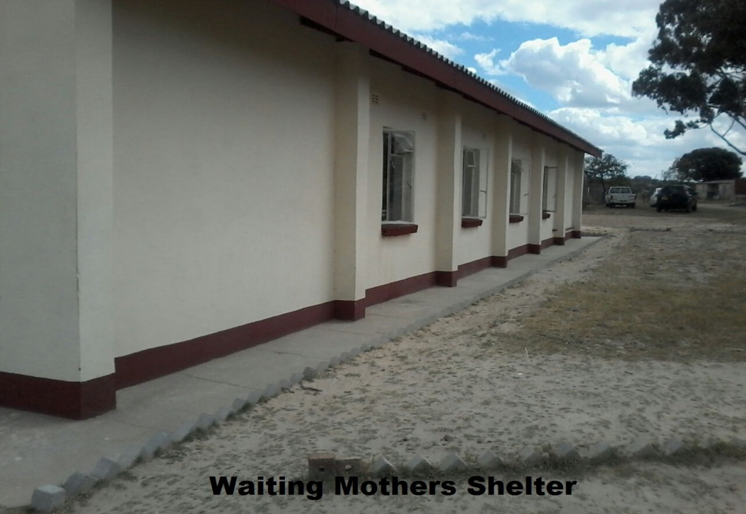
Fig 1.0: Expectant Mothers Dormitory at Zvamabande Rural District Hospital.
This project was a solution to the problem of pregnant women travelling long distances to the hospital to deliver their babies and also encourage institutionalized deliveries that were in line with the efforts to combat transmission of HIV from the mother to the child. In year 2013, the Ministry of Health and Child Care’s Provincial Medical Director decided that the PMTCT program be moved to the Silobela district. It is during this intervention that the Nyoni clinic recorded a 100% institution deliveries of all registered mothers. Early booking and couple voluntary testing and counselling increased at the clinic.
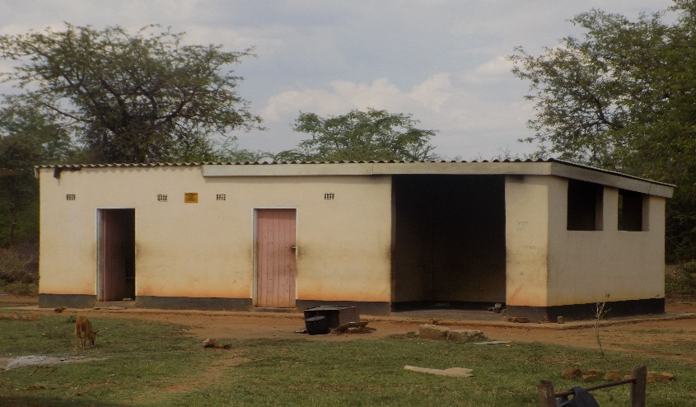
Fig 1.1: Expectant Mothers Home at Nyoni Clinic in Silobela promoting institutional deliveries and PMTCT.
Reported cases of exposed babies born HIV negative were made during this period. Also worth noting was the involvement of men in all these programs. The organization continued to work in this district and mobilized the child bearing men and women to be actively involved in the PMTCT program by creating awareness and giving education to the communities. Under the generous funding of SAT and the community, WICO ZIMBABWE successfully constructed another “Expecting Mothers’ Home” in order to drive the message of institutionalized deliveries and reduce the incidences of maternal death in the province. The community leadership appreciated the gesture and this only fuelled the desire to Strengthen Health Systems by this upcoming organization. Positive results were reported by the health institution of Nyoni clinic and the PMTCT was deemed a success as exposed babies were reportedly born HIV negative.
TUBERCULOSIS PREVENTION AND MANAGEMENT
WICO ZIMBABWE successfully advanced a project on TB Prevention and Management in Silobela, Midlands Province (2013-2016). On the backdrop of HIV/TB continuing to remain partners in the HIV pandemic, the organization was able to bring awareness to the communities on the identification of symptoms and care of the TB patients. With the assistance of the District focal person of the Ministry of Health and Child Care, the organization successfully trained 30 TB cadres in the identification, monitoring and referral of patients as well as Directly Observed Treatment Supervision (DOTS). TB in Silobela has remained under control partly as a result of this intervention and the Prevention and Control, DOTS surveillance and monitoring systems have made the effort effective in the communities.
SEXUAL REPRODUCTIVE HEALTH AND RIGHTS
In Sexual Reproductive Health and Rights (SRHR), WICO ZIMBABWE integrated this program in Silobela (2013-2016) where it assisted in the basic improvement of communication within the marriage institutions and men and women involved reported better relations. Partners were able to relate better in their sexual and marital relations. The program later cascaded into schools targeting the school going boys and girls who had a tendency to drop out of school and reported cases of teenage pregnancies among the girls. It also focused on their general sexual health and HIV prevention. WICO ZIMBABWE trained school heath masters and peer educators to drive the message closer to the school going pupils, and among the highlights of the schools program was the formation of WICO ZIMBABWE health clubs and the running of the Zonal sports Festival which involved four schools.

CIRVICAL CANCER SCREENING
Pertinent to Cervical Cancer Awareness and Screening, WICO ZIMBABWE made tremendous achievements during 2015- 2016 VIAC program. Cervical cancer is the most common cancer among women in Africa accounting for the majority of deaths in the middle aged. However with the advent of HIV, women are getting cervical cancer at a younger age accounting for 34% of all cancers among women. With this knowledge WICO ZIMBABWE found itself pursuing cervical cancer screening in the same catchment to the benefit of most of the women in Ward 15 and 26 of Silobela who came for screening. Word went around to other areas and women from other areas began to seek the service and the demand for the service continued to grow. Our funding partner SAT went the extra mile and provided a vehicle to conduct outreach clinics to the hard to reach areas thereby increasing coverage.
WOMEN EMPOWERMENT AND LEADERSHIP
Promoting Women and Girls Participation in Leadership, Governance and Political Processes programs in the Midlands province contributed to increased voter registration of women and girls.

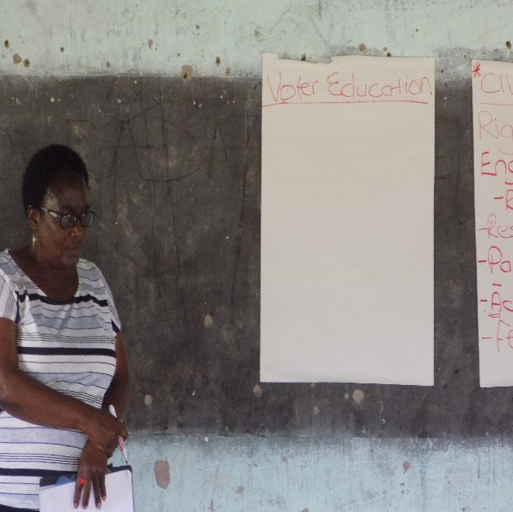
Fig 1.2: Facilitator conducting voter education.
VIOLENCE AGAINST WOMEN AND GIRLS
On the issue of Violence Against Women and Girls (VAWG) or Gender-Based Violence (GBV), WICO ZIMBABWE tackled the issues in Silobela (2013-2016) by focusing more on the perpetrators to spread the message of reducing GBV in the homes and in the communities. The project successfully trained 25 male motivators who were given the task to reach out to other men and use the hot spots such as beer halls, mining sites and other places frequented by men.
- In 2019, WICO ZIMBABWE was awarded a Gender Champion Award by the Netherlands Embassy for great impact in fighting GBV through training of male motivators. Subsequently, the organization implemented a project of Addressing GBV in the Workplace in the Midlands Province.

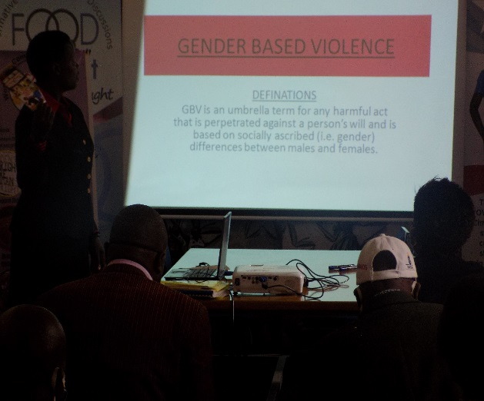
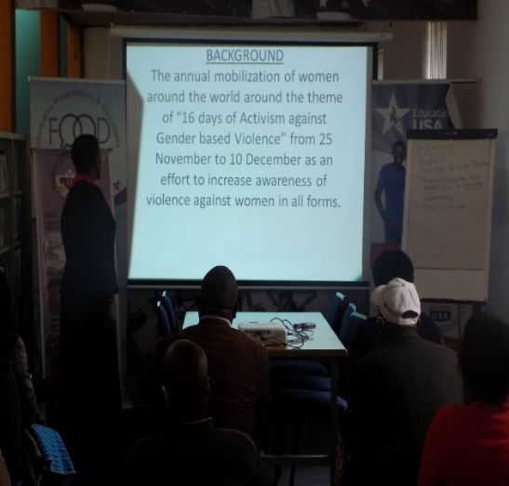
Fig 1.3: (Left) GBV Awareness raising workshop. (Right) Facilitator highlighting the background of GBV.
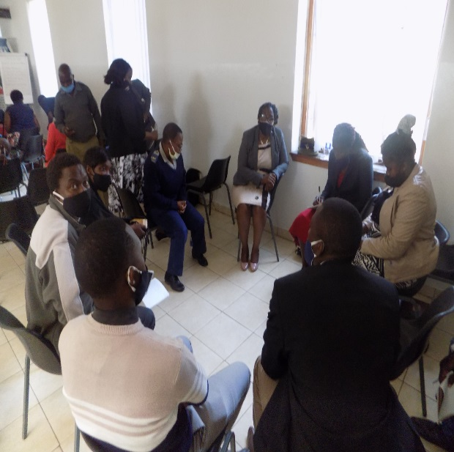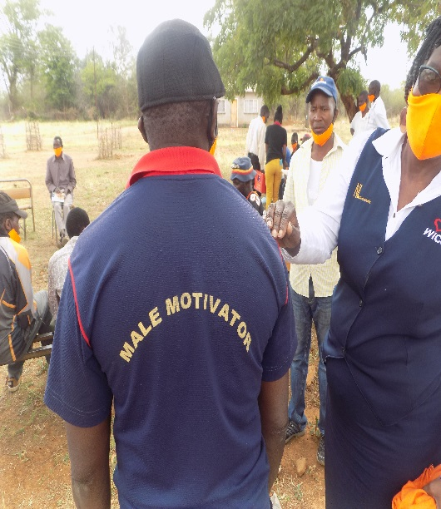
Fig 1.4: (Left) Focus Group discussions on GBV. (Right) Male Motivator in Silobela District.
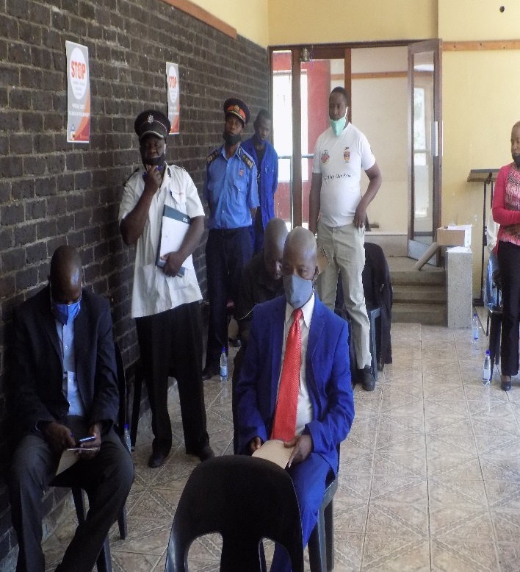
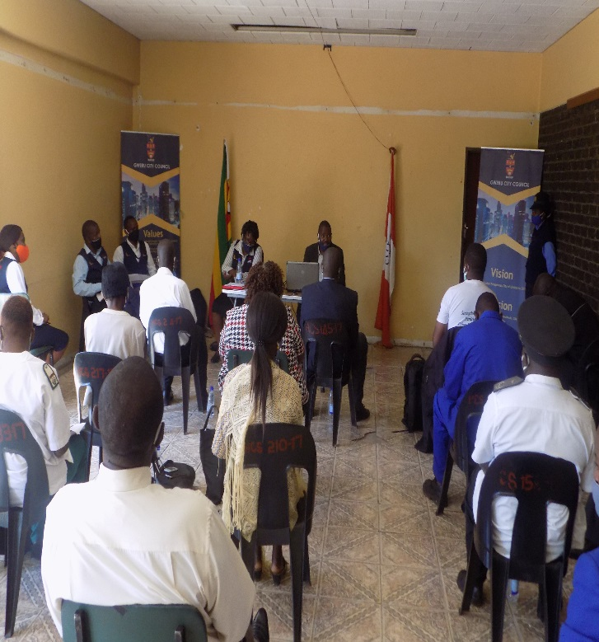
Fig 1.5: Engagement meeting with Gweru City Council management to advocate for GBV and Sexual Harassment Policy.
DISASTER RISK REDUCTION & MANAGEMENT AND CLIMATE ACTION
In the area of Disaster Risk Management, Climate Change Adaptation, and Sustainable Environmental Conservation WICO ZIMBABWE contributed to greater impact in the communities. In October 2016 WICO ZIMBABWE received funding from UNDP GEF SGP to implement a programme on Supporting Community Action in Addressing Land Degradation and Income Generation in Mfiri Village. The 3 key objectives included reclamation of two gullies in Mfiri village, curbing siltation of Mfiri dam by protecting the catchment area and scaling up the already existing community garden by improving the watering system through provision of solar pumping technology and storage tank.
Through this fund, the following was achieved:
- Drilling of 1 borehole and installation of solar water pumping system to improve access to water for the community irrigation plot.
- Construction of silt trap measuring 140m long, 6m wide and 4 meters deep across the river bed channel and this resulted in the reduction of silt entering into the Mfiri Dam which is the main source of water.
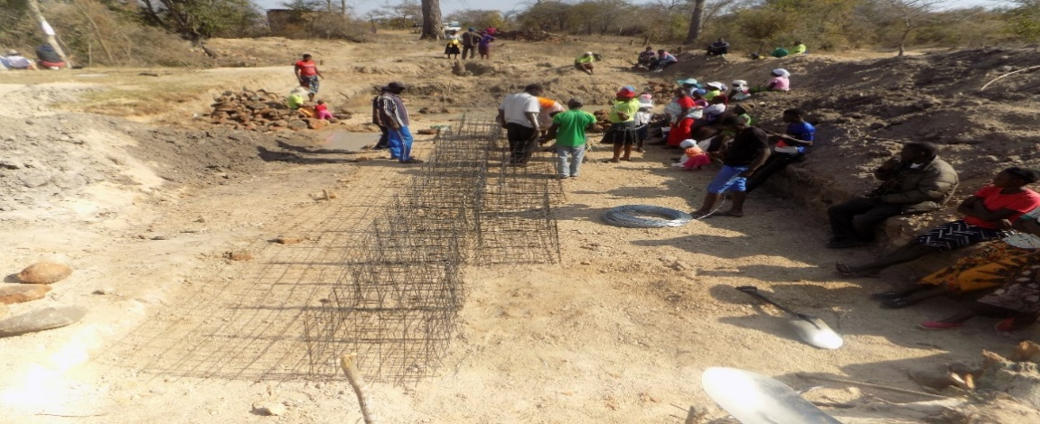
Fig 1.6: Mfiri villagers laying the foundations for gabion cage silt trap to reduce siltation of Mfiri dam.

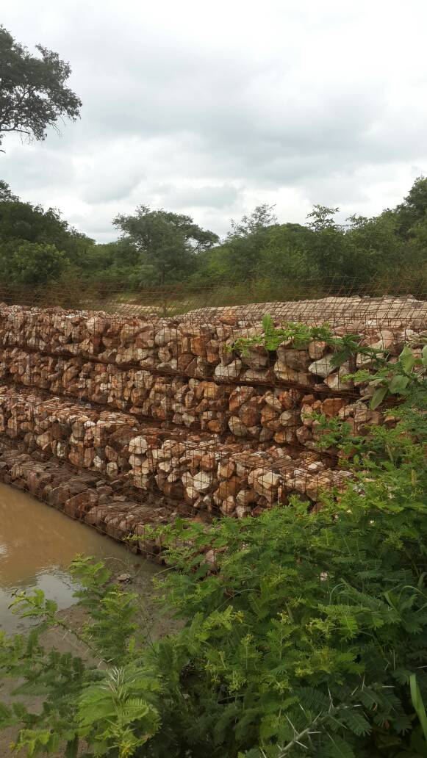
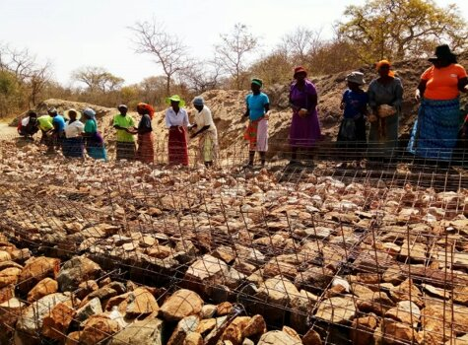
Fig 1.7: (Left) Women helping in construction of gabion cage silt trap to reduce siltation of Mfiri Dam, Shurugwi. (Right) Completed gabion to curb silt into the dam.

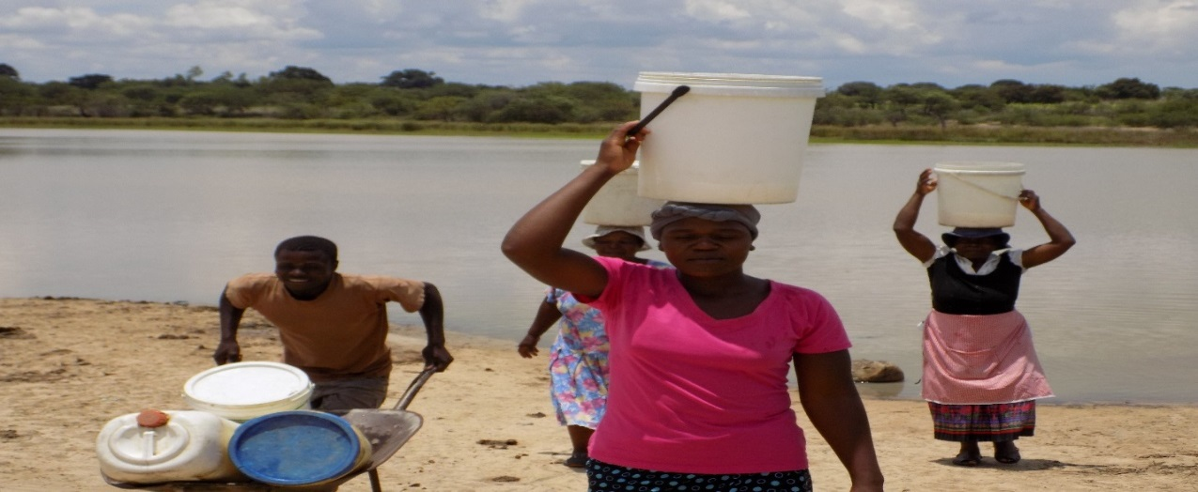
Fig 1.8: Mfiri villagers fetching water from Mfiri Dam manually fetching water from Mfiri dam.
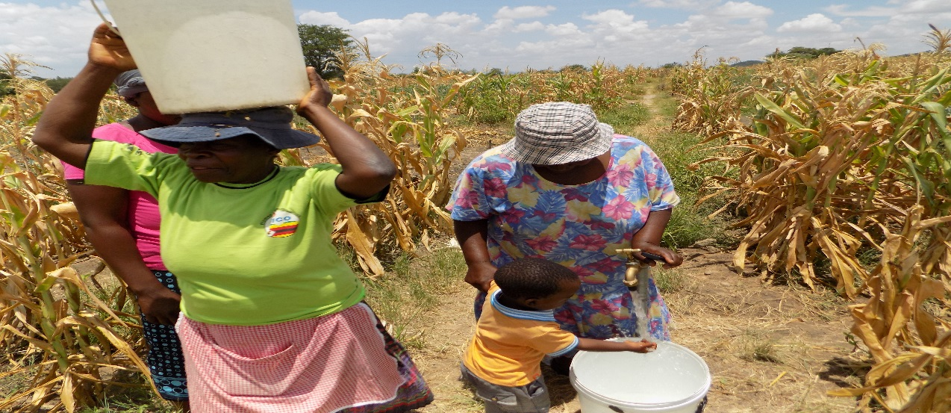
Fig 1.9: Improved access to water for community garden after project intervention.
- Fencing of 1.5 hectare community irrigation plot. The irrigation plot is now protected from livestock intrusion which was the challenge prior to fencing. The garden is benefitting 142 farmers who are practicing organic horticulture production for consumption and surplus for sale.
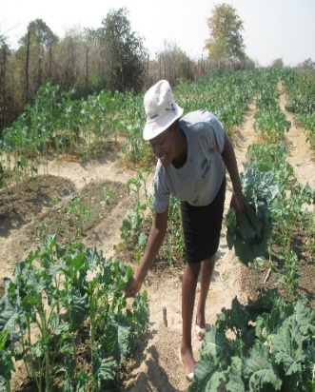
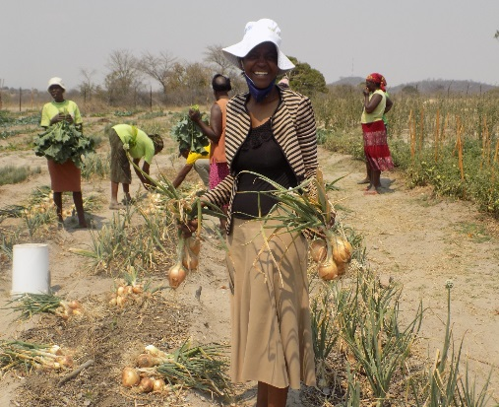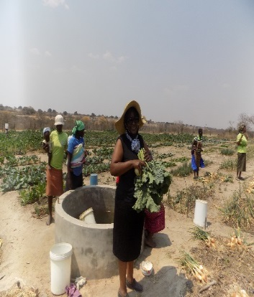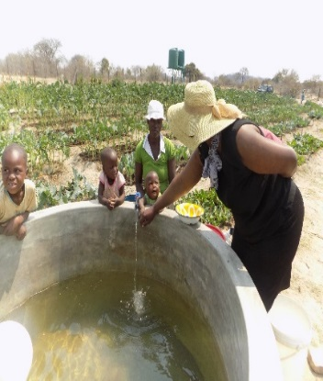
Fig 10.0: Mfiri Consolidated Nutrition Garden (Shurugwi, Midlands Province) benefiting about 153 women with improved livelihoods and nutrition security.
- Conducting training workshops on environmental conservation and the communities are now aware of the benefits of conserving the local resources such as water bodies and trees.

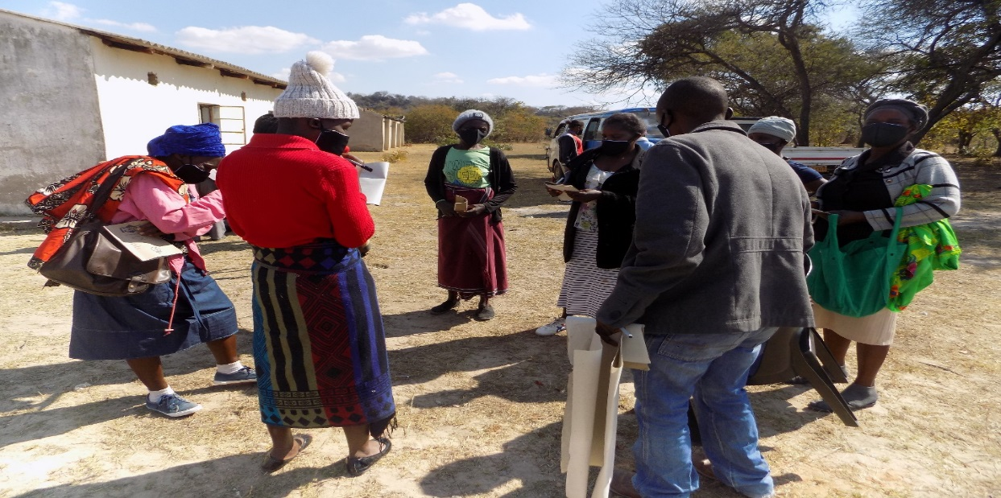
Fig 10.1: Group discussions on Climate Change Adaptation and Disaster Risk Management in Shurugwi District.

HUMAN RIGHTS
WICO ZIMBABWE managed to reach many marginalized rural communities on awareness raising on the Universal Bill of Rights, Constitution, and Constitutional Rights.
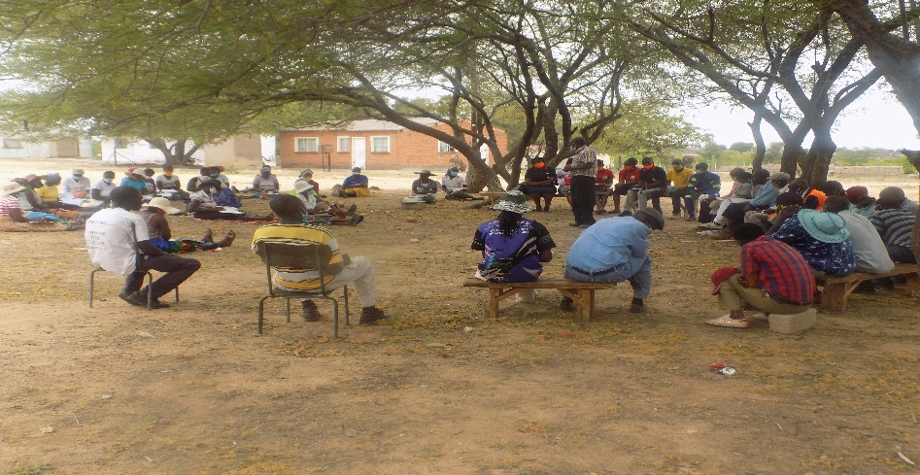
Fig 10.2: Awareness raising on the Universal Bill of Rights and Constitutional Rights.

COVID-19 AWARENESS RAISING AND RESPONSE
In 2020 with funding from Cultural Information Trust (CIT), Women In Communities Zimbabwe implemented a project on COVID-19 Awareness and Response. The project directly benefited Gweru City Council; Shurugwi; and Zvishavane.
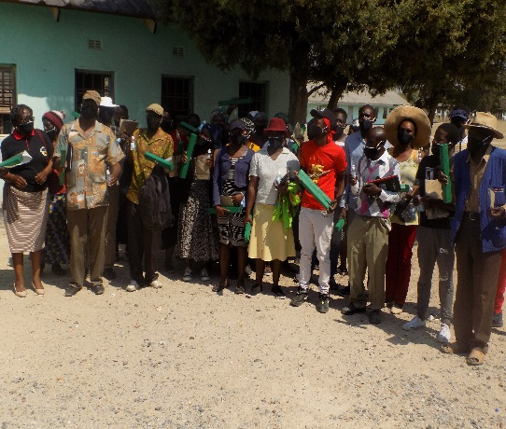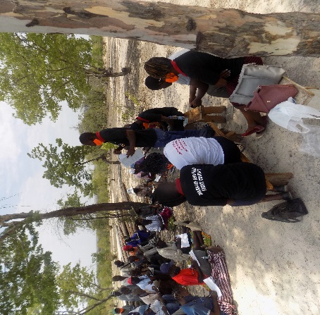
Fig 10.3: (Left) Promoting hand-washing practices and (Right) raising awareness of COVID-19 in Shurugwi and Zvishavane.

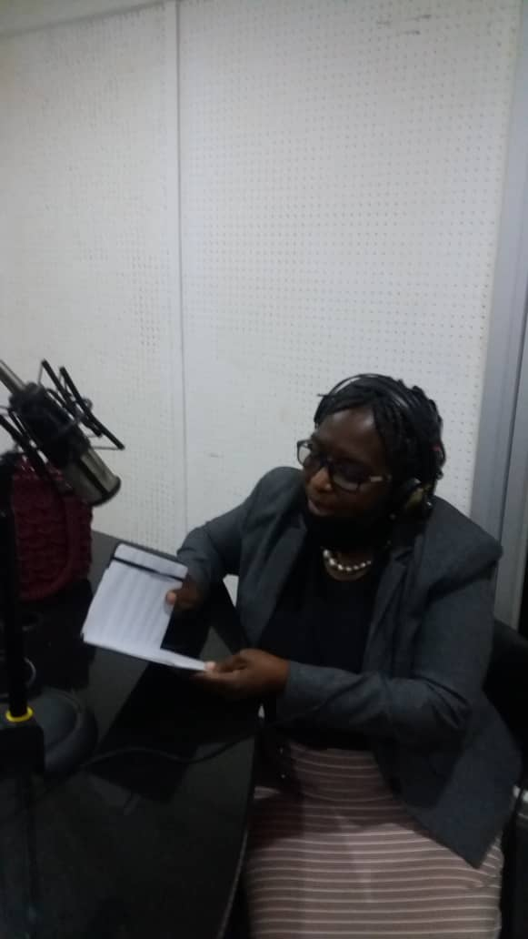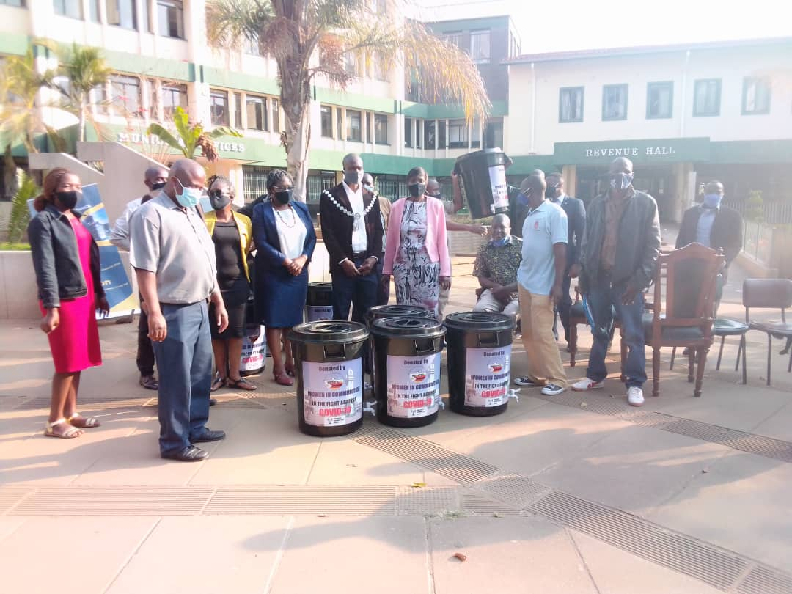
Fig 10.4: (Left) COVID-19 radio awareness raising campaigns in Gweru, and (Right) promoting hand-washing practices at Gweru City Council

CURRENT PROJECTS
Currently, Women In Communities Zimbabwe is managing projects aimed at supporting community action in addressing economic and climate challenges through women empowerment in biointensive gardening and apiculture through funding from the French Embassy and Global Greengrants Fund.

COMMUNITY BIO-INTENSIVE AND NUTRITION GARDENING
A Community Biointensive garden was establishe in 2022 and is benefiting 100 women, girls, men, and boys.
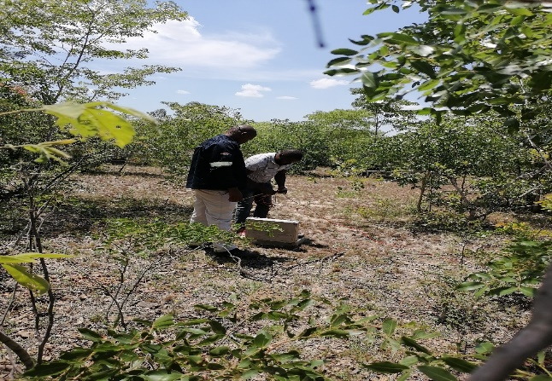
Fig 10.5: Geologist exploring for water in the target project area.
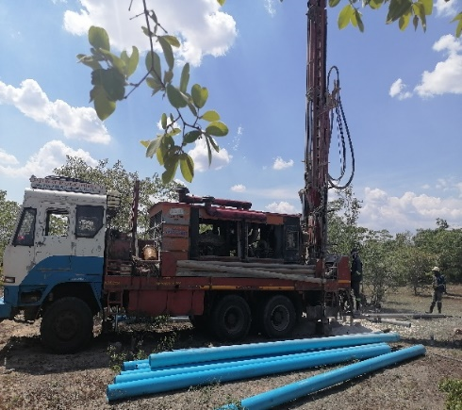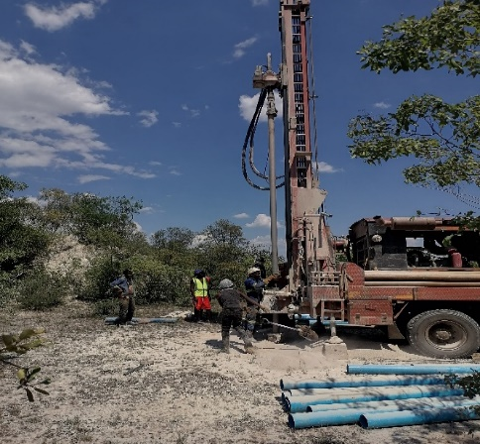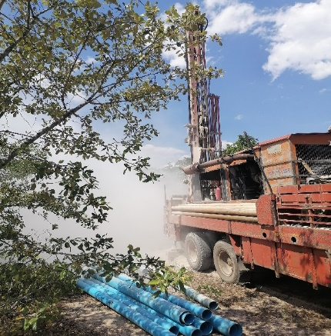
Fig 10.6: Drilling rig for drilling borehole. Fig 10.7: Drillers at work. Fig 10.8: Completing the drilling.
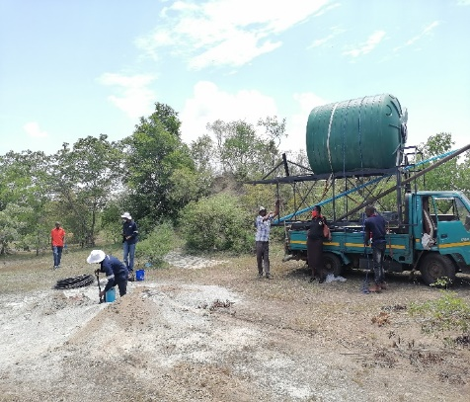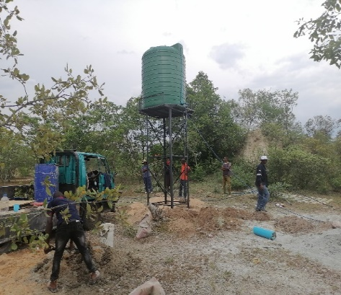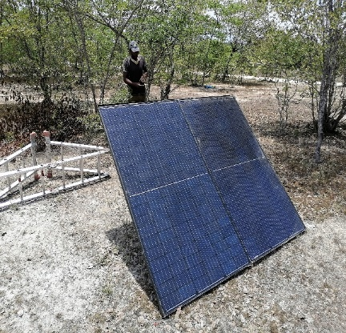
Fig 10.9: Borehole drilling completed. Fig 11.0: 1,000 Litre water tank installed Fig 11.1: Solar panels ready.

COMMUNITY APICULTURE
40 women and girls were trained in apiculture and honey processing and establishment of community apiculture initiative and 30 beehives are installed to date with 5 of them colonized.

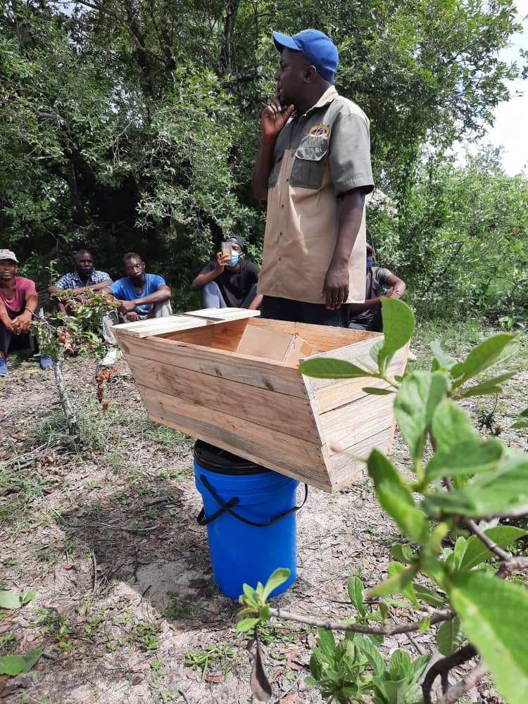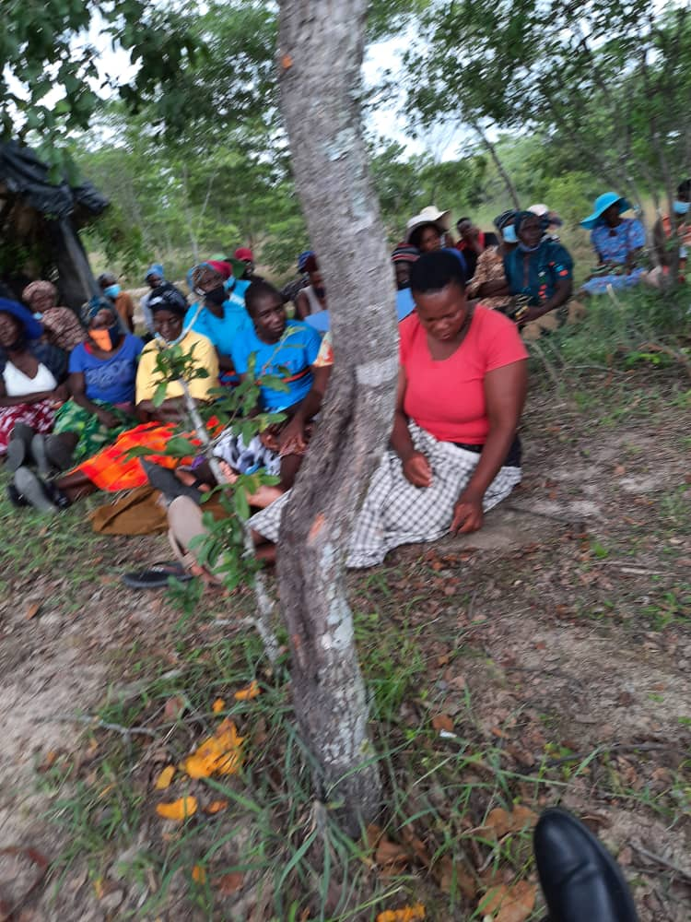
Fig 11.2. (Left) Consultant from Organo Seven training target beneficiaries in apiculture. (Right) Women following through the training session.

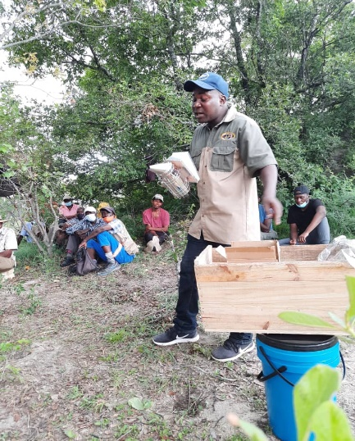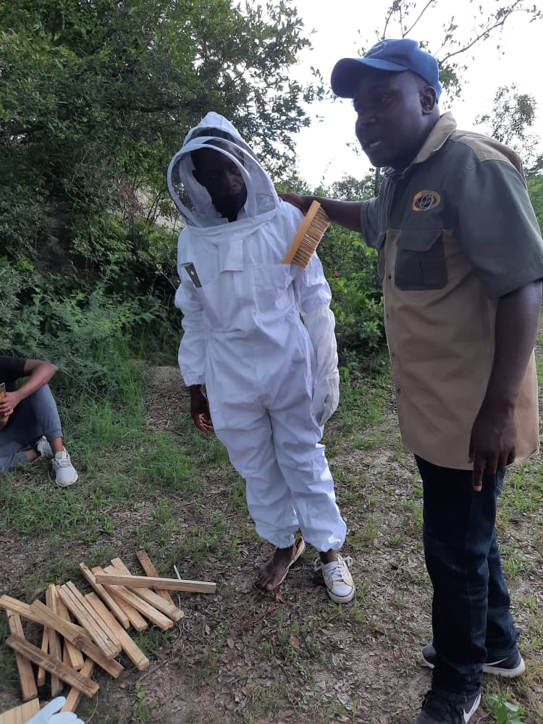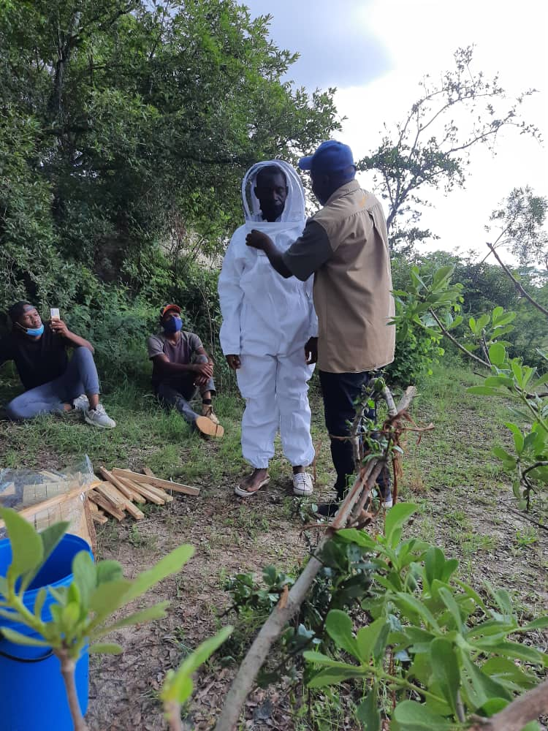
Fig 11.3. (Left) Consultant from Organo Seven stressing a point on hive-making and installation. (Middle & Right) One of the men in bee-suit, and consultant taking the participants through bee-suit wearing.

CLIMATE SMART AGRICULTURE

40 women and girls were trained in climate-smart agriculture.

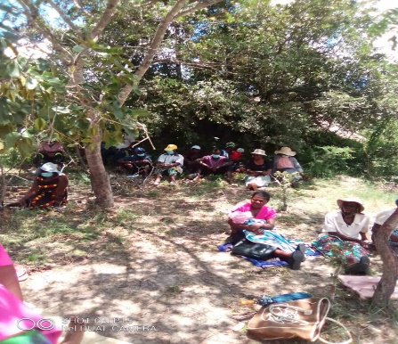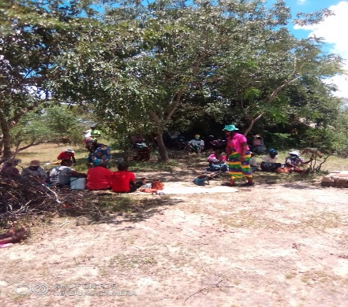
Fig 11.4: (Left) Beneficiaries following through training in Climate Smart Agriculture. (Right) Agriculture Extension Services (AGRITEX) officer training the beneficiaries.

AWARENESS RAISING ON INDIGENOUS KNOWLEDGE SYSTEMS
The villagers were taken through Indigenous Knowledge Systems and how this system can be adopted and integrated into their subsistence agricultural practices. Since the communities rely heavily on rain fed agriculture, adoption of indigenous knowledge systems was welcomed.

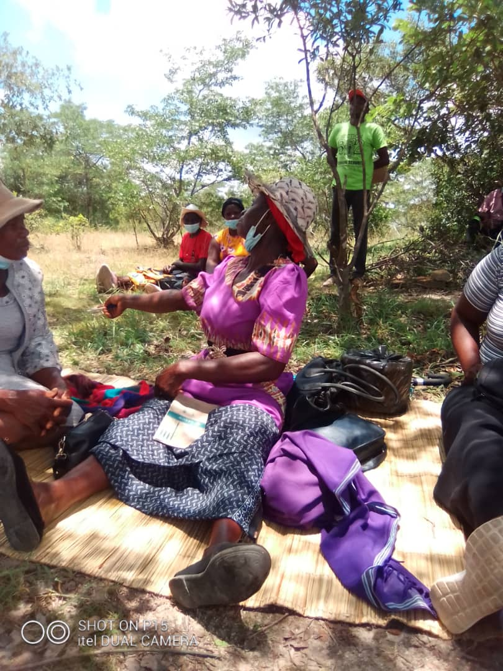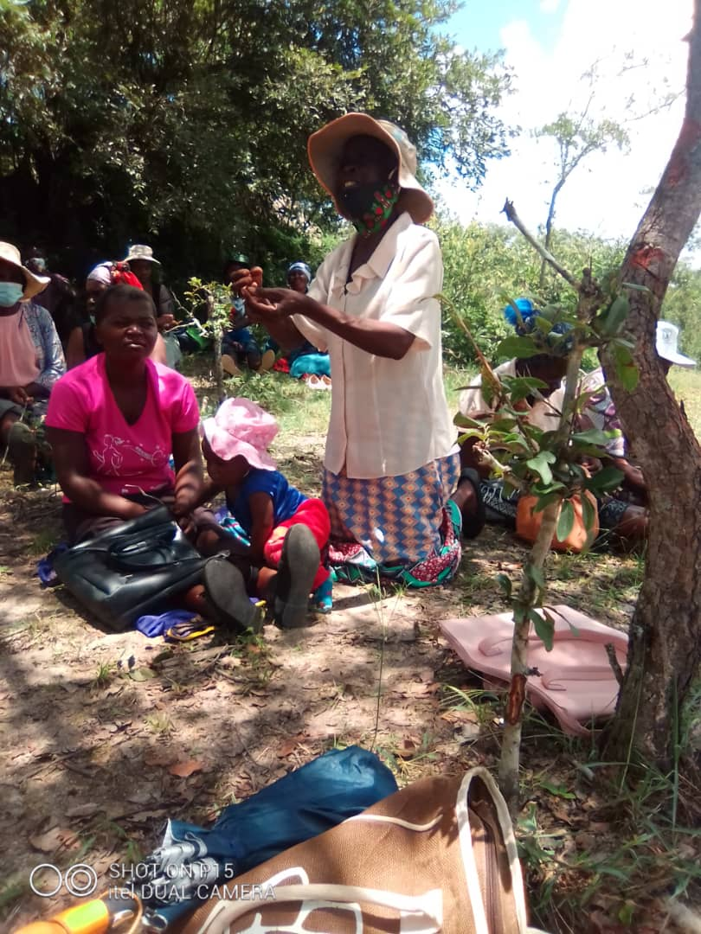
Fig 11.5: Some of the women narrating their experiences in adoption of indigenous knowledge systems.

INTERNAL SAVINGS AND LENDING (ISAL)
An ISAL scheme was established to build the resilience of 3 villages from economic and climate challenges. This initiative will also support the financial and impact sustainability of the project beyond French Embassy funding.
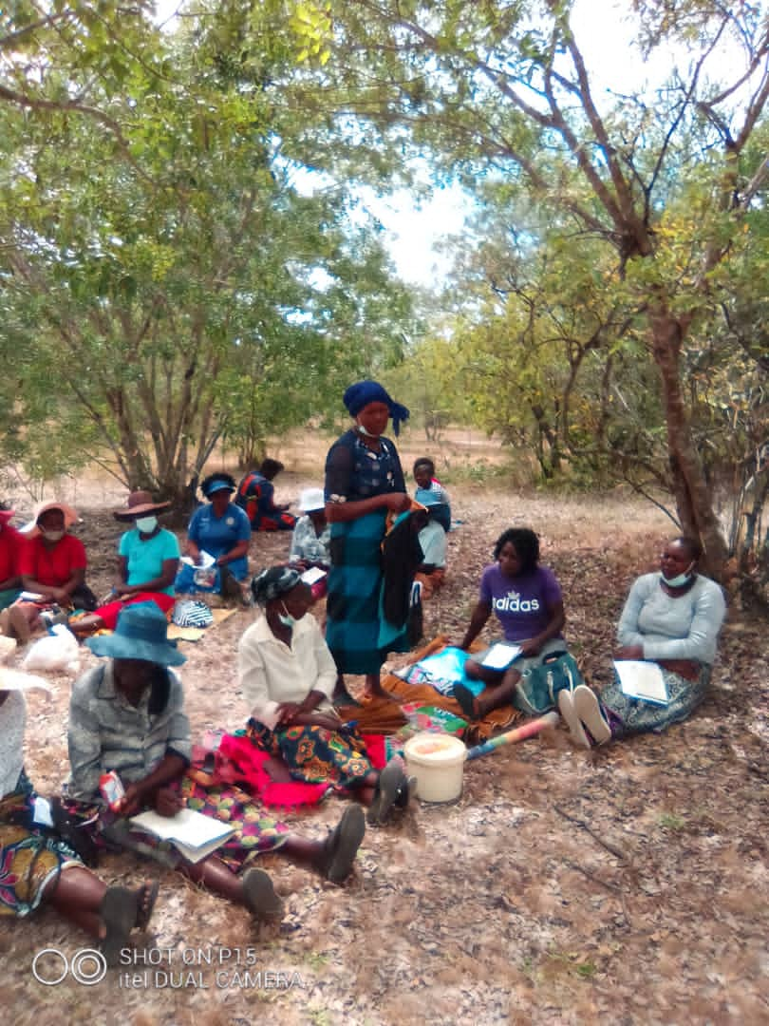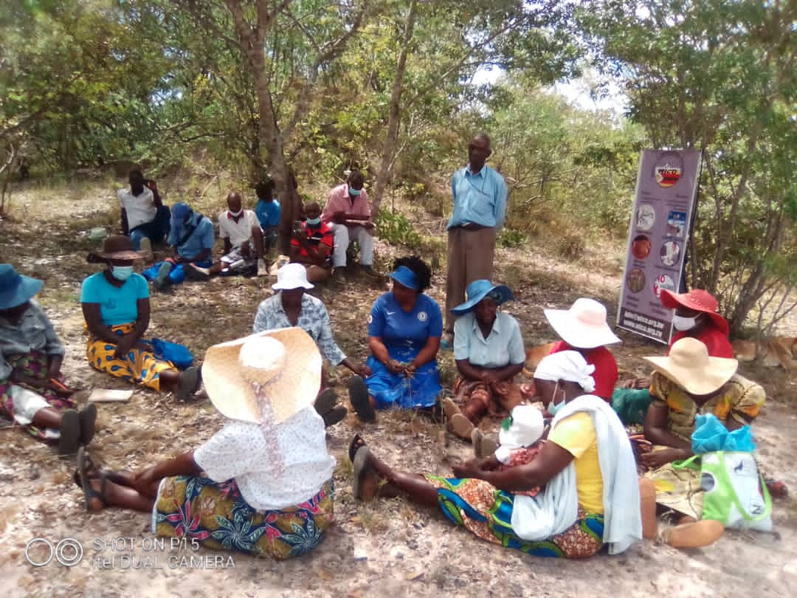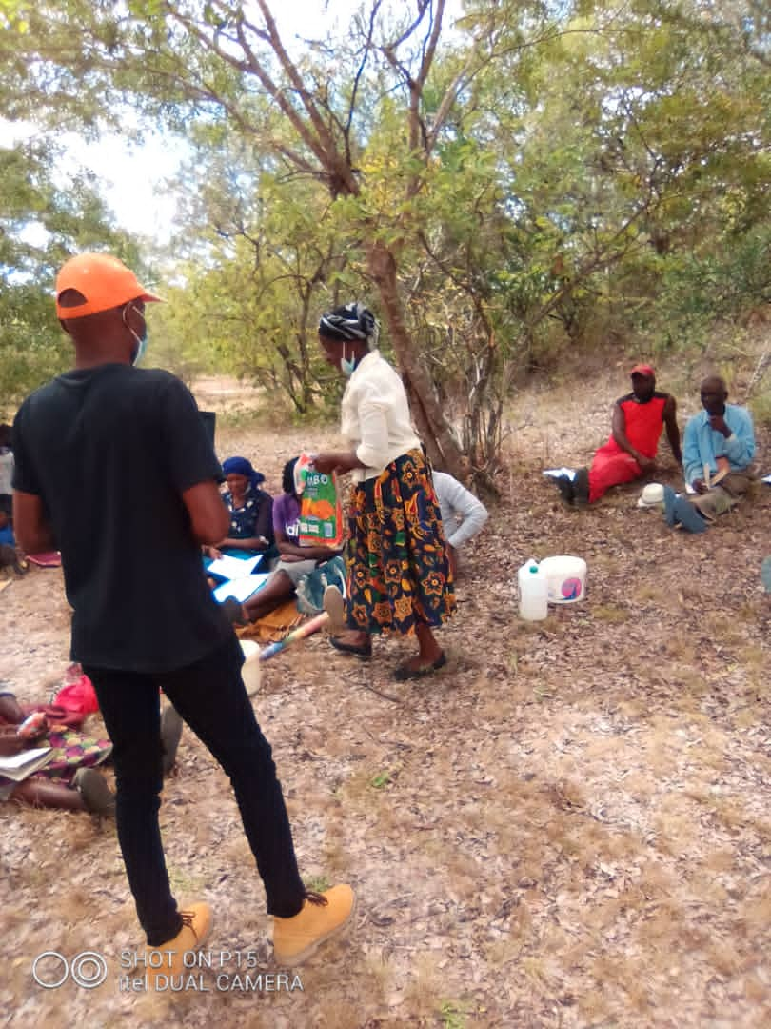
Fig 10.2. Women role-playing the ISAL scheme

Benefits from Internal Savings and Lending
- Improved income.
- Improved access to farming implements.
- Improved income to boost community poultry project.
- Costs for security of bio-intensive garden and apiculture fully covered.

ACCOLADES
- WICO ZIMBABWE received the National Association of Non-governmental Organisations (NANGO) award for “Best Community Development” – 2019.
- The Netherlands Embassy 16 Days of Activism against GBV – 2019 gender champion award.

AFFILIATIONS
- Zimbabwe AIDS Network (ZAN).
- National Association for Non-Governmental Organisations (NANGO).
- World Patients Alliance (WPA).
- National Age Network of Zimbabwe (NANZ).
- Women Coalition of Zimbabwe (WCOZ).
- Zimbabwe Alzheimer’s and Related Disorders (ZARD).

FUNDING PARTNERS
- Canadian International Development Agency (CIDA).
- Southern African AIDS Trust (SAT).
- UNDP (GEF SGP).
- Netherlands Embassy.
- Global Green grants Fund.
- Cultural Information Trust (CIT).
- French Embassy.
CONTACT DETAILS
Phone: +263 772 358 569 / +263 719 358 569 [Executive Director]
Email: info@wico.org.zw / wicozimbabwe@gmail.com
Website: www.wico.org.zw
Twitter: @WicoZimbabwe
Facebook: WICO ZIMBABWE

