Photos for September 2025 Project Report

#1 Parent Board distributing the Monthly Food Baskets
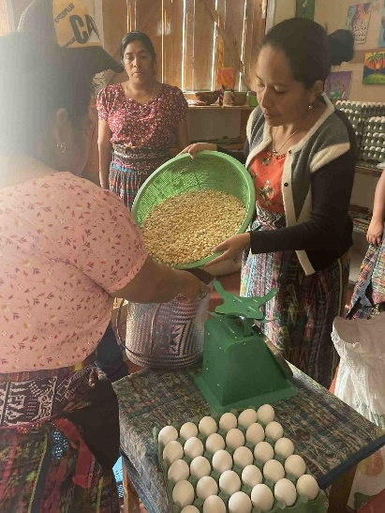
#2 Our Pre-Preschool group at play
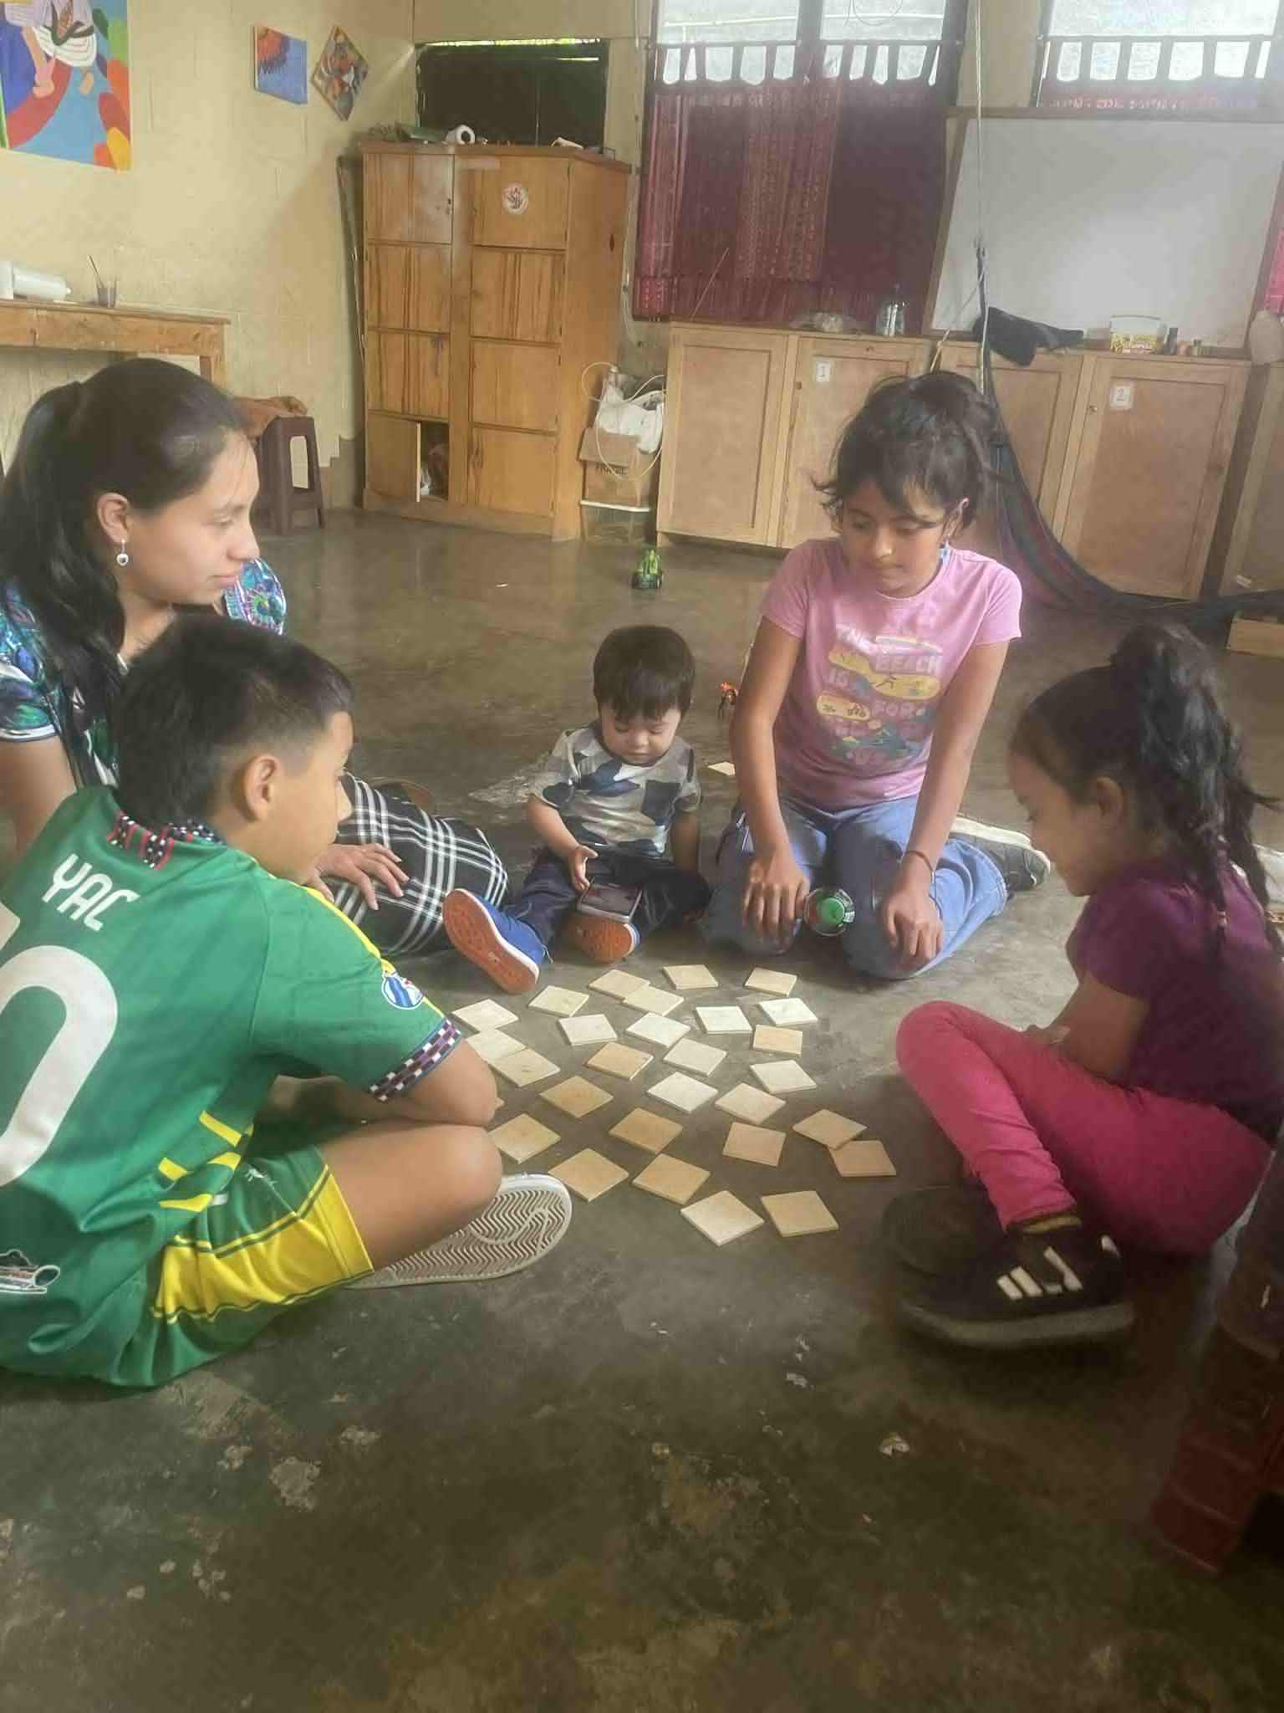
#3 Our small store
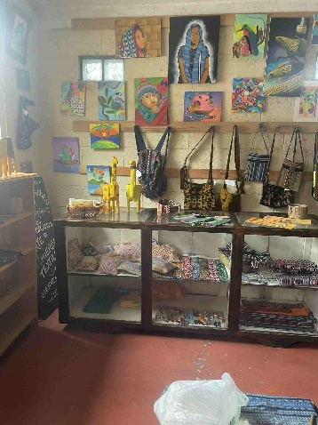
#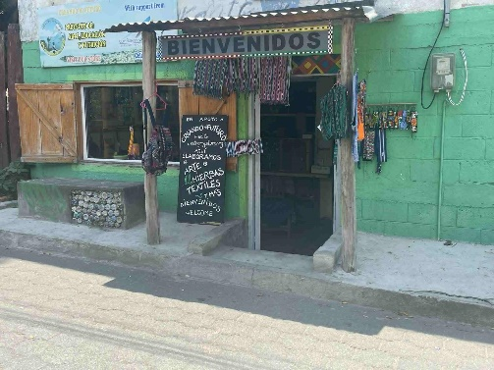4 Front of our project building
# Flowers for cooking – Rosa’s harvest
