PHOTOS FOR January 2026 GG report
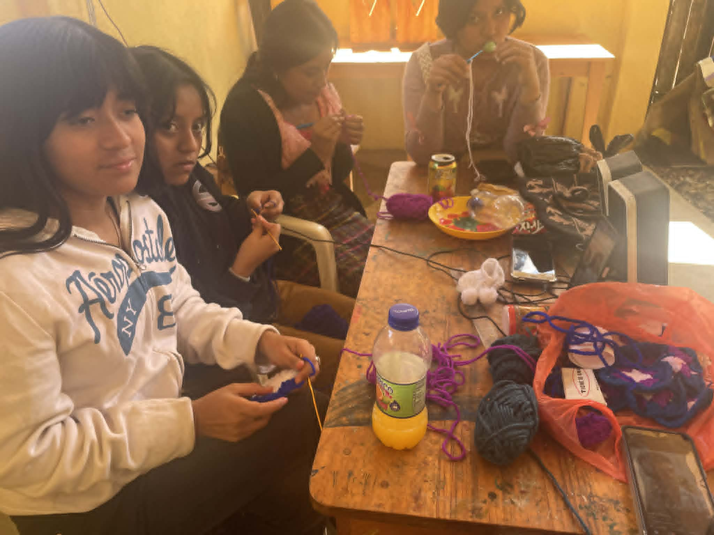
The older girls, learning to crochet. Marta, Josefa, Florinda and Leidy. Rosalia out-of-sight
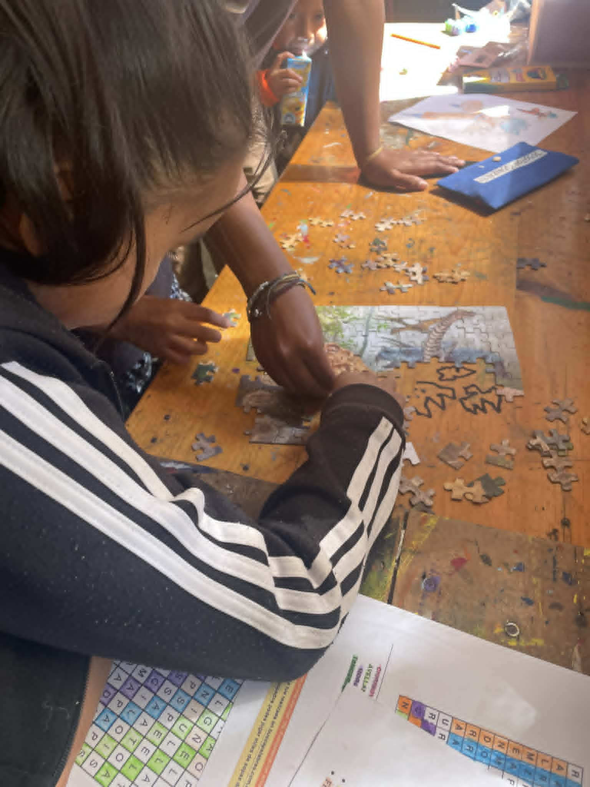
Middle Group - Solving puzzles. (3 heads are better than one!)
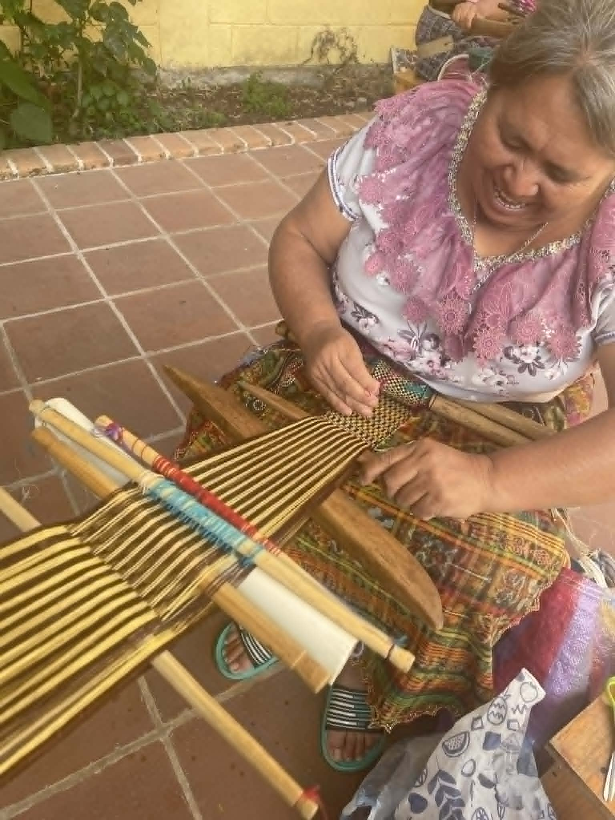
One of our weaver-mothers, in typical San Pedro “traje” (clothing) and a traditional woven faja or belt in process on the backstrap loom

