PHOTOS FOR AUGUST 2026 REPORT
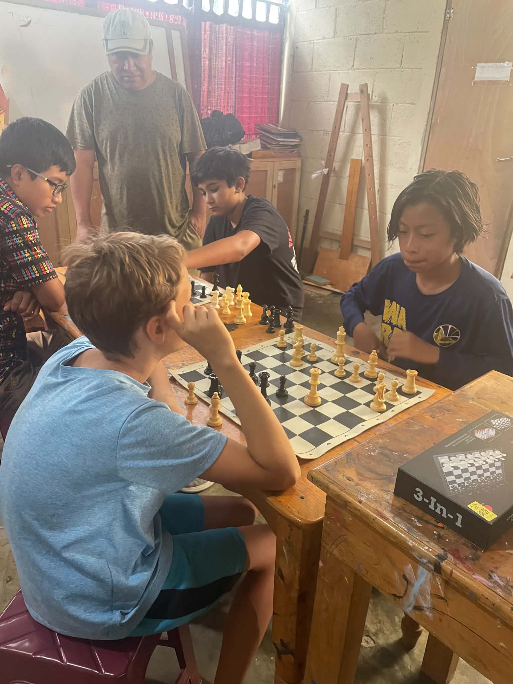
THE BOYS’ GROUP (with a Gringo visitor)

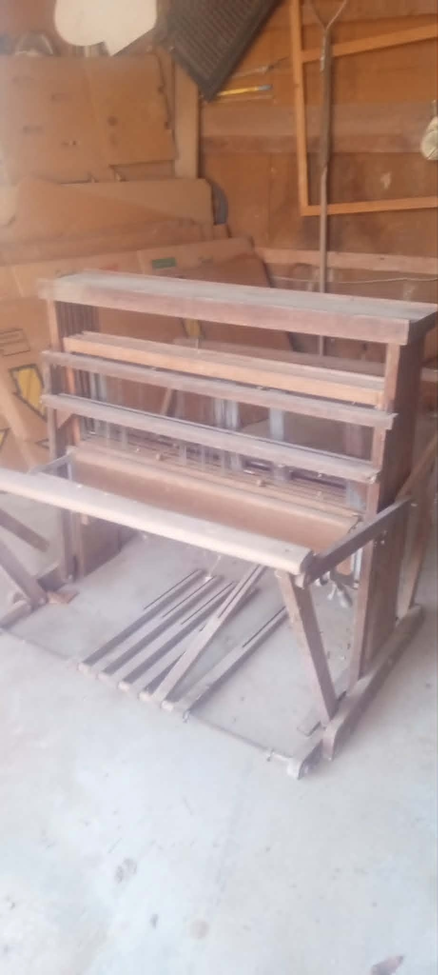
One of the looms.
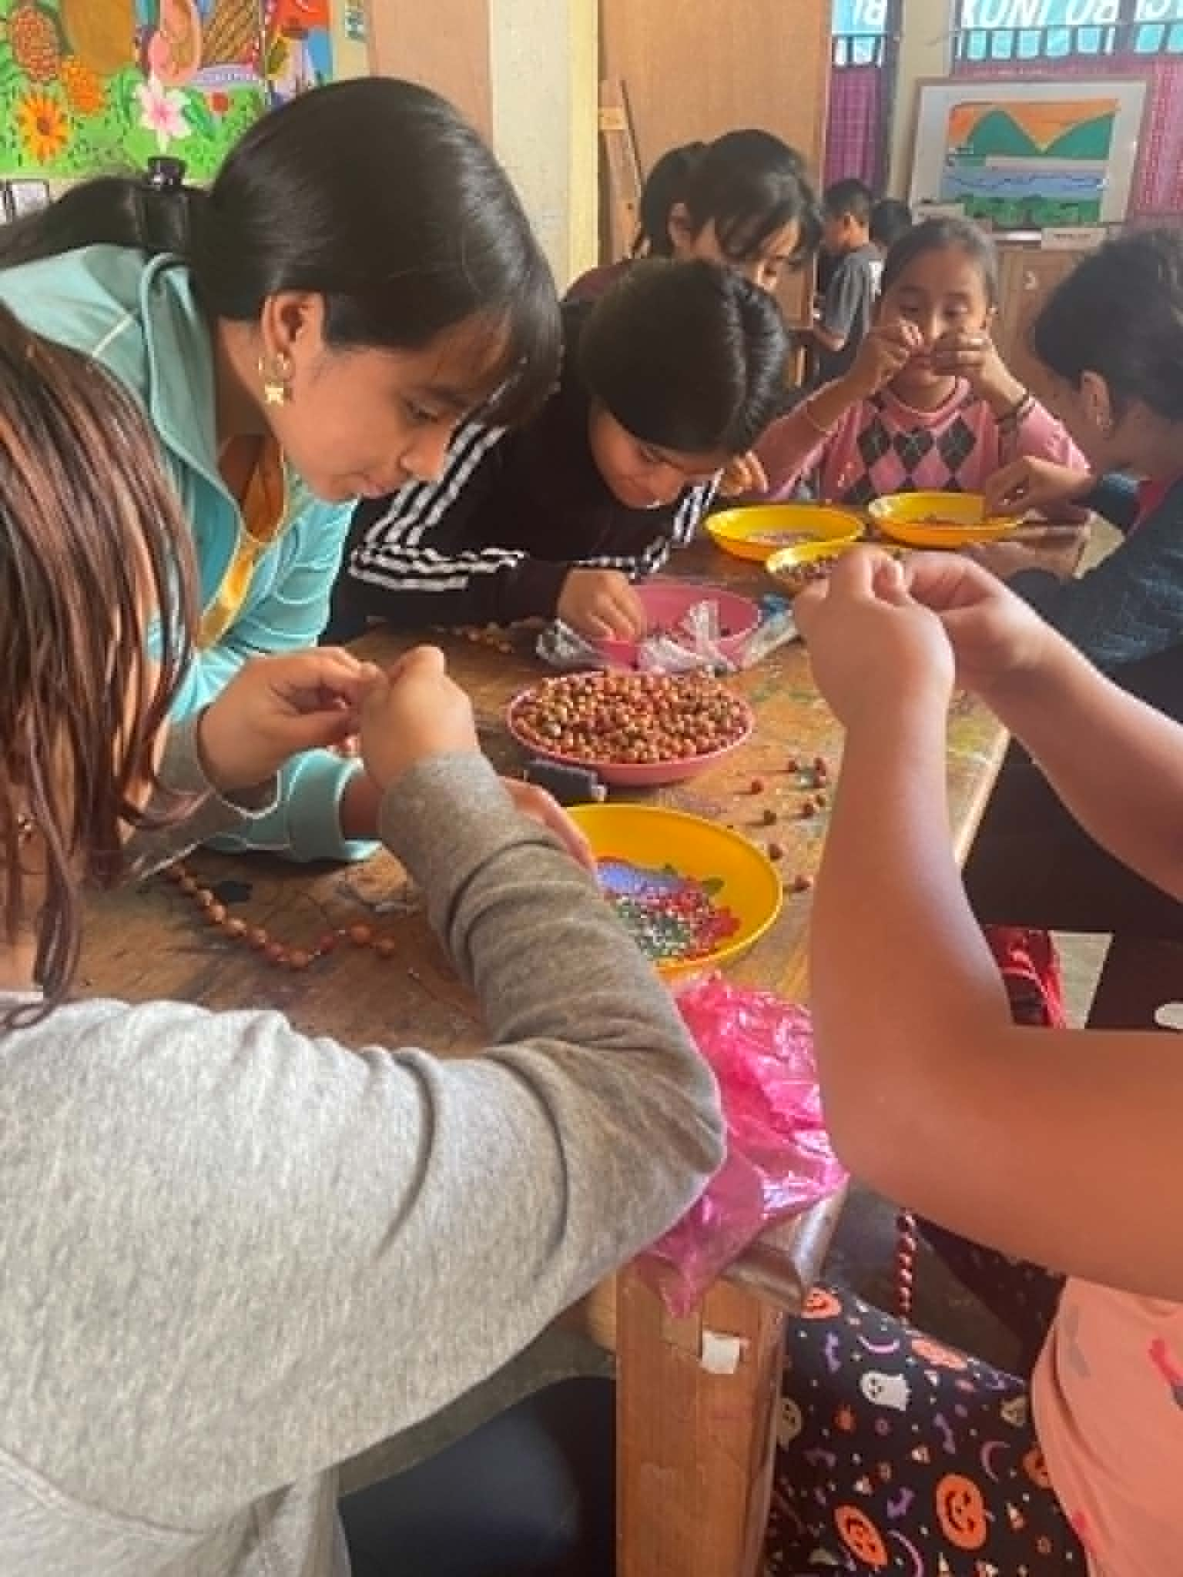
YOUNG GIRLS’ GROUP
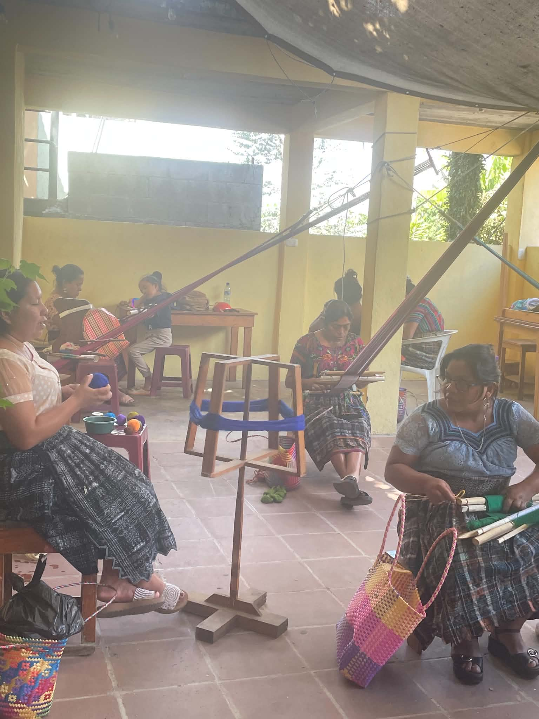
WOMEN’S GROUP. Not really foggy that day, but you see the people. Usually 10-12 women and 5-7 kids.
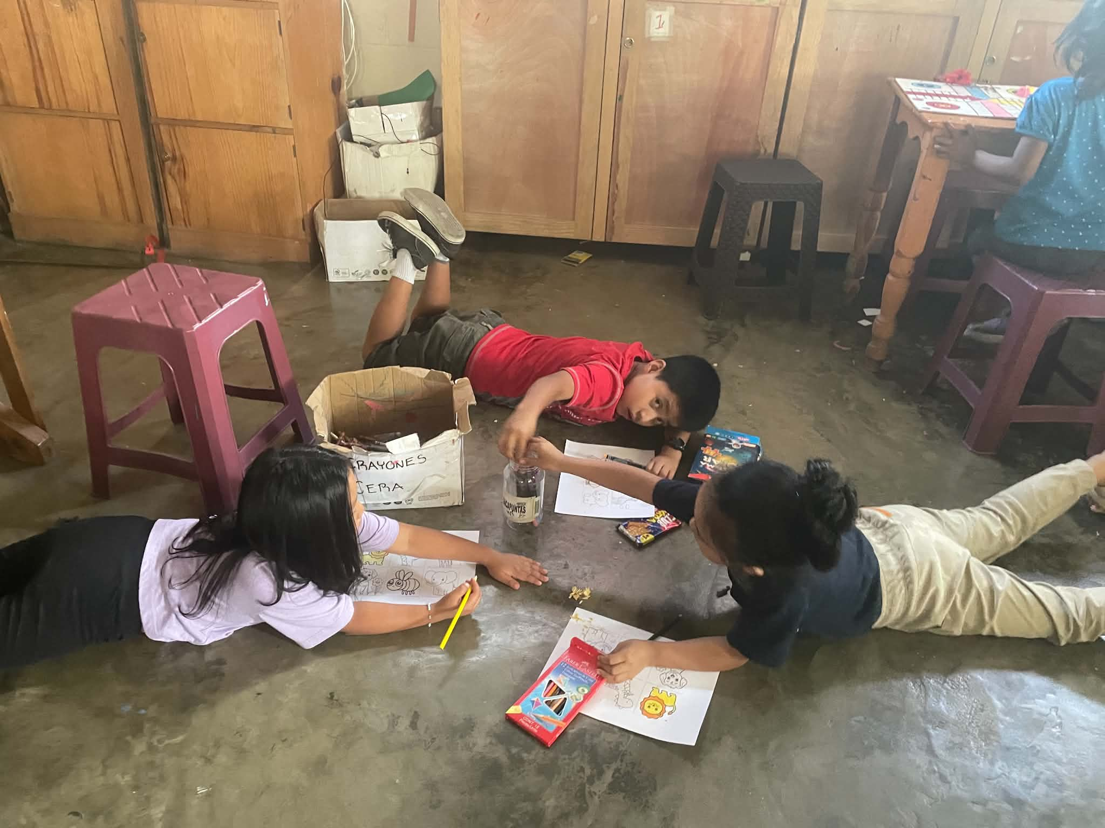
Little group….the teacher is at the table with exercises for other kids.

