CREANDO REPORT PHOTOS 5/25

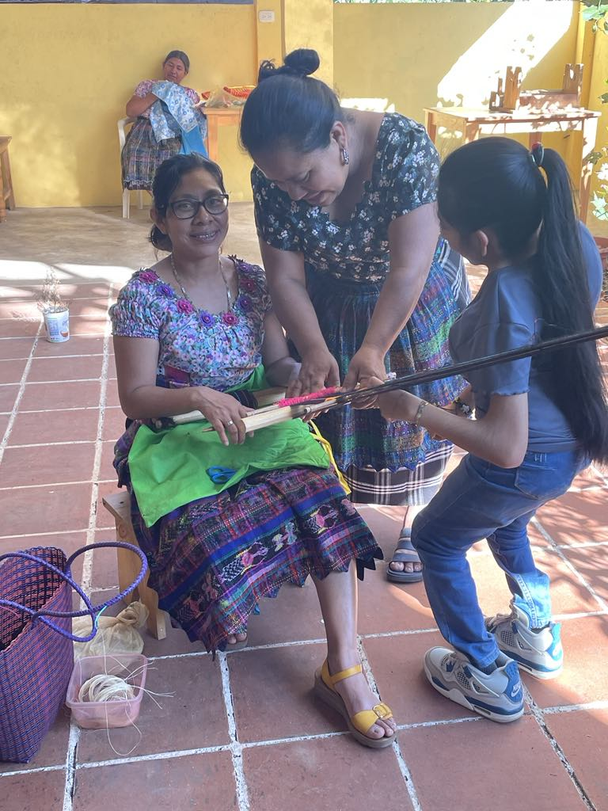

One mom learning from another.

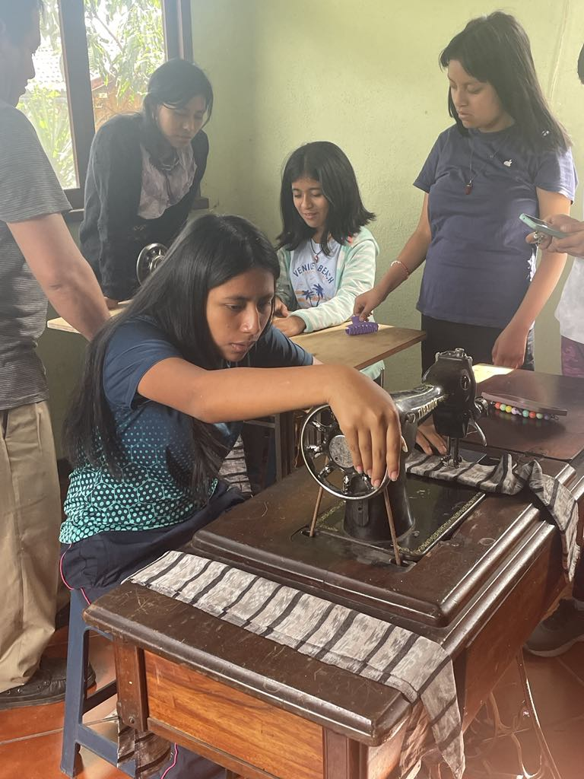

Girls learning to sew.

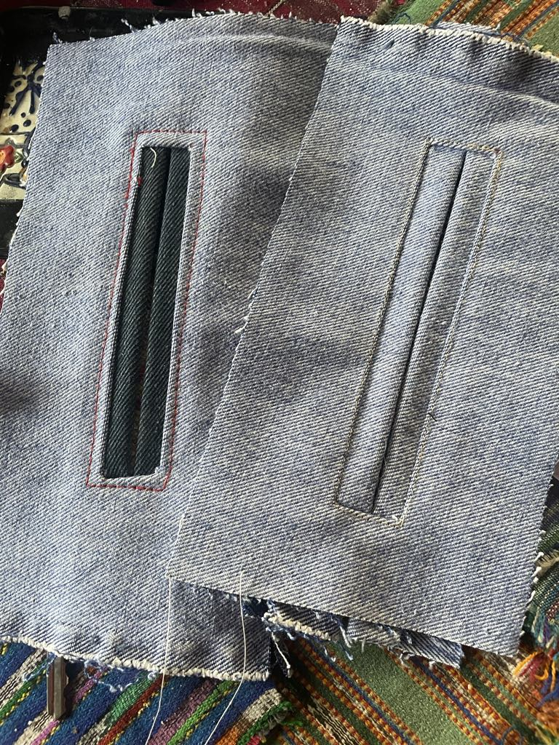

Will you look at these pockets? I’ve sewn a long time and can’t do this (think of men’s suit pants pockets.) this is pretty precise work for young girls. But they will be learning women’s blouses as soon as they can do French seams, tucks, and so on.

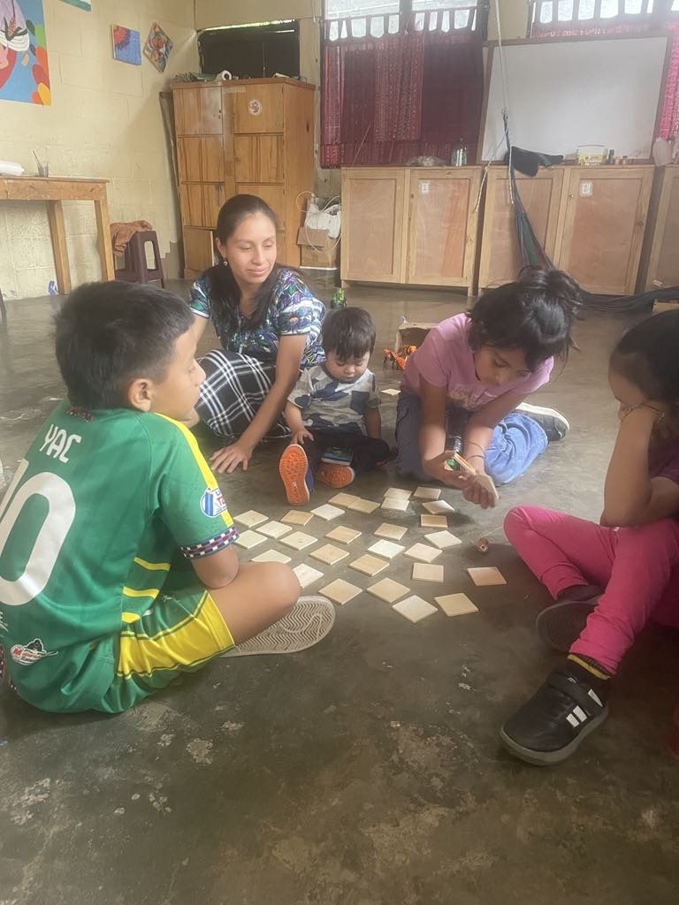

Teacher Fatima and about half of our afternoon crew – learning thru games.