A REPORT ON WORLD CLEAN-UP 2024 CONDUCTED AT BANGLADESH AND MIKINDANI BUYBACK CENTRES ON 21ST SEPTEMBER 2024 BY PLASTSAFI/ PWANI YOUTH NETWORK PARTNERED WITH VSO KENYA
INTRODUCTION
On World Clean Up Day 2024, a group of people from all walks of life came together to work towards a cleaner and safer planet by working towards the common ground around ridding their world claim about its waste pill. More than 60 waste pickers, teachers from for schools, community based organizations (CBOs) and youth-led organizations participated in the event this year.
Notably was the commisioning of Plastsafi Buyback Centre supported by VSO Kenya and our CEO Pwani Youth Network Mr. Alfred Sigo. Our objective is to collect single-use plastic waste and recycle this, emphasizing the creation of sustainable life for people; this undivided society stands in unity while advancing sorting andrecycling initiatives.
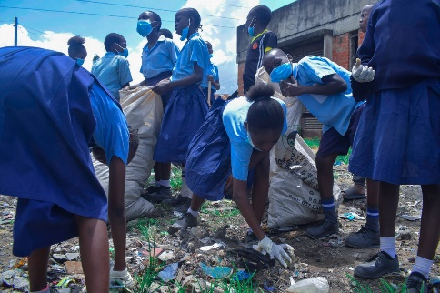

Key Activities
Waste Collection:
The clean-up drive collected over 2 tonnes of less compostable waste. While the waste pickers would gather students from schools, youth orgs and CBOs to clean up their local streets and public spaces. Plastics, paper, glass and other non-biodegradable waste were separated from the collected garbage and further sorted for recycling at the new Plastsafi Buyback Centre at Mikindani.
School and Youth Engagement:
Four schools participated in the clean-up, with teachers and students leading by example in creating a cleaner environment. Educational sessions were also held during the event, where teachers and community leaders emphasized the importance of reducing waste, recycling, and the role of young people in building a sustainable future.
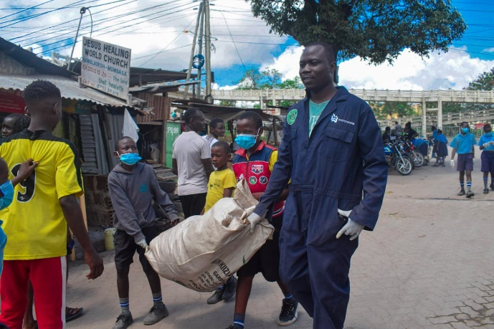
CBOs and Youth-Led Organizations:
Local community-based organizations and youth-led groups were instrumental in mobilizing volunteers and organizing the clean-up activities. Their leadership and dedication helped ensure that the event ran smoothly and had a lasting impact on the local community.
Launch of Plastsafi Buyback Centre
The event also marked the official launch of the Plastsafi Buyback Centre, supported by VSO Kenya. The buyback center is a major milestone for the community, as it will provide a structured platform for collecting and recycling plastic waste. Waste pickers can now sell collected plastics to the center, which will process and recycle them, contributing to the circular economy.
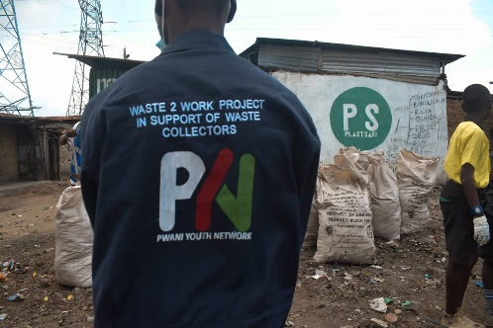

Key Impacts of the Buyback Centre:
- Improved Livelihoods: Waste pickers and community members will have a steady income stream by selling recyclable materials to the center.
- Environmental Protection: The buyback center will help reduce the amount of plastic waste that ends up in landfills and oceans, protecting the local environment and contributing to broader global environmental goals.
- Community Empowerment: The initiative fosters a culture of responsibility and sustainability within the community, empowering individuals to take charge of their environment.
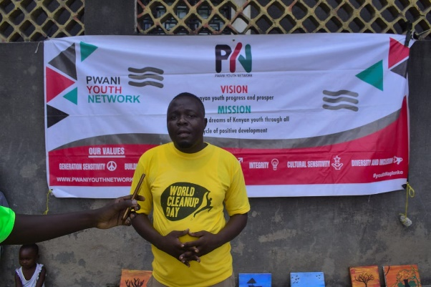
Outcomes and Impact
- Over 2 tonnes of disposable waste were collected, directly contributing to a cleaner environment.
- Increased awareness of the importance of waste management, recycling, and environmental stewardship, especially among the youth.
- Economic opportunities created for waste pickers, enhancing livelihoods through the recycling and buyback system.
- Strengthened community bonds as schools, CBOs, and youth organizations worked together for a common cause.
Conclusion
World Clean Up Day 2024 was a resounding success, demonstrating the power of collaboration in tackling environmental challenges. The event not only improved the cleanliness of the local community but also laid the foundation for sustainable waste management practices through the Plastsafi Buyback Centre. This initiative will have long-term positive effects on both the environment and the livelihoods of the local community members.
