The two-day training entailed exploring intrapersonal skills the champions and educators had towards creating change for sustainability for the growing generation and equipping them fully with life skills required for them to be agents of change within the society.
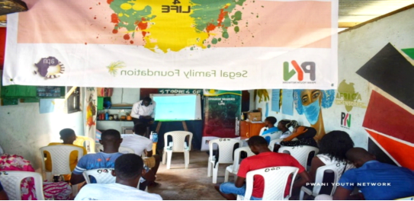

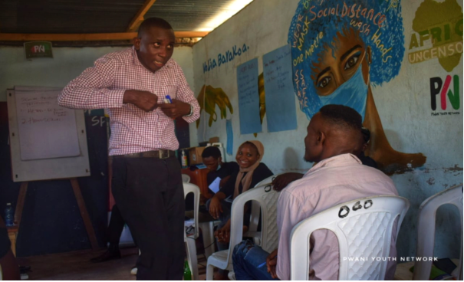

At the end of the two-day training, the youth participants were equipped with information and techniques to handle and coordinate perfectly with their participants for healthy discussions. An aspect of behavioral and mindset change could be foreseen in the youths compared to their initial state. When change is embraced positively, intrapersonal and interpersonal engagement is expected to be of importance for those involved.
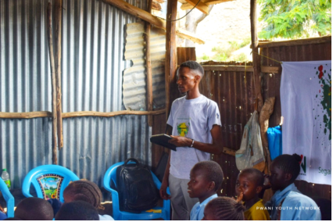
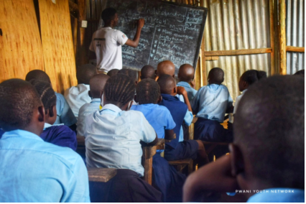

The community too was not left behind when this course began. Schools within the localities also had a share of what was in store for them during this process as constant engagements were made to make their learning environment conducive and sustainable. Now the youths who underwent the Changemakers training had an opportunity to put into practice all they had to be agents of change as the theme goes 'be the change you want to see, take responsibility.'
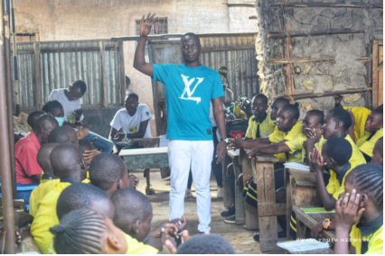
The program aimed at reaching out to the schools with up-to-date information on Behavior Change Process and empowering them with basic life skills knowledge to be able to live and create a sustainable space for the growing generation. Sessions were organized in six primary schools within the Bangladesh community i.e., St Mary’s school, St Agatha, St Consolata, Gift Primary School, Jerusalem Primary, and St Peters with the youth champions assigned roles to be lead facilitators in administering this channel of mentorship. Creating awareness, mass sensitization, and one-on-one engagements were the strategies used to effectively purpose the objectives of this course. For change is a process and it is inevitable, the school activities would take maximum ample time for it to reach out to the adolescents with the essential information. Topical discussions were selected accordingly to fit into the exact normal activities experienced in daily life in the community.

The post-reflection of the program would be bringing up a generation of individuals with attributes and personalities that build the community towards its growth and development and the possibilities could be seen. The schools’ representatives saw a bright future amongst their students as there was a sense of behavior change from their teenagers as experienced before. They appreciated much the work and patience put in place by the Changemakers to reach out to the teenagers with information to assist in their growth and behavior change.
The activity could not leave the fun part behind as too much work without fun for sure makes Jack a dull person. The process would use sporting engagements to raise awareness amongst the school-going children to maximize to its full capacity the change-making theme. Fun activities in between tasks were key in brainstorming for a productive engagement towards the end goal of change when associating with participants at the grass-root level.
Positive engagement creates room for healthy and sustainable growth in an individual and community as a whole. With the Changemakers program in place to facilitate Life Skills mentorship within the respective schools in the marginalized environment of Bangladesh, the participants' effective engagement called upon the involvement of outdoor activities to maximize fully the interaction between them and the Changemakers. The outdoor activities are aimed at bringing the participants(students) from their normal study environment to a more Edu-sport system of engagement whereby the facilitation will comprise sporting activities in between the interactions. This will greatly help the participants be able to perform effectively both in and out of school upholding their activities fully to the Sustainable Development Goals.
A two-day inter-school and one-month community tournaments were organized by Pwani Youth Network in partnership with African Philanthropic Network to establish healthy relationships amongst the schools and break the monotony experienced by the students from their normal day-to-day engagements.
Since in the community football is the widely ventured in sport, preferred and has an attraction of the mass, it was fit to have a football tournament within the locality involving all the seven schools under the program. The tournament aimed at raising awareness of the importance of sports in Education, sensitizing the community on embracing change towards development, and setting up a platform for talent exposure to the adolescents and young person’s participating. During this period, a good population from the community had the opportunity to be part of the process of maintaining good coordination among the participants and ensuring a conducive environment for the activity was set.
Parents turned up in large numbers to witness the abilities their children had out of their normal learning environment. They were appreciative of the team for making the event possible for it helped keep their children away from ill activities and the use and misuse of drugs that would likely tamper with their education. And from the feedback they issued as they were interacting with the Changemakers, it was evident to them the program had played a bigger and crucial role in spearheading the changes they were observing in their children. Their mental state awareness was heightened and they seemed to be making relevant decisions based on their personal and communal development.
The teachers on the other end could not hold their joy seeing how active and dedicated their students were to the activity. The sessions in schools were a real boost to their curriculum with change as the key factor notable during the period since its initiation. The schools could now offer safe spaces for peer-to-peer engagement, and mentorship sessions that contribute to a holistic conducive learning environment. The tournament paved way for the adoption of the Edu-sport channel within the schools to maximize fully the interaction of all the involved parties in child safeguarding and sustainable development.
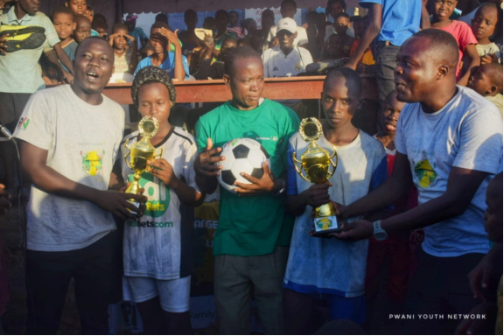

Amongst those individuals benefiting from the partnership are staff members at Pwani Youth Network born and raised in the community who have been advocating day in out for better health, mass information awareness on matters of Sexual Reproductive Health (SRH), sports, film and art exposure to the creation of decent employment for the opportunity youths within the community. Born and raised within the community,

