MEN'S MENTAL HEALTH AWARENESS WORKSHOP REPORT
Date: 13 June 2026
Time: 9:00 AM – 12:00 PM
Venue: Bangladesh Youth Space
Organized By: Bangla Talent Senior Team

1. Introduction
On 13 June 2026, the Bangla Talent Senior Team successfully organized a Men's Mental Health Awareness Workshop at the Bangladesh Youth Space. The workshop brought together participants to discuss the importance of mental well-being among men, promote emotional awareness, and encourage healthy coping mechanisms. The session provided a supportive platform where participants could openly engage in conversations about mental health challenges and solutions.

2. Objectives of the Workshop
The workshop was guided by the following objectives:
- To increase awareness and understanding of men's mental health issues.
- To reduce stigma associated with discussing mental and emotional challenges.
- To create a safe and supportive environment for sharing experiences.
- To equip participants with practical strategies for managing stress and maintaining emotional well-being.
- To promote peer support and encourage individuals to seek professional help when necessary.

3. Activities Conducted

Opening Session
The workshop commenced with welcoming remarks and an introduction to the significance of mental health. Participants were encouraged to actively engage and contribute to the discussions throughout the session.

Awareness Presentation
Facilitators delivered an informative presentation covering common mental health challenges affecting men, including stress, anxiety, depression, and the impact of societal expectations on emotional expression.

Interactive Discussions
Participants engaged in open discussions focusing on the barriers that prevent men from speaking about their struggles. The conversations highlighted the effects of stigma and the importance of building supportive networks.

4. Key Observations and Challenges

Time Constraints
Some discussions generated significant interest and participation, resulting in extended conversations that affected the planned schedule. Future workshops may require additional time allocation or structured discussion periods to accommodate participant engagement.

Hesitation to Share Personal Experiences
Many participants initially found it difficult to openly discuss personal challenges due to fear of judgment and societal expectations. However, confidence and participation improved as the workshop progressed, demonstrating the value of creating safe and trusting environments.

5. Outcomes and Impact
The workshop achieved the following outcomes:
- Increased awareness of mental health issues among participants.
- Improved understanding of the importance of emotional well-being.
- Enhanced willingness among participants to discuss mental health concerns.
- Strengthened peer connections and support systems.
- Encouraged positive attitudes toward seeking help and support when facing mental health challenges.

6. Recommendations
To enhance future mental health initiatives, the following recommendations are proposed:
- Organize regular mental health awareness sessions and follow-up discussions.
- Incorporate more trust-building and team-bonding activities.
- Engage qualified mental health professionals in future programs.
- Establish peer support groups within the community.
- Provide additional educational materials and resources on mental wellness.

7. Conclusion
The Men's Mental Health Awareness Workshop was a successful and impactful initiative that fostered meaningful conversations around mental well-being. The session highlighted both the challenges and opportunities associated with promoting mental health among men. Continued efforts through regular engagements and support programs will further strengthen awareness, resilience, and emotional well-being within the community.
Annexes
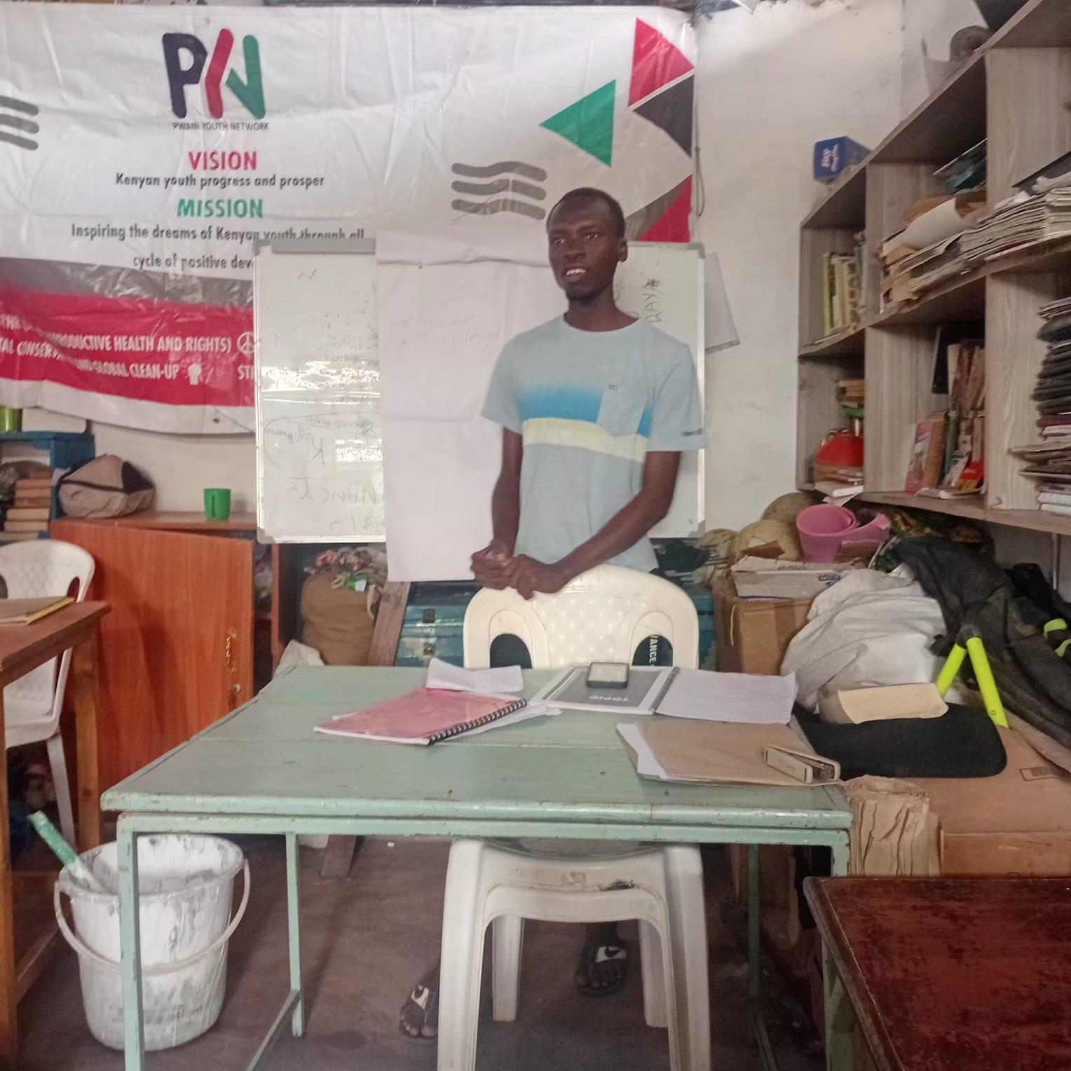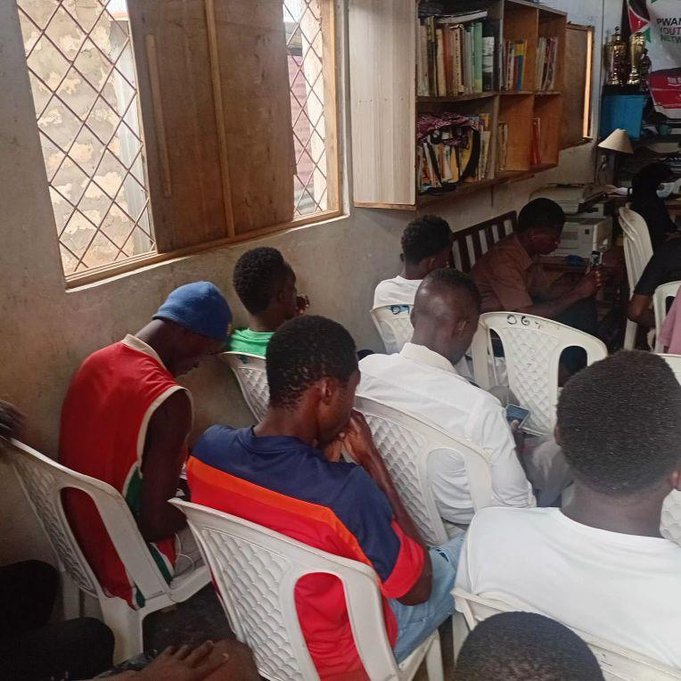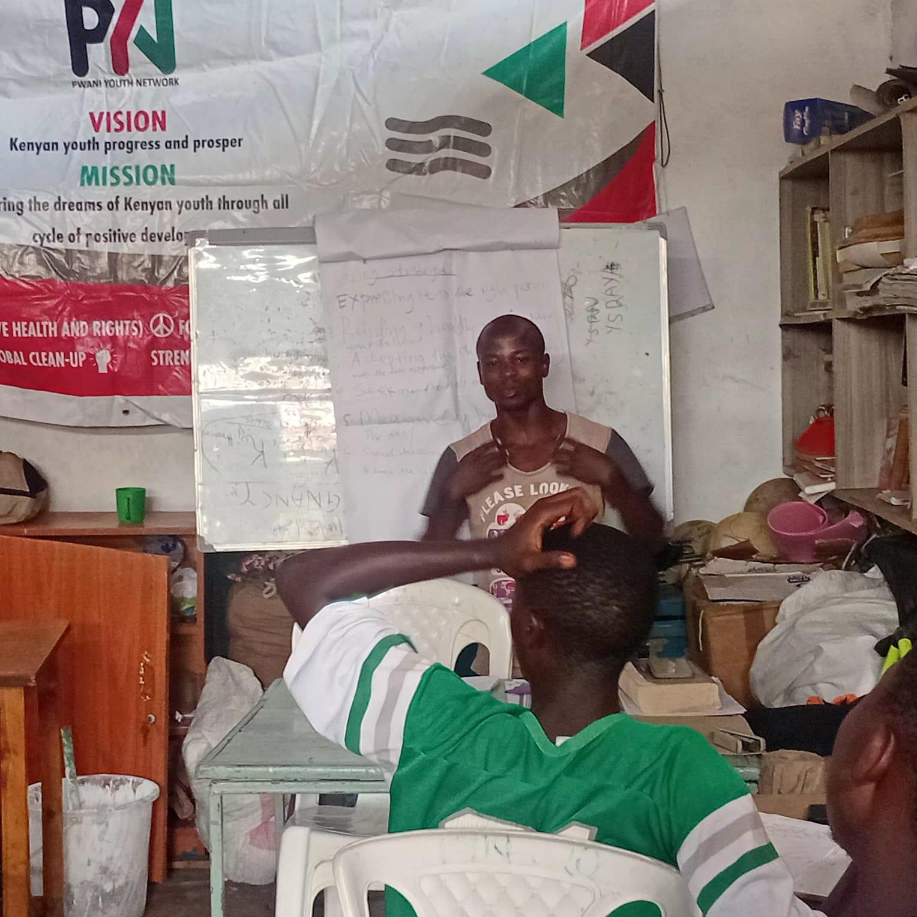
Prepared By: Julius Odhiambo
Position: Bangladesh Youth Space Co-ordinator
Date of Submission: 16 June 2026

