PROJECT REPORT
Better Nutrition for the Nigerian Child Via ADHFP (#60216)

Brief on the project at identified PHC

Nigeria, diverse and populous, grapples with child well-being in remote areas, marked by inadequate nutrition and healthcare access. Malnutrition affects 1 in 3 children in developing countries like Nigeria. (1) According to UNICEF, as of 2020, Nigeria had over 10 million out-of-school children, many of whom were from remote communities, with high child malnutrition rates, and approximately 2.5 million children are suffering from severe acute malnutrition. These challenges require urgent support.
One of the role played by PHCs, especially in rural areas, is Nutrition and Childhood development. A large number of PHCs in rural Nigeria are not able to offer these services because they are dilapidated or grossly unequipped.
The ADHFP through its intervention in rural Nigeria aims to bridge the gap in nutrition and on education about nutrition first by revitalizing PHCs in rural Nigeria making it fit to deliver nutrition services and education.

The pictures below show the existing condition of the Health Clinic.

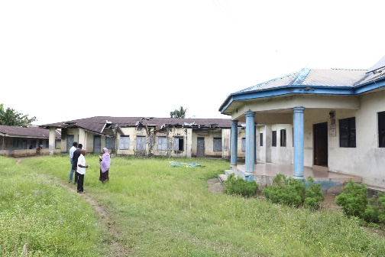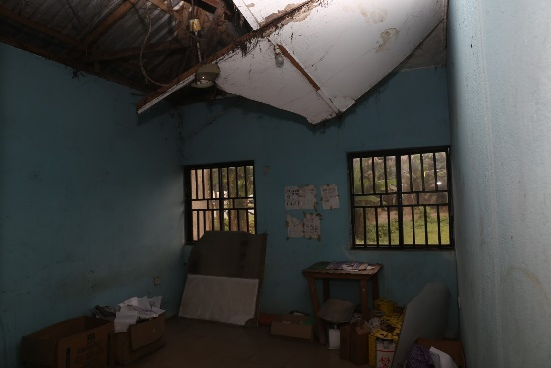
Omunowa PHC in Ikwerre LGA, Rivers state Pharmacy in Omunawa PHC
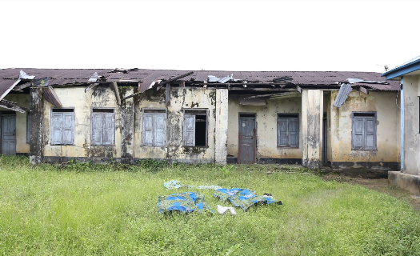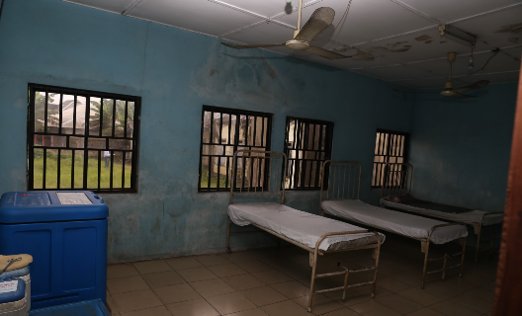
admission ward in Omunawa PHC, Ikwerre LGA

PSHAN proposed Solution
PSHAN can revitalize facilities in these communities, providing vital healthcare, capacity-building for workers, and nutritional education for caregivers to identify danger signs. PSHAN will support infant and young children feeding with micronutrient supplementation such as deworming, Vitamin A, and Iron supplementation through community campaigns.

Summary of Activities

Some of the activities
1. Healthcare Gaps: Many remote communities lack well-equipped healthcare facilities, hindering access to essential nutritional services for children. The ADHFP aims to improve the status of these health facilities to be able to provide nutritional services.
2. Education and Awareness: Low levels of maternal education can lead to suboptimal childcare practices, including poor feeding and hygiene habits, which contribute to child malnutrition. Childhood nutrition education will form the core of this intervention.

