Hello again, we love sharing with you a month in the life of our team and projects. As you already know, to carry out our community process we have to address different needs specific to the autonomy processes of each space.

In the upper region of Chiapas, we have increased the level of nurseries and one of them is in the Carrizalito town belonging to the municipality of San Cristóbal de las Casas Chiapas. This project is one of the most important since it arises from the awareness of a group of indigenous women who are dedicated to making toast made with corn, which requires firewood to cook. Analyzing the situation, the felling of trees is A very worrying and very noticeable problem is why they decided to create a forest nursery to avoid deforestation in more areas, that is how they approached them for the training since they were completely unaware of the subject. Throughout the process of developing the nursery, support has been provided along with various workshops such as: composting, vermicomposting, seed collection, seed germination, pruning workshop, identification of mother trees, children of different ages of the only primary school in the town. Various talks have also been held with the members to channel the ideas, emotions, attitudes and learning that they have obtained with the creation of the nursery. These types of actions make a big change in society because being a small community makes more people from the surrounding towns interested and motivated to learn more about environmental education.

Lorena member of the group collecting oak sedes.

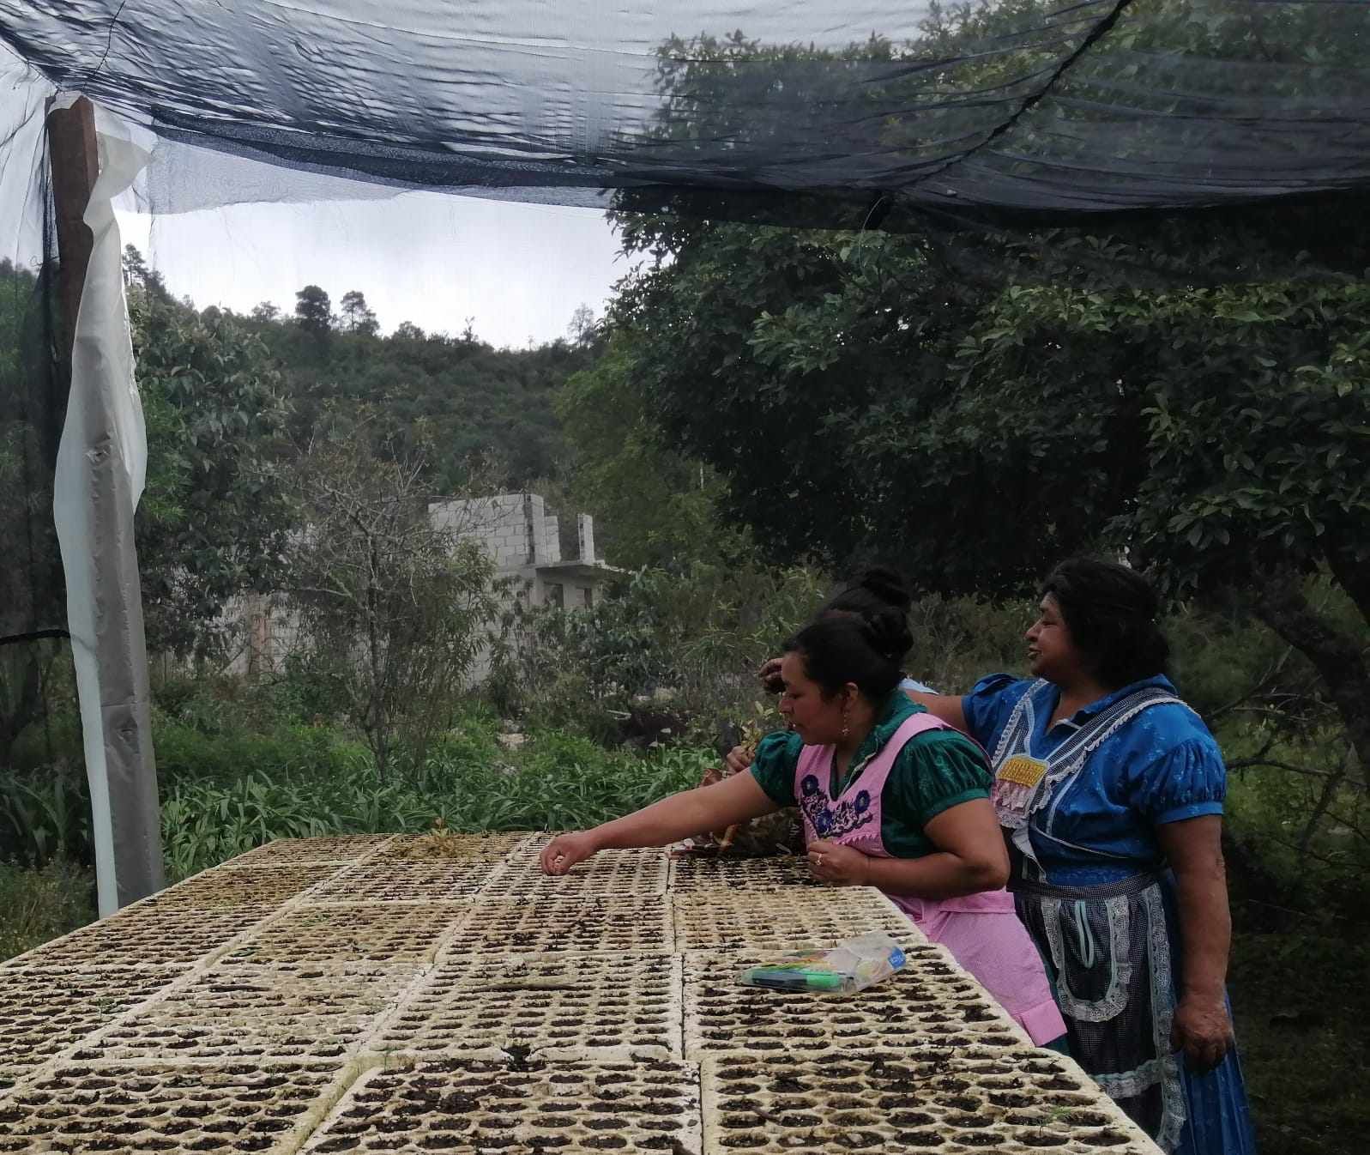

**Ladies in the process of seed germination**

**Preparation of irrigation schedules together with local children and group members**