Hello, I would like to share a little of what we have done over time. Unfortunately, we have not been able to move forward as we would like because financial resources have limited everything, but we are hopeful that with your help we will achieve something.

1st Reply
No. | PHOTOGRAPH | DESCRIPTION
1 | 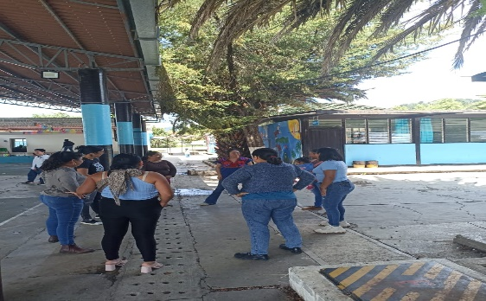 | Starting ritual day 1: Participants were invited to form a circle on the court and each participant was asked to propose a movement for the rest of the group to replicate, then use a word to mention how they felt .  Presentation: A circle was formed on the court where they introduced themselves with their name, mentioning their favorite dish, color, and if they were the father or mother of a student.
2 | 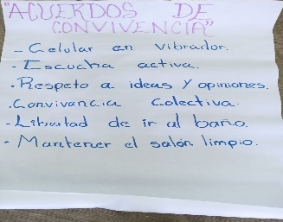 | Coexistence agreements: A poster was placed in the middle of the group so that the group could propose agreements for coexistence and that the entire group would agree.
 | 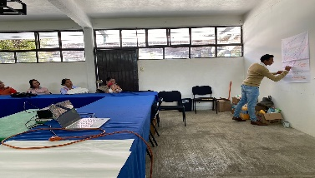 | Pre-assessment : Through a brainstorming session, the topic of climate change and its respective subtopics were implemented and in plenary session they mentioned their knowledge on the topics.
 | 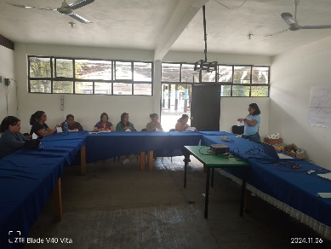 | Global warming: Each participant made a fanzini (a notebook with a sheet of paper) in which they were invited to write and answer a question on each sheet, there were 4 in total. Afterwards, each of the questions was shared in plenary session and at the end, each person was left with their own reflection.
 |  | Greenhouse effect: We addressed questions with the parents regarding the greenhouse effect if they had any idea about the subject. Each parent mentioned certain arguments, after which we presented the subject with slides.
 | 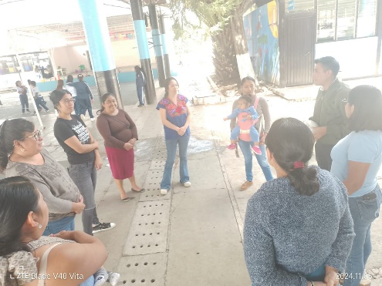 | Closing: They were invited to go out on the field and each one to say what significant learning they had and how they left it.
2nd Reply
No. | PHOTOGRAPH | DESCRIPTION
1 | 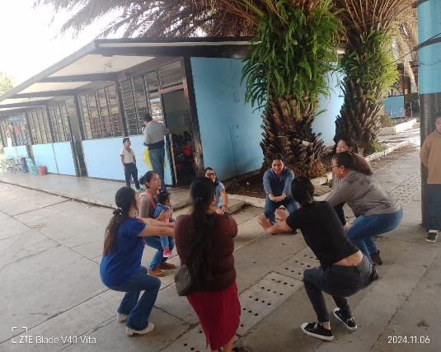 | Beginning ritual day 2: The activity “Energy compost” was carried out. They were invited to make a circle in the space outside and give themselves a massage from head to toe. Continuing, we intended with a word what we wanted to contribute to the workshop and with our hands we stirred this compost for the group.
2 | 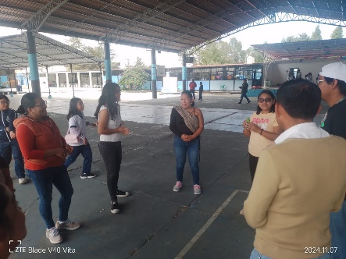 | Recovery of learning from the previous day: Through the dynamic “The potato is burning” each person shared their learning from the previous day and how they felt.
3 |  | Consumerism: The topic was explained through triggering questions about the things you use on a daily basis. generating reflection on the topic and in plenary they were proposing how they would implement the change from home
 | 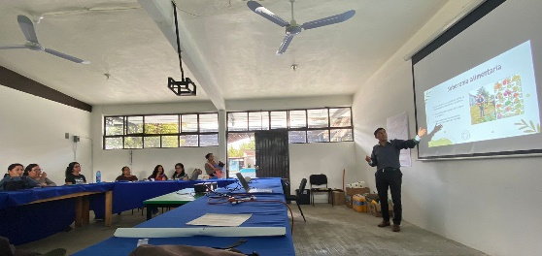 | Slide presentation : The topic was explained: Various International Treaties on Environmental Matters, to which Mexico has been a party, and in plenary the participants mentioned how they felt.
 |  | Slide presentation : Generative questions were asked to determine if they had any knowledge of the topic: mitigation, resilience and adaptation, and then the topic was explained using slides.
 | 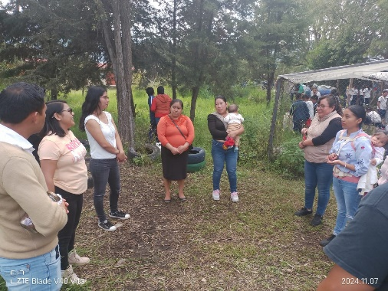 | Closing: A circle was formed in the middle of the court and according to the direction of the clock they were mentioning how they felt during the workshop and with what they expressed what emotion they were leaving with.
3rd Reply
No. | PHOTOGRAPH | DESCRIPTION
1 |  | Presentation : Triggering questions on the topic were asked to the parents and they presented themselves individually.
2 |  | Feedback : The previous day 's topic was given feedback with generative questions about the topics seen, with the sea and land dynamics each of the members who lost in the dynamic was asked a question about the topic.
3 |  | Relaxation dynamics : Through the “ Ball Thief ” dynamic , the topic of ecosystem services was explained : supply, regulation and culture, the parents formed two lines and balls were placed on a table, inviting people to come and take some of them individually and then they were asked to reflect on the consequences if we exceed the overexploitation of our natural resources.
 | 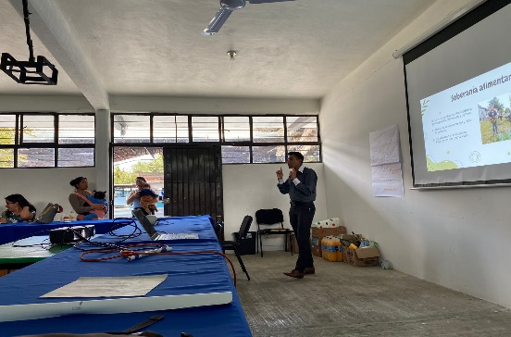 | Video presentation : It was projected the short film “Wolves changed history” and subsequently a space for reflection on the importance of ecosystem services was generated .
 | 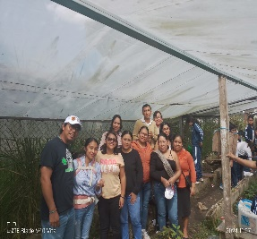  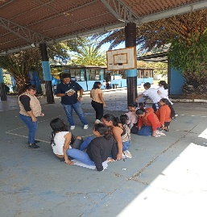 | Closing: Through the dynamic “dispossession of the territory” two flipcharts were placed in the middle of the field where the parents stood on top of them, narrating how in our daily lives we influence the various dispossessions of natural areas. In plenary they were using their voices and expressing with what emotion they were leaving.
4th Reply
PHOTOGRAPH |  | DESCRIPTION
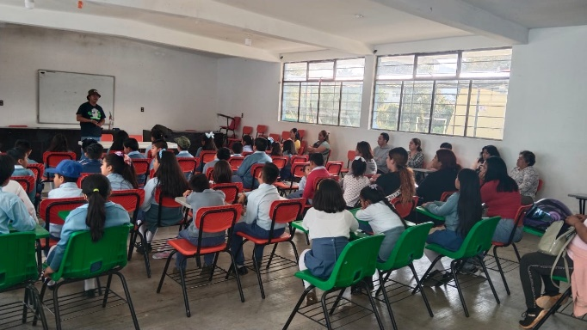 |  | Presentation: We introduced ourselves to the parents again, as more parents joined every day . On this occasion, the children were invited.  .
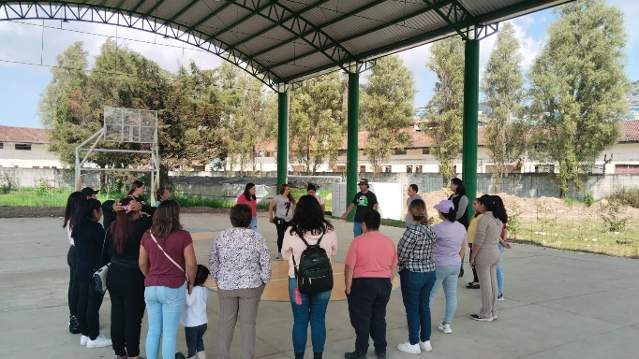 |  | dynamic : “Energy compost” was repeated again. Participants were invited to make a circle in the space outside and massage themselves from head to toe. Continuing, we intended with a word what we wanted to contribute to the workshop and with our hands we stirred the compost for the group.
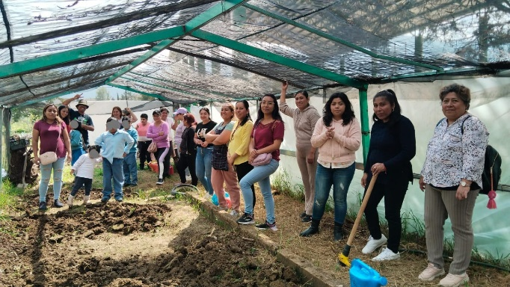 |  | Feedback : In the continuation of the application of the replicas, reinforcement mechanisms were shared for the topics seen in the previous sessions. In this case, we addressed awareness, co-responsibility for caring for the environment and ways to share knowledge with others.
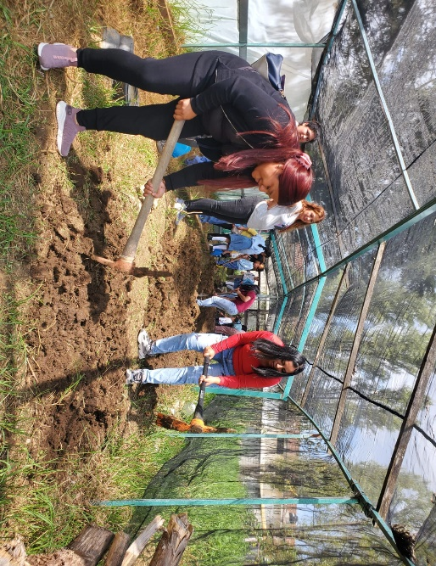 |  | Closing: As part of the commitment to parents and the learning space, a symbolic planting of vegetables was carried out , this as part of generating a correlation between theory and practice through agroecology.
ATTENDANCE LIST

Annex 1.

Attendance list for the first session ( Monday , November 4)

- Jorge Lopez Ruiz.
- Alberto Antonio Diaz Diaz .
- Emanuel Zeriya Santiago.
- Leticia del Carmen Porraz Ruiz.
- Hiram Moralees Dominguez .
- Juliana Rasgado Jimenez .
- Cecilia Lucia Hernandez Jimenez .
- Pablo Erique Gonzales Hernandez .
- Minerva Garcia Gomez .

Attendance list for the second session ( Tuesday , November 5)

- Veronica Hernandez mendez .
- Diana Estefania Coello Muñoz.
- Lucia Karina Santiago Gomez .
- Fabiola Lizbeth Bermudez Carpio.
- Bertho Yolanda Fonseca Carpio.
- Sweet Veronica Martinez Abarca.
- Estefani del Carmen Santiz Jimenez .
- Rodolfo Martinez Esponda.
- Sara Lorena Gomez lopez .
- Brianda Yareni Lopez Penagos.
- Monica Judith Herrera Gomez .
- Liliana del Rocio Moreno Gonzales.

Attendance list for the third session ( Wednesday , November 6)

- Adelina Jimenez Mendoza
- Yedi Carla Gomez Lopez
- Yudith Fabiola Carpio Hernandez
- Rayo Guadalupe Rodríguez Ruíz
- Katia Itzel Tepepa Ocaña
- Clara Lopez Porras
- Gisela Guadalupe Perez Fuentes
- Manuela Paleton
- Yobana Carolina Bartolome Trujillo.

Attendance list for the fourth session ( Thursday , November 7)

- Karina Guadalupe Ruiz Martinez
- WHITE LAURA ZUNIGA HERNANDEZ
- ALEXANDRA DE JESUS AGUILAR ALVAREZ
- QUEEN JHOCELIN JOY CUETO
- Teresa Lucia Ico Gomez
- NIDIA CONCEPTION CARPIO CARPIO
- Fredy Raúl Cruz Vazquez
- YARA DENISE GARCIA VILLAFUERTE
- GUADALUPE DEL C MARTINEZ VILLATORO
- CECILIA HERNANDEZ LOPEZ
- Vanessa Yanet Perez Fonseca
- ALEJANDRA G SANCHEZ GOMEZ
- EVA FRANCISCA LOPEZ FLORES
- Ruby Alexandra Cantoral Perez
- GUADALUPE ALEJANDRA ALAVAREZ CRUZ
- TANIA ELIZABETH GORDILLO HERNANDEZ
- MONICA EDALY PASCACIO ARMENDARIZ
- JANNETH COURTOIS HERNANDEZ
- BLANCA ESTHELA ALVAREZ GOMEZ
- Yadira del Carmen Morales Guillen
- Elizabeth Munoz de la Cruz
- CECILIA DEL C GUTIERREZ SANCHEZ
- GUADALUPE DEL ROCIO VALENCIA
- DAIKELYS LEOVED SOLIS PÉREZ
- Esteka Gomez Lopez
- BERENICE GARCIA LOPEZ
- IRAZU GPE RUIZ GARCIA
- MARCELA J LOPEZ ALVAREZ
- Silvestre Rodriguez Jimenez
- Lizbeth Roman Lazaro
- SHELY YURIAN RAMIREZ MARTINEZ
- Patricia Del Bermudez Gomez
- Hugo Alberto Villatoro Dominguez
- CITLALY FABIOLA PINACHO MORENO

