Attendance Report for the Sustainable Chiapas State Fair
Date: Tuesday, March 18, 2025
Location: Municipality of Marqués de Comillas, Chiapas
Organization Represented: Na Bolom Cultural Association AC

1. Introduction
The Na Bolom Cultural Association's Climate Change program participated in the "Sustainable Chiapas State Fair" with the goal of engaging youth and society in promoting and achieving the Sustainable Development Goals (SDGs) of the UN's 2030 Agenda. This participation reinforces our commitment to environmental conservation and sustainability in the communities of Chiapas.

2. Activities Carried Out
- Na Bolom Exhibition: An exhibition table was set up where various types of trees were presented and the conservation and sustainability work carried out by Na Bolom in the highlands and jungle region was explained.
- Presentation with the Municipal Secretary of Marqués de Comillas: The carbon credit project, its feasibility, and benefits for the region were discussed.
- Dialogue with Representatives of the Chajul Station and the El Porvenir Community: Discussions were held to implement the carbon offset proposal on 400 hectares, with the goal of advancing conservation and environmental compensation strategies.

3. Results.
- Raising awareness among attendees about the importance of reforestation and the conservation of natural resources.
- Networking and strategic alliances with key stakeholders for the implementation of the carbon offset project.
- Identification of opportunities for collaboration with local communities and organizations on environmental initiatives.

4. Travel Costs
The total cost of the trip amounted to $3,500.00 MXN , broken down into the following items:
- Transportation: $1,800.00 MXN
- Food: $1,000.00 MXN
- Lodging: $700.00 MXN

5. Conclusion
Participation in the Sustainable Chiapas State Fair strengthened the visibility of Na Bolom and its work in environmental conservation. Furthermore, progress was made on the potential implementation of a carbon offset project on 400 hectares, which represents an important step in the search for sustainable solutions for the region's communities. It is recommended that the agreements established with the stakeholders be followed up on to implement the proposed actions.

6. Photographic Annexes.
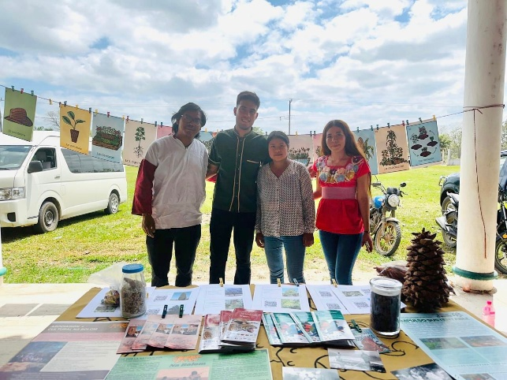 | 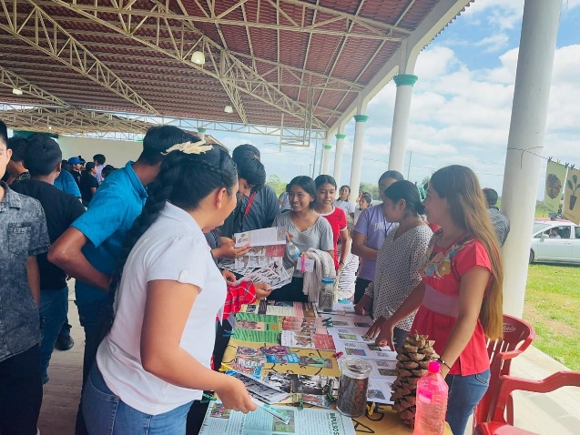
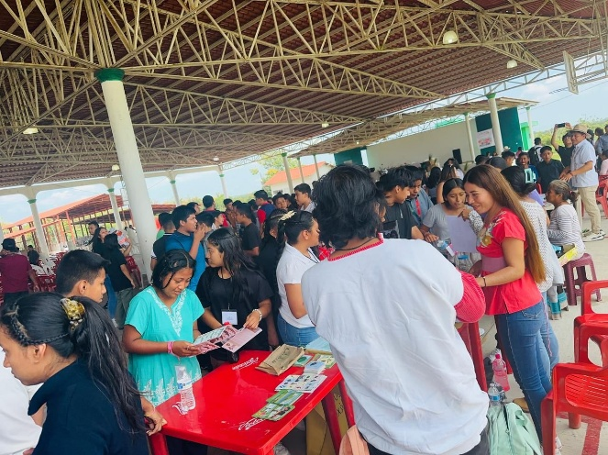 | 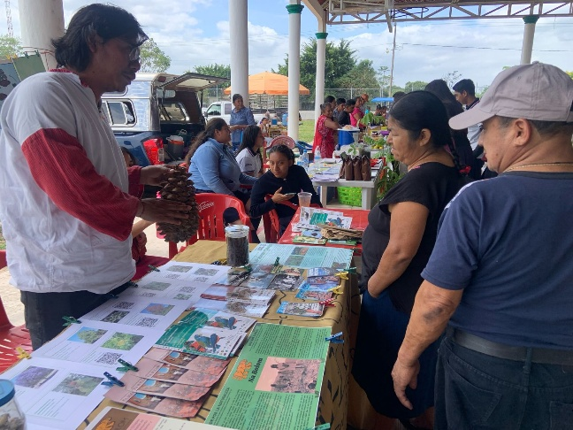
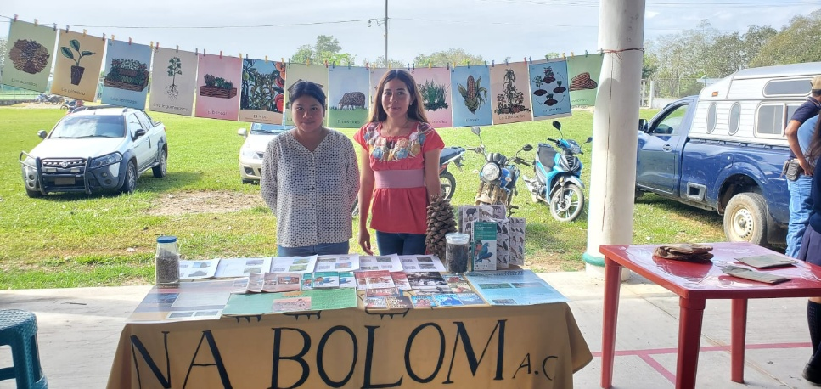 | 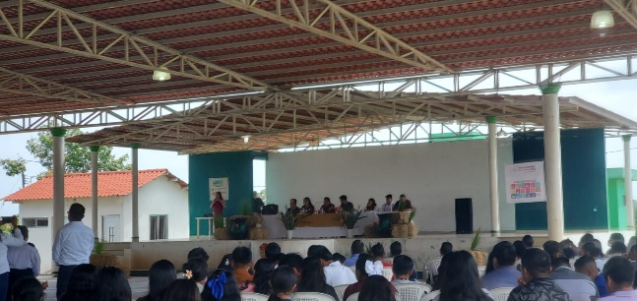
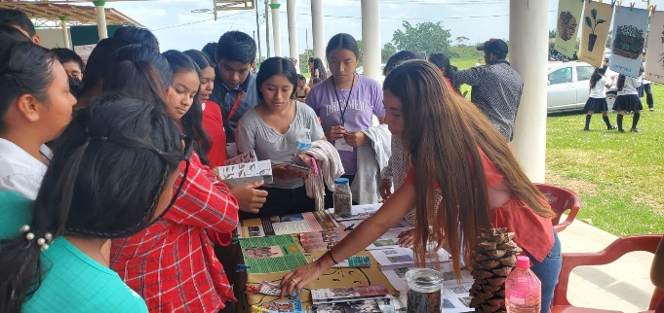 | 



