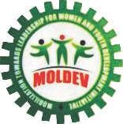
MOBILIZATION TOWARDS LEADERSHIP FOR WOMEN AND YOUTHS DEVELOPMENT INITIATIVE (MOLDEV)

PRIMARY HEALTH CARE PROJECT REPORT

IN

KULAKDHANI COMMUNITY OF SHANI, LOCAL GOVERNMENT, BORNO STATE NIGERIA.

MARCH 8, 2024

PROJECT BRIEF
The rural Community of Kuladhakni, Shani Local Government of Borno State Nigeria has been without a basic health facility in its many years of existence until 2017 when MOLDEV came through with a Primary Health Care project to provide basic health services to over 5,000 inhabitants of the community and its surroundings. The project is expected to address Maternal/Child care as well as some common health challenges such as Malaria, Typhoid, Hepatitis, Hypertension and worm infestation. Based on our findings, Maternal/Child mortality rate is high due to the above mentioned health challenges. In some complicated cases, the people have to travel about 60kms to get to the nearest health facility, sometimes deaths are recorded along the way.
Lack of potable water in the community and its surroundings is a major challenge affecting the wellbeing of the inhabitants. This brought about the idea of installing a solar powered borehole to address the water need of the clinic and the community. Likewise, it was realized that the community had no functional school. There was provision for and a running school but the services were withdrawn without notice or cause and the building became abandoned. There are a few NCE graduates in the community who are willing to take up the service but are torn between free services and fending for their survival, the community has over 400 school age children who have no hope for basic education and are yearning to learn, without a meaningful intervention they are looking at a bleak future.
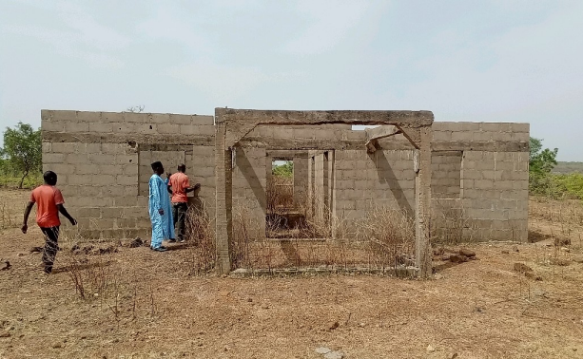
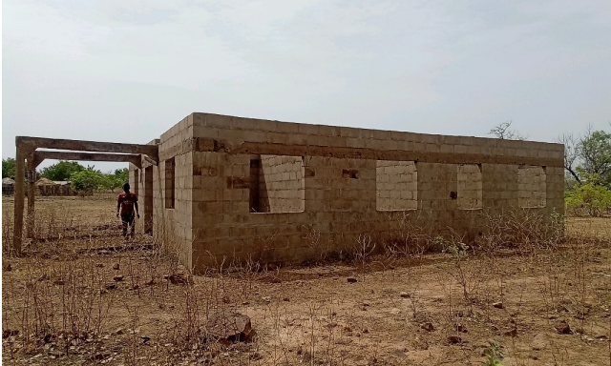
STRUCTURAL MPLEMENTATION OF THE CLINIC From 2019 to date The structural design has been implemented to lintel level as seen in the pictures below.
Front view of the Clinic Building at Lintel Level
Side view of the Clinic Building at Lintel Level

FUNDING SOURCES
The project from the beginning has been funded by the Founder/Executive Director of MOLDEV. She paid for the, structural design and building of the structure to roofing level and more needs to be done to complete the project for use by the community.
CHALLENGES
Inadequate funds has halted the completion of the project to date. There is need for multiple funding sources to get the needed funds for the completion of the Clinic, School and more boreholes project. The next phase will involve roofing, finishing and equipping of the facility, renovation of the school and if possible an additional borehole point.
RESOURCE MOBILIZATION STRATEGIES
We have implemented some resource mobilization strategies to raise funds for the completion of the projects. These include;
- Advocacy visits to philanthropic individuals and likeminded charity organizations
- Fundraising appeal letters to potential donors
- Partnership with Global Giving for Crowd Funding
- Partnership with benefitting communities
- Flyers publication for public support
- Fundraising Social Media Campaign
FUNDRAISING/CROWDFUNDING OUTCOME
During the last Giving Tuesday in November 2023, we have gotten a total of $100, although it is far from the project but we are very grateful to the donor and more encouraged to keep on with the pursuit of the goal to complete the project to achieve the needed social impact in the lives of the residents of the community.
The total project goal is $104,814 to complete and equip the Primary health care center for use. This year 2024 with your continuous support, we are looking forward to achieving this project goal for the good of the people.
A borehole project which we also initiated to compliment the operation of the Clinic and provide potable drinking water to the community has also received support of equipment worth about N6 million ($4,445) from some local philanthropies. We are also deeply grateful by their act of charity. The community is also grateful for the support.
Staff of moldev volunteered to install the borehole while the host community supported in manual labour, water and sand. They also expressed their readiness to ensure the safety and protection of the entire project facilities for proper use with a dedicated community member assigned to control the borehole supply schedule.
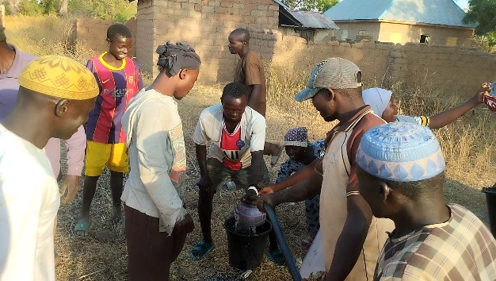
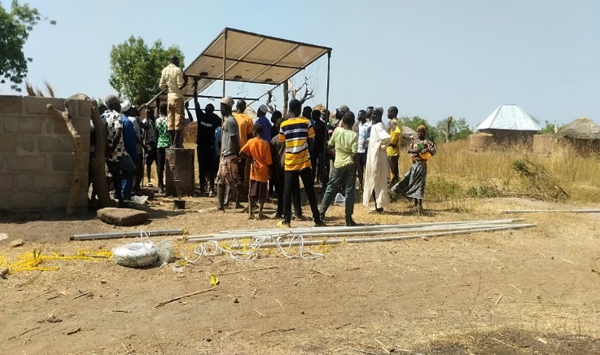

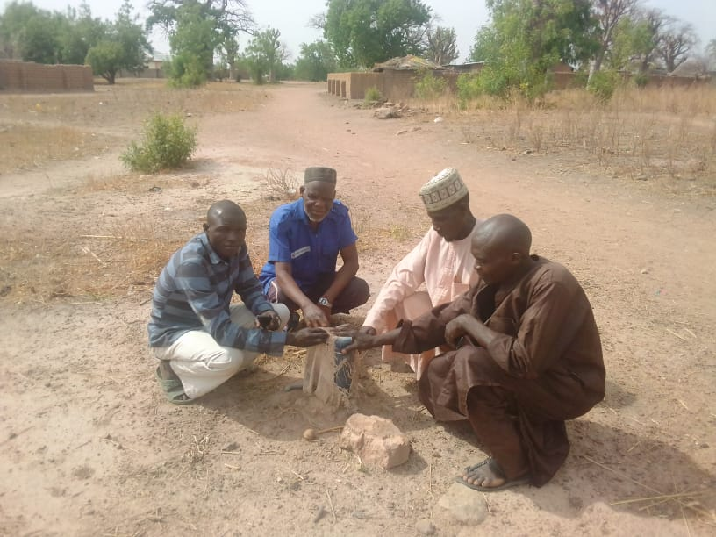
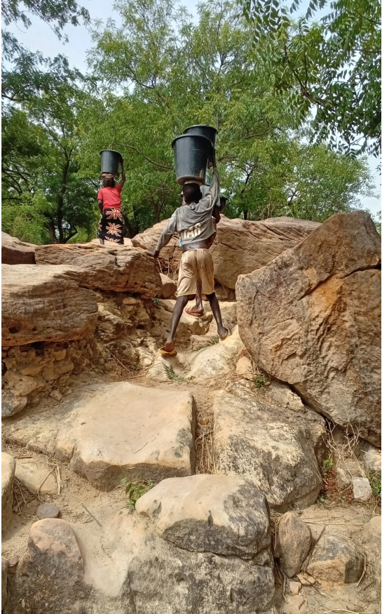
Installation of solar panels
Community Leaders on the site of the dug Borehole
Children fetching water from the river through a difficult terrain
Testing the installed pump

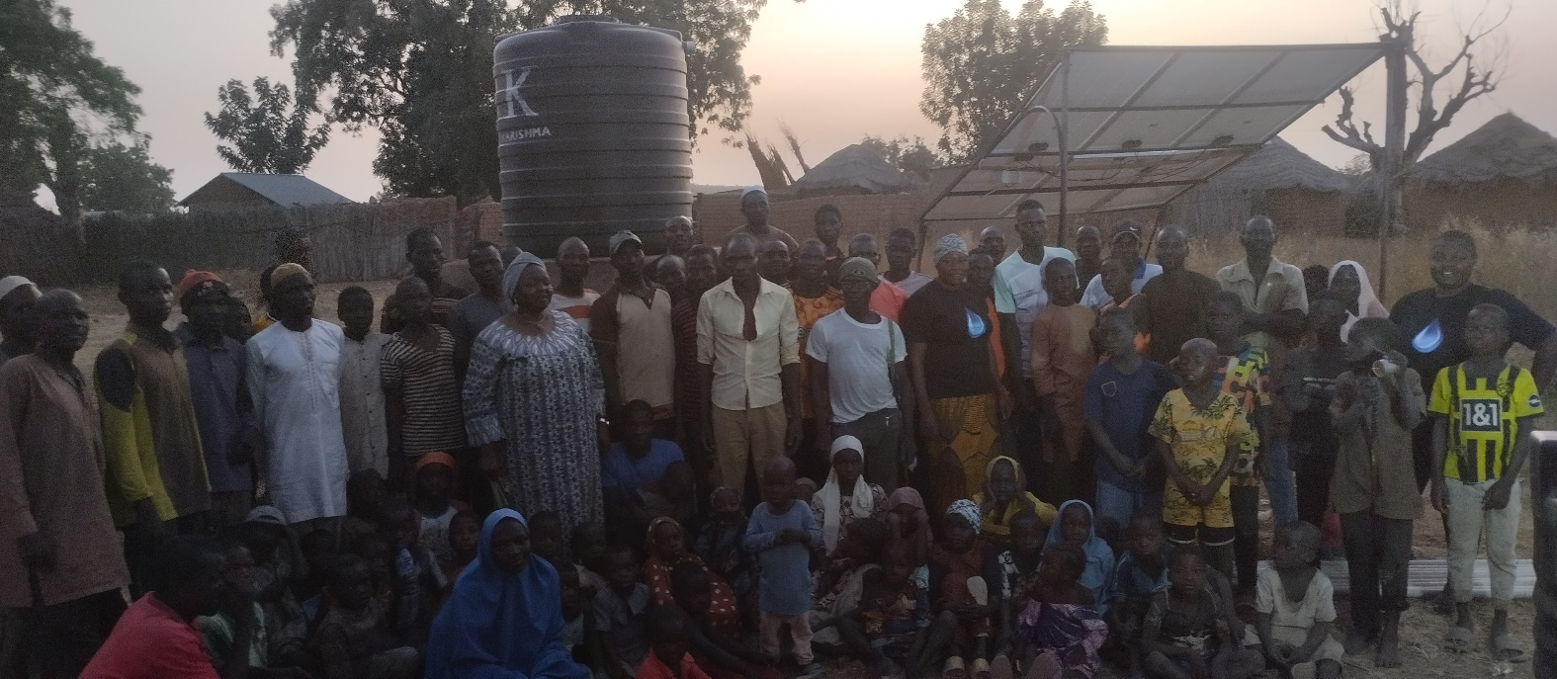

Benefitting community with Staff and ED of MOLDEV
RESOURCE NEEDED TO COMPLETE THE PROJECT
The total amount needed to complete the clinic for use by the community is N80 Million Naira ($104,814).

EXPECTED LONG TERM IMPACT
Over 5,000 people resident in the community will no longer travel long distances to access the basic primary health care services, good education and clean water thereby improving their productivity, livelihood and wellbeing as an agrarian community.

THANK YOU NOTE
FROM THE EXECUTIVE
DIRECTOR/FOUNDER

On behalf of the Board of Trustees, Management Staff and volunteers of MOLDEV, I wish to express our profound appreciation to all those who contributed so far to this very important project in their possible ways.
I want to specially express our joy to Mr. John Odah for the Borehole Equipment and the Kuladhakni Community for offering to provide free labor for installation of the borehole equipment.
I also want to thank Global Giving for partnering with us to crowdfund for the completion of this project, the journey so far with you has been encouraging and we remain optimistic on a fruitful out from the crowdfunding campaigns currently running.
We have passed 40% completion, congratulations to all of us. We will continue to keep you informed on the impact of your contributions and work with you diligently for the successful completion of the project to the satisfaction of all.
Let’s all decide the next phase!!
Thank you.
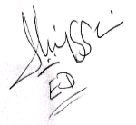

Comr. Ladi Iliya
Founder/Executive Director

