**Dear friends,**

**This report high lights a specific goal success reached by this project through to three months period**.



In business, being - Visionary, Resilient, and Innovative are the three key attributes that define successful young entrepreneurs and individuals. But in Life, generally, certain characteristics make the YOUTH admirable and help them to stand out as unique.

However, most start-ups do not have the knowledge to formulate a sound business plan that has the potential for loan approval. It was then imperative for our Organization to go out of our way and offer training sessions to 20 entrepreneurs.

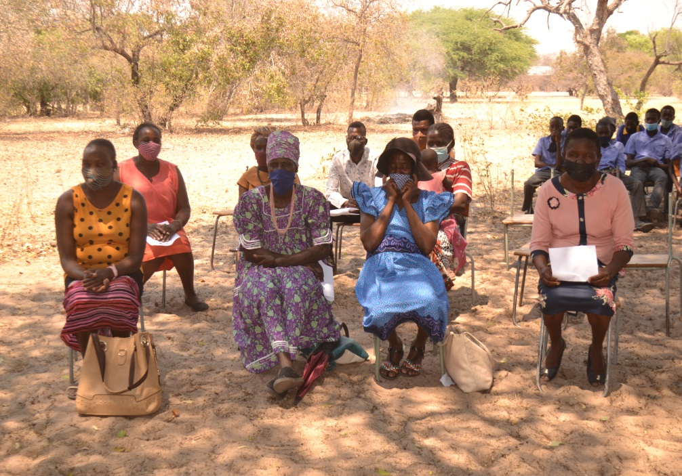

The trained participants had different trades they operated in their various locations. These ranged from welding, carpentry, tailoring, computer repairs, and catering.

**The awareness of accessing funding from our organization for start-up entrepreneurs Subtheme 1: Opinion about start-up businesses accessing funding or loans to develop/boost their businesses**

Asked about what they thought about accessing funding to develop their businesses, participants had mixed feelings. The majority of participants were in support of start-ups getting loans to develop their businesses while few were not.

According to the accounts given by participants, findings indicate that many start-ups preferred to access funding to finance their start-ups since they started with little resources while few start-ups believed in working hard to grow their businesses with little capital coming from their savings.