Over the past three months, we launched the second intake at Ineza Vocational Training Center, welcoming 51 girls and 4 boys. The students were excited and grateful to be selected for our program, which offers them the opportunity to gain new skills they can use to generate income and build their future.
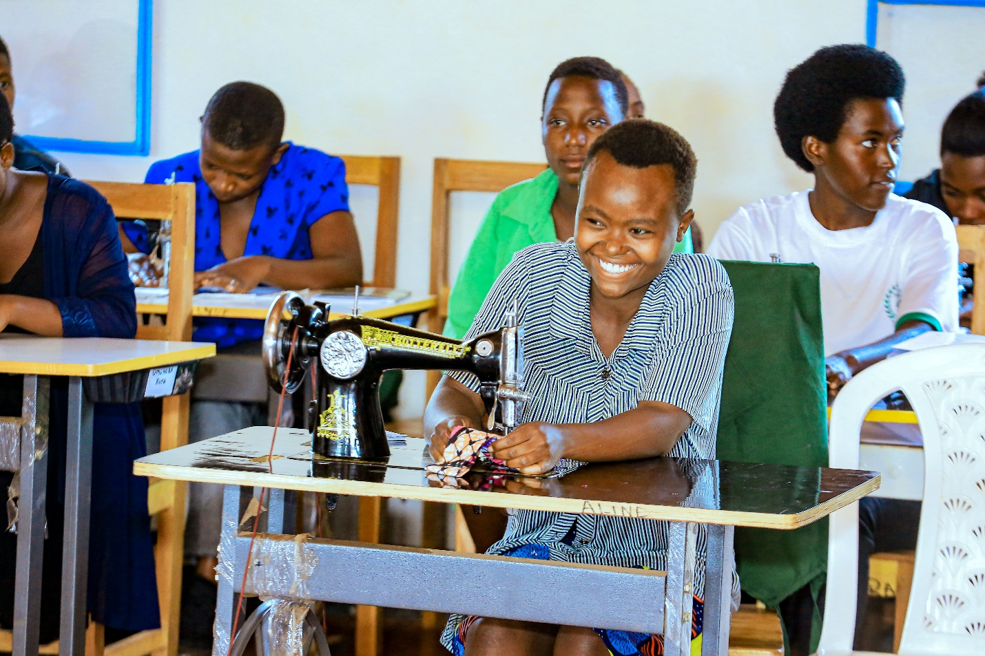
One of the girls shared her story, explaining that after dropping out of school due to early pregnancy, she felt like her life had come to an end. However, after being welcomed into the REAP program and given the chance to learn sewing skills, she now feels confident that she can create a better future for herself and her child.
Another girl, whose father is currently in prison following a family conflict that left her mother injured, expressed her hope that the skills she gains through the program will allow her to earn income and support her younger sister, who is currently in Primary 3. She is determined to help pay her sister’s school fees and ensure she continues her education.
All of the participants at the vocational training center come from difficult backgrounds, but now they feel supported, hopeful, and empowered. By learning practical skills, they are gaining the tools they need to generate income and build a brighter future for themselves and their families.
