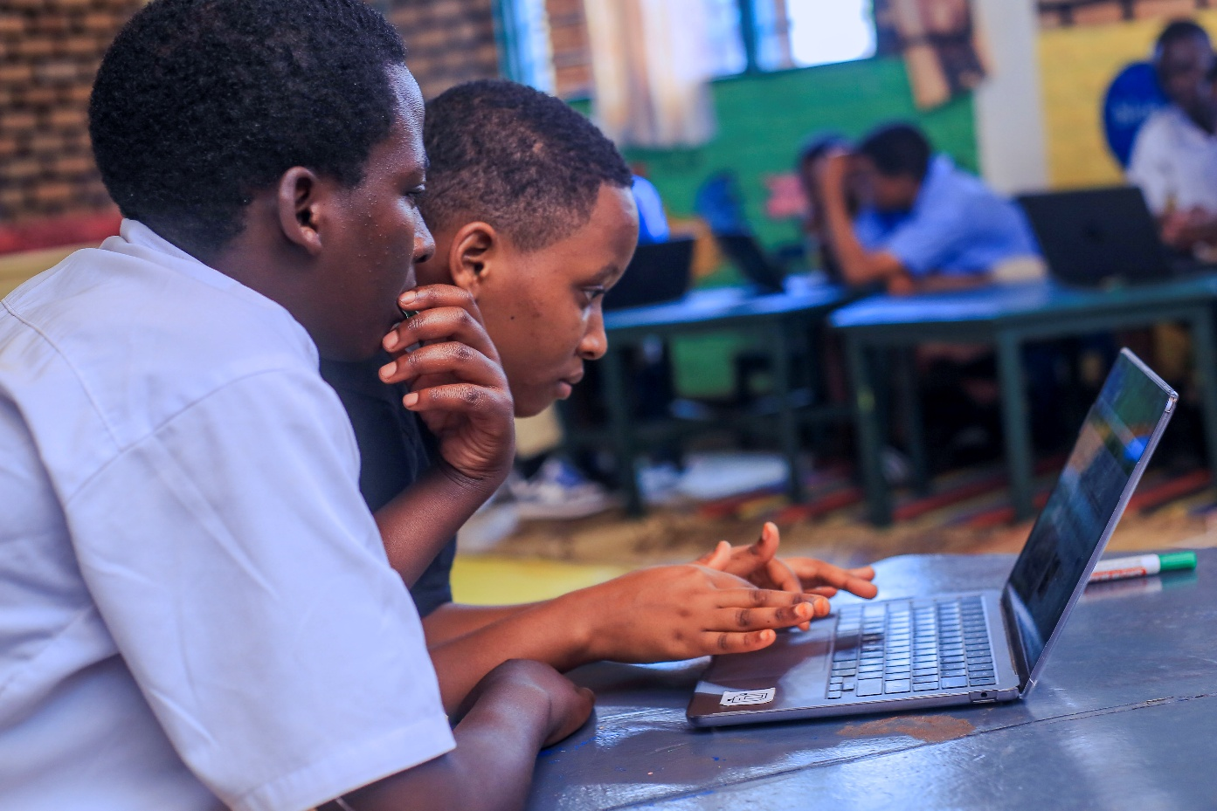
During the period from January 1 to March 31, we continued supporting 21 high school students and four university students through our scholarship program. We were also fortunate to welcome a new sponsor who is covering the tuition costs for a fifth university student, while REAP provides support for her other educational expenses. Our scholarship program covers tuition, transportation, school supplies, and internship costs. Scholarship recipients are selected based on both financial need and academic performance, ensuring that deserving students have the opportunity to pursue their education despite economic challenges.
Inspiring Student Story
Josiane is an 18-year-old girl and the oldest of four children. She lost her mother at the age of seven, and when she was 12, her father abandoned the family and never returned. The children were separated and raised by different relatives.
Josiane was taken in by her aunt, a single mother of two who survives by working on neighbors' farms and doing other casual labor. The family often struggles to afford even one meal a day, and Josiane was frequently sent home because they could not pay her school fees.
Despite these hardships, Josiane persevered. She completed Grade 9, passed the national examination, and earned a place at a government School of Excellence. However, her family could not afford the cost of secondary school. At that critical moment, REAP stepped in with a scholarship.
Josiane has now successfully completed Grade 10 and will begin Grade 11 this September. She dreams of becoming a high school teacher and is working hard to make that dream a reality.
Thanks to the generosity of our sponsors, students like Josiane have the opportunity to continue their education and build a brighter future.

