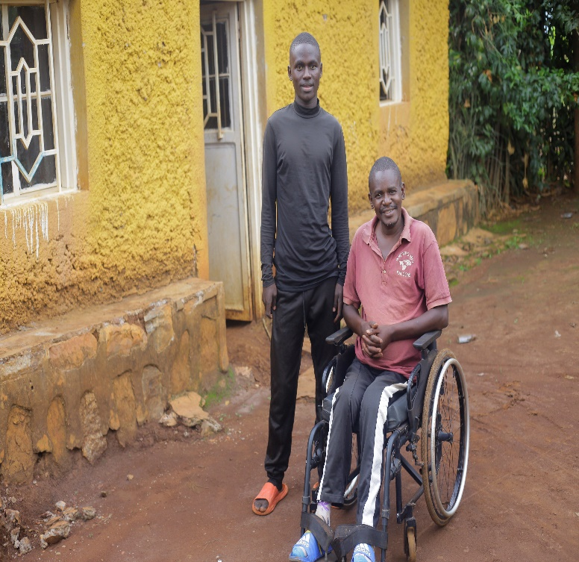
During the three-month period from April 1 to June 30, we continued providing scholarship support to 23 high school students. This group included 18 returning students and 5 new recipients. 7 of them graduated in July and we are receiving new applications for the coming year. Our scholarships cover full tuition, transportation, school supplies, and internships for students in the program. Recipients are selected based on their financial need and academic performance, with the goal of empowering them to pursue their educational dreams and transform their lives.
Below is one of inspiring stories from the students:
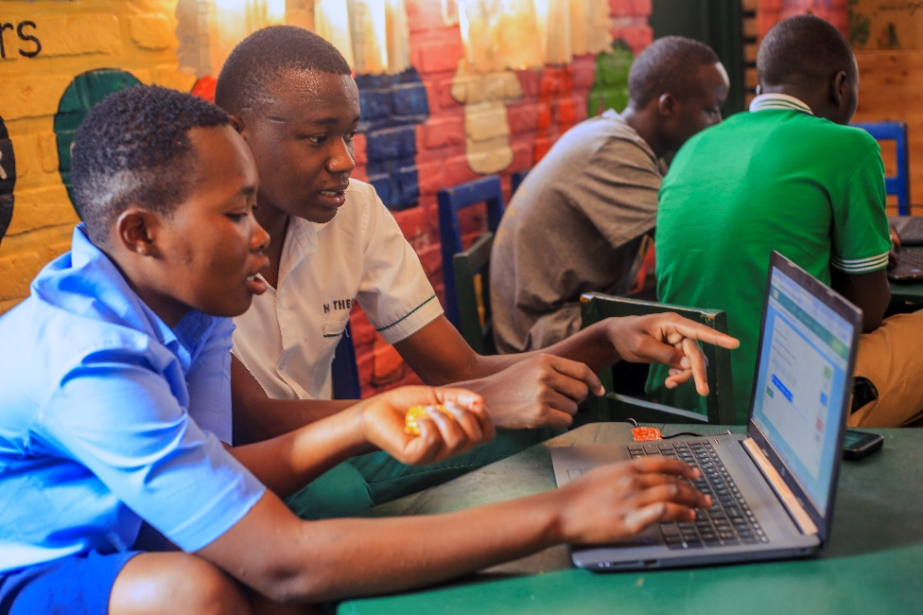
A bright 19-year-old boy, lives with his father in a modest home left by his grandparents. He is his father’s only child, born out of wedlock, and has grown up without a mother for most of his life. In 2009, his father suffered a terrible accident while fixing electricity, leaving him permanently in a wheelchair. When his mother passed away in 2018, life grew even harder. With no stable income and growing responsibilities at home, He was forced to drop out of school more than once. But he never gave up.
Against the odds, he passed the national Grade Nine exams with excellent marks and earned a spot at a school of excellence—an opportunity that could change his life. Now in Grade eleven, he is studying computer science and dreaming of a brighter future for himself and his father.

