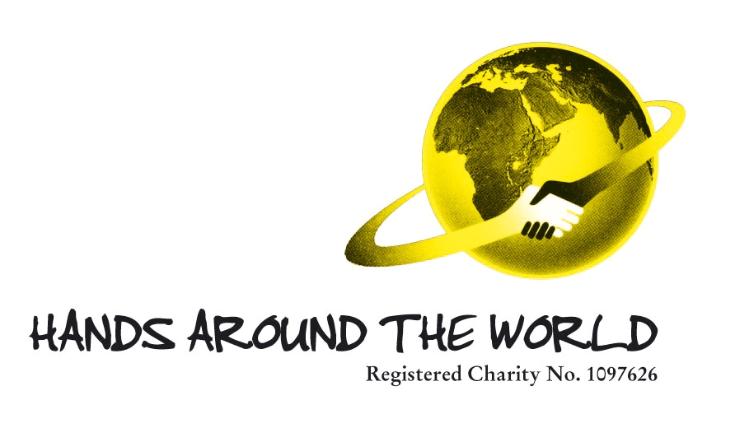

Aim:

To help provide high quality training at Siriba Vocational Training Centre, Masindi District, Uganda where many of the children are orphans and refugees.

HANDS AROUND THE WORLD is very interested in the development of the work of the Siriba Vocational Training Centre. This UK-based charity, through its volunteers, assisted in providing the building in which the VTC operates and with supplying tools and other supplies for its ongoing work. Recently we were encouraged by a visit to the unit by Mike Williams, one of our volunteers, who reported that the unit was fully functioning with courses being run by very competent tutors in carpentry and tailoring. The number of students who had signed up for the courses was encouraging and their enthusiasm was impressive. It was good to see that a project which had been conceived as an act of faith could, so quickly, come to fruition.

HANDS AROUND THE WORLD has supported this project, and similar projects elsewhere, because potentially they can make the students self sufficient. The skills which the students acquire will enable them either to gain employment or even set up their own businesses in due time. It is an important part of the curriculum at the VTC to train the students in entrepreneurship, thus giving them some basic business skills alongside their craft skills. In the changing economics of this part of Uganda it is surely very important that students should be given these life opportunities.

It was also encouraging to see that the project was being responsibly managed by a Management Board set up by Bishop Stanley Ntagali and by a local Project Committee. The Board, chaired by Canon Harrington Maiteka, had its second meeting in May, and looked at plans for the future development including its financing. It was agreed to appoint a subcommittee to advise the Board on finance and this also met in May.

It is clear from the work of the Board and the Finance Committee that there is a problem with ongoing financing. The main source of ongoing income is student fees but, because students in the locality are often unable to pay, fees cannot provide the necessary level of income for the future development of the VTC. It has been agreed that HANDS AROUND THE WORLD, the Bishop, and the Board will continue to work together to see how this problem can be overcome, and seek additional funding for the Siriba Unit. The support of the church, and also the Department of Education and Sports will be vital.

The budget for the next 3 years anticipates expenditure of $27579, principally on materials, tools and salaries.

We feel that the project at Siriba could make a very significant contribution to the local economy through training young adults in key skills. It is also important that the Siriba VTC is registered and recognised by the Department of Education and Skills and with the appropriate Examinations Board. We fully support the application by the VTC in gaining this recognition as soon as is possible. We also support good relations between the VTC and the Kiryandongo Technical Institute. It is good to know that the Institute is represented on the VCT Board and that students completing the course at the VTC have the opportunity for more advanced studies if they wish to continue their practical education.

