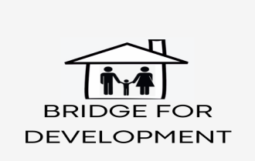
BDO Ethiopia

Organizational Profile of Bridge
for Development Organization (BDO)
Address:
Nefas Selk Lafto Sub city; Woreda 01, HN-New
Contact and SM Presence:
Call፡ (+251) 911685306;
Em፡najigm52@gmail.com;
Bridgedevelopoment4com@gmail.com
b20d20o20@yahoo.com;
b20d20o20@gmail.com
Website: www.bridgefordevelopment.com
Twitter: bdo_for_development;
Telegram: t.me/bridgefordevelopment

Establishment:
Ethiopia is one of the countries with the weakest social infrastructure, widespread poverty and rapid population. Our country is a country of teenagers and young people. As a result, these groups are exposed to a variety of related problems: addiction, unemployment, HIV / AIDS, harmful traditional practices, gender-based violence, and reproductive health problems. BDO is a board-led, non-governmental community service organization. It was established in October 2019 and licensed by the Federal Civil Society Agency under Registration No. 4509.
Vision:
The vision of BDO is to see women, children, adolescents and young people live healthy, happy and decent lives in Ethiopia.

Mission:
The mission of BDO is to enable women, children and young people in need of special support to receive health, education and employability support and job and life skills training to develop motivation and self-confidence.
Values and principles:
The organization's values, principles, and beliefs include: Equal opportunities, universal human rights, transparency, and readiness to accept positive change, gender equality, humanity,
loyalty, cooperation, and fairness.
The main strategies:
• Communicate with key partners and
associations and form partnerships
• Gather resources and experts.
• Organizational and human capacity building.
• Develop current organizational policies
• Use modern and up-to date ICT and MIS

Programs Directions:
• Child development, protection, care and
education.
• Protection of women and girls, health,
life skills and education.
• Adolescent health, life skills and education.
• Advocacy in relation to women, children and
youth.

Office and Service Locations:
Currently, the Addis Ababa City Administration, Amhara and Oromiaregions are considered, but the organizationdoes not have defined border and ethnic area.

