Children’s Voice GlobalGiving

Quarterly Project Management Report

School scholarships for vulnerable youth project

(1st September – 20th October 2010)

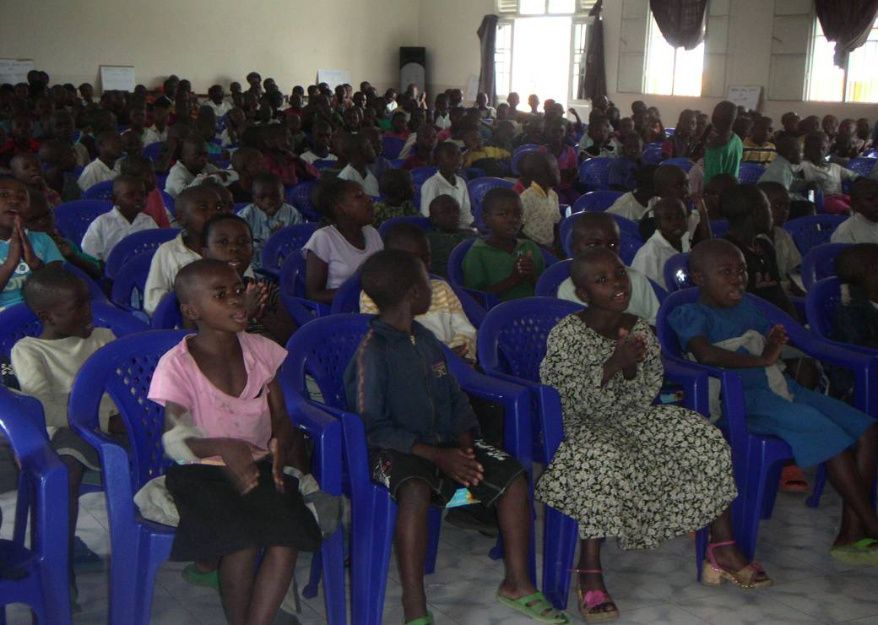

Children Voice Learning Centre

DRC/Eastern Region

Children’s Voice Project

A1. Project profile

Project Name | School Scholarships for Vulnerable Youth
Project program goal and outcomes | Contributing to the provision of a education, safe , healthy environment for vulnerable streets children living in the township of Goma
Project Number | # 5947
Project Location | Goma, North Kivu Province , Eastern DRC
Target Population | Direct beneficiaries: 384 orphans, unaccompanied children and other vulnerable children living in the streets of Goma town and in its surrounding communities, families, authorities, young and children.
Focal problems identified
Many children are living on the street because of the political, economic and social problems. They are abused and neglected and have little or no literacy skills. | - Provide a save environment to street children  - Provide family reinsertion and following up  - Provide vocational training in mechanic, cooking and masonry  - Provide to read and to write  - Provide health support and potable water  - Provide some basic toys and educational resources
Duration of Project | 10 months  1-September-2010 to 30-June-2011
Funding Information  Total Funding Received to Date:  Remaining Goal to be Funded:  Total Funding Goal: | $ 390  $19,609  $20,000
Funding source(s) | GLobalGiving
Report Contact person | Coordinator Children’s Voice  Christine Musaidizi Mut.  christinemusaid@hotmail.com  Mobile: +243818888706  Centre director  Richard Kabala Ntumba  kabalantumba@yahoo.fr  Mobile: +243998786874

A2. Narrative summary of progress

DRC is a country of severe conflict. The last democratic election in 2006 and agreements with militia have provided some stability. In Goma, eastern Democratic Republic of Congo (DRC), the orphaned and vulnerable children have no system of social support apart from families and communities.

Basic Government social services are almost non-existent. Many orphans are stigmatized due to the possibility that they have been soldiers, have been raped or accused of witchcraft. Most are unable to continue school and many have never been able to afford to go at all.

In addition, the years of contact conflict including tribal conflict has caused the death of many family members and traumatized the children who bore witness to many of the atrocities. This conflict has also led to a shift in population towards the “safer” urban areas. This has increased the economic vulnerability of families who are forced to leave their farms and livelihoods.

Many children are more vulnerable in urban areas to exploitation, including sexual exploitation such as child labor and prostitution. Due to the economic difficulties and the stigmatization of many of these children, most families are unable to take on the responsibility of caring for orphans, even if they are linked to their previous communities. Many of these children are forced to earn a living by begging in the streets, being involved in early marriage or sexual exploitation, having their labor exploited and suffering from violence, illnesses and malnutrition.

In the town of Goma several hundred vulnerable orphaned and vulnerable children with themselves and exposed to all forms of violence and do not attend school.

Children’s Voice provides a safe place for children to receive informal schooling, vocational training and find the time to play, under the supervision of facilitators.

At the beginning of the current project, an assessment conducted identified the need of the children as being the following;
- Access to a save environment to street children
- Access to family reinsertion and following up
- Access to read and to write for young from 9 to 14 years old
- Access to vocational training for those up to 14 to 17 years old
- Access to health support and potable water
- Access to some basic toys and educational resources

- Child rights training for parents, guardians, police, authorities and children

The project, whose implementation began in September ’10, seeks to contribute to the care of 250 orphans, unaccompanied children and other vulnerable children living in the streets of Goma town giving them a safe protective environment and improving their health.

A3. Activities

Children’s Voice offers:
formal schooling, vocational training, counselling, and family mediation.
1.Formal Schooling: children ages 9-14 years old are accepted into an accelerated primary school where they complete two years of curriculum within one year.
2.Vocational Training: youth ages 14-17 years old who have not gone to primary school are accepted into a vocational training program accompanied with literacy courses.
1. Formal Schooling
Class level | children started on 1st September 2010
 | girls | boys | total
Level 1a | 32 | 24 | 56
Level 1b | 35 | 36 | 71
Level 2a | 26 | 34 | 60
Level 2b | 28 | 25 | 53
Level 3a | 21 | 23 | 44
Level 3b | 37 | 16 | 53
Total | 179 | 158 | 337

2. Vocational training
Class level | children started on 1st September 2010
 | girls | boys | total
Mechanic | 4 | 41 | 45

3. Medical and counselling support,
4. family mediation
More details in next quarterly report.

Further, a total of 12 social agents and workers of the Children’s Voice Virunga and Bujovu centers were trained on the education of orphaned and vulnerable children and how to support those victims in psychological care. In addition they have received indepth trainings on the Convention on the Rights of the Child and child protection which guides them as they interact with children at the centre.

Many of children attending the Children’s Voice centre have benefited from basic medical assistance. Further, children in the centre have also received sensitization on HIV/AIDs. School age children and young adults have been sensitized about how HIV/AIDS is contracted and what preventative measures can be taken against it.

A4. Report on budget

Kindly find the financial budget for the first quarter.
Received on 8th september 2010 |  |  |  | 627.29
Expenses | Unit | Unit Cost | Quantity | Total Cost
papier duplicateur | piece | 7 | 6 | 42
White and coulor chalk | piece | 5 | 5 | 25
Registred book for teachers | piece | 5 | 10 | 50
Pen | piece | 5 | 5 | 25
Files | piece | 5 | 12 | 60
Clearning product | piece | 30 | 2 | 60
Medicaments | box | 6 | 30 | 180
Material for training | rouleau | 4 | 40 | 160
Total |  |  |  | 602
Balance (not used) |  |  |  | 25.29

The children attending the Children Voice Learning Centre since august and started school program on 6st September 2010. They have greatly benefited from the training and school materials. A child who received states as follows;
“After my parents died in the war in 2004, I came in Goma and stayed in street. Now I am happy to be at school. I will learn to read and to write. I will send a letter to the president Obama, I keep what I will tell him. I was lost. I thank Children Voice and those who have a big heart for helping me to have a new life. ”
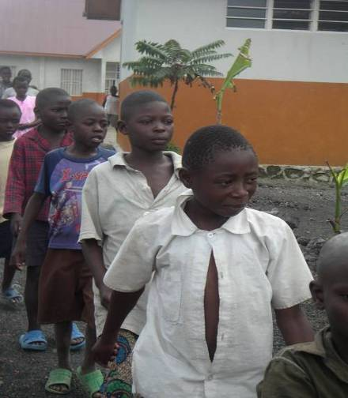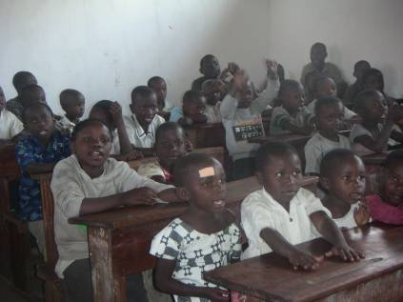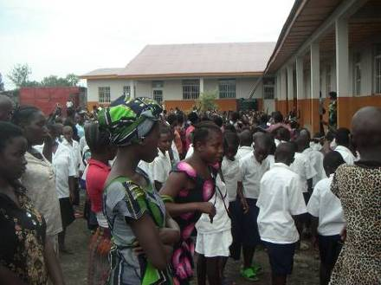
Children in Virunga center
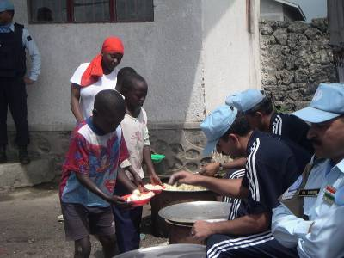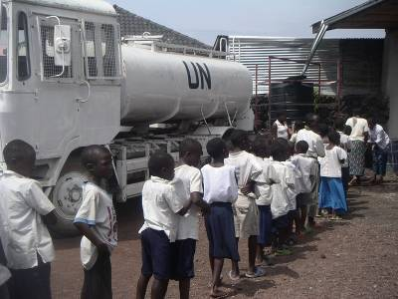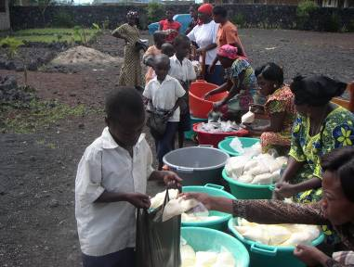
The receive food and water once a week from Monusco Indian police
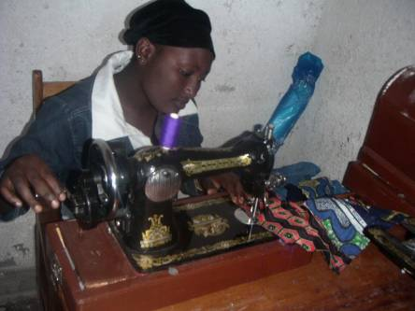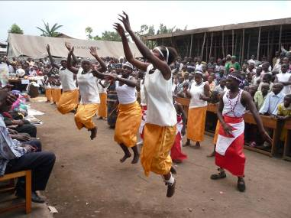

In Bujovu center, the girl learns to make clothes. The other picture, dance is one of therapy for counselling

A

5.

Thanks to you all
I would like to sincerely thank our donors for this generous donation through GlobalGiving to the School Scholarships for Vulnerable Youth. Every donation helps ensure that we can continue helping our community.
I think particularly to:
Rebecca Klein,
Zachary Larson-Rabin,
Jamison Jordan,
Margaret Rawson,
Izzy Hirson

And those who did not give they namse.

I hope you will be around during this project.You are welcome in Goma, in Democratic Republic of Congo.
I know there are a lot of other ways you could have spent this money, but you believe in our cause, so you chose to invest it in our project. Because of this investment, I want you to feel like part of our team. We're in this together. I want our success to be your success.
Until our project is fully funded, we will be sending you regular reports about our work. You'll know what your donation has helped fund, what accomplishments we have achieved and what our current needs are.
I hope you find this partnership valuable and worthwhile. I know the economy is tough, so thank you for investing your hard-earned money on our cause. Please consider telling your friends and family about our project - share the link on your blogs or social networks, use the tell-a-friend feature on the project page to email your network, or just bring us up in conversation. You know your friends and family best, so use your own words - tell them why you chose our project and what it means to you.
Thank you again for all you have done to help this cause.
Conclusion
I know you have many ideas and suggestions how to do much better to help these children. Do not hesitate to give us you proposal. We are running this project together. I would like to see all of you in our centres. Sure it is possible. Please tell me how you think we can work together to attract wider support for this project.
Be blessed,
Christine Musaidizi
Program Manager
Children’s Voice
Goma, DR Congo
Tel. +243818888706
Email.christinemusaid@hotmail.com
http://children-voice.org/

