Projects Report:

Project: Water4Life (Drilling Hand Pump in Nepal For poor families.)
By: Md Hamid – Secretary
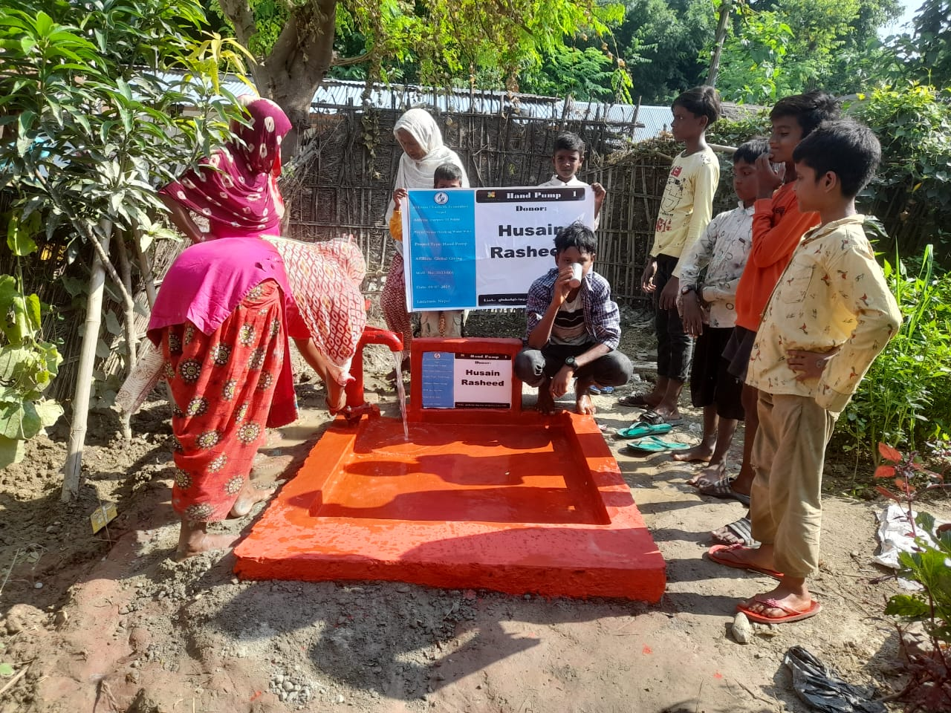
- Ground report of Nepal:
Nepal is one of the poorest and least developed countries in the world. The country is a very young democracy. It is in the process of emerging from a politically and socially fragile post-conflict period. Its people have worked hard and achieved much to reduce poverty in Nepal. Twenty years ago, nearly every other family lived in extreme poverty, earning less than $1.25 a day. Although this number has halved, today there are still one in four families living in abject poverty.
Nepal has faced many crises in the short period of time. However, one of Nepal's most pressing crises is the problem of access to clean water.
especially in rural areas. Despite Nepal's rich water resources, a significant portion of the population still lacks access to safe and clean drinking water. This lack of access contributes to the spread of waterborne diseases, hinders personal hygiene, and adversely affects the overall health and well-being of communities.

According to a report by the World Health Organization and UNICEF, approximately 38% of Nepal's rural population lacks access to improved drinking water sources. This problem is exacerbated by factors such as poor infrastructure, inadequate sanitation facilities, and the geographically challenging terrain of the country.
Insufficient access to clean water has far-reaching consequences, particularly for vulnerable groups such as children, women, and the elderly. Lack of access to clean water leads to increased vulnerability to waterborne diseases like diarrhea, cholera, and typhoid, which can be deadly, especially for children under five years old. Furthermore, women and girls are often burdened with the responsibility of fetching water, which takes time away from pursuing education or engaging in income-generating activities.
Without addressing the issue of clean water access, progress in other areas, such as education, health, and economic development, will be significantly hampered. Therefore, it is essential to prioritize and invest in solutions that can provide access to clean water in rural areas of Nepal.
One effective solution to this problem is the installation of drilling hand pumps. Drilling hand pumps are a sustainable and cost-effective technology that can extract clean and safe water from underground sources such as wells. These pumps can provide a year-round water supply to rural communities, even in areas prone to water scarcity or insufficient rainfall.
The benefits of drilling hand pumps include:
1. Reliability: Drilling hand pumps provide a consistent and reliable source of water, ensuring that communities have access to clean water.
2. Cost-effectiveness: Compared to other water supply solutions, drilling hand pumps are a cost-effective option, requiring minimal maintenance and operational costs.
3. Community Involvement: Installing drilling hand pumps can be a community-driven effort, involving local residents in the planning, installation, and maintenance process. This allows communities to take ownership of their water supply systems, leading to greater sustainability and long-term success.
4. Health and Hygiene: Access to clean water through hand pumps reduces the prevalence of waterborne diseases, improving public health and hygiene practices in the community. This, in turn, reduces healthcare costs and improves quality of life.

- Our aim to Drilling Hand Pump:
Our aim to drilling hand pump in rural area to provide clean and safe water to poor families, who cannot financially afford to drill hand pump and has no access to clean water.
With the help of global giving donors we have installed about 3 hand pump and 3 hand pumps are under-construction.
Here are some Photos:

