Project Report |MAY 29, 2025

Dear Friend,
You subscribed to email updates from Sponge community in rural China for cleaner river by Beijing Fuqun Social Service Center, a project on GlobalGiving. Here's the unedited update:

Sponge Community Project 2024 4rd Quarter Report
By Wanling Ji | Project Assistant
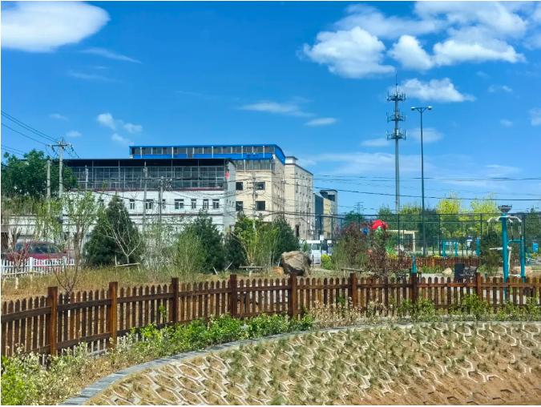
Background
Laoniuwan Village is located in Shahe Town, Changping District, Beijing, situated along the Nansha River. As an important waterway for both Changping District and Beijing, the Nansha River's primary pollution source stems from domestic wastewater discharged by residential areas within the watershed. Currently, Laoniuwan Village has one temporary sewage treatment facility, which fails to meet local wastewater processing demands. The absence of a rainwater-sewage diversion system exacerbates the problem, particularly in the southwestern area of the village committee compound—one of three major rainwater accumulation zones in the village. During rainfall events, knee-deep waterlogging occurs, triggering sewage overflow that contaminates both the village environment and the river channel.
Project Objectives
- Sponge Community Development
Establish rain gardens and create landscaped spaces to restore the ecological environment.
Develop a "Zero-Waste Garden" to positively impact the surrounding area.
- Ecological Restoration
Replant native vegetation to rehabilitate the ecosystem.
Introduce much-needed green spaces to enhance the park’s ecological function.
- Community Engagement & Recreational Space
Provide villagers with a gathering and recreational venue that fosters social interaction.
Create a vibrant, inclusive, and nature-integrated multi-generational activity space.
Offer diverse leisure options to strengthen family bonds through parent-child interaction.
- Sustainability & Reconnection with Nature
Promote eco-friendly and nature-conscious design elements.
Rebuild the community’s connection with the natural environment.
Project Significance
The Laoniuwan Village Sponge Community Project has successfully integrated innovative technologies with community co-creation, demonstrating remarkable resilience during Beijing's extreme "7·31" rainstorm in 2023. It achieves triple objectives:
- Environmental Governance - Mitigates flooding while restoring urban hydrology
- Resource Circularity - Enables rainwater harvesting and ecological purification
- Public Engagement - Fosters environmental literacy through participatory design
Project Progress
- 1. Implementation of Four Key Initiatives
(1) Sponge Community Co-Creation Program
Focused on environmental transformation with full participation by Fukang volunteers
Established a complete cycle from ideation → design → implementation
Effectively enhanced volunteer engagement and sense of achievement
(2) Ecological Garden Co-Building Project
Applied permaculture design principles
Conducted waste upcycling workshops
Established a community resource recycling mechanism
Significantly improved reuse rate of discarded materials
(3) Nature Education Initiative
Organized volunteer-youth family collaborations
Developed ecological farms and educational gardens
Created a series of nature-based curricula
Promoted practical application of eco-conscious concepts
(4) Green Public Market Campaign
Launched secondhand goods exchange zones
Conducted environmental awareness campaigns
Facilitated community resource circulation
Elevated residents' ecological awareness
2. Infrastructure Completion
(1) Water Treatment Systems
Sedimentation & purification tanks (1,680 m²)
Biological purification systems
(2) Rain Garden Construction
Comprehensive rain garden (4,000 m²)
Fully equipped supporting recreational facilities
- 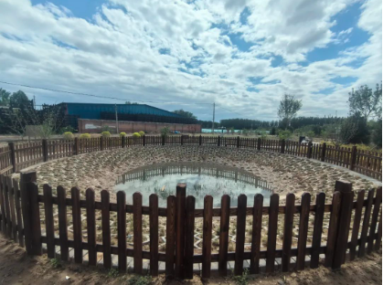
Achievements
1. Environmental Benefits
Increased community stormwater absorption capacity by 40%
Reduced community carbon emissions by 15%
Expanded green spaces by 2,000 m²
2. Social Benefits
Trained 10 community environmental leaders
Established 3 sustainable eco-action groups
Created a long-term environmental governance mechanism
3. Educational Impact
Mobilized 173 volunteers contributing 692 service hours
Achieved 80% accuracy rate in waste sorting among residents
Improved water conservation awareness in 90% of participating households

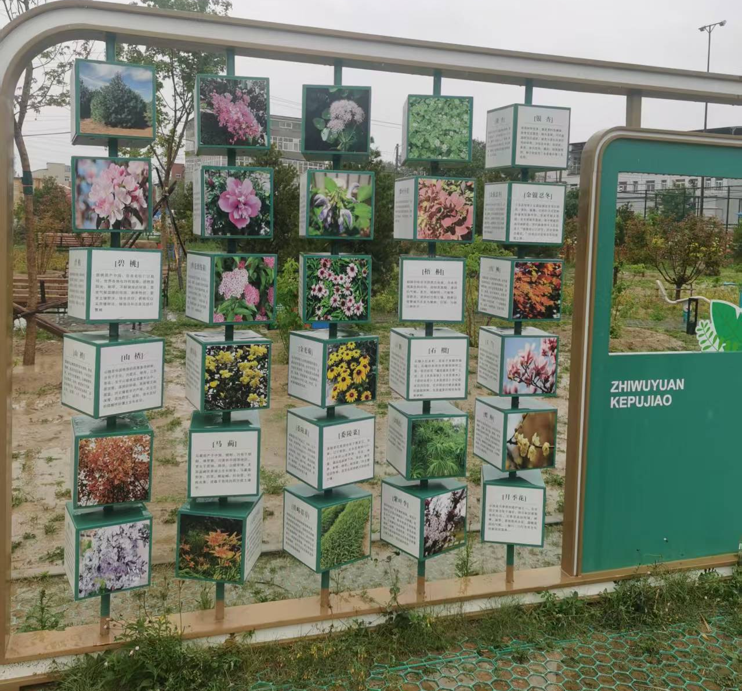

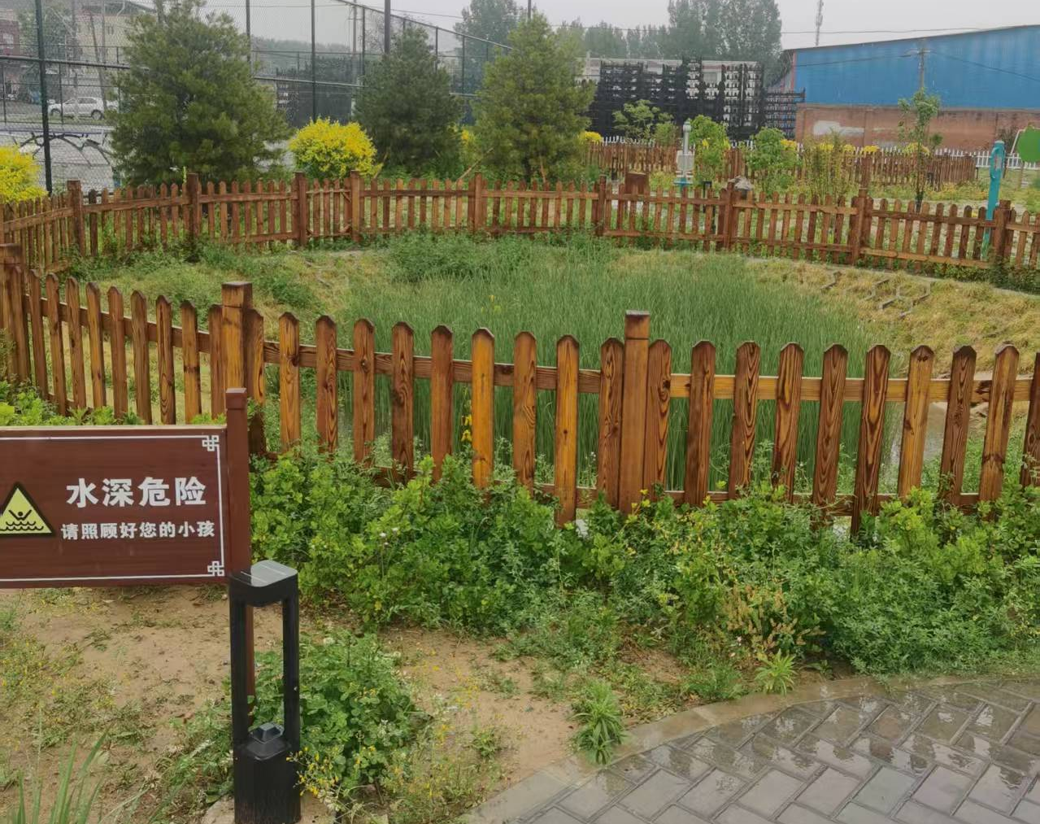
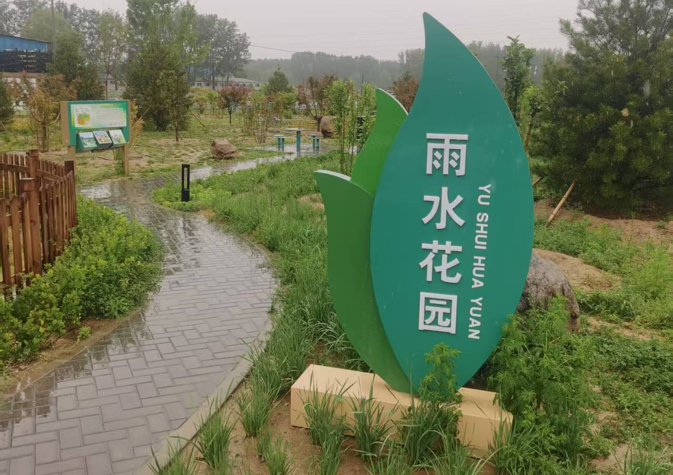
Links:
- FUQUN official site

