Final Report
Narrative
Narrative Report
Please provide a detailed description of activities undertaken with funds and any progress made toward the goals of this Grant to date, including unexpected delays or challenges.
老牛湾村位于北京市昌平区沙河镇，毗邻海淀区，因地处南沙河的一个大转弯处而得名“老牛湾”。村子沿河而建，占地面积1561亩，老牛湾村现有人口4000多人，常驻人口以老人居多，流动人口大多是附近工作的年青人。
老牛湾村现有临时污水处理设施1座，但不能满足现有污水处理需求，导致污水溢流至南沙河。村里雨污不分流，导致村子临时污水处理设施污水管道容量超标而发生溢流，溢流的污水对当地土壤和南沙河造成直接的生活污水污染，污染区域臭气熏天。村子也存在尾水通过雨水口排放的现象。
2021年12月1日，福田康明斯同北京富群和老牛湾村共同启动了“海绵社区”项目，旨在解决雨水在城市中带来的污水溢流、积水内涝、携带地表污染物排入河流、污水溢流污染南沙河导致南沙河水质污染严重等问题，推动海绵社区建设，使雨水通过下渗、滞蓄、净化之后排入河道，减少对河流的污染，缓解社区汛期内涝，同时提升社区居民环保意识，改善社区环境。2022年项目开展的第一阶段主要是通过雨水花园解决源头污染，减少进入污水管道的污水量，解决老牛湾村污水溢流和积水内涝的问题，以及受污染的雨水直排入河的问题，同时推动村子环境的改善。利用老牛湾村游乐场南部空地三分之一的区域修建了一座小型的雨水花园，并修筑了两个小型的沉淀净化池。此阶段工作有效地解决了雨水花园区域积水内涝的问题，成功证明了雨水花园项目进一步扩大化的可行性。结合国内近期频发的城市内涝灾害，老牛湾村有潜力成为分散式雨洪治理的样板，推广至全国其他内涝严重地区的社区，缓解城市内涝。
2023年9月-2023年9月，项目的第二阶段在第一阶段工作的基础上，修筑了一个1680平方米的沉淀净化池，搭建了生物净化系统，增强了雨水花园的气候适应性和净化能力；并将三个净化沉淀池连接成一个整体，将整块场地改造成了一个4000平方米的雨水花园，并完善了道路、植被、路灯等花园配套设施，建设了一个集雨水收集净化、环境教育、居民游憩为一体的公共空间。具体开展的主要工作有：
1、多方沟通会议
2022年9月20日、2023年3月28日，由富群组织福田康明斯志愿者、老牛湾村村委会等召开沟通会议，讨论老牛湾村需求和项目需求。2023年3月16日、2023年6月5日， 富群赴北京市福田康明斯发动机有限公司向福田康明斯管理层汇报海绵社区项目成果及下一步工作规划，并一起踏查雨水花园，介绍项目成果，福田康明斯领导对项目的实施提出了建设性的意见。
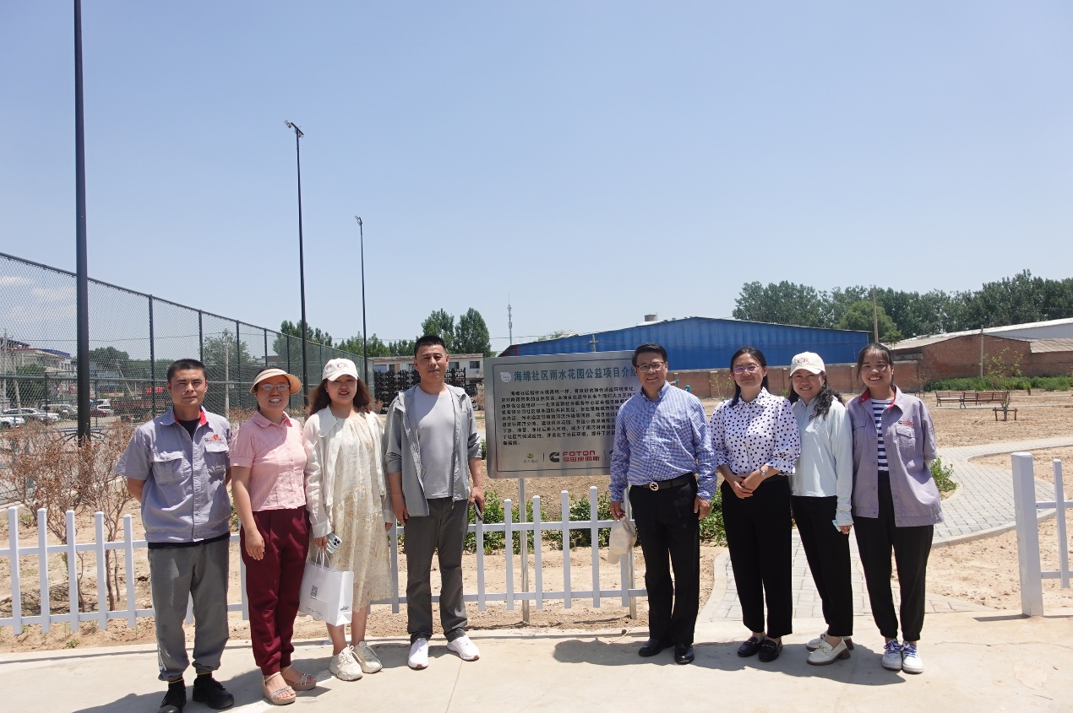
2、海绵社区揭牌仪式暨种植活动。2022年9月28日，海绵社区揭牌仪式在老牛湾村举行。福田康明斯总经理、老牛湾村书记、北京富群及企业志愿者等出席仪式，对海绵社区项目表示了肯定和支持。揭牌仪式后，30名福田康明斯员工开展了种植和浇水活动，并树立了花园展示牌、对花园垃圾进行了清理。
3、水循环专家、湿地专家及社区营造专家为老牛湾村海绵社区项目出谋划策。2022年11月15日，富群邀请北京林业大学贾亦飞副教授、湿地领域专家韩老师前往老牛湾村及南沙河沿岸考察。富群并邀请专家与老牛湾村召开座谈会。会上就雨水花园实施规划及具体操作进行了讨论。
4、雨水花园施工方确定及建设方案设计。2023年4月，经多方、多轮沟通，确定了雨水花园二期改造方案，包括沉淀净化池建设、道路系统、植被系统等具体方案。
5、向昌平区沙河镇提交项目报告和方案。2023年5月，富群向昌平区沙河镇提交项目报告和方案，沙河镇镇长将海绵社区项目作为企业、社会组织和社区共建的典型案例，向大家推荐。
6、清理雨水花园实施地点的建筑垃圾并进行覆土。清理了5040立方米的建筑垃圾，建筑垃圾清走之后，回填2000平方米，厚约50公分的优质土壤，为雨水花园的后续建设给予了充分保障。
7、地面整形，搭建雨水花园骨架。开挖1680平方米沉淀净化池一个，并根据三个沉淀净化池调整了地面形状，引导积水汇聚到沉淀池中。通过管道铺设，将三个沉淀净化池相连接，使其形成一个完整的湿地生态系统。
8、完善雨水花园地面设施。雨水花园系统打造完成后，项目也争取到了村子的配套支持，在与村方的共同努力下，雨水花园共计安装护栏80米，安装长椅7条、棋盘桌2个、健身器材8个、垃圾桶4个，修建道路312平方米，铺设路牙588米；安装太阳能地灯40盏、安全警示牌若干、海绵社区介绍牌1个，这进一步完善了雨水花园的设施，满足了村民的基本需求。
9、开展雨水花园植被设计和建造。雨水花园经过有效的设计、合理的植物配置及妥善的维护，不仅能改善小区的环境，为鸟类、昆虫等动物提供食物和栖息地，还能达到良好的景观效果，成为社区居民休闲娱乐的场所。来自福田康明斯的志愿者也前后参与了方案的设计和改善，并参与了雨水花园的植物种植活动。共种植西府海棠10株、北美海棠16株、大叶黄杨1600株、华北紫丁香10株、香蒲10株、唐菖蒲10株、芦苇10株、金叶榆20株、苜蓿等草本植物4000平方米。
10、志愿者参与雨水花园建设与维护。2022年9月至2023年8月共组织了6次志愿服务活动，福田康明斯的员工志愿者参加共计173人次。活动包括：
（1）2022年9月22日，来自福田康明斯的20名志愿者在雨水花园开展了垃圾清理工作，清理了雨水花园及其周边的垃圾，为海绵社区揭牌仪式做准备。

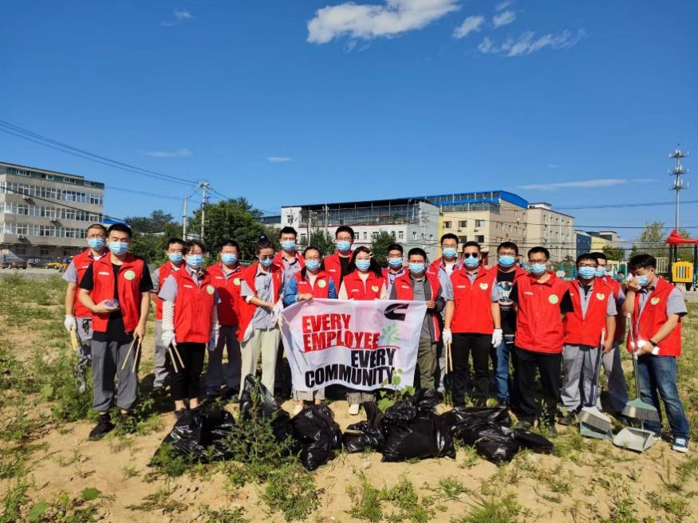
（2）2022年9月28日，海绵社区揭牌仪式在老牛湾村举行。福田康明斯总经理、老牛湾村书记、北京富群社会服务中心理事长等出席仪式。揭牌仪式后，30名福田康明斯员工开展了种植和浇水活动，并树立了花园展示牌、对花园垃圾进行了清理。
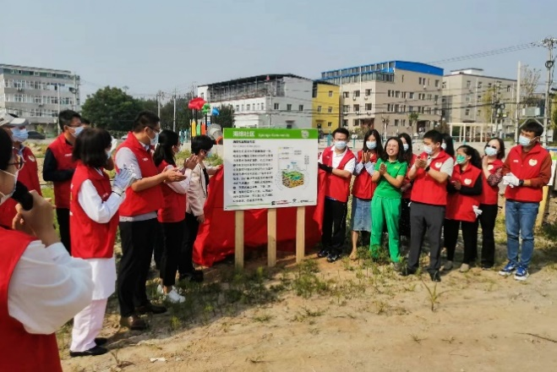

（3）2023年5月19日，来自福田康明斯的31位志愿者在富群的组织下，与园艺工人一起围绕沉淀净化池种植绿篱。志愿者们安装分组，根据规定的间距，在沉淀净化池附近种下了一千多株大叶黄杨，这些灌木一方面能起到水土保持的作用，防止水池坡面垮塌；另一方面也可以阻挡行人过于接近水池而产生的安全隐患。
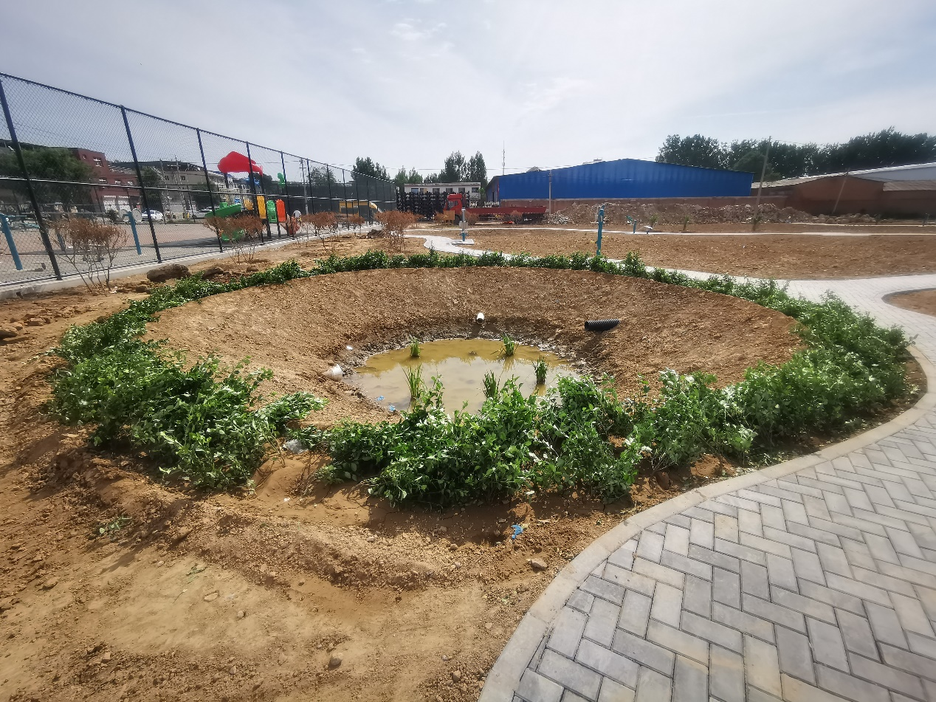
（4）2023年5月26日，来自福田康明斯的31位志愿者在富群的组织下，与园艺工人在雨水花园种植小乔木，增加雨水花园的景观效果和水土保持能力，共种植西府海棠10株、北美海棠16株。
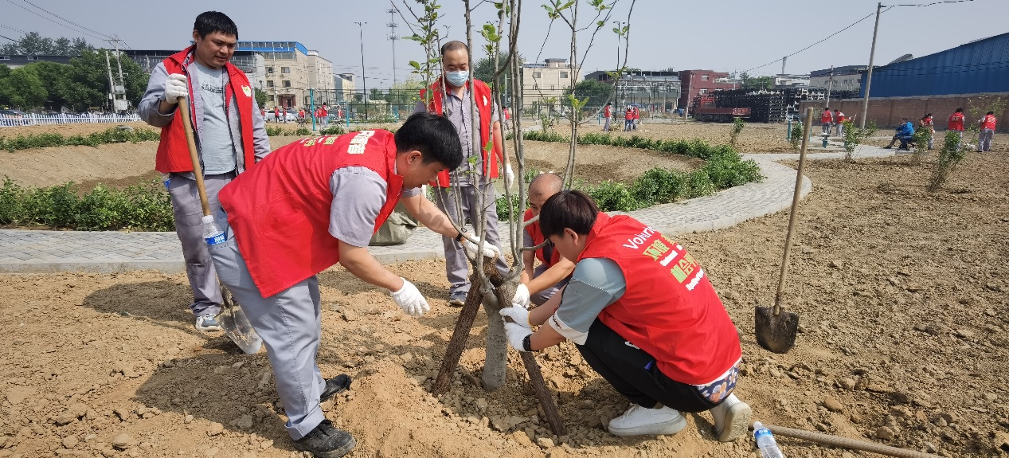
（5）2023年6月29日，富群设计问卷并组织21位福田康明斯志愿者在老牛湾社区进行发放，设计海绵社区节水宣传文创手提包100个并一并发放。调研回收有效问卷26份，形成问卷调研报告一份。调研显示，雨水花园的使用者不仅包括老牛湾村居民，还包括周边村庄的居民和租住在老牛湾村的福田康明斯等企业员工；人们对雨水花园满意度较高，并对景观建设和沉淀池沉淀安全较为关切。
（6）2023年8月28日，40名福田康明斯志愿者在老牛湾村村域开展垃圾清理工作。40名志愿者分成四个小组，在不同的区域开展垃圾清捡活动，他们认真地进行分类和投放，确保垃圾得到了正确的处理方式。

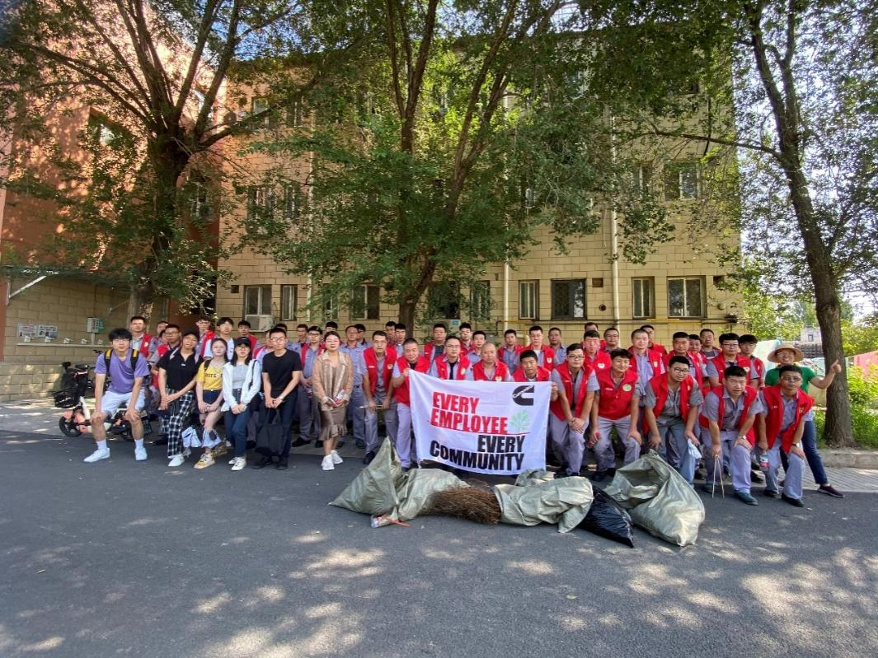
11、组织北京林业大学学生团队到老牛湾村开展志愿服务。2023年8月底至9月初，在富群对接、北京林业大学校团委支持下，北京林业大学学生实践团队赴老牛湾村开展实践调研工作，踏勘雨水花园并绘制平面图，并就雨水花园植被建设提供建议。
12、在联合国《湿地公约》第十四届缔约方大会上分享海绵社区成果。2022年11月，在在联合国《湿地公约》第十四届缔约方大会CEPA湿地教育与保护分论坛上，富群分享了老牛湾村海绵社区建设的实践成果和经验。
13、向北京市、十堰市等政府领导介绍海绵社区项目成果。2023年10月，富群受北京市团市委邀请，向来自十堰市的领导、北京市团市委领导及北京市社会组织介绍海绵社区项目及成果，同行的六家社会组织及北京团市委领导对海绵社区项目给予了赞许和肯定。
通过以上活动开展，雨水花园二期改造顺利完成；雨水花园所在地积水内涝问题得以彻底解决；老牛湾村雨污消纳能力得到进一步提升，成功抵御了2023“7.31北京暴雨”；老牛湾村及南沙河沿岸垃圾得到清理，环境得到保护和美化；提升了员工和当地社区环保意识。
Online translation:
Laoniuwan Village is located in Shahe Town, Changping District, Beijing, adjacent to Haidian District. It is named "Laoniuwan" because it is located at a big bend of Nansha River. The village is built along the river and covers an area of 1,561 acres. Laoniuwan Village currently has a population of more than 4,000 people. The permanent population is mostly the elderly, and the floating population is mostly young people working nearby.
Laoniuwan Village currently has a temporary sewage treatment facility, but it cannot meet the existing sewage treatment needs, causing sewage to overflow into the Nansha River. Rainwater and sewage in the village are not diverted, causing the capacity of the sewage pipes in the village's temporary sewage treatment facilities to exceed the standard and overflowing. The overflowing sewage causes direct domestic sewage pollution to the local soil and Nansha River, and the polluted area is filled with stench. The village also has the phenomenon of tail water being discharged through rainwater outlets.
On December 1, 2021, Foton Cummins jointly launched the "Sponge Community" project with Fuqun and Laoniuwan Village in Beijing, aiming to solve the problems of sewage overflow, waterlogging, and surface pollutant discharge caused by rainwater in the city. Into the river, sewage overflow pollutes the Nansha River, resulting in serious water pollution of the Nansha River. Promote the construction of sponge communities, so that rainwater can be discharged into the river through infiltration, retention, and purification, reducing pollution to the river, alleviating community waterlogging during the flood season, and at the same time Enhance the environmental awareness of community residents and improve the community environment. The first phase of the project in 2022 will mainly solve source pollution through rain gardens, reduce the amount of sewage entering the sewage pipes, solve the problems of sewage overflow and water logging in Laoniuwan Village, and the direct discharge of polluted rainwater into the river. problems while promoting the improvement of the village environment. A small rain garden was built using one-third of the open space in the southern part of the playground in Laoniuwan Village, and two small sedimentation purification tanks were built. This phase of work effectively solved the problem of water logging in the rain garden area and successfully proved the feasibility of further expansion of the rain garden project. In light of the recent frequent urban flooding disasters in China, Laoniuwan Village has the potential to become a model for decentralized stormwater management and be promoted to other communities in severe flooding areas across the country to alleviate urban flooding.
From September 2023 to September 2023, in the second phase of the project, based on the first phase of work, a 1,680-square-meter sedimentation purification tank was built, a biological purification system was built, and the climate adaptability and climate adaptability of the rain garden were enhanced. purification capacity; connected three purification sedimentation tanks into a whole, transformed the entire site into a 4,000 square meter rain garden, and improved garden supporting facilities such as roads, vegetation, street lights, etc., and built a rainwater collection and purification It is a public space that integrates environmental education, residents’ recreation and entertainment. The main specific tasks carried out include:
1. Multi-party communication meeting
On September 20, 2022, and March 28, 2023, Fuqun organized Futian Cummins volunteers, Laoniuwan Village Committee, etc. to hold communication meetings to discuss the needs of Laoniuwan Village and project needs. On March 16, 2023, and June 5, 2023, Fuqun went to Beijing Foton Cummins Engine Co., Ltd. to report the sponge community project results and next work plan to Foton Cummins management, and inspected the rain garden together to introduce the project results. , Foton Cummins leaders put forward constructive opinions on the implementation of the project.

2. Sponge community unveiling ceremony and planting activities. On September 28, 2022, the unveiling ceremony of Sponge Community was held in Laoniuwan Village. The general manager of Futian Cummins, the secretary of Laoniuwan Village, Beijing Fuqun and corporate volunteers attended the ceremony and expressed their affirmation and support for the sponge community project. After the unveiling ceremony, 30 Foton Cummins employees carried out planting and watering activities, set up garden display signs, and cleaned up garden waste.
3. Water cycle experts, wetland experts and community construction experts provide suggestions for the sponge community project in Laoniuwan Village. On November 15, 2022, Fuqun invited Associate Professor Jia Yifei of Beijing Forestry University and Teacher Han, an expert in the field of wetlands, to Laoniuwan Village and along the Nansha River for inspection. Fuqun also invited experts to hold a symposium with Laoniuwan Village. At the meeting, the implementation plan and specific operations of the rain garden were discussed.
4. Determine the rain garden construction party and design the construction plan. In April 2023, after multiple parties and rounds of communication, the second phase renovation plan for the rain garden was determined, including specific plans for the construction of sedimentation purification tanks, road systems, and vegetation systems.
5. Submit the project report and plan to Shahe Town, Changping District. In May 2023, Fuqun submitted a project report and plan to Shahe Town, Changping District. The mayor of Shahe Town recommended the sponge community project to everyone as a typical case of joint construction by enterprises, social organizations and communities.
6. Clean up the construction waste at the rain garden implementation site and cover it with soil. 5,040 cubic meters of construction waste were cleared. After the construction waste was removed, 2,000 square meters of high-quality soil with a thickness of about 50 centimeters was backfilled, which fully guaranteed the subsequent construction of the rain garden.
7. Ground shaping and building the framework of the rain garden. A 1,680-square-meter sedimentation and purification tank was excavated, and the ground shape was adjusted according to the three sedimentation and purification tanks to guide the accumulated water to gather into the sedimentation tank. Through pipeline laying, the three sedimentation and purification tanks are connected to form a complete wetland ecosystem.
8. Improve the ground facilities of the rain garden. After the construction of the rain garden system was completed, the project also obtained supporting support from the village. With the joint efforts of the village, a total of 80 meters of guardrails were installed in the rain garden, 7 benches, 2 chessboard tables, 8 fitness equipment, and garbage were installed. 4 barrels, 312 square meters of road construction, and 588 meters of curbs were installed; 40 solar floor lamps, several safety warning signs, and 1 sponge community introduction sign were installed, which further improved the facilities of the rain garden and met the basic needs of the villagers. .
9. Carry out rain garden vegetation design and construction. With effective design, reasonable plant configuration and proper maintenance, rain gardens can not only improve the environment of the community and provide food and habitat for birds, insects and other animals, but also achieve good landscape effects and become a place for leisure and entertainment for community residents. place. Volunteers from Futian Cummins also participated in the design and improvement of the plan, and participated in plant planting activities in the rain garden. A total of 10 crabapples, 16 crabapples, 1,600 boxwoods, 10 North China lilacs, 10 cattails, 10 gladioli, 10 reeds, 20 golden leaf elm, alfalfa and other herbaceous plants were planted in 4,000 square meters.
10. Volunteers participate in the construction and maintenance of rain gardens. A total of 6 volunteer service activities were organized from September 2022 to August 2023, with a total of 173 Foton Cummins employee volunteers participating. Activities include:
(1) On September 22, 2022, 20 volunteers from Futian Cummins carried out garbage cleaning work in the rain garden, cleaning up the garbage in and around the rain garden in preparation for the unveiling ceremony of the sponge community.

(2) On September 28, 2022, the unveiling ceremony of the Sponge Community was held in Laoniuwan Village. The general manager of Futian Cummins, the secretary of Laoniuwan Village, and the chairman of Beijing Fuqun Social Service Center attended the ceremony. After the unveiling ceremony, 30 Foton Cummins employees carried out planting and watering activities, set up garden display signs, and cleaned up garden waste.

(3) On May 19, 2023, 31 volunteers from Futian Cummins, organized by Fuqun, worked with gardening workers to plant hedges around the sedimentation purification tank. The volunteers installed the structures in groups and planted more than a thousand large-leaved boxwood trees near the sedimentation purification tank at prescribed intervals. On the one hand, these shrubs can play a role in soil and water conservation and prevent the pool slope from collapsing; on the other hand, they can Block the safety hazards caused by pedestrians getting too close to the pool.

(4) On May 26, 2023, 31 volunteers from Futian Cummins, organized by Fuqun, and gardening workers planted small trees in the rain garden to increase the landscape effect and soil and water conservation capacity of the rain garden, and planted Xifu crabapples. 10 plants and 16 Begonia plants.

(5) On June 29, 2023, Fuqun designed a questionnaire and organized 21 Foton Cummins volunteers to distribute it in Laoniuwan community. It designed 100 sponge community water-saving promotional cultural and creative handbags and distributed them together. The survey collected 26 valid questionnaires and formed a questionnaire survey report. Surveys show that users of rain gardens include not only residents of Laoniuwan Village, but also residents of surrounding villages and employees of companies such as Futian Cummins who rent in Laoniuwan Village; people are highly satisfied with rain gardens and have high expectations for landscape construction. and sedimentation tank sedimentation safety are of greater concern.
(6) On August 28, 2023, 40 Foton Cummins volunteers carried out garbage clean-up work in the village area of Laoniuwan Village. 40 volunteers were divided into four groups to carry out garbage collection activities in different areas. They carefully classified and put out the garbage to ensure that the garbage was disposed of in the correct way.

11. Organize a student team from Beijing Forestry University to carry out volunteer services in Laoniuwan Village. From the end of August to the beginning of September 2023, with the support of Fuqun Docking and the Youth League Committee of Beijing Forestry University, the student practice team of Beijing Forestry University went to Laoniuwan Village to carry out practical research work, surveyed the rain garden and drew a floor plan, and discussed the construction of rain garden vegetation. Give suggestion.
12. Share sponge community results at the 14th Conference of the Parties to the United Nations Convention on Ramsar. In November 2022, at the CEPA Wetland Education and Protection Sub-forum of the 14th Conference of the Parties to the United Nations Convention on Ramsar, Fu Qun shared the practical results and experience of sponge community construction in Laoniuwan Village.
13. Introduce the results of the sponge community project to government leaders in Beijing and Shiyan. In October 2023, Fuqun was invited by the Beijing Youth League Committee to introduce the sponge community project and results to leaders from Shiyan City, Beijing Youth League Committee leaders and Beijing social organizations. Sponge Community Project gave thumbs up and recognition.
Through the above activities, the second phase of the rain garden renovation was successfully completed; the waterlogging problem where the rain garden was located was completely solved; the rainwater and sewage absorption capacity of Laoniuwan Village was further improved, successfully withstanding the 2023 "7.31 Beijing Heavy Rain"; Laoniuwan Village Garbage along the Nansha River has been cleaned up, and the environment has been protected and beautified; the environmental awareness of employees and local communities has been enhanced.
1.Would you say that your grant project was successful?
Yes
- Why or why not?
因为项目的开展为社区带来了极大的变化，彻底解决了社区积水内涝问题并增强了社区气候适应性；将一个充满建筑垃圾的废弃地块建成了一座优美的雨水花园。雨水花园具备出色的雨污消纳和净化能力，能够缓解雨污溢流造成的临近河流污染。并且开展了多次志愿服务活动，优化了社区环境，提升了员工和社区的环保意识。
Online translation:
Because the implementation of the project has brought great changes to the community, it has completely solved the waterlogging problem in the community and enhanced the community's climate adaptability; an abandoned plot full of construction waste has been built into a beautiful rain garden. The rain garden has excellent rainwater absorption and purification capabilities, and can alleviate the pollution of adjacent rivers caused by rainwater overflow. It has also carried out many volunteer service activities, optimized the community environment, and enhanced the environmental awareness of employees and the community.

- What is your project’s biggest accomplishment?
项目促成了老牛湾村、福田康明斯、高校专家等多方参与下的海绵社区建设，建成一座4000平方米的环境优美、功能性强的雨水花园，建设了一块集引水、蓄水、净化为一体的小微湿地。按照受雨面和该区域年均降水量估算，该湿地每年有约16.8831万吨雨水流经并得到一定程度净化，极大减轻了雨水对下水系统的冲击和污水溢流导致的污染，为解决南沙河污染问题探索了一个成功的案例。这一案例也在联合国湿地公约大会上被分享。
在这个过程中，富群负责把控项目开展进度；专家负责提供技术指导，走访项目地并现场指导；村委会协助组织村民和召开会议，讨论机制与制度；村民参与花园施工；志愿者开展花园种植、花园和临近水域环境维护活动；最终共同设计完成了花园建设。这一模式可以复制到其它村庄，从而进一步解决南沙河流域或其它流域雨污溢流造成的河流污染。
Online translation:
The project promoted the construction of a sponge community with the participation of Laoniuwan Village, Futian Cummins, university experts and other parties, and built a 4,000-square-meter rain garden with beautiful environment and strong functionality. It also built a rain garden that integrates water diversion, water storage, and purification. of small wetlands. It is estimated based on the rainfall area and the average annual precipitation in the area that approximately 168,831 tons of rainwater flows through the wetland every year and is purified to a certain extent, which greatly reduces the impact of rainwater on the sewer system and pollution caused by sewage overflow. In order to solve the problem The Nansha River pollution problem was explored as a successful case. This case was also shared at the United Nations Convention on Ramsar.
During this process, Fuqun is responsible for controlling the progress of the project; experts are responsible for providing technical guidance, visiting the project site and providing on-site guidance; the village committee assists in organizing villagers and holding meetings to discuss mechanisms and systems; villagers participate in garden construction; volunteers carry out Garden planting, garden and adjacent water environment maintenance activities; finally jointly designed and completed the garden construction. This model can be replicated in other villages to further solve river pollution caused by rainwater overflow in the Nansha River basin or other basins.

- What are the lessons learned from this project?
- 社区项目设计和执行过程中尽可能充分调动社区参与，可以强化社区对项目的拥有感，把项目当成自己的项目。
- 项目调动社区参与项目开展还可以避免许多不必要的纠纷。例如，如果是外部施工队，施工时噪音问题很容易被投诉，但如果是村内施工队，其会内部达成和解。此外，社区所给的报价也略优惠于市场上的工程公司，有助于节省项目开支。
- 组织多方讨论很有必要。而且在讨论中应当保持克制，引导参与方进行思考和讨论，而非替参与方思考和决策。一方面这是对参与方的充分尊重，另一方面也有助于强化参与方的责任心和收获感，同时也有助于让参与各方员将一些想法和顾虑说出来。
- 志愿活动的受益者不仅是社区，也包括志愿者。对于志愿者而言，志愿活动也是很好的受教育和进行团队建设的机会。在组织志愿活动时，也应该充分考虑志愿者的体验和收获。
Online translation:
Mobilizing community participation as fully as possible during the design and implementation of community projects can strengthen the community's sense of ownership of the project and regard the project as their own.
Projects that mobilize communities to participate in project implementation can also avoid many unnecessary disputes. For example, if it is an external construction team, it is easy to complain about noise problems during construction, but if it is an in-village construction team, it will reach an internal settlement. In addition, the quotations provided by the community are slightly more favorable than those of engineering companies on the market, which helps to save project expenses.
It is necessary to organize multi-party discussions. Moreover, restraint should be maintained during discussions, and participants should be guided to think and discuss rather than think and make decisions for the participants. On the one hand, this is full respect for the participants; on the other hand, it also helps to strengthen the participants’ sense of responsibility and gain, and it also helps to allow the participants to express some of their thoughts and concerns.
The beneficiaries of volunteer activities are not only the community, but also volunteers. Volunteering is also a great educational and team-building opportunity for volunteers. When organizing volunteer activities, the experience and gains of volunteers should also be fully considered.
Financial Report
Financial Reports
Financial Report comments
Impact - Project Outcomes & Metrics：
- 社区至少1/3面积（村域面积1561亩，其三分之一大约500亩，即333000平方米）的积水问题得到解决；
- 在降雨期间减少了30%的雨水流入污水管道，为现有排水系统减负，减少或根除由于雨污不分流导致的溢流造成的土壤及河道污染；
- 年均雨水净化量约16.8831万吨；
- 绿化面积4000平米，植物种植超过2000株，预计固碳约11.440吨^{[1]}，预计涵养水资源1022.72吨^{[2][3]}；
- 2400立方米（约12096吨）建筑垃圾得到清理。
- 建设了一处4000平方米兼具环境教育功能和游憩功能的雨水花园。雨水花园共计回填2000平方米、厚约50公分的优质土壤，开挖1680平方米沉淀净化池一个，破除原水泥矮墙80米，安装金属护栏80米，安装长椅7条、棋盘桌2个、健身器材8个、垃圾桶4个，修建道路312平方米，铺设路牙588米，安装太阳能地灯40盏，安装安全警示牌3块。
- 项目影响改善了4000多居民的生活环境；营造增加了至少4000平方米的公共空间；
- 至少173名志愿者参与活动，志愿时长至少为692小时；
- 为城市内涝灾害如何在社区分散治理提供了样板，可持续推广到全国其他内涝严重地区。
[1]邓亮,崔耀平,唐晔,赵浩程,李万隆,孙亚茹.城市绿地碳储量分布特征及其影响因素[J].森林与环境学报,2023,43(03):319-328.
[2]龚诗涵, 肖洋, 郑华, 肖燚, 欧阳志云. 中国生态系统水源涵养空间特征及其影响因素. 生态学报, 2017, 37(7): 2455-2462.
[3] HJ 1173—2021，全国生态状况调查评估技术规范——生态系统服务功能评估[S]．北京：中国生态环境部，2021．
Online translation:
The water accumulation problem in at least 1/3 of the community (the village area is 1,561 acres, one third of which is about 500 acres, or 333,000 square meters) has been solved;
Reduces the flow of rainwater into sewage pipes by 30% during rainfall, reducing the burden on the existing drainage system and reducing or eradicating soil and river pollution caused by overflow caused by undivided rainwater and sewage;
The average annual rainwater purification volume is approximately 168,831 tons;
The green area is 4,000 square meters, with more than 2,000 plants planted. It is expected to sequester approximately 11.440 tons of carbon[1] and conserve 1,022.72 tons of water resources[2][3];
2,400 cubic meters (approximately 12,096 tons) of construction waste were cleared.
A 4,000-square-meter rain garden with both environmental education and recreational functions was built. The rain garden backfilled a total of 2,000 square meters of high-quality soil with a thickness of about 50 centimeters, excavated a 1,680 square meter sedimentation purification tank, demolished 80 meters of the original cement low wall, installed 80 meters of metal guardrails, and installed 7 benches and 2 chessboard tables. , 8 fitness equipment, 4 trash cans, 312 square meters of roads were built, 588 meters of curbs were paved, 40 solar floor lights were installed, and 3 safety warning signs were installed.
The impact of the project has improved the living environment of more than 4,000 residents; created an increase of at least 4,000 square meters of public space;
At least 173 volunteers participated in the activity, and the volunteer time was at least 692 hours;
It provides a model for how to manage urban waterlogging disasters in decentralized communities, and can be continuously extended to other areas with serious waterlogging across the country.
Number of Cummins
Employees who Helped Number of Hours Cummins：
173名福田康明斯志愿者参与，贡献692小时志愿服务时间
173 Foton Cummins volunteers participated and contributed 692 hours of volunteer service time
Employees Volunteered
Can this project continue without further funding from GlobalGiving in partnership
with Cummins?
Yes
Actions that ensure the project is sustainable
- 和村委会沟通确定了村委会将在后期持续进行维护活动。
- 花园建植所选植被大多未生命力旺盛、抗逆性强、适应北京气候的植被。这些植被在前期维护下形成成熟群落后，拥有群落的抵抗力稳定性和修复力稳定性，能够自我更新和修复。
- 未来雨水花园可以在低维护的状态下持续提供雨污消纳和净化的功能。
Online translation:
Communicated with the village committee and confirmed that the village committee will continue to carry out maintenance activities in the future.
Most of the vegetation selected for garden construction is vigorous, stress-resistant, and adapted to Beijing’s climate. After these vegetations form mature communities under early maintenance, they have the resistance stability and repair power stability of the community, and can self-renew and repair.
In the future, rain gardens can continue to provide rainwater absorption and purification functions with low maintenance.
Grant report metrics for proposal project type = environment
Please select one of the following which best describes the purpose of your project:
If "Other" please describe
Employees who HelpedNumber of Hours Cummins：
How many kiloliters of water did your project conserve or make fit for use, if applicable?
168831KL。
How many trees or seedlings did you plant, if applicable?
2000。
How many metric tons of waste did you collect, if applicable?
12096 tons。
How many metric tons of the collected waste were recycled or diverted from landfills, if applicable?
How many metric tons of Greenhouse Gas did your project reduce, if applicable?
11.44 tons。
How many people were educated, if applicable?
216 person-times。
What successes and key accomplishments has your project achieved that were not captured through previous metrics?
- 雨水花园大幅减轻了污水处理的系统的载荷和开支。北京市污水处理收费标准为居民1.36元/吨 (京发改〔2014〕865号)，每年所消纳的雨污若改为化工方式处理，则需27.01万元。雨水通过雨水花园的沉淀和净化，也能有效补给地下水。
- 所建设的雨水花园，除生态功能和雨污消纳功能外，还为社区提供了一座可用于科普宣教、活动开展、休闲游憩的场所。
Online translation:
Rain gardens significantly reduce the load and expense of sewage treatment systems. The sewage treatment fee standard in Beijing is 1.36 yuan/ton for residents (Jingfa Gai [2014] No. 865). If the rainwater consumed every year is treated chemically, it will cost 270,100 yuan. Rainwater can also effectively recharge groundwater through the precipitation and purification of rain gardens.
In addition to the ecological function and rainwater absorption function, the rain garden constructed also provides the community with a place that can be used for science education, activities, and leisure.
Storytelling - Photos and Videos：
Inspiring storiesPhotos / Videos
