HEREAFTER GHANA (MHP)
QUARTERLY REPORT FOR GLOBAL GIVING (APRIL-JUNE 2025)
PROJECT TITLE: MOBILE CLINIC SERVICES TO DEPRIVED COMMUNITIES

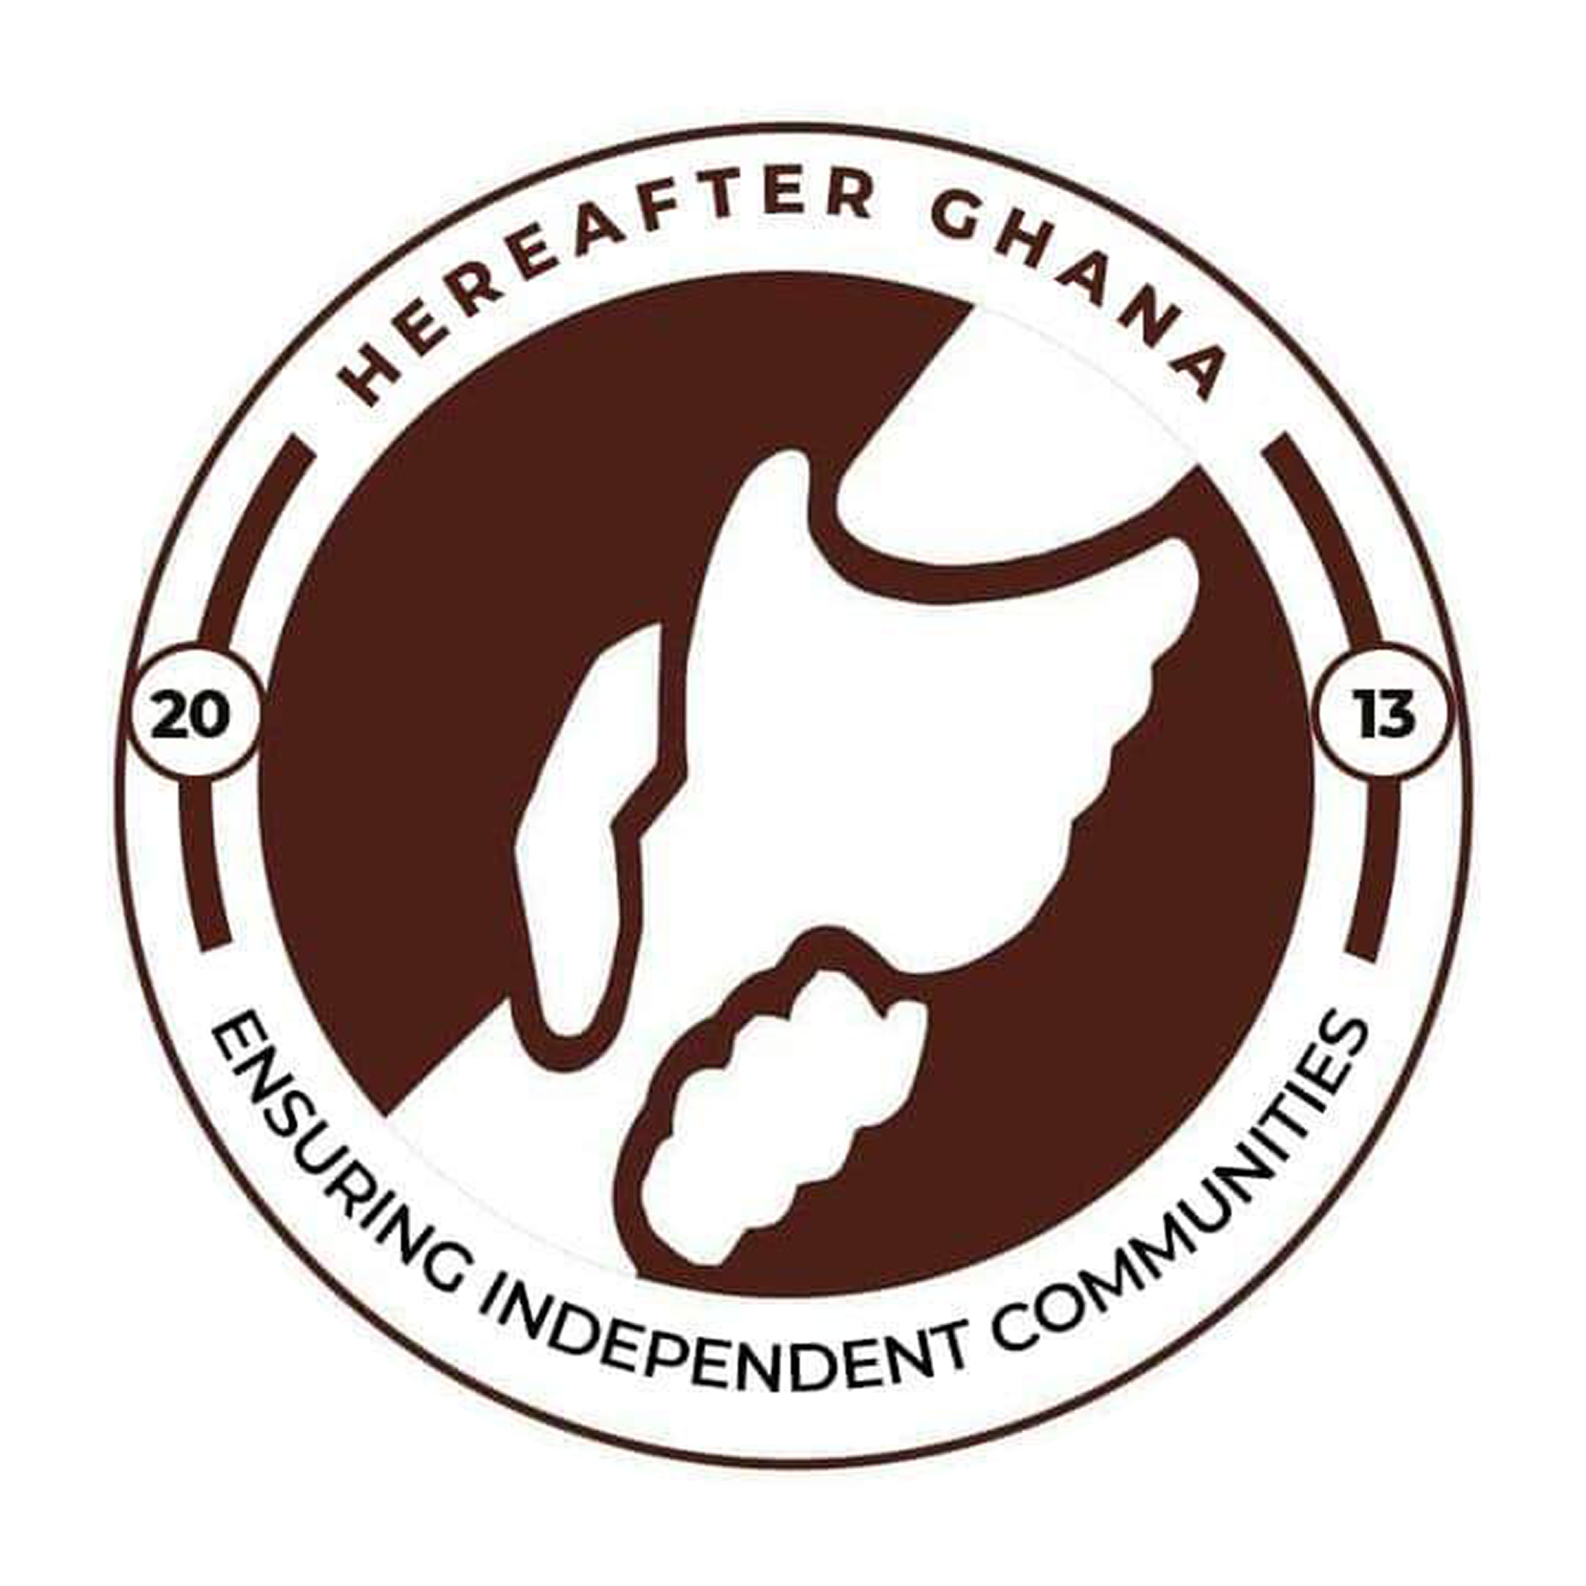

Date: 23rd June 2025
Prepared by
Sulemana Suabira Suhuyini
Administrative Assistant

INTRODUCTION
As part of its commitment to promoting health awareness and improving access to essential medical services, Hereafter Ghana continues to implement impactful health outreach programs within local communities. These community-based initiatives are designed to provide vital health education and services, addressing pressing health concerns while fostering overall well-being. By prioritizing the dissemination of accurate health information and facilitating preventive care, this outreach project seeks to empower individuals and communities to make informed health decisions and live healthier lives.

This quarter, Hereafter Ghana focused on Health education. Educating the youth on Malaria and sanitation.
This initiative is fueled by a collective dedication to assist the underserved communities and enhance overall well-being by providing them with the essential knowledge about their health.
MAIN OBJECTIVE
The primary objective of the outreach was to provide students at Presby Senior High with comprehensive information on Malaria prevention and proper sanitation practices. This was aimed at equipping them with the knowledge to make healthier life choices and reduce the prevalence of preventable diseases within the school environment and their homes.
KEY ACTIVITIES
There was an interactive session between the Hereafter Ghana team and the students.
The MHP health team educated students on the causes, symptoms, and prevention of malaria. Emphasis was placed on the importance of sleeping under insecticide-treated nets, eliminating mosquito breeding sites, and seeking prompt medical care.
Furthermore, the team proceeded by educating students on the importance of personal hygiene and environmental cleanliness. Students were encouraged to maintain clean surroundings, use proper waste disposal methods, and ensure regular hand washing to prevent the spread of diseases.
The students actively participated in the session by asking questions and sharing their experiences, which enriched the engagement and understanding of the topics discussed.

CONCLUSION
The session was well-received by both students and school authorities. Students expressed appreciation for the practical information shared, while the school administration acknowledged the relevance of the topics to the students’ health and well-being. The outreach fostered greater awareness and responsibility among the students regarding malaria prevention and sanitation practices.
Hereafter Ghana remains committed to strengthening health education and outreach in schools and communities across Ghana. By equipping the youth with knowledge on preventable diseases and healthy habits, we aim to contribute meaningfully to the overall health and development of future generations.
ACKNOWLEDGEMENT
Hereafter Ghana extends its heartfelt appreciation to all our esteemed donors, the dedicated Health Volunteers, and the committed staff of Hereafter Ghana for their invaluable contributions to the project.
Your unwavering support and collaboration have been instrumental in ensuring that vulnerable underserved communities gain access to essential healthcare services including education and consultation. The success of this initiative reflects your shared commitment to safeguarding the health and well-being of the underserved communities, and we are deeply grateful for the trust and partnership you continue to show.
GALLERY
