HEREAFTER GHANA
QUARTERLY REPORT FOR GLOBAL GIVING (OCTOBER-DECEMBER 2024)
PROJECT TITLE: DONATE TO SUPPORT MOBILE CLINIC SERVICES TO DEPRIVED COMMUNITIES

INTRODUCTION
Hereafter Ghana as a means of enhancing health awareness and access to medical services within the communities, execute impactful health outreach programs. This community outreach project prioritizes providing health information, with the goal of tackling key health concerns and improving overall well-being within the community.
This quarter, Hereafter Ghana successfully executed two health outreach programs.
- Breast cancer screening
- Mobile Clinic
This initiative is fueled by a collective dedication to assist the underserved communities and enhancing overall well-being by providing them with the essential knowledge about their health.
BREAST CANCER SCREENING
The organization held a breast cancer screening at the Aboabo community in the Tamale Central Constituency. This initiative forms part of the global fight against breast cancer and creating awareness as well as the early detection of breast cancer.
The screening was designed to educate the community both men and women on the early detection, precautions, preventive and the general awareness of breast cancer.
Key Activities
- Health Education
To create the general awareness of Breast cancer to the community, medical officers gave a detailed interactive session focusing on preventive measures, risk factors, symptoms, and the importance of regular check-ups. Encouraging community members on reporting any symptoms or cases to the hospital.
- Screening
With the help of the Hereafter Ghana team and medical officers, the screening started with vital checks. It was done in an enclosed setting to ensure privacy and confidentiality.
- Consultation
Free consultation was also provided on nutritional health and general well-being and how they can check themselves regularly each month to be able to detect any early symptoms to prevent extreme cases.
The active corporation, participation and feedback of the community made it a successful screening meeting the aim of spreading awareness and detecting early symptoms.
In conclusion, the efforts of the breast cancer screening made a meaningful difference in the lives of individuals and families in the Aboabo community by providing awareness.
Hereafter Ghana have therefore supported the community members in improving their well-being and quality of life.
GALLERY
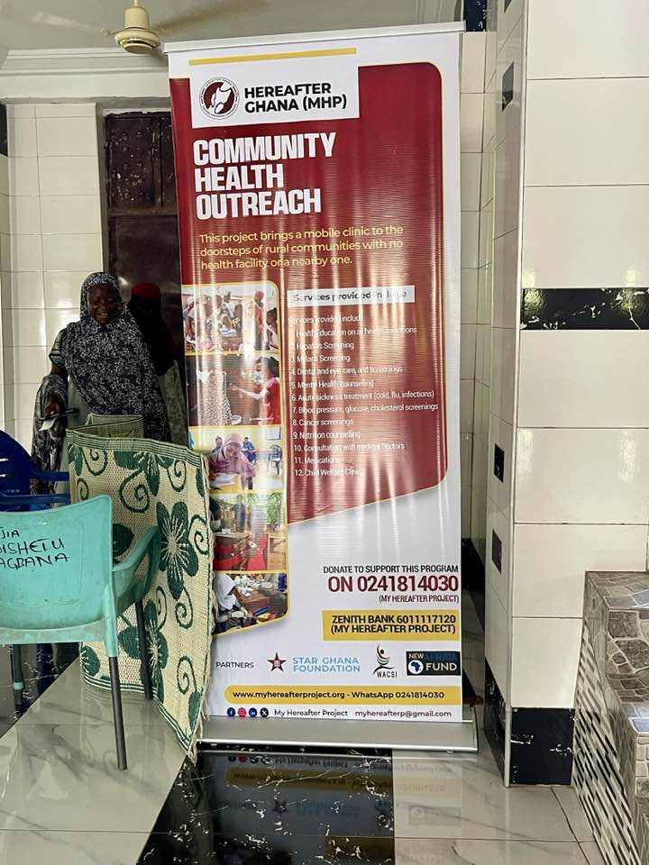
Creating an enclosed setting to ensure comfort and confidentiality for the screening.

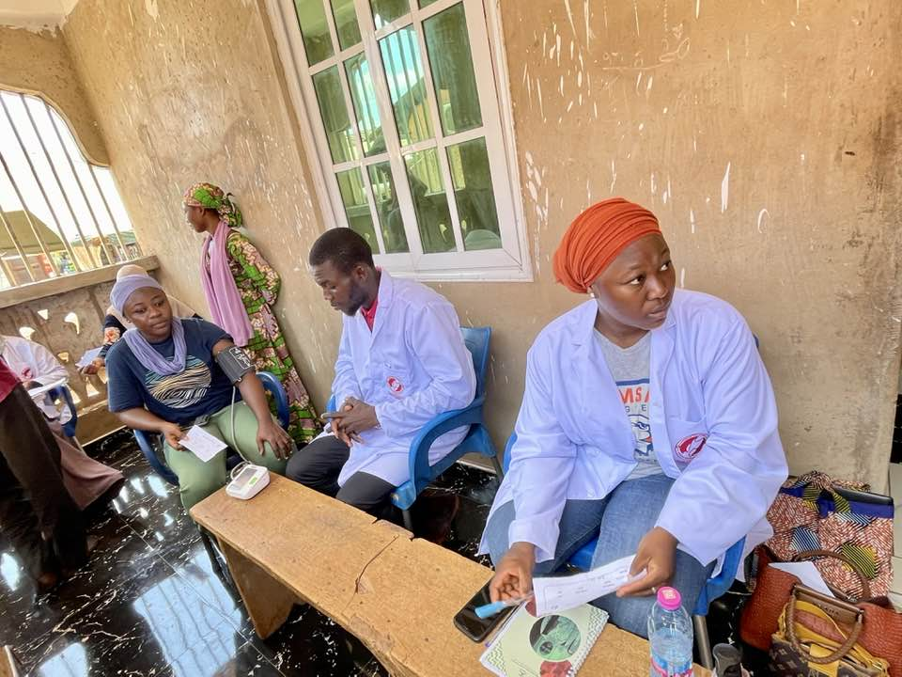
Hereafter Ghana team taking and recording vitals.

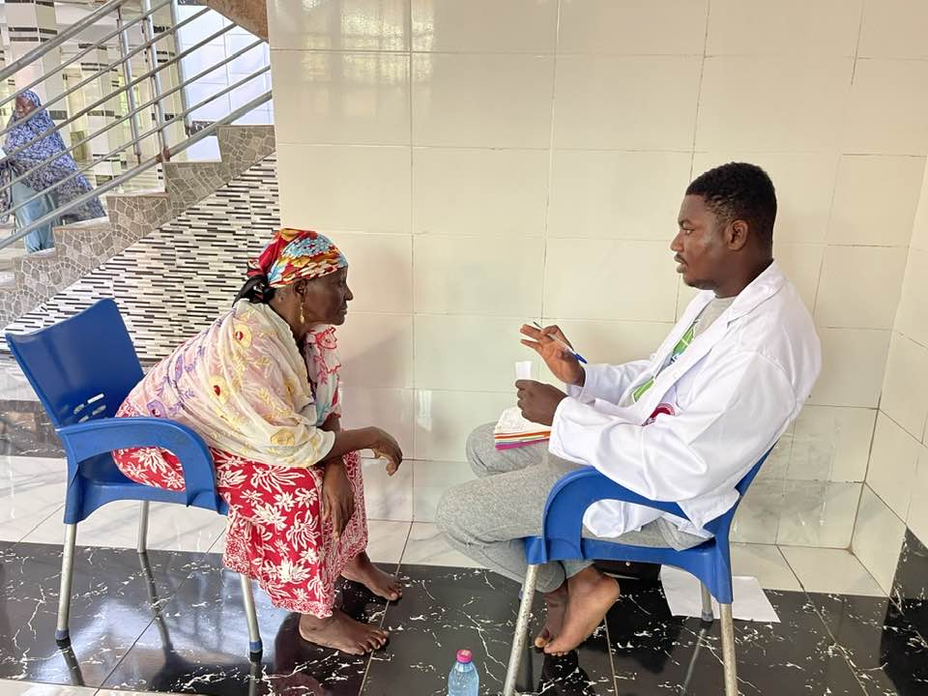
Consultation by medical officers after screening.

