HEREAFTER GHANA
QUARTERLY REPORT FOR GLOBAL GIVING (APRIL – JUNE 2024)
PROJECT TITLE: DONATE TO MOBILE CLINIC SERVICES TO DEPRIVED COMMUNITIES.

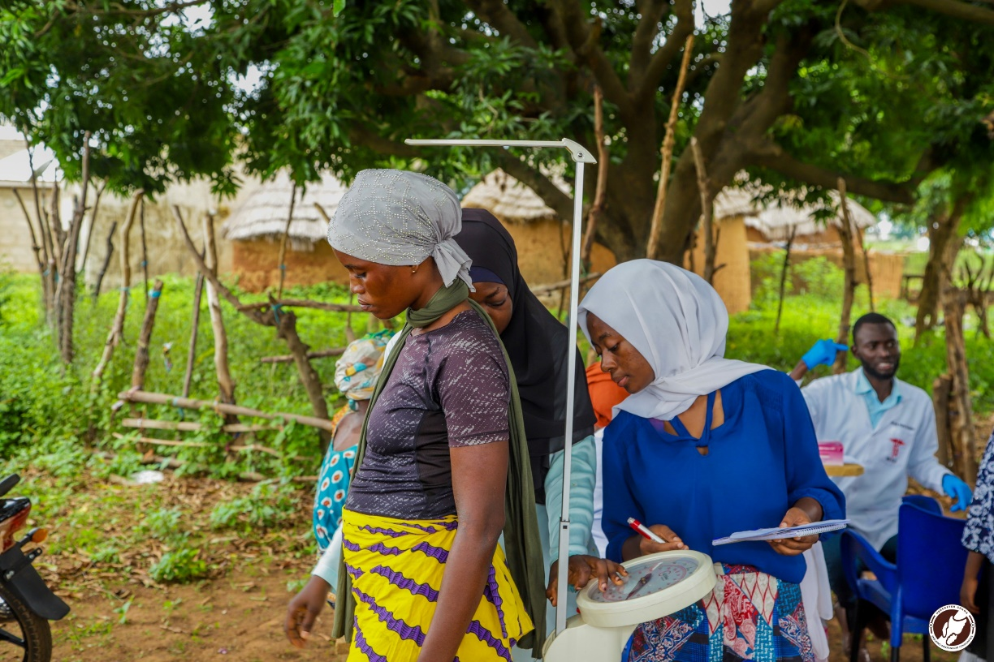
INTRODUCTION
A health education and screening exercise was successfully organized in the Yagyili community. The primary objective of this initiative was to enhance awareness about malaria, its causes and effects, prevention and to provide essential health screenings for both parents and children. This report outlines the activities conducted during the event, the participation levels, and the outcomes of the screening.
Objectives
1. To educate the community about malaria, including its causes, symptoms, and preventive measures.
2. To conduct health screenings for malaria, Body Mass Index (BMI), and blood pressure.
3. To provide medical consultations following the screenings to address health concerns.
Activities Conducted
- Health Education Session:
The health education session was a pivotal component of the health education and screening. With the aim of empowering participants with knowledge about malaria and general health practices, enabling them to make informed decisions regarding their health and well-being, our health practitioners held a comprehensive educational session with community members. Emphasize was placed on the importance of understanding malaria as a life threatening disease caused by parasites transmitted through the bites of infected female anopheles mosquitoes. The importance of early diagnosis and treatment was also emphasized, along with an explanation of rapid diagnostic tests used during the screening. Participants learned about how malaria spreads and the risk factors associated with it, including environmental conditions, lack of preventive measures and socioeconomic factors. The session highlighted various methods to reduce mosquito breeding, such as eliminating standing water and using mosquito nets. Also, the importance of community involvement in malaria prevention efforts was stressed, encouraging participants to work together to create a healthier environment.
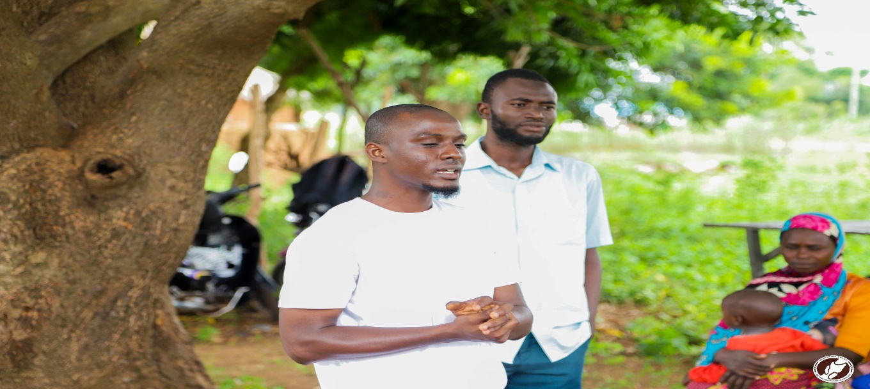

- Health Screening:
Upon arrival, participants were registered by volunteers who collected basic demographic information, including name, age, gender, and contact details. The screening exercise was divided into several stations, each focusing on different aspects of health:
Vital Signs Monitoring:
Healthcare professionals measured participants' blood pressure, heart rate, and temperature to identify individuals at risk of hypertension.
Nutritional Assessment:
Participants' height and weight were recorded to calculate Body Mass Index (BMI). Nutritional counseling was provided based on individual assessments.
Malaria Testing Station:
Participants were tested for malaria using RDTs. This involved a quick finger prick to collect a blood sample, which provided results within 15-20 minutes.
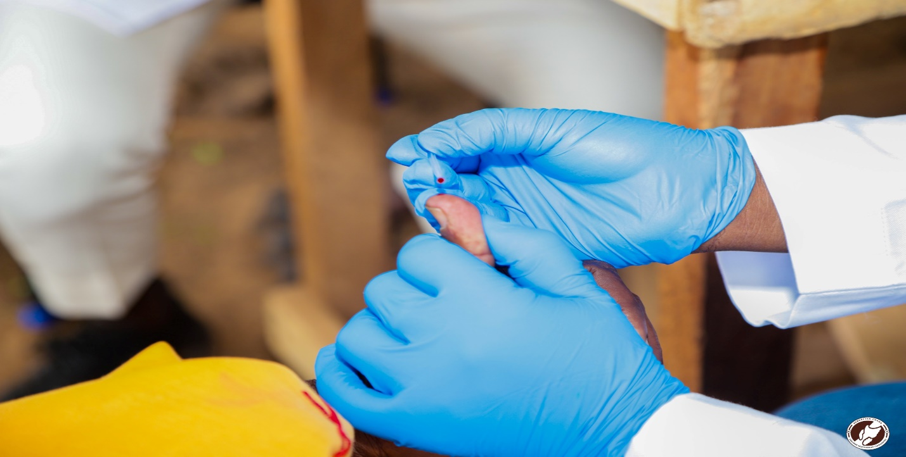
- Consultation Services:
After the screenings, our team of medical doctors provided consultations to discuss individual health results. Participants received personalized advice on managing their health conditions, including guidance on malaria prevention and lifestyle modifications.
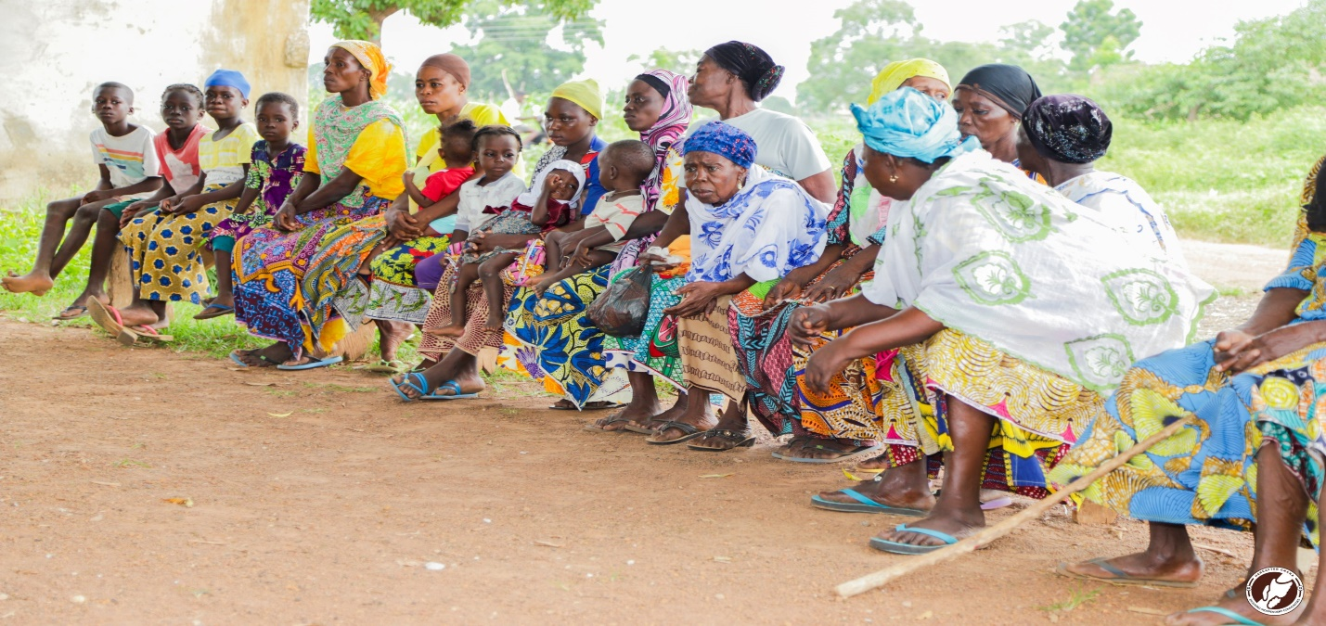
- Counseling and Referral Services:
Individuals who tested positive for malaria were provided with medications while those with other health concerns were also given immediate counseling about treatment options and were referred to local healthcare facilities for further care.
Participation
The event attracted a significant number of community members, with approximately 162 participants that included children and adults. The turnout exceeded our expectations, indicating a strong interest in health education and wellness within the Yagyili community.
Outcomes
Out of the total participants screened for malaria, 27 people tested positive, and appropriate treatment was advised. The BMI measurements revealed and blood pressure readings indicated that some adults were at risk of hypertension.
CONCLUSION
The health education and screening exercise at Yagyili community was a resounding success. The initiative not only raised awareness about malaria but also provided critical health services that addressed immediate health concerns among community members.

