HEREAFTER GHANA
QUARTERLY REPORT FOR GLOBAL GIVING (JANUARY – MARCH 2024)
PROJECT TITLE: DONATE TO MOBILE CLINIC SERVICES TO DEPRIVED COMMUNITIES.
INTRODUCTION
Our organization, dedicated to uplifting underserved communities, recently executed an impactful health outreach program in the Kulaa community. The outreach program initiative focused on health education, aiming to address critical needs and promote well-being among community members. This year, the program aims to raise awareness about maternal and child health in rural areas through creative health education methods.
This is an initiative driven by a shared commitment to supporting underserved communities and promoting well-being for all by equipping the people with the right knowledge regarding their health.
Health Education Program
The health education program was meticulously designed to empower community members with knowledge and resources to improve maternal and child health outcomes. Through engaging activities and informative resources, participants gained valuable knowledge on topics such as preconception, prenatal care, post natal care, nutrition, hygiene practices, and breastfeeding as well as child development. The program not only disseminated crucial health information but also fostered a sense of community support and solidarity around maternal and child well-being.
The active participation and positive feedback from community members underscored the success of the health education program in raising awareness and promoting informed health decisions. By equipping individuals with valuable knowledge and skills, the program contributed to enhancing the overall health and well-being of participants and their families.
In conclusion, the efforts of the health education program have made a meaningful difference in the lives of individuals and families in the Kulaa community. By providing essential health information, we have supported community members in improving their well-being and quality of life.
GALLERY
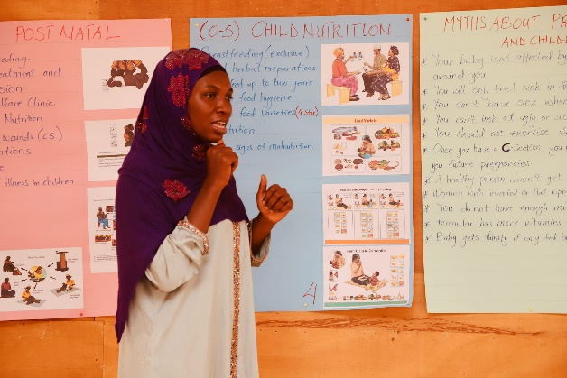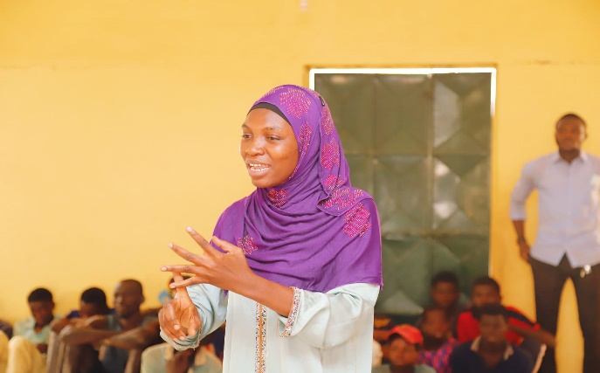
Health Education presentation by a volunteer midwife officer on the topic Maternal and Child health.
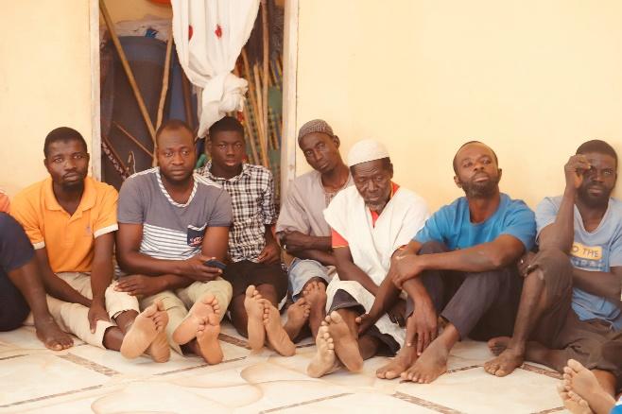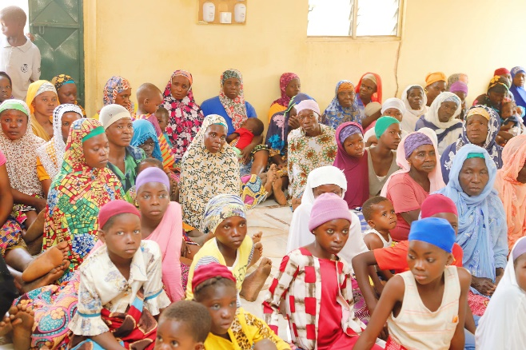
Community members participation in the health education program.
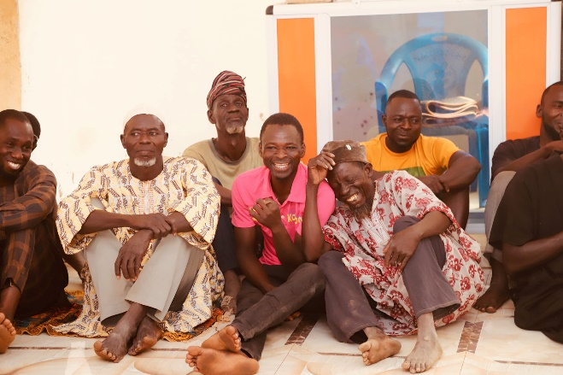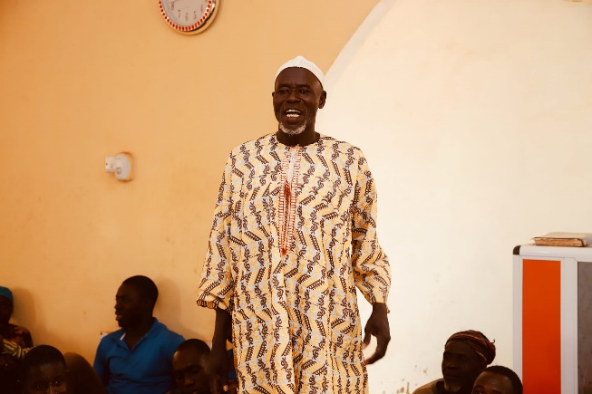
The community members were given the honor to contribute, ask questions and seek clarifications on the thoughts on keen issues related to maternal and child health.

