HEREAFTER GHANA (MHP)
QUARTERLY REPORT FOR GLOBAL GIVING (JANUARY-MARCH)
PROJECT TITLE: MOBILE CLINIC SERVICES TO DEPRIVED COMMUNITIES

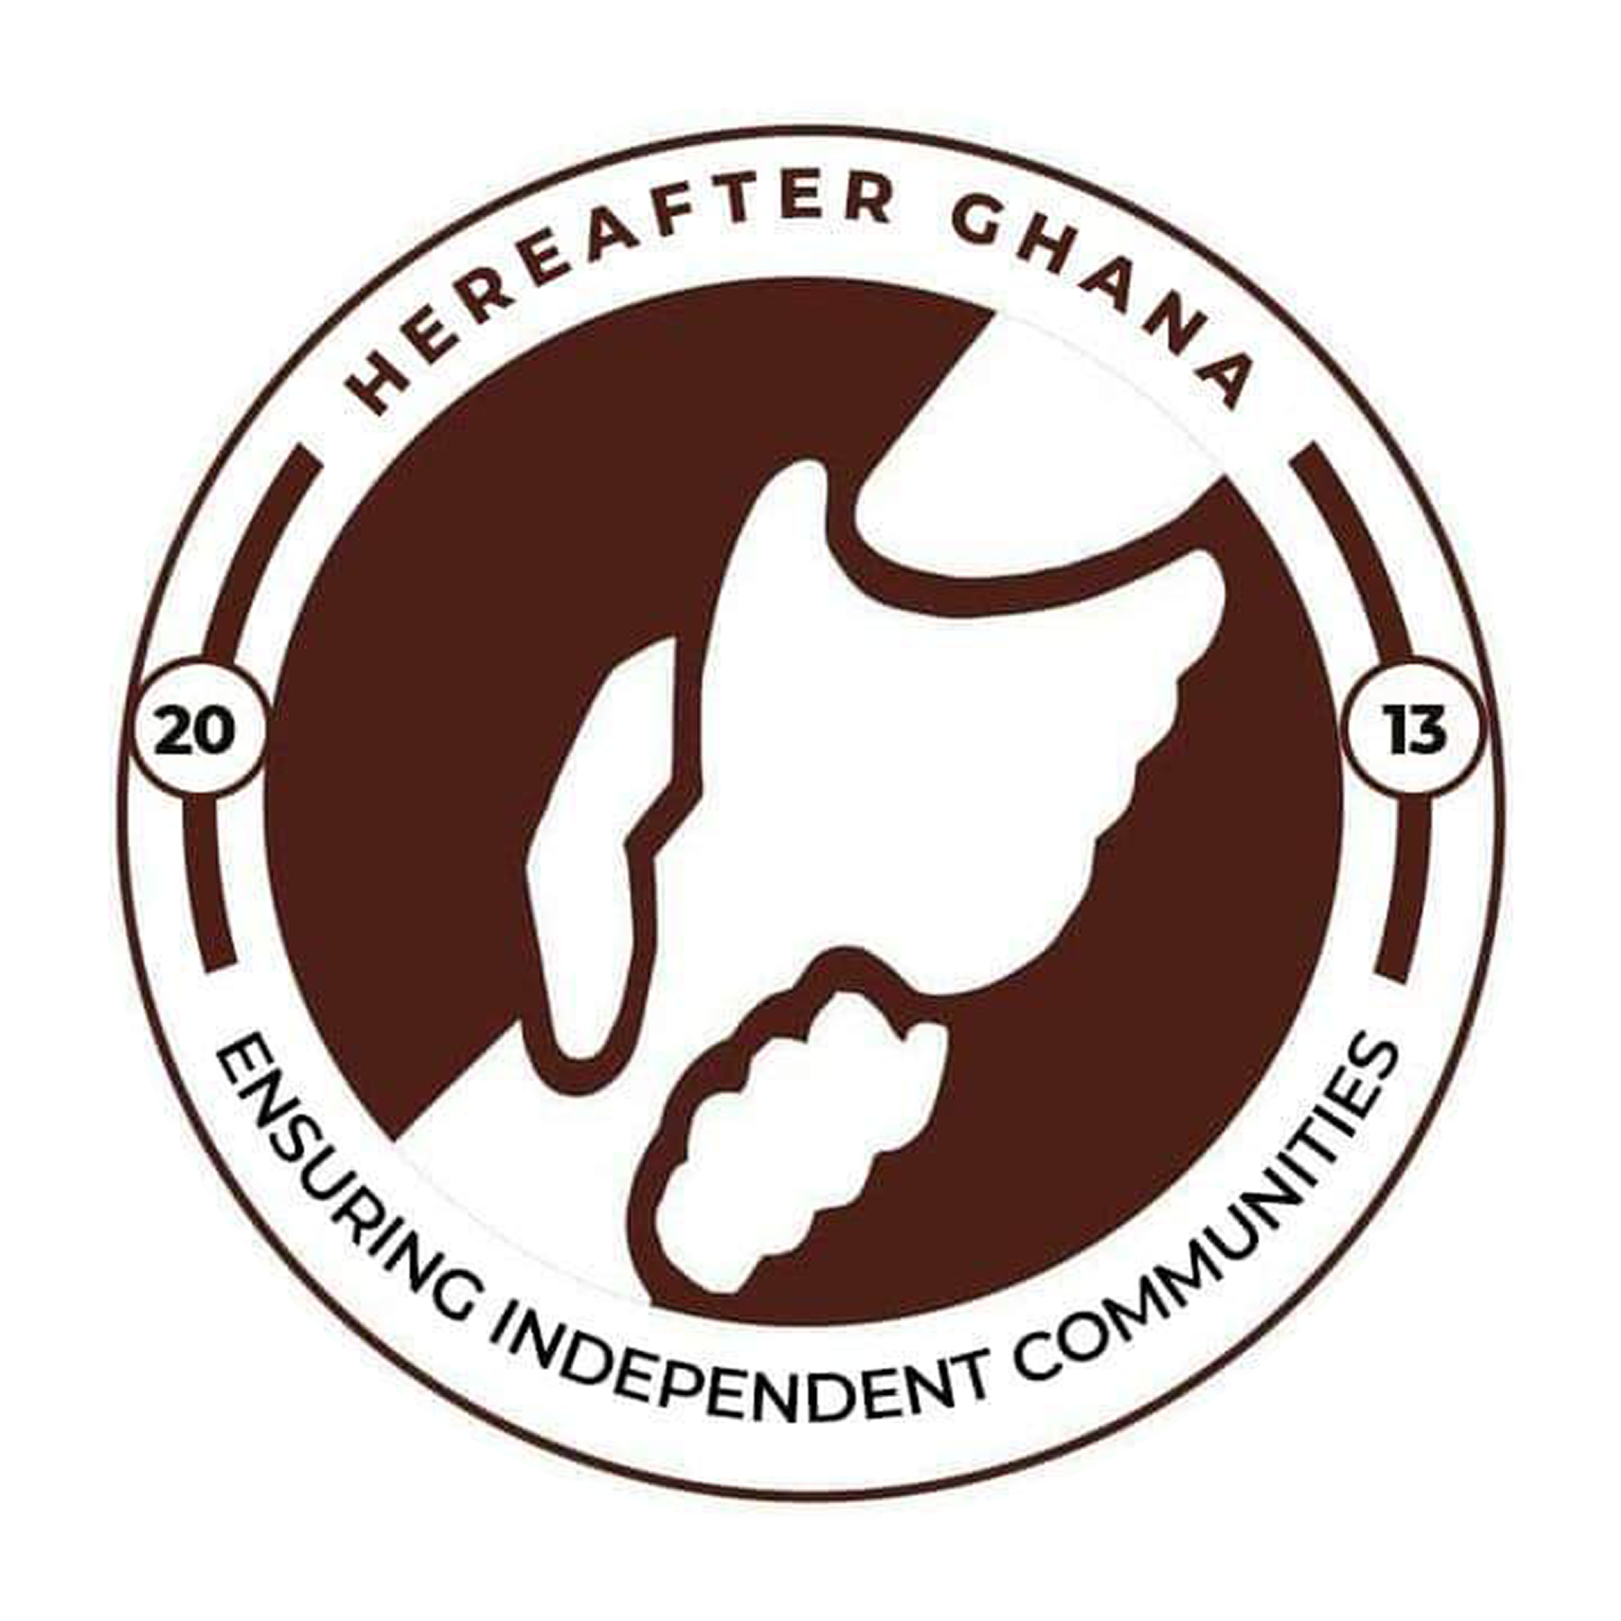

INTRODUCTION
As part of its ongoing commitment to advancing health awareness and improving access to essential healthcare services, Hereafter Ghana implements impactful outreach programs within local communities. These initiatives are strategically designed to deliver critical health education and services, address prevalent health challenges, and promote overall well-being. By emphasizing the dissemination of accurate health information and encouraging preventive care practices, the outreach program aims to equip individuals and communities with the knowledge needed to make informed health decisions and lead healthier lives.
During this quarter, Hereafter Ghana placed a strong focus on health screening on Typhoid and malaria, particularly targeting underserved communities. This effort is driven by a shared commitment to support underserved communities and improve their well-being by providing essential knowledge about health and its long-term implications.
TYPHIOD AND MALARIA SCREENING
In line with its commitment to reducing prevalent health risks and promoting early detection of diseases, Hereafter Ghana conducted a community health screening exercise in Jengung, located in the Nanton District.
The team, including medical officers, visited the community to facilitate the screening process. In addition to conducting diagnostic tests, the medical team provided health education sessions, focusing on the causes, symptoms, and preventive measures of the identified ailments.
Furthermore, volunteers were present to support community members by capturing the details of individuals requiring membership renewal, thereby enhancing their access to healthcare services.
KEY ACTIVITIES
1. Screening
Community members were screened for malaria and typhoid to enable early detection of potential cases. Rapid diagnostic tests were administered to identify infections and support timely intervention.
2. Consultation
Medical officers provided on-site consultations for individuals based on their screening results and presenting symptoms. Appropriate medical advice was given, and suspected or confirmed cases were referred for further treatment where necessary.
3. NHIS Data Registration
Representatives from the National Health Insurance Scheme (NHIS) registered and updated the details of community members, particularly those requiring renewal of their membership. This facilitated continued access to affordable healthcare services.
4. Health Education
Health education sessions were conducted to raise awareness on malaria and typhoid, focusing on causes, symptoms, modes of transmission, and preventive measures. Community members were encouraged to adopt healthier practices and seek early medical care when symptoms arise.
CONCLUSION
The community health outreach conducted in Jengung within the Nanton District was successfully implemented, achieving the objective of improving access to basic healthcare services and promoting early detection of malaria and typhoid. A total of 175 community members were screened during the exercise, reflecting strong community participation and engagement.
The integration of screening, medical consultation, NHIS registration support, and health education ensured a comprehensive approach to addressing the health needs of the community. Beneficiaries not only received immediate medical attention and guidance but were also equipped with essential knowledge to adopt preventive health practices.
Overall, the outreach contributed to enhancing health awareness, strengthening access to healthcare services, and reinforcing Hereafter Ghana’s commitment to improving the well-being of underserved communities.
Gallery
