STREET CHILD UNITED REPORT
Introduction:
Street Child United is a global organization that empowers street children to advocate for the protection and opportunities they deserve. They recently hosted the second Street Child United Cricket event in Chennai, India in September 2023, bringing together 19 teams from 13 countries. This event used cricket as a platform for social change and championed the rights of street-connected children. In addition to the cricket tournament, the program included advocacy sessions, art workshops, and a cultural night show.
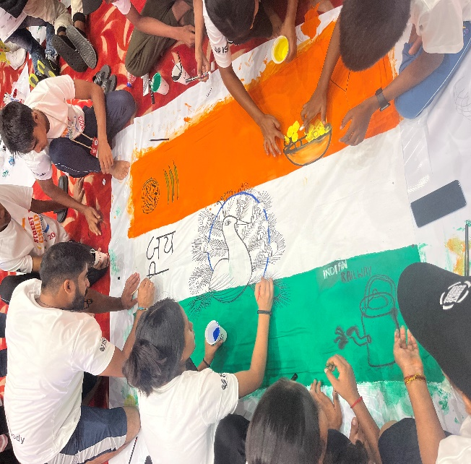

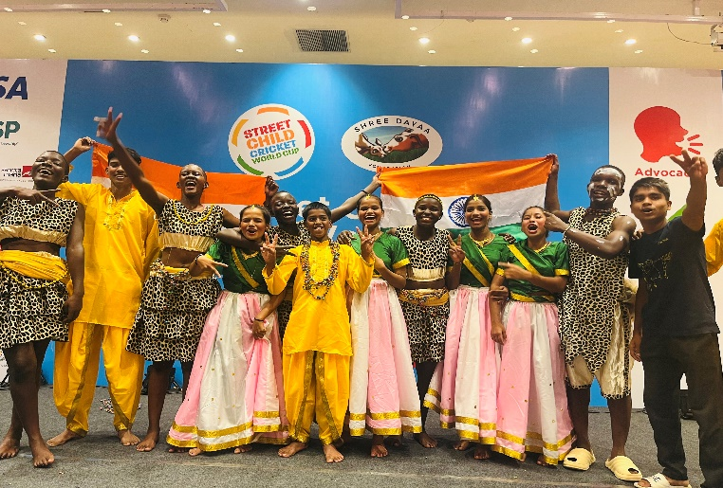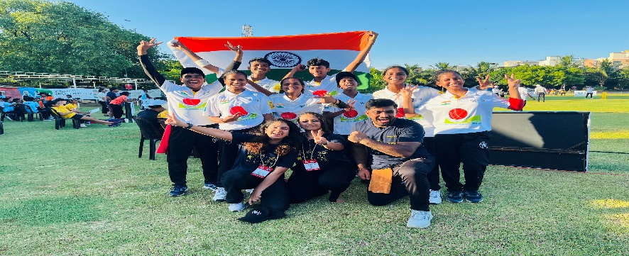
The Journey:

The Salaam Baalak Trust Team, consisting of 3 leaders and 8 children (4 girls and 4 boys), embarked on their journey from Delhi to Bombay on September 19th, 2023, thanks to the generous support of Vistara Airlines. This was the first flight experience for the children, and Vistara ensured a smooth and memorable journey by providing constant support and making a special announcement during the flight about their participation in Street Child United Cricket. The pilots even took the time to meet the kids before the flight, adding a special touch to the experience. In Bombay, they met with the SCU team and other Indian teams, and on September 20th, they continued their journey by train to Chennai, joined by 7 teams from Mauritius and India, creating a fun and unforgettable experience.

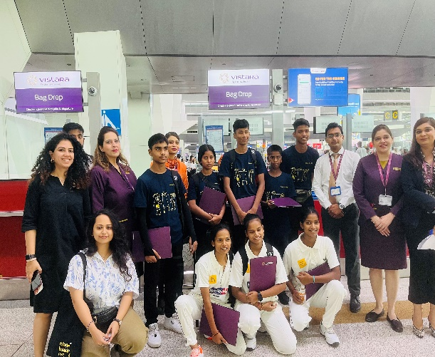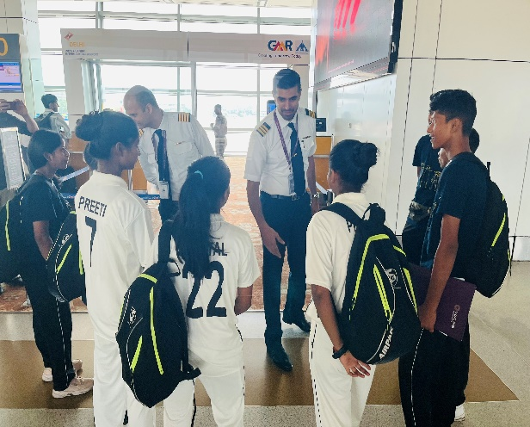
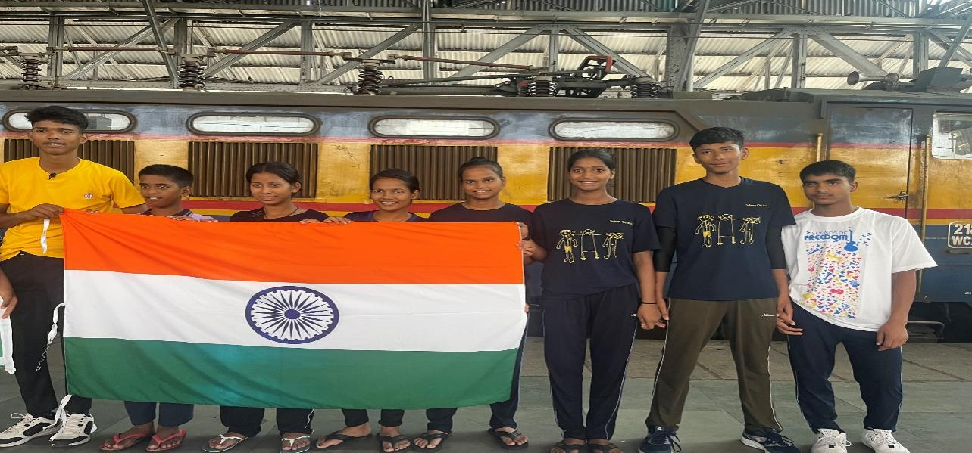

Impact:
During our 10-day stay in Chennai, we engaged in various enriching activities. Team leaders and children from different countries participated in group workshops, fostering cultural exchange, friendships, and bonds. Congress sessions focused on community children's issues, empowering us to advocate for child rights and promoting kindness and solution-oriented thinking.
Unfortunately, our team could not win however they played a fair game and learnt the sportsman spirit and the overall experience was much enriching.
Art and body movement workshops allowed the children to explore each other's creativity and physical expression. We were exposed to various news and media outlets, including BBC Sports, Hindu, and NDTV.

One remarkable moment was when Kasim, a young leader from Team LION, SBT, who couldn't participate in the cricket tournament due to dengue, had the honor of presenting the final trophy to Team Uganda, the winners of Street Child United 2023.
In summary, this platform provided our children with a holistic development experience encompassing education, advocacy, and sports.

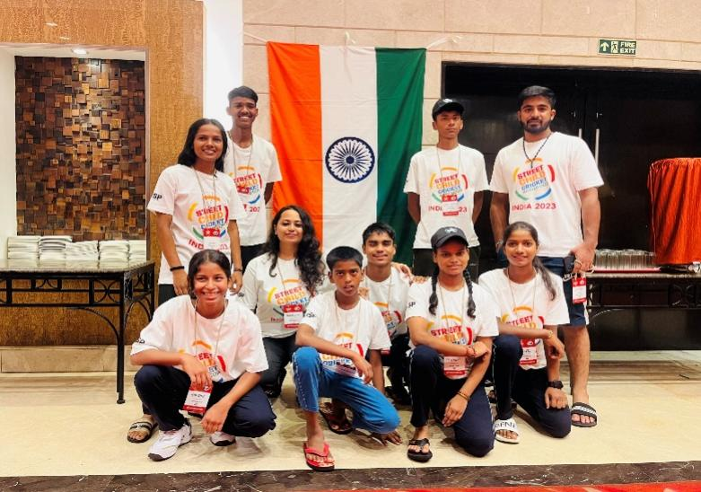
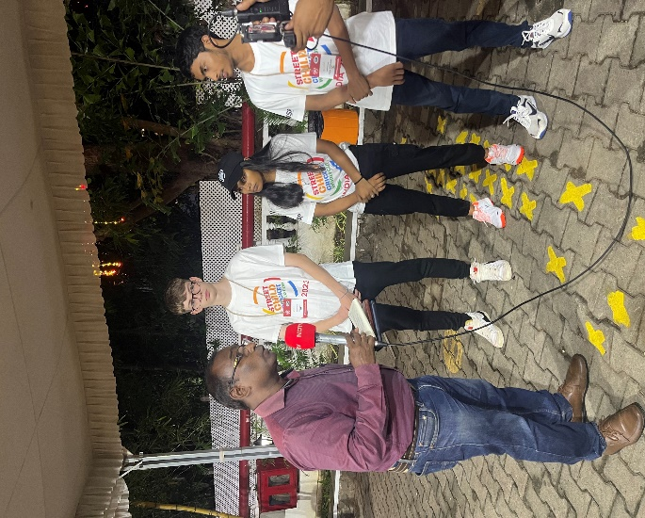

KASIM presenting the Final Trophy to winning Team of Uganda!!

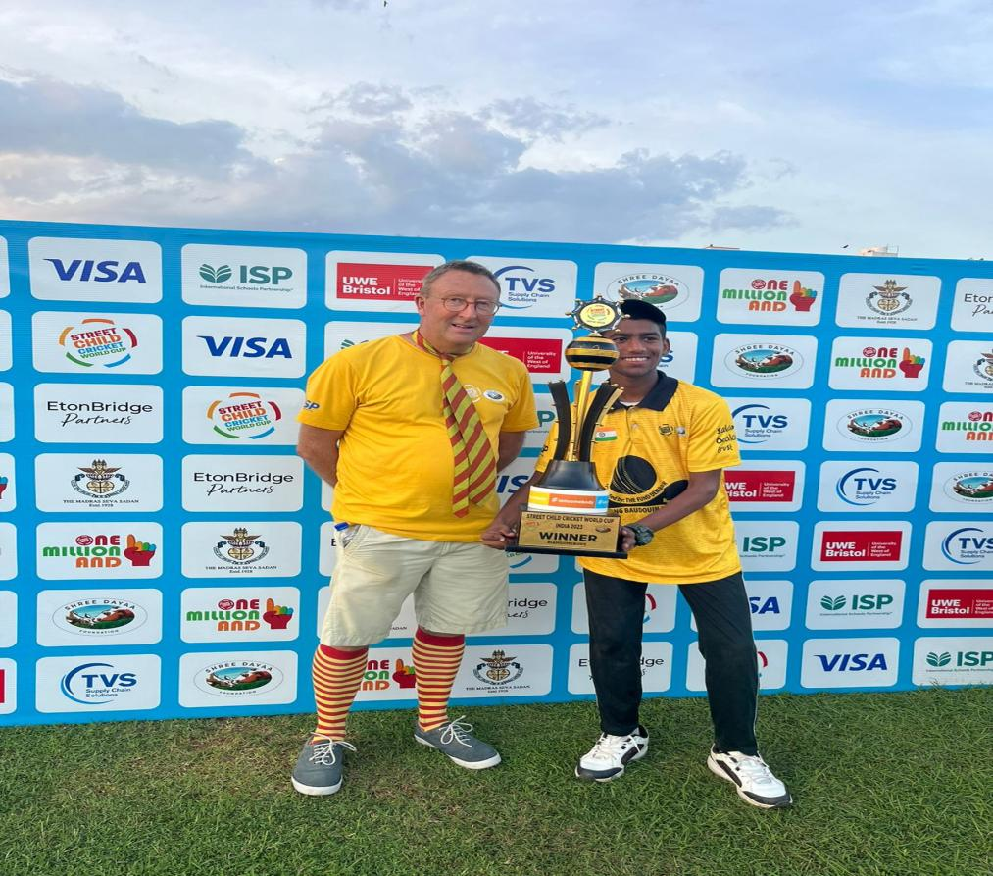

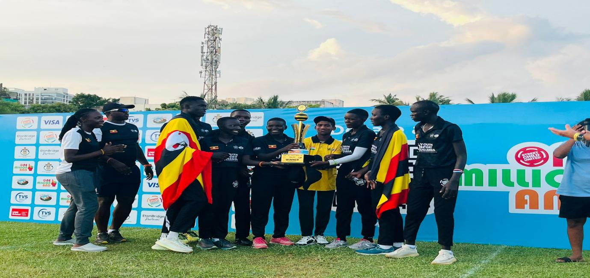

TEAM LION DELHI

