Our children develop and thrive

**By Johannes Shikuloh Project leader**

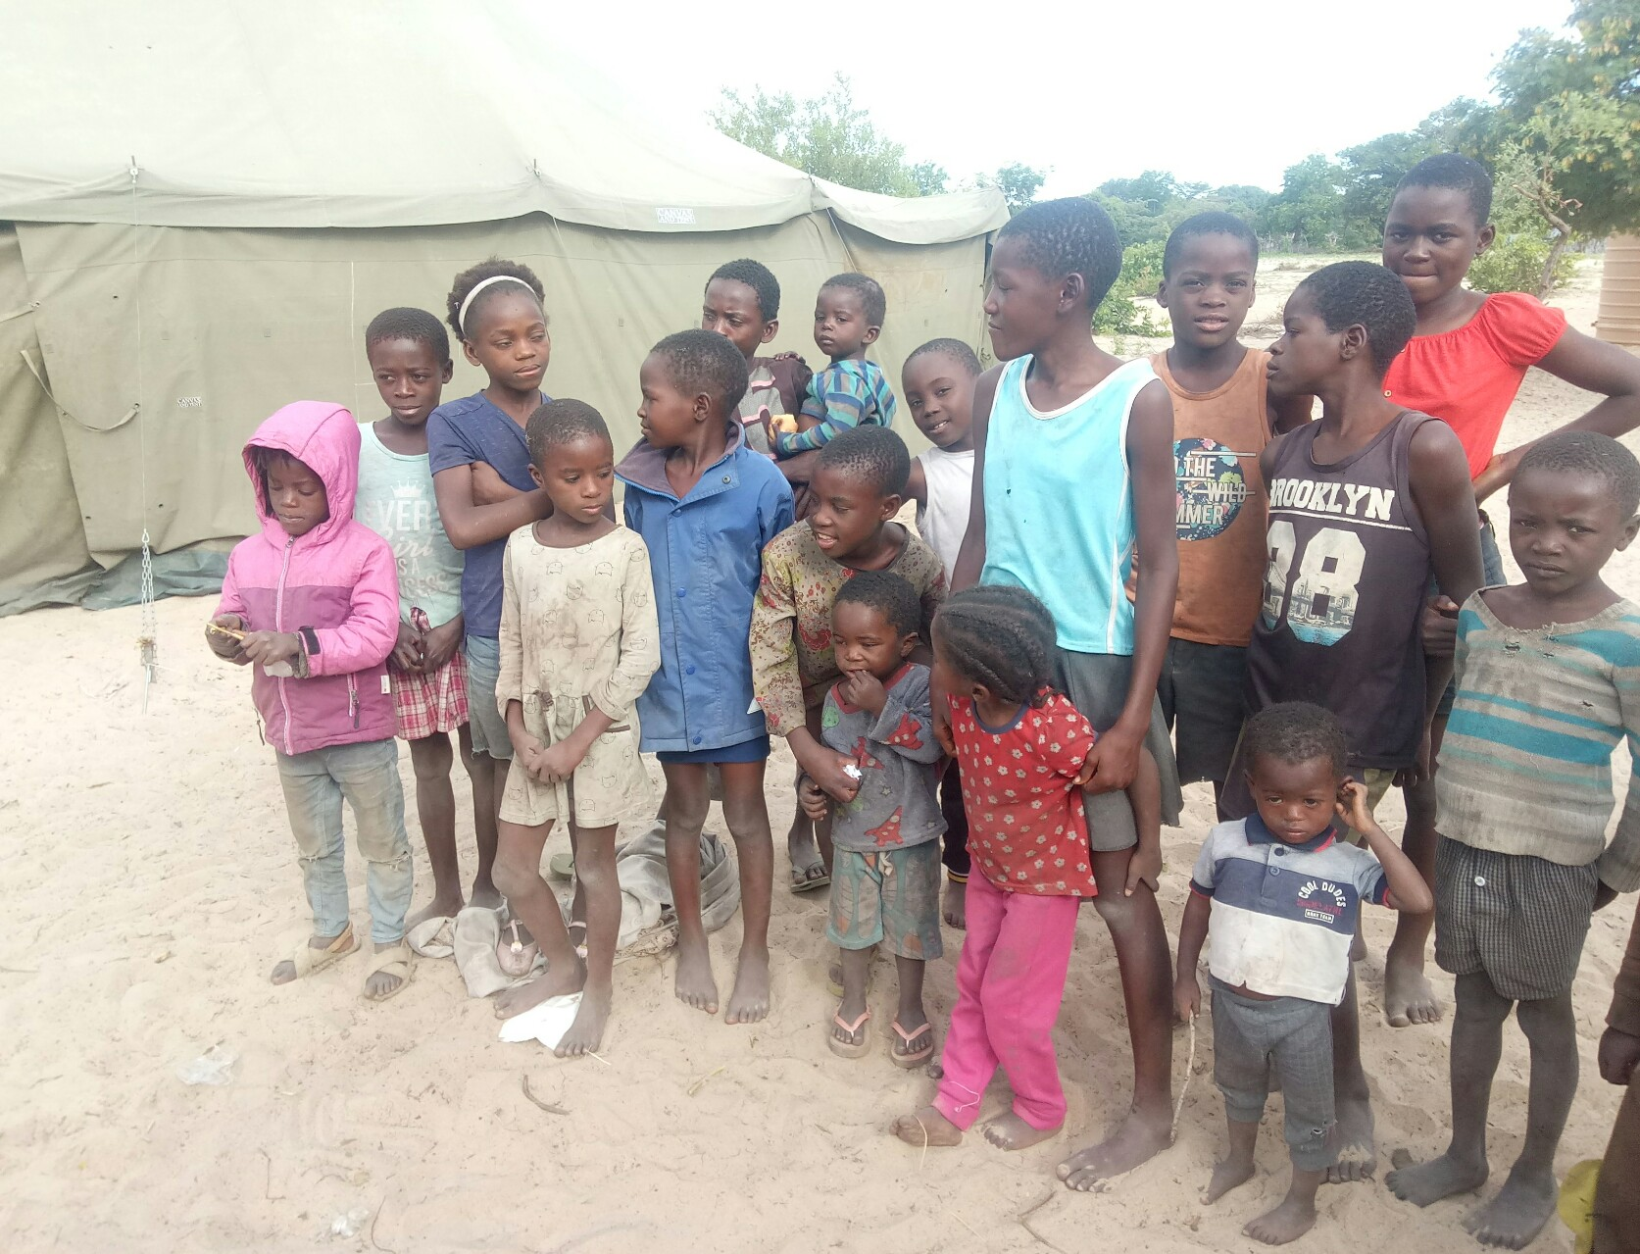

Dear Supporters and Friends

The organization provides, through formal and non-formal education, an environment conducive to learning for 300 children at risk of education disruption, children will also have provided with nutrition supply, shelter, WASH and child- friendly space and protection who were relocated in the flood relocation camps. Donation is still needed during the upcoming floods in the coming months in order to meet needs of vulnerable children and younger women and fulfill their rights to health, survival and development.

The successful provision of formal and non-formal education, an environment conducive to learning for 300 children at risk of education disruption, children have been provided with nutrition supply, shelter, WASH and child- friendly space and protection. Donation is still needed in order to meet needs of vulnerable children and younger women and fulfill their rights to health, survival and development.

Successful provision of these services has been due to the active involvement of parents and their communities working with relocation camps staff and our implementation partners. Next step has now started and we expect the co-operation and lessons learned will only get better. As we reporting now, 300 vulnerable children, young mothers, teachers our volunteers and our implementing partners have benefited from this involvement. In addition, 25 children with disability learners received specialist and help to cope with their requirements. The WASH component benefitted over 500 children from 60 villages.

Parent involvement has been essential for the success of the project phase and the knowledge learned will ensure the project reaches a successful conclusion. The key objectives learned from the first phase are:

• Connect girls with their parents to help manage the menstruation period during the stay in the relocation camps, WASH practices and other hygiene issues helping to spread knowledge to the wider family and community.

• Engage parents in girl’s hygiene and WASH activities.

• Involve parents in the maintenance and support of sanitary pits, WASH basins and the water supply.

• Engage parents in decision making including the design and management of relocation camps.

The following testimonial identifies the help and support the project has given to a neglected girl and a learners supported by the organization. (name have been changed).

**How the neglected girl became a role model for affected flooding children?**

My name is Ellen I am come from Ohangwena region, Namibia and I am in grade 8. I found myself self in care of ASPOVC organization at just 5 five years old. Apparently I was in their care at just ten months old after I was neglected by my thirteen years old mother, who was just my age today but with the help of supporters, able were able to find a protection and loving home for me to thrive. I enjoyed the engagement with my fellow children of whom from the same background as me, during the flood relocation camps I have been able to share my difficulties and experience through to today. I was given an opportunity for motivating other girls to be themselves and become a new encouragement for the next generation.

At the end, I am very much grateful to ASPOVC, Ohangwena Region, for supporting me and my education as well as they are on my side always. I am sure there are other children out there who might need support, love and belonging like me and I am praying for ASPOVC to be there always for every child in need.

The above story is one small example of how this project is helping girls and boys to lead an active life in modern times and understand the importance of working together and to also understand how and why children have to help one another for good.

Thank you for your help and support. I hope you can continue to support us and please ask your friends to contribute. We have to continue our works and prepared before the flood begins coming November and December.

Many thanks and our best wishes.

Johannes

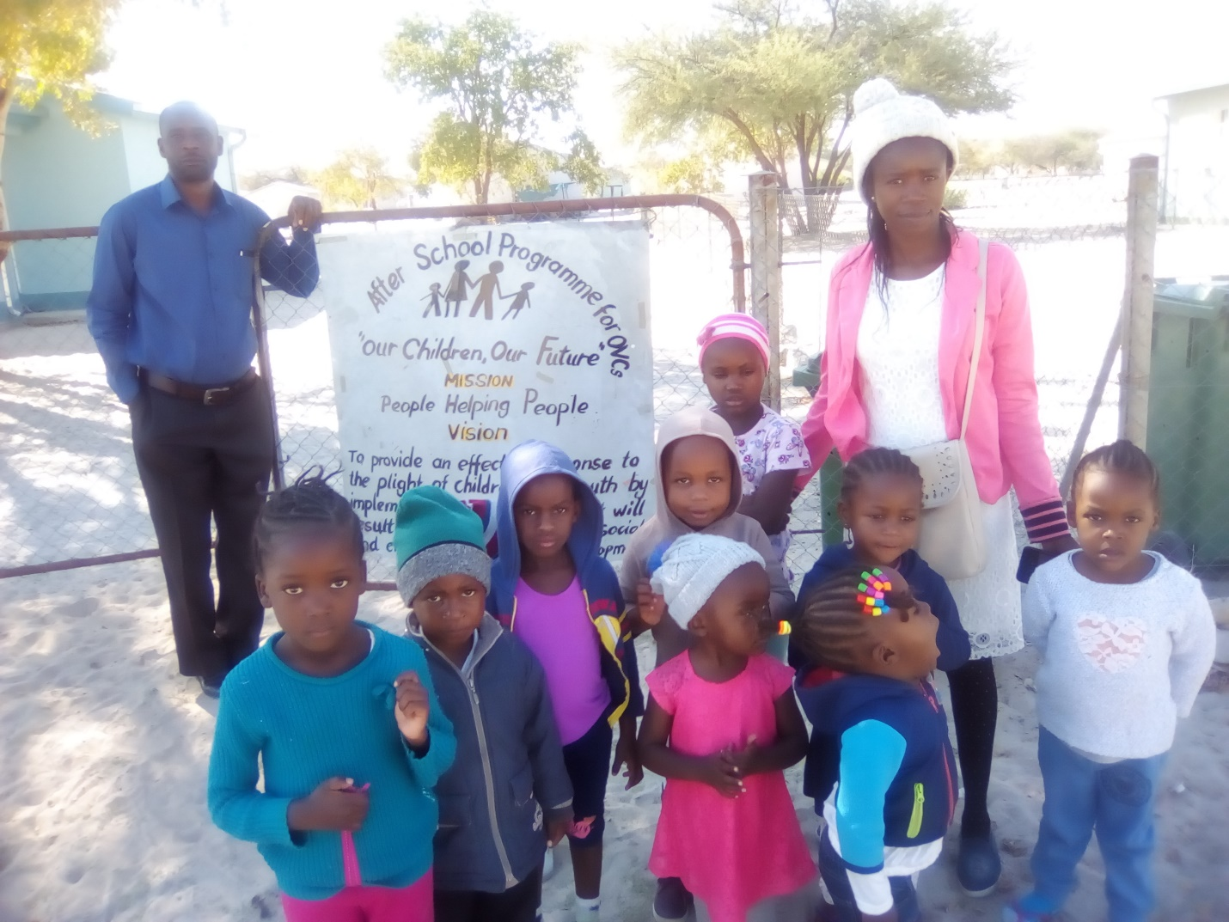

Ellen and her colleagues at ASPOVC day care!

|  |  |  |  |  |  |  |  |  |  |  |  |  |  |
| --- | --- | --- | --- | --- | --- | --- | --- | --- | --- | --- | --- | --- | --- |
| C:\Users\SHIKULO\Pictures\FEEDING PHOTOS\IMG-20210426-WA0005.jpg  ***Supporting vulnerable children creates more adaptive, productive, and healthy adults. These adults have healthier cognitive and character traits later on. Children with proper support also translates into a future society with reduced crime, increased workforce productivity, lower teenage pregnancy, and the development of other positive character traits. Most importantly, it creates stronger future families.*** | |  | | --- | | **Who We Are**  **After School Programme for Orphans and Vulnerable Children (ASPOVC) is a welfare charitable non-profit organization run exclusively by volunteers. We work together with international and local partners on collaborative children development projects.**  **About Us**  ***EQUITY, INTEGRITY, ADAPTABILITY, INCLUSIVITY, Empathy***  **Contact Us**  Phone: +26481 378 8083 Email: ovceenhana@gmail.com Web: Web address | | |  |  | | --- | --- | | C:\Users\SHIKULO\Pictures\ASPOVC LOG.png | Company Name  ASPOVC  Private Bag 88004, Eenhana, Namibia | |  |  | |  |  | | | |  | | --- | | C:\Users\SHIKULO\Pictures\FEEDING PHOTOS\2345.jpg | | Company Name | | *After School Programme for Orphans and vulnerable Children-ASPOVC* | |
| *Many adults with character flaws and chronic health and emotional struggles were once healthy children. Studies show early intervention in the lives of disadvantaged children is far more effective than rehabilitating them.*  What we do  *We seek to respond effectively to the plight of children, providing interventions that will result in their Physical, Psychological, Social and Emotional wellbeing and development.* | *‘’We learned that orphans are easier to ignore before you know their names. They are easier to ignore before you see their faces. It is easier to pretend they’re not real before you hold them in your arms. But once you do, everything changes’’. –David Platt*  ***Every child needs food, clothing, and shelter to survive. They need much more than that to thrive. Help children receive the resources they need to grow into capable adults that can create strong homes in the future.* *There is also nothing quite like seeing a child smile who hasn’t for some time*.**  **How can we do it**  *We team up with individuals,* [*organizations, foundations, and companies*](https://www.orphanagesupport.org/osso-supporters) *to empower local children’s organizations with resources so they can better support the children in their care.* | C:\Users\SHIKULO\Pictures\FEEDING PHOTOS\DSC_0064.JPG  *Cultural awareness helps children break down cultural barriers, build cultural bridges, and learn how to love, and appreciate those different from them. They can relate better to people with cultural differences as they begin to understand themselves better. This results in more cultural connection and less cultural conflict.*  **Our Products and Services**   * *On -site (school/family) counseling and psychosocial support* * *Family/group based support in and with academic homework* * *Child support services for legal documentation* * *Referrals programs* * *Feeding scheme* * *Extra -curricular activities (Sport, Art, Music, Dance, Poetry and Drama)* |