The Action that made hopeless community to thrive-A three months report by After school programme for orphans and vulnerable children for project ID #59138

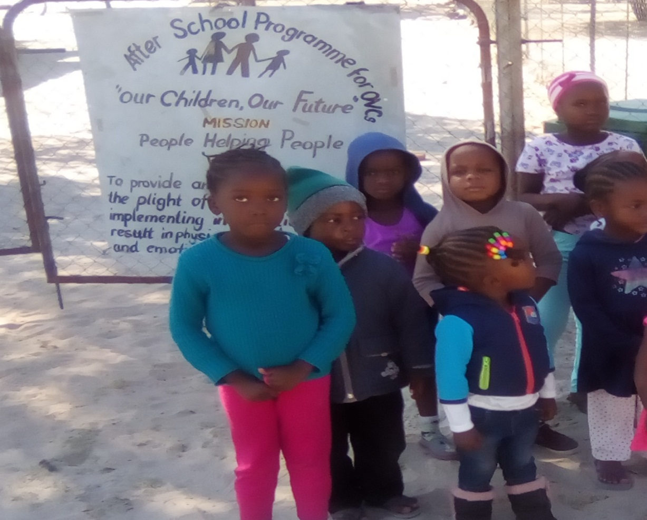

AS children and community continues to cope with the negative societal effects brought on by floods, ASPOVC has been so far assisting affected parties to deal with extensive economic losses, consequently affecting their livelihoods, businesses and daily basic services.

Since affected parties depends on subsistence farming as their source of income and only survival, it’s a major part of the survival has been destroyed by the effect of floods.

It’s then the major and incredible work of our organization ASPOVC to offer psychosocial support to affected community, continue providing afternoon classes to school going children, contact effective referrals for total healing and help sustain for the children safe space.

During the period under review, we helped children to attend school regularly, provide them food, additional classes and engaged them in arts, sport and Christianity activities.

We are pleased to report that since December 2023, we had started with formal awareness of floods preparedness among the affected community due to fact that the critical flooding period is expected during the month of March 2024.

Currently the project is busy with program for engaging government ministries to lobby and pull them in so that the protection for affected community would be maximized this year.

It is therefore needs to raise more funds to enable this project to realise its objectives and continue.

Compiled by: Johannes Shikuloh

Organization leader.