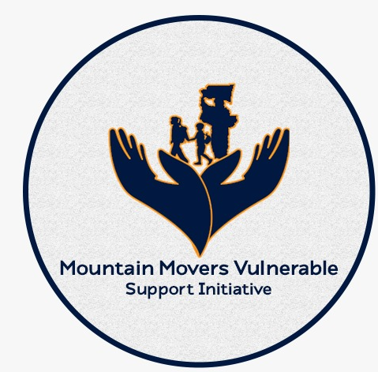

Report
Project name | SCHOOL OUTREACH PROGRAM
Location | EBONYI STATE
Grant No. | INDIVIDUAL CONTRIBUTIONS
Reporting period | APRIL – JULY 2022
Report compiled by | CHINYERE NZEH
Date submitted | 20th JULY, 2022

BACKGROUND OF THE INITIATIVE
The MMoVuSI is a Non-Governmental Organisation in Ebonyi state, duly registered with the Corporate Affairs Commission (CAC) of Nigeria, members are individuals who work towards bridging the gap for the vulnerable and the averaged.

THEMATIC AREAS
We operate in 3 thematic areas
- School Outreach Program – providing necessary learning materials and school wears for primary school pupils in the public schools who do not have the school essentials. Responding to their needs could aid their learning abilities for a sustainable future.
- Old People’s Hope Program– where the old men/women are identified and taken care of by providing their daily needs and personal care ensuring they are comfortable.
- Women Alive Program – Supporting vulnerable women who suffer alone in their struggle by listening to their challenges, helping them learn new skills, set up small scale business that helps in improving their wellbeing.

SCHOOL OUTREACH PROGRAM
According to the Sustainable Development Goals(SDG) – Goal 4 – Quality Education, that education liberates the intellects and opens a world of opportunities to generations yet to come, knowing the fact that there are pupils in the schools who have the desire to learn but lack the learning resources and uniforms for achieving their goals, looking very unkept in schools and non concentrating just because they do not have access to essential learning aids. Following our visit in some public schools in Abakaliki at Agbaja Unuhu Community Primary School and Community Primary School Ogbaga, Echi-aba Development Centre, Ozibo Local Government in Ebonyi State, we discovered some pupils in this condition and carried out an intervention where 100 pupils were provided with new school supplies(school uniforms, sandals, customized school bags, pencils, rulers, erasers, sharpeners and customized exercise books) Some pictures of how we met them and what they turned out to be are attached below.

Activities & Outputs

SCHOOL OUTREACH PROGRAM
Status | Concluded for the last quarter
Objective | Ensure all children in the communities gain access to quality early childhood development, education by providing the necessary learning resources and an enabling environment for learning.
Activity dates | 24th June, 2022
Progress | This activity had in the budget to carter for children who attend school without the necessary learning aids and materials and to serve as motivation to many pupils who do  How we met the pupils in their school at Community Primary School Ogbaga Nakaliki Community Primary School, Echi-aba Development Centre, Ebonyi Local Government Ebonyi State. They are very uptimistic to learn despite not having the necessary requirements that could aid their learning but they still showed up in school and learn with those that had uniforms and books.
  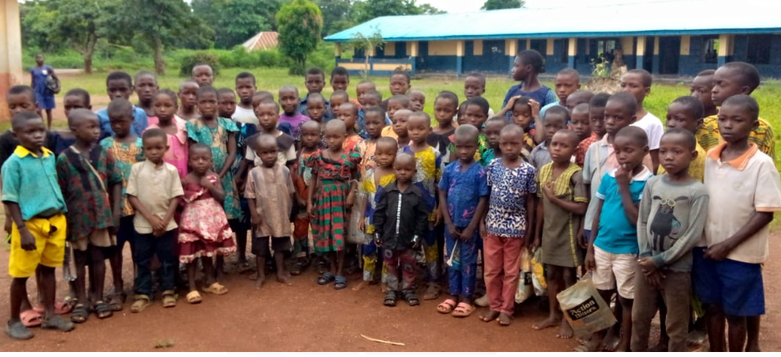 | 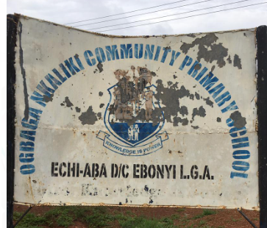
  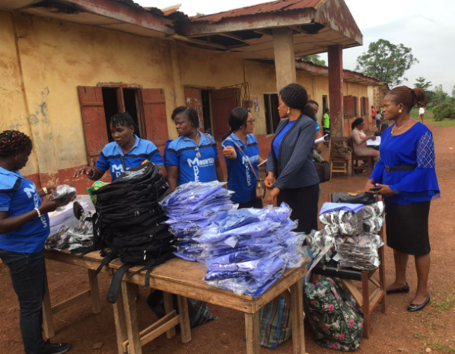  MMoVuSI team arrives the school and arranges items for distribution | 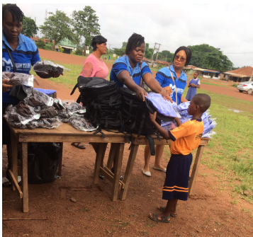  Distribution of items to the pupils | 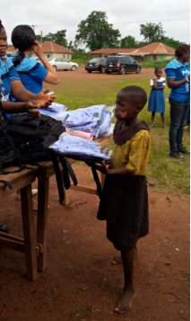  Pupil colleting her items
  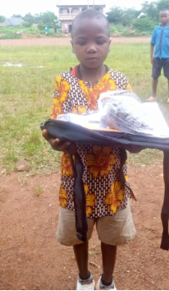 | 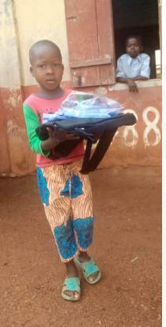 | 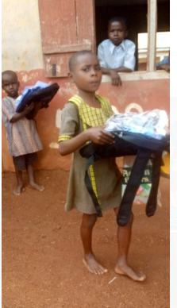 | 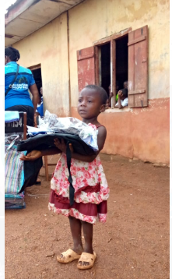 | 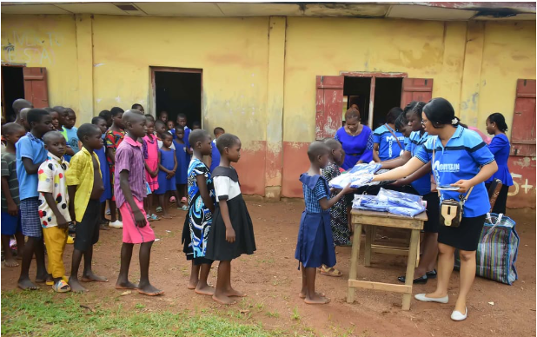
  50 pupils joyfully receives school uniforms, school bags, sandals, customised exercise
  books and writing materials(Pen, ruler, sharpner and eraser)
  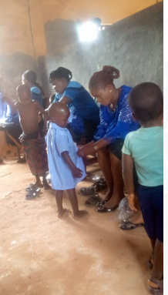  MMoVuSI team dresses the pupils with new atire | 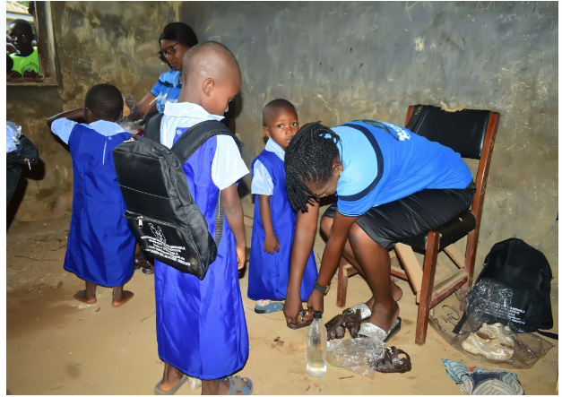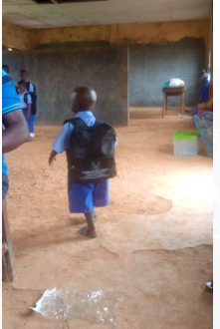 READY TO LEARN
   |  | Life can be frustrating and discouraging to children when they do not have equal access with others in same school same class, this has made many to be discouraged attending school.
  HOW WE MET THEM
  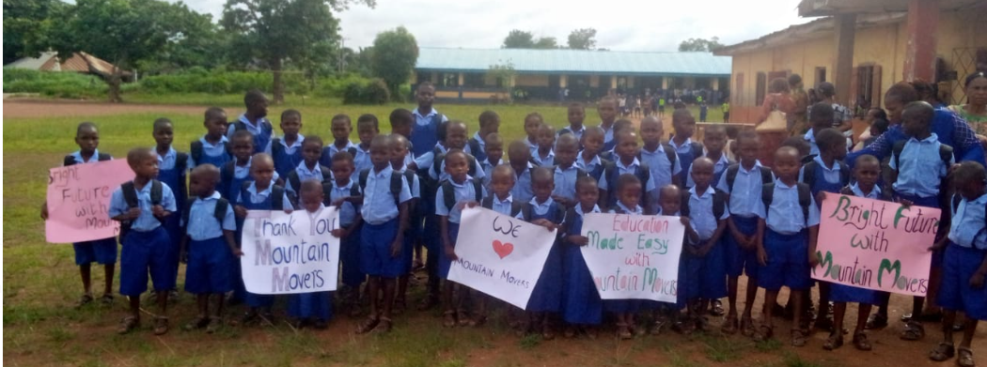  HOW THEY APPEAR NOW – READY TO LEARN | In life, when one is given tools to work then a very good outcome would be expected, for this children their future is bright because they have got the basic educational tools needed to learn.
    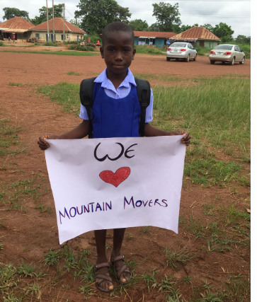 |  | 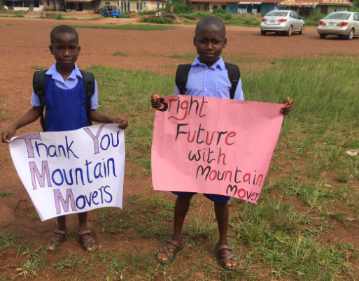
  PUPILS APPRECIATING ALL THE SUPPORTERS OF MMoVuSI
AFTER
AFTER

BEFORE

SCHOOL OUTREACH AT AGBAJA UNUJU COMMUNITY PRIMARY SCHOOL – 1st JULY 2022
On this day the MMoVuSI team arrived Agbaja Unuhu Community Primary School at Abakaliki School to visit the under priviledged children who do not have access to learning materials which has impeded the progress of their studies.
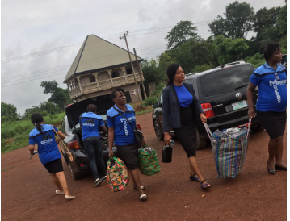
MMoVuSi team storms Agbaja Unuhu Community Primary School

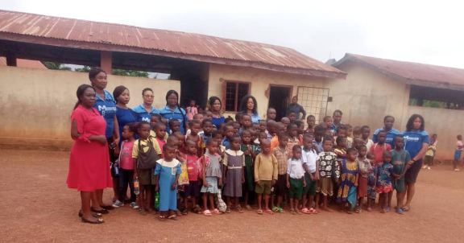  BEFORE | This was how we met them in their different classes. These children deserves the best hence we believe that they are the future of tomorrow. In this community so many children have been discouraged and led them staying home without being in school

The pupils cue up to receive their learning materials which motivates them to learn more. Motivate a child today and secure the future. | 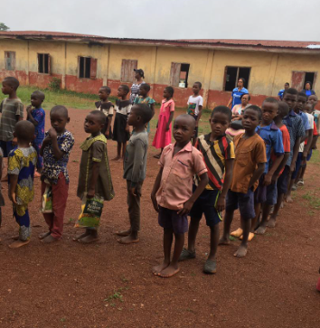
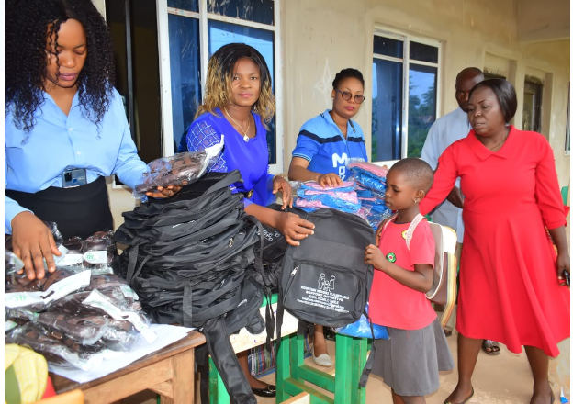 |  | 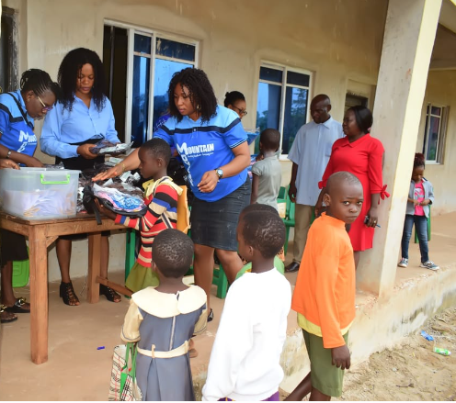
MMoVuSI teams begins distribution of items to the pupils

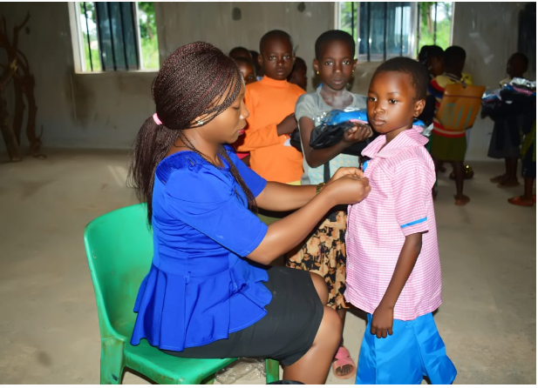 | 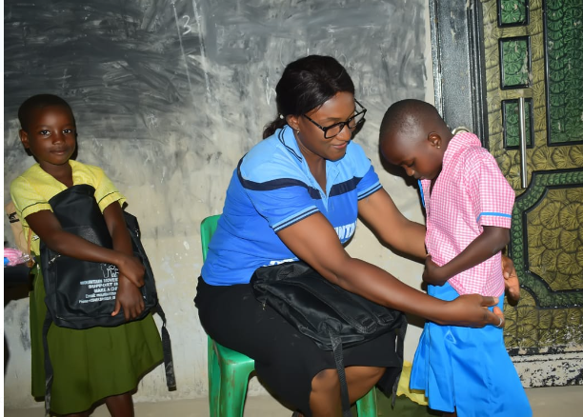
Kitting up the children the way they should appear in school, we could dictate the smiles on their faces and indeed this paves way to brighter future.

THE AFTER
AFTER

This is how they have become and ready to learn, highly motivated
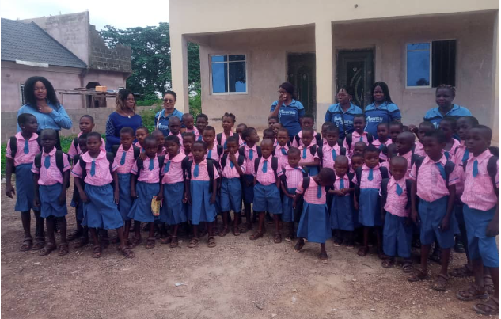
MMoVuSI and the children
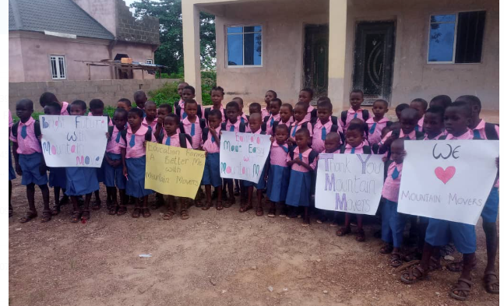
The pupils celebrates the Mountain Movers

Outputs created | In July 2021, 40% of the pupils in the schools were looking very unkept and non concentrating because of lack of learning and then in 2021 September 14th MMoVuSI provided 100 pupils with basic learning materials. 6 months later not only did the pupils develop in their learning habits but more than 30% additional students from Agbaja Unuhu and Ogbaga Community enrolled in the school with the hope of receiving materials soon. When we enquired what motivated their performance for those that received items they confessed that it was the outcome of our intervention that gave them much hope and motivation to be more committed and punctual.  In this quarter (April – June 2022) One hundred and one (101) pupils benefited from the team, as they were given adequate learning materials that would aid their learning abilities and attract focus and concentration in school.  Subsequent visits to the schools to monitor the progress of the children who benefitted from the intervention showed that they were improving in their studies and still had their school supplies in good condition. In addition to this, more children who required similar invention had enrolled into the school with the hope that sooner than later, they will be beneficiaries.

NEXT POINT OF ACTION
The children were good and ready to learn but we observed that when most of them go back to their classes after being kitted, they would sit on the floor (uncemented floor) because some of the classes had no chairs and table where the pupils could sit and write on comfortably, they sit on an uncemented floor to learn. This has become a concern for us in MMoVuSI and we have included it in our budget for next quarter.
MMoVuSI plans to executes its intervention to more Local Government and communities across Nigeria.

FUNDING
Sources of funding are from the members and private individual donors with philanthropic minds who chose to serve humanity in this aspect and through MMoVuSI, At the course of this project in June and July 2022, the following donated to the group:

Challenges & Lessons Learnt
The following table summarises the challenges we have faced during the reporting period and the lessons learned / solutions for each challenge.
Challenge | Lessons learned / solutions
Due to the low spirit in their learning habits, so many previously identified students that were supposed to be beneficiaries on the day of event did not turn up, as poor attendance has been part of the school and then the students present were benefited as they replaced the absentees. | We have learnt to identify with the parents of the said children and communicate effectively for adequate participation. Community awareness creation would also be in place before any of our activities for community participation and ownership.
The students that were not with learning materials in this school forms a larger percentage (70%) and as such only 10% of the children benefited and this is because we have limited funds. | To solicit for funding from goodwill individuals, organisations both local and internationally.
Some of this schools also do not have chairs and tables for the children to sit and write comfortably, this is a big challenge as we kit up this kids and they go back sitting down on the floor is a great issue to us | To make plans on how to fund this.

NEXT ACTIVITY DATES– 23rd and 30th of September 2022
We have carried out the Need Assessment to another 2 Local Government in Ebonyi i.e Izzi LGA and Ezza North LGA where we identified 2 public schools where so many children have been discouraged from attending school because of lack of motivation and no learning aids. The schools are Edukwu Ogbodo Community Primary School in Izzi LGA and Uwaoma Primary School Okposhi Umuoghara, 155 pupils have been identified in these LGAs to be helped but in our capacity we would only undertake intervention for 100 students while being hopeful that in the future there would be more.

In summary, it has been an awesome experience touching the lives of our children in the communities, and our vision is establish our foot print across Nigeria, as we believe no stone should be left unturned. The future of this Nation lies on the good foundation we give the pupils today.
We recognise all your efforts, both financially, morally, prayers and advice in terms of donation of equipment in our new office. God bless you all.

Sincerely

Chinyere Nzeh
E.D MMoVuSI

