Proeducacion IAP is a private non-governmental organization, with no political or religious attatchments. Founded in 1997, our mission is to contribute and improve the quality of education received by girls and boys from public elementary schools in Mexico. In Proeducacion we believe in the integral strengthening of the public, elementary schools through our own School Strengthening Model: “Integral School”, which accompanies the whole school community, improving the quality of education that children receive in Public Elementary Schools in Mexico.

Proeducación actually benefits 92 public schools in 9 States of the Mexican Republic, benefiting more than 29,068 individuals (22,940 children, 1,256 teachers, and 4, 872 parents).
Our Goal is to:
- Help Public Elementary Schools become solid educational, integrated communities, centered in learning with their own management capacities.
- Students will achieve the expected levels of learning and will develop the necessary competences to lead a responsible, active and dignified life in society.
- Teachers, parents and students will work together to achieve a better education.
Our Mission: is to contribute to improve the quality of education received by children in public elementary schools through the comprehensive development of the educational community.
Our Vision: We endeavor to be a reference for school strengthening at a national level, through a model that accompanies the school community and links society with the public school.
Our Theory of Change:
As we strengthen, elementary public schools, through a model of accompaniment for the school community as a whole ------------------------------ The quality of public education in Mexico, can be improved.

Integral School Model (MEI):
The Comprehensive School Model (CSM) contributes to providing public elementary school students with access to quality education.
With the CSM we hope to achieve changes in school culture: in the participants that make up the school, in their relationships and interaction processes, and in the environments and physical conditions conducive to teaching and learning.
We defined a series of attributes that describe how we would like the different components of the school to look in order to be able to say that quality education has been achieved:

- Students with a taste for and expectations to continue learning, who are able to communicate clearly and fluently, who can take care of themselves and their environment and live together harmoniously.
- Administrative Staff who exercise participatory and pedagogical leadership. They are capable of integrating and adapting the guidelines set by the educational authority to their own program of continuous improvement, supported by the community.
- Teachers with commitment, self-esteem and appreciation for their profession, who participate and associate with the school community, are in continuous training and focus their practice (and continuing education) on the learning of their students.
- Families who get involved and take responsibility for their children's education, see themselves as educators and value and support school training.
- Integrated, learning-focused school communities with autonomous and participatory management capacity.
- School Sites with physical conditions and educational resources that favor learning.

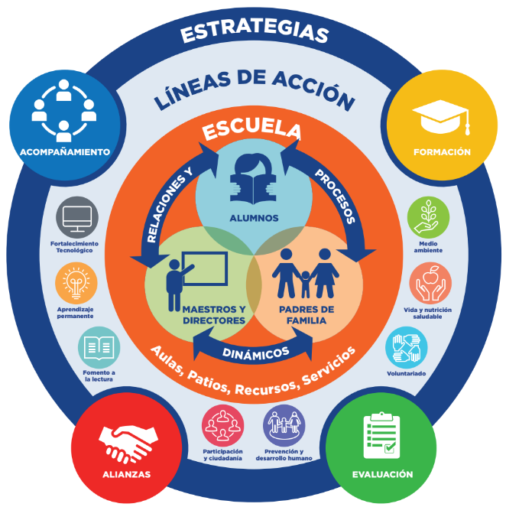

Translation:
Strategies
Course of Action
School
Relationships and→Processes→Dynamics
Students →Parents→Teachers
Formation | Evaluation | Partnerships | Support
Environment | Prevension and Human Development | Promote Reading
Well-being and Nutrition | Participation and Citizenship | Lifelong Learning
Volunteering |  | Strengthening Technologies

MEI Strategies:
Starting from the CSM, we encourage the school to achieve its goals through four key strategies:

1. Continuous Support. We create a bond of collaboration and trust by observing and listening to needs, promoting conversations and participating in school projects. We encourage co-responsible participation between parents and teachers for the benefit of the students.

2. Strategic Partnerships. We manage and coordinate partnerships with specialists in terms of content and methodology; with companies, donors and other philanthropic organizations; and with educational authorities at the local, state and federal levels.

3. Building Skills and Training. We integrate eight courses of action with programs for students, teachers, administrative staff, principals and parents that promote collaboration, teamwork, relationship with the environment and the improvement of school spaces.

4. Evaluation for Improvement. Based on the participatory diagnosis and the evaluation of results that we carry out annually, we identify needs and contribute to effective decision-making for improvements in schools. This strategy is:
- Participative: because the actors participate in evaluating themselves and others. The results are shared with the school, so they can be taken into consideration for future planning.
- Appreciative: This Evaluation aims at recognizing the effort and achievements invested in the process, it also aims at making advances visible to the whole school community. Necessities are identified, because it is important for each school to know their own needs, in order to make important changes for the better.
- Periodic: It is applied at the beginning of each school process, and after that, each year, this allows the school to continually evaluate it´s own advances, this evaluation includes workshops, conferences and seminaries. Through this, the school knows where it has been, and where it is headed.

Lines of Action:
All of our activities are organized in 8 lines of action, these lines of action are offered in accordance with each school´s own needs, through an earlier diagnosis of each school´s needs:

- Permanent Learning: Development of teaching skills, pedagogical leadership and participation of parents, through courses, workshops and talks with an inclusionary approach for the achievement of learning in all children.

- Reading Enhancement: Integration of the school library into the teaching and learning process by installing infrastructure, relevant collections, training and support for the use of the library and to promote reading.

- Technological Strengthening: Integration of technology in the teaching and learning processes by installing infrastructure, connectivity, equipment, software, training and support in the operation of the media room and use of technology.

- Participation and Citizenship: Development of management and leadership skills through training and support for the participation of parents, students and teachers in school improvement and the construction of citizenship.

- Prevention and Human Development: Training and support of the entire school community for emotional strengthening, the promotion of protective school and family environments for the full development of children and the prevention of addictions.

- Wellbeing and Nutrition: Promotion of healthy eating habits, participation in appropriate food services, physical activities and sports for a healthy life.

- Environment: Awareness of environmental responsibility in the school community through training in geotechnics and participatory management of sustainable projects for the care of the environment.

- Volunteering: Awareness of co-responsibility and social participation in the transformation of schools by improving infrastructure, strengthening skills and promoting environmental care.

Accompaniment Cycle:
Our accompaniment strategy is the cornerstone of our Integral School Model. Through a continuous, long term accompaniment, in charge of our field staff (coordinators and advisors), who visit the school once a week, they identify what each school needs and then they propose the activities, conferences, workshops, and teacher training, all imparted by our specialists within our 8 lines of action.
We have designed our own “Accompaniment Cycle” which identifies the main moments of this strategy. We must make it clear that this accompaniment does not occur in a lineal fashion, it repeats itself through all the time we work with the school. At the center we identify the different experiences of the school actors, and all of those participating in this project:

Circles in the center:

Language / Thought
Social Human Being
Emotions
Corporality

Recognize actors, relationships and all the school needs.

Inquire into how can we improve, detonate and procure new conversations with each school.

Propel each school to administer its own objectives and goals (central Action)

Gather school evidences and make shared reviews.

Appreciate achievements, and replicate the results that were obtained.

Shared revision of the school cycle.

- Recognise: Our Field crew, begins each school cycle with a recognition exercise. To achieve this, our crew reviews the results of our annual evaluation, which allows them to identify all the advances, achievements and obstacles shown in our Internal School Model´s indicators. At the beginning of each school cycle our crew refreshes each school´s file.
- Inquire: Our personnel allows conversations with the different school actors. To find out about their different needs and goals; they identify6 what each school needs and how they plan to achieve it.
- Propel: Our accompaniment labor is centered in the strengthening of each school´s management capacities so they can reach their own objectives.
- Recollect: Our Field Crew documents school activities and gives perfect account of each achievement during each school cycle.
- Apreciate: The achievement of our goals grows when there are high expectations and what has been achieved is fully appreciated.
IMPLEMENTATION STAGES:
- Learning Together: CSM begins with a strengthening phase during 4 to 6 school cycles. We provide close support in the school that promotes a culture of co-responsibility so that each participant feels integrated into his or her community. Based on a participatory diagnosis, we offer courses and workshops tailored to the entire community and based on the courses of action. We promote participatory processes such as the School Council for Social Participation and we create and equip educational spaces such as the school library and media room.
- Let´s Do It Together: At this stage, schools are still in a consolidation phase. During 1 to 3 school cycles, we provide moderate support that supports the schools in the advancement of their School Improvement Program. We strengthen management and social participation skills through leadership and management consulting for principals and teachers; support of participation committees with students and parents. Furthermore, we offer teacher training in the schools and training to members of the school community to replicate and give continuity to the programs of the seven courses of action.
- School Net: At this stage, CSM, more than implementation, seeks to ensure that what has been achieved continues. Therefore, at this stage we invite schools to remain in a process of continuous improvement through virtual and physical spaces for updating and socializing experiences; access to educational resources and new pedagogical strategies.

Stages of CSM
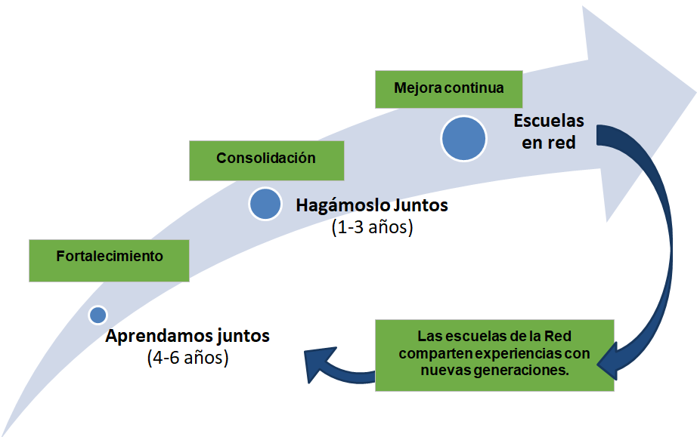
Translation:

Strengthening | Consolidation | Ongoing Improvement | Schools within the network
Learning together (ages 4-6) | Let’s do it together (ages 1-3)
 | ← | Schools within the network share experiences with new generations. | ↓  ←

EVALUATION:
A fundamental part of our Integral School Model is our Evaluation process, which we have carefully designed with the support of external professional evaluators. At the end of each school cycle PROED´s field crew, applies questionnaires to a broad spectrum of our students, teachers, school directors and parents; results are analyzed, and reports are made. Which allow us to identify our actions in each school. This is how we identify where we have to prioritize in each school. Through this process, the school can plan their actions for the upcoming cycle.

EVALUATION INDICATORS:
For our Evaluation process in our Integral School Model (MEI), we defined the attributes that describe how we see the different school components that help us improve the quality of education in each school:
- Students: Learning expectations, they communicate in a clear, forward fashion, they take care of themselves, they coexist in harmony with each other and with their school community.
- School Directors: They exercise positive leadership, they are capable of adapting the traits that characterize their authority and PROED´s program of continual improvement supported by their school community.
- Teachers: They show compromise, self- esteem and appreciation for their role, they participate with the school community and are in continual formation, they are involved in each student´s learning process.
- Parents: they are involved with their children´s learning process, they see themselves as educators and they value and support school formation.
- School Communities: Integrated, centered in learning and with their own management capacities.
- School Facilities: With proper learning conditions, with proper learning materials and resources.
Through these attributes we construct the indicators and the instruments that we apply in our representative model for our evaluation process. Year after year we compare results to measure advances, achievements and challenges. The reports for each school are made during the months of July and August.

