Progress Report: January – March 2026

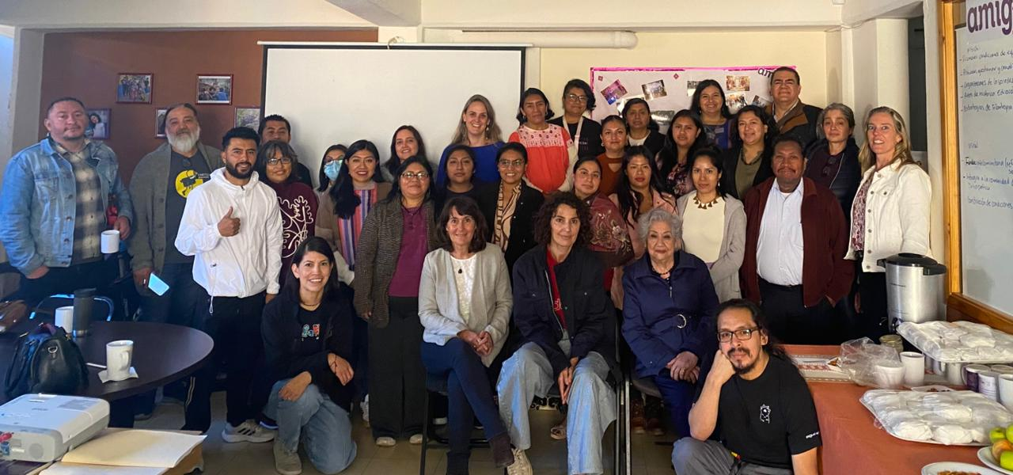

We begin this quarterly report of the year with enthusiasm, strengthening partnerships, capacities, and on-the-ground support. We also renew our commitment and share with you the steps we continue to take alongside communities. This 2026 brings new projects that we will be supporting, strengthening local processes focused on health, community organization, and the defense of rights—always hand in hand with those who build alternatives day by day from their territories.

At the same time, we continue to invest in strengthening our operational team through training and learning spaces, convinced that growing internally allows us to better support each initiative. During these months, we have also carried out visits to the projects, reaffirming relationships and closely listening to the experiences and challenges of each community.

As this year we aim to implement a new monitoring and evaluation system, in this first stage we will establish a baseline that will allow us to better measure the progress and impact of the projects, using tailored indicators.

We continue moving forward with the conviction that there is still much to be done, but also with the joy of seeing how these shared eforts bear fruit.

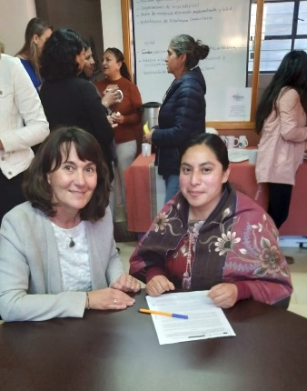
2026 Project Launch

With the signing of agreements with partner organizations on February 12, we officially began the implementation of new development projects.
For us, this was a great joy because, as a community foundation, we hold a clear conviction: no one goes far alone. That is why we are deeply committed to building strong connections and partnerships.
By investing in the strengthening of the local organizational fabric, we contribute to sustainable, community-based solutions to challenges in education, health, and the environment.
Thus, each agreement is not just a document, but a shared commitment to move forward together in creating better living conditions for everyone.

In 2026, Amigos de San Cristóbal is supporting 16 civil society organizations whose projects have an impact in the Los Altos region of Chiapas. Would you like to know which ones they are?
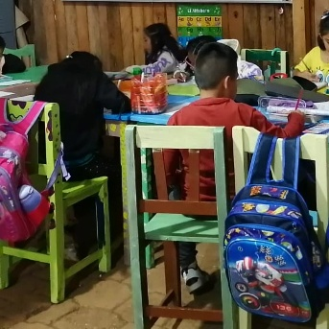
1. Organization: Tierra Roja Cuxtitali Community Center A.C.
- Project name: “The Big House: Tierra Roja Cuxtitali, a space for learning, coexistence, and the building of paths toward peace and dignity.”
- Project description: A learning space where paths toward peace and dignity are built through engagement with families, schools, and partner projects.

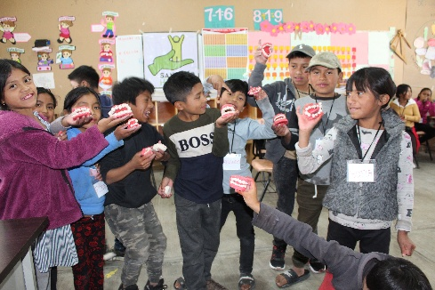
2. Organization: Sanando Heridas A.C.
- Project name: “Strengthening oral health in Tsotsil communities of Los Altos de Chiapas – continuity proposal.”
- Project description: Strengthens oral health in Tsotsil communities of Los Altos de Chiapas.

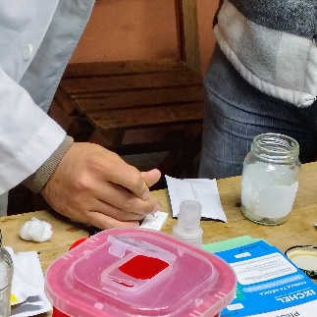
3. Organization: Ixchel, Medical and Logistical Support A.C.
- Project name: “Prevention and support for prostate cancer among Indigenous men in Los Altos de Chiapas.”
- Project description: Prevents and reduces late detection of prostate cancer among Indigenous men in Los Altos de Chiapas.

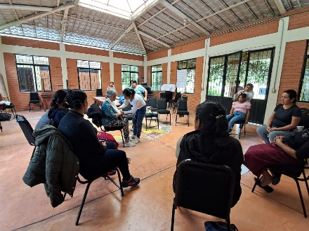
4. Organization: Mujeres Transformando Mundos, A.C. (MUTRAM)
- Project name: “Intergenerational training of community facilitators for health and territorial defense.”
- Project description: Provides intergenerational training for community facilitators in health and territorial defense, promoting a dignified life free from violence.

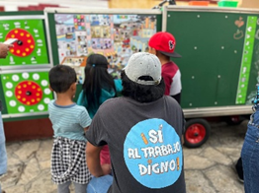
5. Organization: Melel Xojobal A.C.
- Project name: “Contextual education as a right for the comprehensive development of working Indigenous children in San Cristóbal de Las Casas.”
- Project description: Strengthens the right to contextual education for working children aged 4 to 11 through educational, emotional, and family support to prevent educational lag.

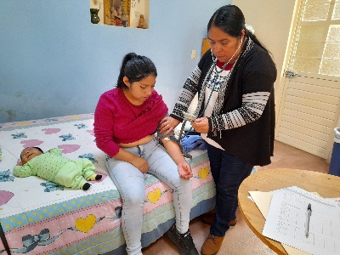
6. Organization: Hogar Comunitario, Yach’il Antzetic, A.C.
- Project name: “New women: comprehensive development free from violence for Indigenous Maya women.”
- Project description: Promotes the rights of women and minors—mostly Indigenous—living in situations of violence, poverty, and high marginalization in Los Altos de Chiapas, supporting their economic autonomy.

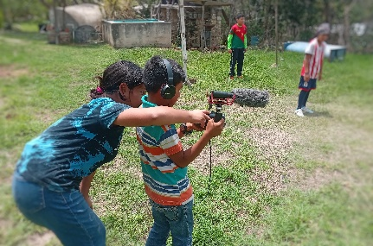
7. Organization: Promedios de Comunicación Comunitaria, A.C.
- Project name: “Cinetiqueta (Cinema for Children).”
- Project description: Strengthens children’s creative skills through audiovisual and film workshops, promoting a culture of peace and community bonds.

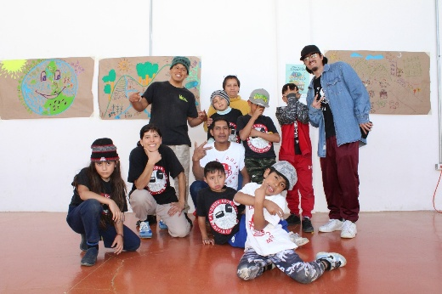
8. Organization: Foro para el Desarrollo Sustentable, A.C. (Semillero and Patrulla Roja)
- Project name: “Guardians of the Earth: Children and Youth Cultivating Hope.”
- Project description: Strengthens social fabric and community leadership through educational, artistic, and environmental activities for new generations.

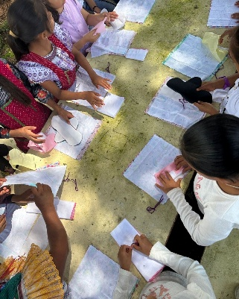
9. Organization: Sinergia Consultora Social, A.C.
- Project name: “Clay Moons: Intercultural Menstrual Dignity.”
- Project description: Promotes the right to health, education, and bodily autonomy of Tzeltal and Tsotsil girls and adolescents through menstrual education and dignified management, from an intercultural and human rights approach.

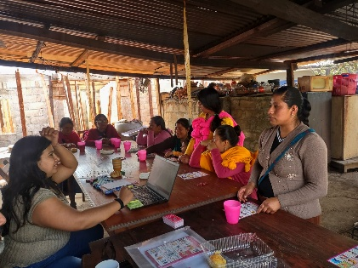
10. Organization: Formación y Capacitación, A.C. (FOCA)
- Project name: “Continuity and Development in Midwife Training for Community Health: Hands that accompany, living midwifery practices.”
- Project description: Strengthens midwife training in Los Altos de Chiapas through a comprehensive, community-based model to improve reproductive health, prevent obstetric violence, and consolidate leadership in intercultural care.

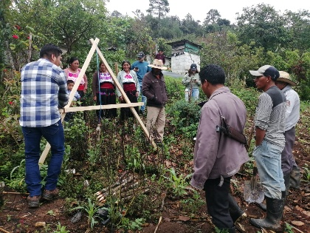
11. Organization: Unidad y Esfuerzo Compartido para el Desarrollo Sustentable, A.C. (UNECODES)
- Project name: “Promoting health and nutrition for vulnerable families through the construction of graywater treatment systems for reuse in the communities of Bochilté (Huixtán) and Chancolom (San Juan Cancuc).”
- Project description: Improves health, food security, and sustainable water use for vulnerable families through graywater treatment and reuse for agriculture.
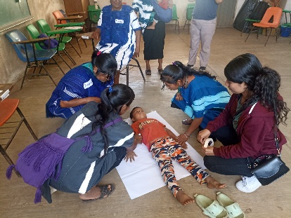
12. Organization: Sakil Nichim Antsetik, A.C.
- Project name: “Living Roots: Weaving Herbal Knowledge in the Hands of Indigenous Women and Youth.”
- Project description: Contributes to the recovery, preservation, and strengthening of herbal medicine to improve the health of women, children, and youth in Indigenous communities of San Juan Cancuc.

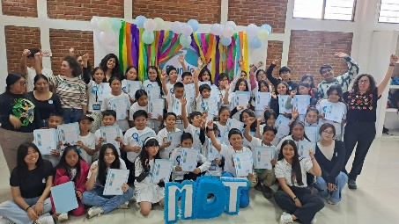
13. Organization: Mundo de Talentos A.C.
- Project name: “Children and Adolescents Exploring Professions and Interesting Trades.”
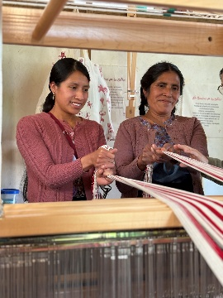
- Project description: Promotes the development of soft skills in 260 children and adolescents in San Cristóbal de Las Casas through vocational guidance activities.

14. Organization: El Camino de Los Altos, A.C.
- Project name: “Weaving to Live: Sustainable Supplies for the Textile Art School.”
- Project description: Strengthens the operation of the Textile Art School by providing sustainable materials and coordination support, ensuring the training of 130 Tsotsil and Tzeltal artisans in Los Altos de Chiapas.

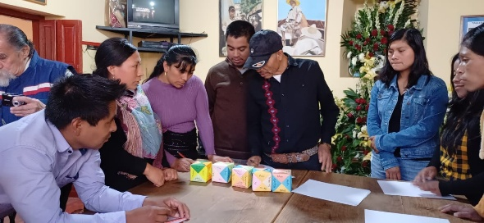
15. Organization: Sna Jtz’ibajom, Cultura de los Indios Mayas, A.C.
- Project name: “FROM SOUNDS TO WRITING: Maya cosmocultural and educational teaching-learning for children and youth in Tzeltal and Tsotsil communities of Los Altos de Chiapas.”
- Project description: Facilitates access to education with cultural values and native languages through the Lekil Kuxlejal pedagogical approach for children and youth in Tzeltal and Tsotsil communities.

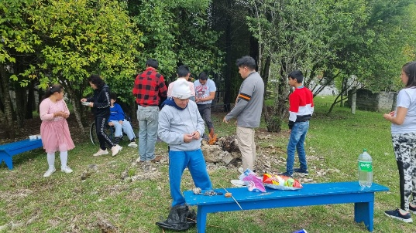
16. Organization: Granja y Talleres para Personas con Capacidades Diferentes Ángeles de Amor, A.C.
- Project name: “Comprehensive Community Center for Training and Social Entrepreneurship to Reduce Barriers Related to Disability.”
- Project description: Establishes a comprehensive community center offering training and social entrepreneurship opportunities for people with disabilities, strengthening their skills and reducing barriers related to their condition.

Team Strengthening
The team participated in various training spaces on monitoring, evaluation (MEAL), governance, and collective learning, strengthening key tools to better support organizations and enhance their impact.
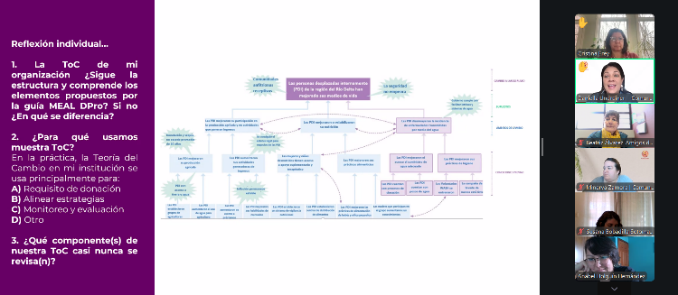
MEAL Course
During this first quarter, we are also participating in a multi-session training: the MEAL DPro Preparation and Certification Course, delivered by the Center for the Strengthening of Civil Society. In this course, we are covering topics such as monitoring, evaluation, accountability, and other key learnings to improve impact in the regions. Thank you, Comunalia, for this effort to strengthen community foundations.
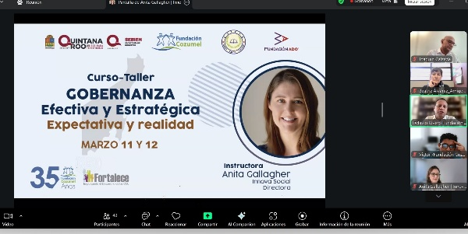
Governance Course
In March, we participated in a very engaging course led by Anita Gallagher, director of Innova Social. We worked with practical case studies to improve governance and the role of Boards of Directors within our organizations, aiming to become more effective and strategic in achieving greater impact. Of course, we also reflected on the gap between expectations and reality, which we had the opportunity to analyze.
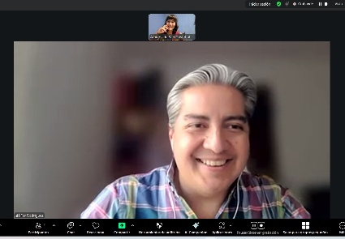
Fundraising Consultancy
We are currently working on strengthening the organization institutionally to move toward medium- and long-term financial sustainability. In collaboration with Fernando Rodríguez from FASE DOS, an Institutional Development strategy is being co-created to complement previous efforts, incorporating income and resource diversification. The process includes a fundraising diagnosis, mapping potential donors, and defining programs and products aligned with different prospect profiles. At the same time, a new narrative and communication strategies are being developed, while strengthening the capacities of the internal team and Board to secure new funding.

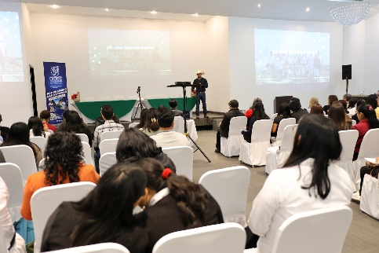
Partnership with Academic Institutions
At the end of January, CIDES (Center for Research on Sustainable Development) held the First Environmental Education Seminar, with speakers from various states across Mexico. Their work focuses on issues such as pollution, biodiversity loss, and committed environmental education and awareness.
It is always important to participate in learning spaces where civil society organizations and academia can exchange best practices and approaches to shared challenges.
Thank you for the invitation. We continue strengthening partnerships.
Networking and Shared Learning
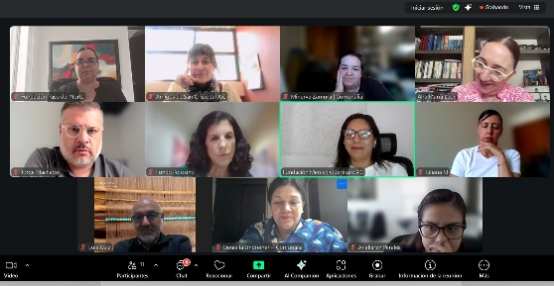
Space with directors of community foundations (Comunalia)
Comunalia shared with us the results of the 2025 Questionnaire, with systematized data and processes from the 17 participating foundations. We also learned about opportunities for both individual and collective capacity building, as well as the possibility of jointly creating a tailored learning pathway for each foundation.
We thank Comunalia for providing these spaces as a Community of Learning and for supporting and strengthening community foundations across Mexico, creating opportunities for learning, technical training, and valuable exchanges of best practices.
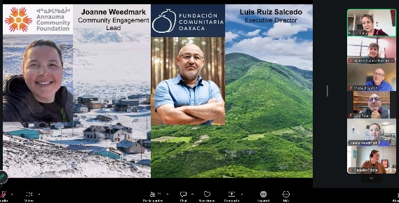
Connecting Communities in the Americas (CCA)
Connecting Communities in the Americas (CCA) offers virtual opportunities to learn about what community foundations are doing across the continent. Thank you, Lisa Schalla, for inviting us to these sessions and for the opportunity to share among peers. The exchange of experiences allows us to grow and go further.
Topics we will be working on this year include creative models to fund operations, support for grassroots initiatives that are not legally incorporated, innovative partnerships with the private sector, measuring what matters, and promoting democracy, civic participation, and a culture of peace, among others.
In the most recent session, Fundación Comunitaria Oaxaca and Annauma Community Foundation presented their work.

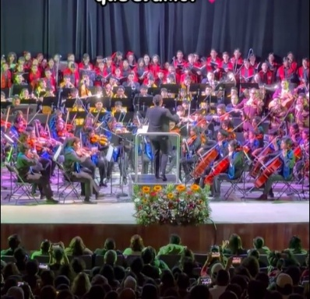
Music Education and Culture that Transform
On March 14, the concert by the San Cristóbal Symphony Orchestra and Choir—paying tribute to “El Divo de Juárez” at the Hermanos Domínguez Theater—was a great success.
At Amigos de San Cristóbal, we feel very proud to be part of this wonderful project and to build alliances as a community foundation with the San Cristóbal Symphony Orchestra and Choir, donors from Grupo Impulsar, and all the sponsors who make this initiative possible.
The musical director, program coordinator, students, teachers, soloists, and mariachis managed—in less than three months—to prepare a repertoire of 15 songs and deliver a top-level performance. These are the kinds of projects that not only provide musical training, but also foster human development.
Field Visits to Projects
In March, we began field monitoring visits to start implementing a new system that will allow us to establish a baseline for each project and closely track their progress. These visits strengthen relationships and allow us to learn directly from community-based practices.
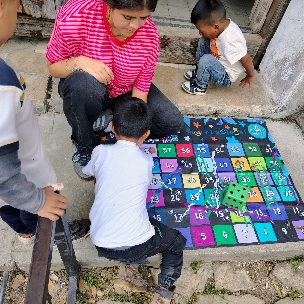
We visited:
Melel Xojobal, A.C.
In this education project for working Indigenous children, we closely observed key variables such as socio-emotional skills, knowledge development, exercise of rights, family environment, and educational trajectory. Learning directly from them in the field is what gives meaning to our work.
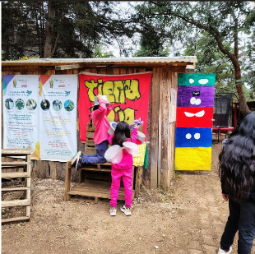
Tierra Roja Cuxtitali, A.C.
At Tierra Roja Cuxtitali, children guided the visit, proudly showing the spaces they have built—from planting and composting areas to the “Little House of Emotions.” We found:
- Learning built through experience and connection with the environment.
- Socio-emotional tools that extend beyond the space (reaching homes and schools), strengthening identity and well-being.
- A safe environment that acts as a “bandage for the heart” for children.
The project continues to consolidate itself as a space of peace, care, and community, where daily coexistence within the neighborhood becomes a laboratory for empathy, respect, and transformation through educational processes.
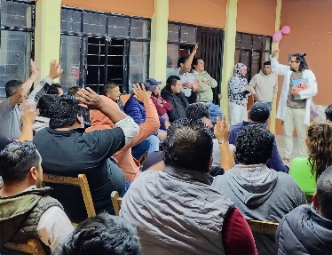
Ixchel-Acompañamiento en Salud, A.C.
During the visit, an early prostate cancer detection campaign was carried out for Route 1 transport workers, with around 60 men participating. Through an informative talk, visual materials, and an open dialogue space, participants addressed questions about symptoms, treatment options, and the importance of early detection and prevention.

Mundo de Talentos, A.C.
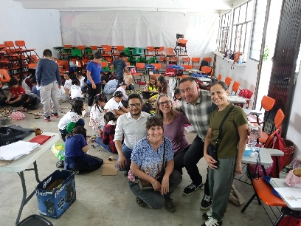
Activities promote active participation, teamwork, and learning about different professions while exploring children’s vocational interests. A total of 47 children participated in a session with two speakers:
- An architect explored the relationship between architecture and cinema, covering concepts such as film types, scripts, scenography, and production, and encouraging character creation.
- A second architect focused on the parts of a city, leading a collaborative activity where children built their own cities using LEGO materials.
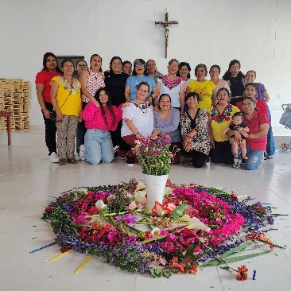
Mujeres Transformando Mundos, A.C. (MUTRAM)
From this visit, we concluded that the more organized women are, the stronger their communities become. Intergenerational work strengthens youth leadership, community networks, and support spaces based on rights, equity, and comprehensive health.
Thanks to their work, new neighborhood groups have emerged, and women’s leadership continues to grow—recognizing and addressing violence while promoting well-being and community participation. The project continues to grow through strategic partnerships and with the vision of creating a comprehensive care center, in an environment of trust, identity, and hope.
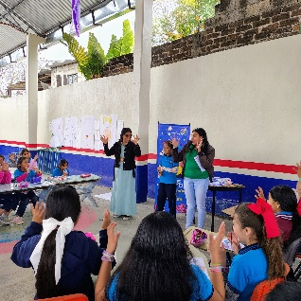
SINERGIA, Consultora Social, A.C.
At Venustiano Carranza Primary School in Teopisca, the “Lunas de Barro” project enabled elementary school girls to talk openly about menstruation without shame. Through dialogue and activities, their confidence, self-esteem, and support systems were strengthened. Its intercultural approach stands out—adapted to each community, valuing cultural identity, breaking taboos, and integrating health, environment, and culture in a safe, community-based space.

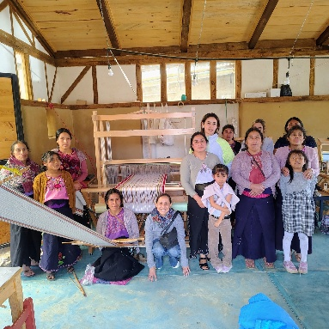
El Camino de Los Altos, A.C.
Last week, we visited the Textile School in San Cristóbal and Zinacantán with the team of this organization of women artisans. We toured embroidery, screen-printing, and weaving workshops using linen, local wool, and ixtle, along with natural dyeing processes. In Zinacantán, the artisans built an ecological space with rainwater harvesting and biofilters. Beyond the techniques, the impact is clear: women strengthen their autonomy, income, and cultural identity. The traveling project “Weaving to Live” brings training to communities, reducing barriers and empowering more than 130 women.

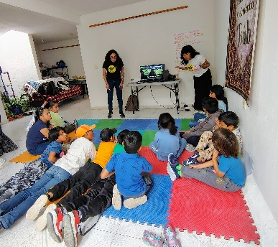
Promedios de Comunicación Comunitaria, A.C. – Cinetiqueta
At the film workshop in the Ciudad Real neighborhood, 11 children experienced a creative process, using cinema to explore their surroundings and express themselves. The project brings film to children in peripheral neighborhoods, allowing them to create their own narratives and reframe their realities. Through sound, recording, and role-based exercises, they developed audiovisual skills, strengthened imagination and teamwork, and recognized their neighborhood as a creative space. The workshop has become a safe and meaningful environment where children learn, create, and connect.
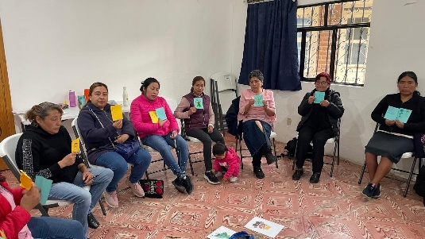
Hogar Comunitario, Yach’il Antzetic, A.C.
In San Cristóbal de Las Casas, we visited this project and its emotional support workshop for 17 women. The initiative supports Indigenous Maya women facing violence, promoting healing processes led by the women themselves. Through group dynamics, participants reflected on emotions and strengthened tools for personal and collective well-being. The project remains a safe space for trust, learning, and transformation.

Sanando Heridas, A.C.
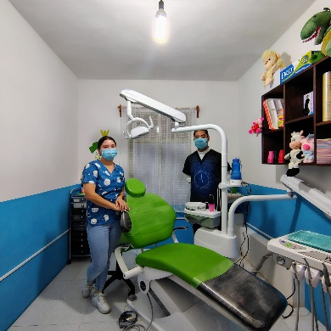
During the visit to their facilities at La Quinta San Martín, within the framework of the oral health project in Tsotsil communities, the team—including education and dentistry staff—shared progress. They currently reach 11 schools with hygiene and oral health workshops. Facing challenges such as high rates of cavities and limited access to treatment, they have innovated through mobile brigades and portable equipment. The committed Tsotsil team strengthens trust and cultural identity, working toward more accessible pediatric dentistry and long-term habit change from childhood. Sanando Heridas shows that community health is built through culture, trust, and continuity.

