Hope for Street Children and Vulnerable People Foundation (HOPLE)
Winter Clothing Distribution Activity Report
Location: Yusufari LGA, Yobe State
Date: 25-12-2024
Introduction
Hope for Street Children and Vulnerable People Foundation (HOPLE Org) successfully conducted a winter clothing distribution activity in Yusufari LGA, Yobe State, with funding support from GlobalGiving through individual donations. This initiative aimed to provide essential winter clothing to orphans, widows, and the most vulnerable populations, with a particular focus on children, women, and people living with special needs. The activity was designed to mitigate the harsh effects of the cold season on these at-risk groups, ensuring their warmth and well-being.
Objectives
To distribute winter clothing, including blankets, sweaters, and other warm apparel, to vulnerable families in Yusufari LGA.
To prioritize support for children, women, widows, and people living with special needs.
To assess additional needs within the community for future interventions.
Activities Conducted
Needs Assessment: Prior to the distribution, a needs assessment was conducted to identify the most vulnerable households requiring winter clothing.
Community Engagement: Collaboration with local leaders, women’s groups, and volunteers to ensure efficient distribution.
Distribution of Winter Clothing: A total of 250 families received winter clothing, with a special focus on children, widows, and individuals with disabilities. The distributed items included blankets, sweaters, hats, and socks.
Monitoring and Follow-Up: Post-distribution visits were conducted to assess the impact of the intervention and identify further needs.
Challenges Faced
Insufficient Resources: The demand for winter clothing exceeded available supplies, leaving many children without adequate protection.
Livelihood Struggles for Women-Headed Households: Many women, particularly widows and female-headed households, require additional livelihood support to sustain their families.
Limited Funding: The current funding was not sufficient to reach all vulnerable individuals in the community. More financial support is required to scale up interventions.
Harsh Economic Conditions: The removal of fuel subsidies, flooding, and economic hardships have exacerbated vulnerabilities, increasing the demand for humanitarian assistance.
Protection Concerns: Reports of abuse against girls in the community highlight the urgent need for protection programs alongside humanitarian assistance.
Recommendations
Expand Funding Opportunities: Increase fundraising efforts through partnerships, grant applications, and advocacy to secure additional resources for winter clothing and livelihood support.
Livelihood Support for Women: Implement livelihood programs, including skill-building and financial assistance for women-headed households, to enhance economic resilience.
Enhanced Protection Measures: Collaborate with local authorities and NGOs to implement child protection initiatives and combat gender-based violence.
Strengthening Community Resilience: Introduce long-term programs such as sustainable agricultural support and microfinance initiatives to help families recover from economic shocks.
Scale-Up Distribution Efforts: Conduct additional clothing distributions to reach more vulnerable individuals in remote areas.
Conclusion
The winter clothing distribution in Yusufari LGA successfully provided warmth and relief to 250 vulnerable families. However, the challenges faced underscore the urgent need for continued support. HOPLE Org remains committed to advocating for and mobilizing resources to address the pressing needs of vulnerable populations. We call on donors, partners, and stakeholders to collaborate with us in scaling up interventions to provide lasting solutions for the most affected communities.
Action Pictures
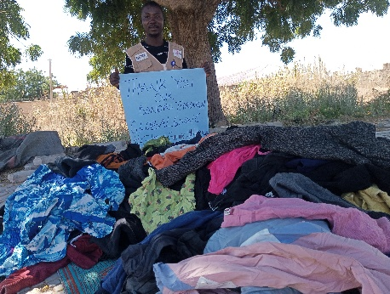 | 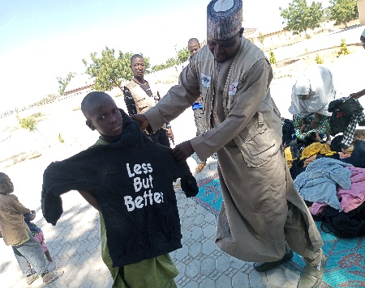 | 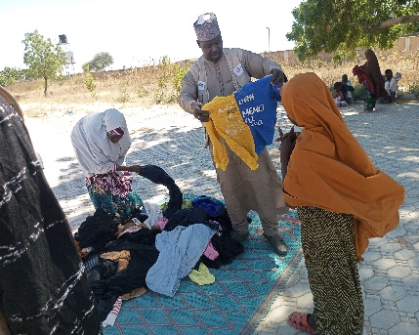
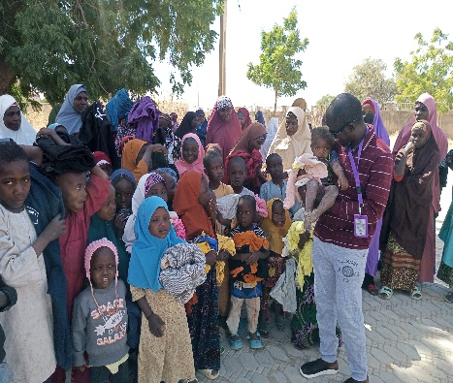 | 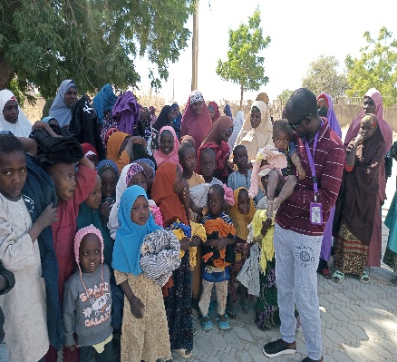 | 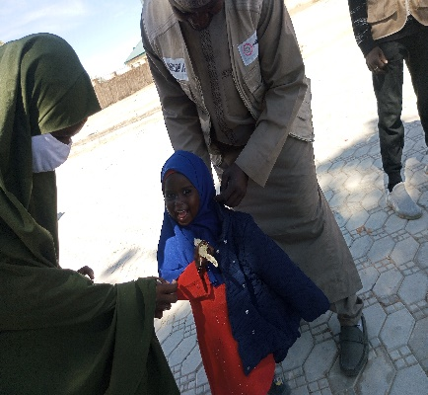

Prepared by:
Ali Mele
Executive Director
Hope for Street Children and Vulnerable People Foundation (HOPLE Org)

