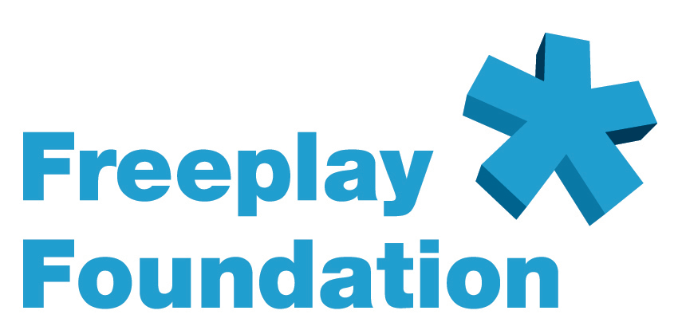

The Vulnerable Children’s Fund

The Freeplay Foundation’s Vulnerable Children’s Fund (VCF) was created to collaborate with organizations that work with children and young people in South Africa to limit the spread of HIV/IDS -- particularly among orphans and child-headed households -- and to give appropriate support and information to those who are suffering from AIDS. The fund helps to provide education and information on HIV/AIDS, health and hygiene. The VCF also provides access to basic educational radio broadcasts for orphans and other vulnerable children who may not have access to formal education or be living with an adult.

The VCF was established as a result of extensive fieldwork. The Foundation developed the Lifeline radio specifically for use by children living on their own, although adults can also use it. Orphaned children in South Africa, Rwanda and Kenya assisted in the development of the Lifeline. For the VCF, we consulted with South African partners who had established successful programs in assisting children and families suffering from AIDS: All agree that access to information and education is key to combating the spread of AIDS, to eliminating the stigma of the disease, and to providing essential life skills, which in turn enhance the prospects of children who have been orphaned, or those who are caring for siblings and parents with AIDS.

These children – of whom there are estimated to be more than 1 million - lack not only the basics like food, clothing and shelter, but also the guidance, support and love generally offered by parents. They often bear the brunt of discrimination and ostracism from others in the community because of the stigma attached to AIDS, and are particularly vulnerable to harassment, violence, and sexual abuse.

Our experience in Zambia, Tanzania, and Rwanda with child-headed households and children orphaned by AIDS, using the operational model we developed, convinced us that it could be implemented to help the large numbers of vulnerable children in similar circumstances in South Africa. Radio is the primary source of information in South Africa, particularly in rural areas.

Our radio content partners have created innovative educational curricula that cover three primary areas specific to HIV/AIDS: knowledge, attitudes, and skills. Our distribution partners are committed to ensuring that the children they are trying to help have access to these broadcasts.

The Freeplay Foundation ensures that key components are in place on any project to ensure sustainable radio communication. These include appropriate content (software), Lifeline radios (hardware), use of structured distribution methodology developed by the Foundation, and monitoring/evaluation.

For the VCF we work with our content partners Takalani Sesame, ANC Ulwazi and Soul Buddyz to ensure that content is appropriate and that quality radio programming is directed at target audiences. We work with our distribution partners such as the Nelson Mandela Children’s Fund, Kidzpositive, Media Monitoring Project, NOAH and Tikkun to ensure that there is a planned and coordinated distribution of radios. (Takalani and Soul Buddyz also have capacity to distribute radios.) Our partners worked with us to consult the intended beneficiaries, the children themselves, and there was a resounding positive response to the project.

The Foundation is working with these same partners to ensure that their projects are monitored and that the impact and effectiveness of the program is evaluated.

The VCF seeks to provide wind-up and solar-powered Lifeline radios to orphans, children heading households, and HIV-positive children in South Africa. The radios are a vital channel for education and much needed information, including AIDS related programs. In more isolated areas there is no access to electricity and little money to buy batteries on an ongoing basis. The Lifeline radio was created to meet the needs of children, specifically those living alone. It ensures continued access to information and education to a wide audience of listeners, as the radio has been designed to be heard by groups of up to 40 listeners.

South Africa has limited state support or social services, so most of these children are institutionalized or left to fend for themselves to live in poverty. They are likely to be malnourished and many have no access to formal schooling. Many struggle to survive without any adult guidance or support. Radio has an important role as a surrogate teacher or as a trusted voice offering useful and important information while easing isolation. These children will not have money to buy a radio or batteries. Lifeline radios do not need batteries or electricity and provide sustained access to vital health related broadcasts and distance education to those most vulnerable.

Without sustained access to radio, valuable information and education does not reach its target audience. Radio programming can offer valuable guidance and information that a parent or caring adult would usually provide. The Lifeline Radio enables sustained access to individuals, classrooms and listening clubs.

The Foundation also supporta its project partners through the sharing of best practices and its experience in effectively addressing issues regarding community listening behavior.

Additionally, the Foundation has evolved a unique method of delivering the radios, which can be packaged in boxes printed with health messages that support the aims and goals of particular projects. Project-specific cartoon instruction sheets or posters are also provided. Created by local cartoonists, they show how to use the radio on one side and on the other, they provide messages and information relative to the project.

Some VCF Partners

The Nelson Mandela Children’s Fund (NMCF) is focusing its energy on AIDS orphans and child-headed households throughout the country. A pilot program called Geolama (a Tswana word meaning "to safeguard and nurture"), supported by community-based organizations and government, gives orphans a sense of family and now reaches over 150,000 of these children. Currently there are 10 pilot sites in the KwaZulu-Natal, Northern, Gauteng and Mpumulanga provinces of South Africa.
NMCF also provides funding to NGOs and local charities to enable them to undertake needed community-based work, and these organizations will also distribute Lifeline radios.

The Kidzpositive Family Fund is dedicated to improving the health of HIV-positive children in South Africa and has a solid record of successful partnerships. In one project, mothers of HIV-positive children are provided with training and raw materials with which to produce beadwork. Kidzpositive buys the completed product to provide the women with money for daily needs. It then markets the beaded products to establish a permanent source of income for the mothers. This project is being extended throughout the sub-region by offering training, raw materials and a market for products. It is a model for a sustainable self-help industry that provides support for the daily needs of affected families.

At Kidzpositive, the mothers use the Lifeline radios. They listen, as a community group, to the radios while beading at the clinic where their children receive AIDS medication. Some of the mothers will also be able to take the radios home with them and listen to news, health and hygiene programs, and HIV/AIDS education programs while they make beadwork at home.

Maafrika Tikkun operates many successful programs for the care of children and families affected by AIDS. It initiates projects where beneficiaries can learn skills to assist them in finding employment and to develop their communities. For example, the development of a vegetable garden ensures a regular supply of organic fresh produce for the patients and surrounding community. Tikkun has also initiated a training program for local residents who volunteer to act as home-based caregivers to the sick and provides these caregivers with training in nursing care, HIV/AIDS awareness, and nutrition.

Takalani Sesame is the world’s first radio version of the popular Sesame Street program and is broadcast in South Africa as a multi-media educational program created for children who have had no exposure to early childhood development. It develops basic skills with numbers and letters and encourages a lifelong love of learning. It also builds self-esteem, and respect for others. The program is broadcast in Xhosa, Zulu, Tsonga, Tsepedi, English and Afrikaans to maximize the project’s reach. The award-winning Takalani Sesame recently introduced Kami, the world’s first HIV-positive Muppet, who also is an AIDS orphan.

Soul Buddyz is a groundbreaking multi-media "edutainment" vehicle for the 8 to 12 year old child. Soul Buddyz is the youth divison of Soul City, the well-respected media nonprofit. Soul Buddyz works with teachers and mentors in the formation of Soul Buddyz Clubs across South Africa, extending the reach of the programming. The listening clubs are fun and provide a safe place for young people to meet. The radio content conveys important messages on HIV/AIDS and sexuality, and has already proved to be a vital tool in the fight against the spread of AIDS. Soul Buddyz has trained facilitators who will distribute the radios as part of their program facilitation.

Media Monitoring Project (MMP) – This NGO analyzes and researches the content, selection, and manner of presentation of news, current affairs, and information on radio and other media. MMP distributes Lifeline radios to children living without an adult, in order to monitor their listening habits and preferences.

NOAH (Nurturing Orphans of AIDS for Humanity) was conceptualized at the end of 2000 in response to the realization that South Africa will face an 'epidemic of orphans' following the AIDS pandemic in the country. Its role is to 'franchise' a community based model of orphan care which aims to help the children orphaned by Aids to grow up into emotionally and psychologically stable adults capable of forming lasting relationships and of being good parents to their own children and good citizens of South Africa. The overall goal therefore is to support communities to sustainably improve the quality of life [health (nutritional / psychological), education and economic status] of orphans and vulnerable children and their families.

To this end, Noah has developed a 10-step program through which enthused, driven and accountable individuals from a given community are mentored to set up their own network of care for their orphaned and vulnerable children. This network is known as an Ark. Each Ark consists of an elected community committee of stakeholders who is tasked with driving the project. This committee then recruits a team of volunteers and both undergo training in the core Noah modules. Volunteers are equipped with the skills and confidence to provide the network of care within their communities.

###

Freeplay Foundation contacts in the USA:

Michelle Riley, Senior Consultant and Freeplay Foundation Project Leader for Coffee Lifeline: riley.freeplayfdn@gmail.com

Midi Berry, Senior Development Consultant: freeplayfoundation@mac.com

PLEASE SCROLL DOWN FOR MORE INFORMATION ABOUT THE FREEPLAY FOUNDATION, TOM HANKS, AND THE LIFELINE RADIO:

EXECUTIVE SUMMARY:

OVERVIEW OF THE FREEPLAY FOUNDATION

AND THE LIFELINE RADIO

Description of the Organization

The Freeplay Foundation mission is to help vulnerable people transform their lives using sustainable, self-sufficient and environmentally friendly technologies.

With access to resources, people seize educational and economic opportunities to improve health, create jobs and advance quality of life. We are committed to act as stewards of the environment to make clean energy technologies available to those in need.

The non-profit Freeplay Foundation works mainly in Africa. By addressing the pressing needs of its women, orphans and vulnerable children, we aim to contribute to total community well being.

Since 1998, the Freeplay Foundation has been creating access to radio information and education for the most vulnerable populations via self-powered radios.

The Foundation is committed to promoting the importance of radio as a vital medium in the developing world. Through the use of self-powered Freeplay Lifeline radios, it also advocates the necessity of ensuring access to broadcasts and sustainability of programming, especially for the most vulnerable groups, women and children.

In communications projects, the Foundation can ensure that information is delivered the “last mile” to populations in the most inaccessible locations. It can serve as the final point in a seamless line of communication -- from satellite and internet-based information, through television and published information -- all the way to Lifeline self-powered radio access in the poorest, most remote villages and refugee camps. The Freeplay Foundation works in a dozen African countries and is on the cusp of becoming a major force within the humanitarian development world, because no one else can offer what Freeplay can. In a global communications campaign, the Foundation is the final step.

In developing countries, especially in areas with large, non-literate populations, radio is the primary means of communication. In sub-Saharan Africa, for example, it is estimated that there are up to 75 times more radios than televisions. However, in most of the developing world, electricity is non-existent and the high cost of batteries makes them unaffordable on an ongoing basis, especially to women and children. Millions of dollars are spent worldwide each year to produce excellent radio programming for development purposes, yet the poor may never hear it. They are unlikely to receive critical information that can help them prevent deadly diseases, improve hygiene, raise agricultural productivity, learn English and math through radio distance learning, or enjoy any educational instruction that could help lift them out of abject poverty and lower mortality rates. Lifeline radios can solve the problem of access for these audiences.

Established in 1998 in the UK by the Freeplay Energy Group as a separate entity, the Freeplay Foundation is a tax-exempt 501(c)(3) charitable organization in the USA, with its senior consultant working from Savannah, Georgia. Additionally, it enjoys Section 21 charitable status in South Africa and is a registered charity in the UK. The Foundation’s main office is in Cape Town. It also maintains an office in London and has consultants based in the USA in Los Angeles and Savannah, Georgia.
Description of the Work

The Foundation’s goal is to utilize radio to ensure that as much accurate information is disseminated to the widest possible population. To this end, the Foundation works with international and local NGOs in a structured distribution methodology of radios to rural communities. The Freeplay Foundation team includes experts that can survey and assess target populations’ radio information needs, work with local broadcasters to set up appropriate content and structure, assess and determine radio distribution criteria, implement radio distribution, form listening groups and focus groups, and monitor and evaluate the impact of the process. Radios are never “just given away.”

In addition, the Foundation has devised unique ideas for delivery and packaging, such as the creation of “health boxes.” The radio boxes can contain other health-related items and print materials to form a complete community package. For instance, supplies could include malaria nets, information booklets, rubber gloves and water purification tablets. Health messages that support a particular project can be printed on the boxes. For example, HIV/AIDS prevention messages are relevant to the entire world, while malaria treatment messages are relevant only to some countries.

The Foundation supports project partners through the sharing of best practices and experience. For example, the Foundation has experience in how to most effectively introduce radios into communities and address potential issues regarding community listening behavior. For many projects, a listening group format is adopted, whereby 10-20 people gather to listen and to discuss or debate a radio program. Freeplay radios are designed for group listening - they are large and robust with excellent speaker quality – easily accommodating up to 40 listeners.

The Foundation also creates project-specific cartoon instruction sheets showing how to use the radio correctly and how it is used in a community setting. The cartoonists are hired locally, wording on the cartoons is printed in vernacular or the national language, and the cartoons are pre-tested first. Oftentimes, the reverse sides of the instruction sheets are also used to augment the program’s key messages and to advertise the program’s station and broadcast time.

The Lifeline Radio

The Lifeline radio is the first radio ever produced solely for humanitarian use.
After extensive fieldwork during the first two years of the Foundation’s existence, the executive director determined a real need expressly for the humanitarian sector, especially children living on their own. The idea for the Lifeline was born.

In 2001, the Freeplay Foundation received the $50,000 education award, underwritten by NASDAQ, as the winner of the Tech Museum of Innovation Awards -- Technology Benefiting Humanity. The Foundation allocated the award money to seed the research and development of the Lifeline radio. All funding needed to bring the Lifeline radio to fruition, including tooling and testing, was received from donors in October 2002. The other donors included the Body Shop Foundation, Anglo American Corporation, the Vodafone Group Foundation, Vytek Chairman Leonard Fassler, and well-known technology entrepreneur Bradley Feld.

Exactly two years after the concept paper for the Lifeline was written, the new radio was launched in April 2003 in a Voice of America (VOA) sponsored project benefiting Burundian youth living in refugee camps in Tanzania. The United Nations High Commissioner for Refugees (UNHCR) was the implementing partner. VOA deemed the project to be so successful that they funded a major expansion of the initiative into the camps.

Already more than 2 million people throughout sub-Saharan Africa are benefiting from access to self-powered Lifeline radio and the Foundation is committed to increase this number manifold in years to come.

A few projects that include the Lifeline radio:
South Africa – Lifeline radios are integrated into the youth radio programme Soul Buddyz. The radios are used to augment Soul Buddyz listening clubs. Radios have been given in support of the Nelson Mandela Children’s Fund’s Goelama Project, which supports child heads of households in the Kwa-Zulu Natal province. Lifeline radios are included in the expansion of the radio version of Sesame Street, called Takalani Sesame, and are distributed to teachers in early childhood learning centers in rural areas. In 2005, Takalani Sesame won the prestigious Peabody Award. The Media Monitoring Project uses Lifeline radios to monitor the listening habits and preferences of child heads of households. UNICEF is the project’s primary funder.

Tanzania – Lifeline radios are used in six different projects in Tanzania, all funded by the Vodafone Group Foundation: The African Youth Alliance (AYA) radio program called Mambo Bomba; a major radio distance learning project called Mambo Elimu that offers a primary school education; a Ministry of Labor, Youth Development and Sport-sponsored youth sports and HIV/AIDS awareness campaign; a project that supports youth development through a variety of media, including radio; a Ministry of Health initiative where Lifeline radios will be placed in prenatal clinics where women gather; and a community radio station/telecenter near Lake Victoria where the radios are used for primary education and to teach children about various technologies.

Afghanistan – Lifeline radios have been distributed to female teachers in remote areas, enabling them access to teacher training programs. This groundbreaking project is coordinated by Media Support Solutions.

###

PLEASE SCROLL DOWN FOR INFORMATION ABOUT TOM HANKS AND THE LIFELINE RADIO

Sept. 29, 2003

Tom Hanks Assists World’s Poor
As Freeplay Foundation Ambassador

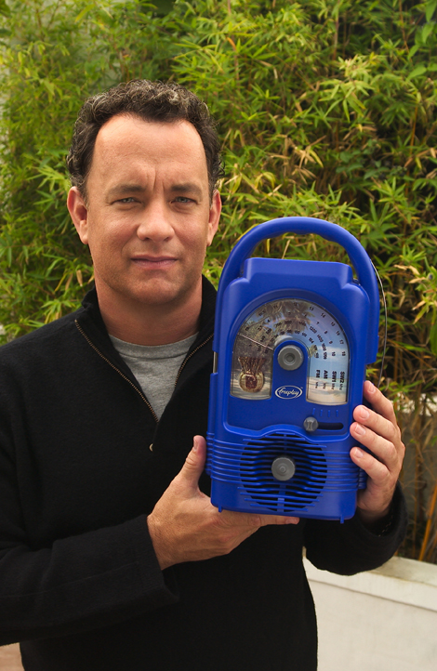

Cape Town, South Africa....The Freeplay Foundation today announced that two-time Academy Award® winner Tom Hanks has become their American ambassador. In this advocacy role, Mr. Hanks will help gain support for the Foundation in the U.S. and promote understanding of the Foundation’s work.
Using Lifeline radios, which do not require batteries or electricity, the Freeplay Foundation provides sustained access to information to the world’s poorest populations, especially children living on their own.

“The extraordinary technology of the Freeplay Foundation’s Lifeline radio can bring vital information to isolated people all over the world,” said Mr. Hanks. “For example, right now there are more than 13 million children orphaned by AIDS. Most can’t attend school and can’t afford batteries or electricity to power a radio. The Freeplay Foundation can hand these children a lifeline to the outside world by giving access to radio programs that teach them how to grow their small garden plots to feed themselves, take care of their chickens or goats, and prevent deadly diseases like malaria and AIDS.”

Freeplay Foundation Executive Director Kristine Pearson said, “We are deeply grateful that Mr. Hanks has chosen to serve as our American ambassador.
By lending his voice in support of the most vulnerable people, especially orphans and other children living on their own, Mr. Hanks will help bring them critical, even life-saving information and education.”

In developing countries, radio is the primary means of communication. The Lifeline radio plays non-stop using wind-up energy and solar power and is the first radio ever produced solely for humanitarian use. Using a structured methodology developed by the Freeplay Foundation, radios are distributed to youth, community health workers, village chiefs, listening groups, teachers, and informal classrooms in the developing world, primarily in Africa. Recipients are trained in how to most effectively listen to radio programming and transfer knowledge they gain to others in their community.

Mr. Hanks joins humanitarian Terry Waite, who serves as the Foundation’s European ambassador. Mr. Waite is well known in the U.S. as the special envoy to the Archbishop of Canterbury in the 1980s. While negotiating the release of U.S. hostages in Lebanon, Mr. Waite was himself taken hostage, serving most of his five years in captivity in solitary confinement.

The Freeplay Foundation works in more than a dozen African countries. It is a fund seeking, U.S.-registered 501 (c) (3) tax-exempt charity. It works with governments, international agencies such as the United Nations Development Program, non-governmental organizations (NGOs), and local communities. With offices in Cape Town, South Africa and London, the Foundation also enjoys charitable status in South Africa and the UK. Learn more at www.freeplayfoundation.org.

###.

PLEASE SCROLL DOWN FOR INFORMATION ON THE LIFELINE RADIO:

Key Design Features and Benefits of the Lifeline Radio

Below describes the features and benefits of the Lifeline Radio. Orphaned children in South Africa, Rwanda and Kenya were consulted throughout the design and development process. The size and shape of the Lifeline Radio is a result of focus group research. The more it is wound, the longer it will play.

Children can grip the handle without difficulty. While the Lifeline Radio is large, it is lighter than other Freeplay radios used in development projects.

The antenna is an ordinary piece of wire, which can be replaced with any piece of wire. It can be taken off and put back on at will as antennas break easily.

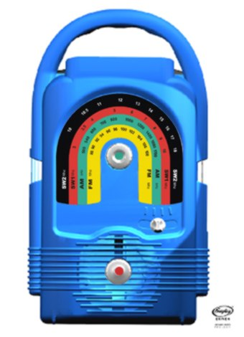

The solar panel is housed in a detachable waterproof casing on a three-meter lead with magnetized clips on top to hold it securely in place. The Lifeline Radio operates in the harshest of conditions in extreme temperatures, rain, moisture, dust, sand and humidity.

The rainbow shaped dial scale has large print making it easy to read even for the visually impaired. As AM/FM/SW is difficult to understand for some, each band is color-coded.

The winding handle (on back) can be turned in either direction to charge the radio. Earlier Freeplay models could only be wound clockwise. Fully charged, the Lifeline Radio can play for many hours.
The dial scale and Lifeline Radio can be custom produced in any combinations of colors, which cannot reflect political parties.

Four-band coverage, AM/FM/SW1/SW2 ensures access to many channels and perspectives. For example, in Zimbabwe where programming is government controlled, SW broadcasts can be received.
The sound quality is excellent enabling at least 40 people to hear it clearly.

Each knob is purposely a different shape.

