The Whaleman Foundation

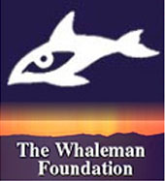
In 1995, Jeff Pantukhoff founded “The Whaleman Foundation” (www.whaleman.org), a non-profit oceanic research, conservation, and production organization dedicated to preserving and protecting dolphins, whales, and our oceans. The Foundation's primary mission is to raise public awareness while educating key decision-makers on the issues that effect cetaceans (dolphins, whales, and porpoises) and their critical habitats. Since Whaleman's inception, Jeff has written, directed, and produced 6 films on the critical issues facing cetaceans and their environment along with numerous Public Service Announcements (PSAs).

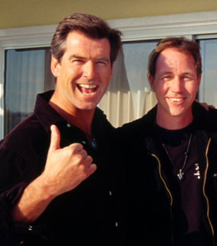
Since its inception, Whaleman has presented films to the United Nations, Congress, and the International Whaling Commission. In addition, our film footage and photographs have been featured worldwide in hundreds of news stories airing on NBC, ABC, CBS, CNN, PBS, the BBC, Reuters and others.

Joining us on our quest as our spokespersons are some of the world’s leading image-makers including Heroes’ star Hayden Panettiere, Pierce Brosnan and his wife Keely Shaye Smith, and Australian actress Isabel Lucas.

Our first victory came when our film “Gray Magic: The Plight of San Ignacio Lagoon”, featuring Pierce and Keely was presented to the 1999 meeting of the United Nations Education, Scientific, and Cultural Organization (UNESCO).
This film was key in stopping Mitsubishi Corporation from building the world’s largest salt plant at Mexico’s San Ignacio Lagoon - a United Nations World Heritage Site and the last pristine mating and birthing grounds for the California gray whale.

Our film “Deadly Sounds in the Silent World,” also featuring Pierce and Keely, was winner of “Best Short Film” at the 2003 Jackson Hole Wildlife Film Festival and was presented to Congress playing a pivotal role in banning the worldwide deployment of a lethal sonar system called LFA Sonar by the US Navy.

The films we presented to the International Whaling Commission in 2000 and 2002 on the Makah Tribe’s illegal gray whale hunt helped to revoke the Makah’s US permit to hunt gray whales in the Olympic National Marine Sanctuary.
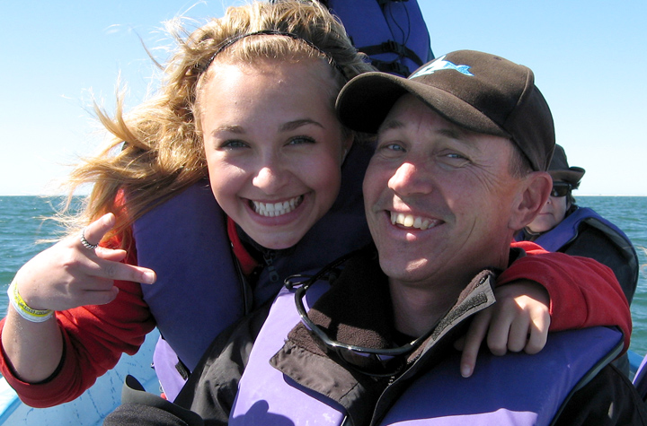
Currently, we are focusing our efforts via our global conservation campaign called "Save the Whales Again!" which was officially launched in Hollywood by Hayden Panettiere and several of her Heroes’ castmates in February 2007.



Most people today believe that the whales were saved because of the very popular “Save the Whales” movement of the Seventies, which resulted in a whaling ban…
But unfortunately, nothing could be further from the truth, because dolphins and whales face more threats today than ever before from toxic pollution, noise pollution, global warming, loss of habitat, entanglement in nets, ship strikes, and expanding whaling.
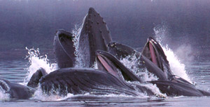
Our campaign’s mission is to end whaling worldwide while raising public awareness to all the threats facing dolphins, whales, and our oceans. We are accomplishing this by direct action, via the internet, and through our films and PSAs featuring Pierce, Isabel, and Hayden.

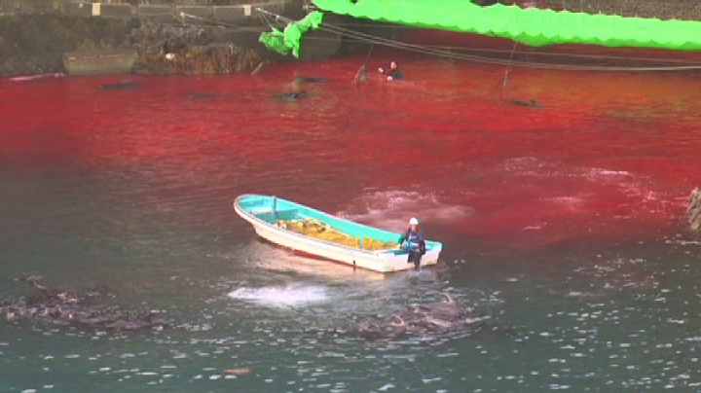
In October 2007, Hayden and Isabel took part in an action in Taiji Japan where they, along with 4 others, risked arrest and paddled out on surfboards to protect a pod of captured pilot whales and to expose the world to the barbaric slaughter of over 20,000 dolphins and small whales by Japanese Fisherman every year. Their actions made international head-lines, the footage was seen by millions of people worldwide, and was featured in the Oscar winning film The Cove.

Currently we are focusing on the following issues:
• Continuing our efforts to stop all whaling by Japan, Norway, and Iceland.
• Continuing our efforts to stop the Japanese coastal dolphin drive hunts in Taiji and the Faroe Islands who slaughter over 20,0000 dolphins, porpoises, and small whales every year.
• Fighting for the regulation of Ocean Noise Pollution at the United Nations.
• Continuing to produce hard-hitting Public Service Announcements (PSAs) and films on the critical issues facing dolphins, whales, and our oceans. We have a new groundbreaking documentary film in production.
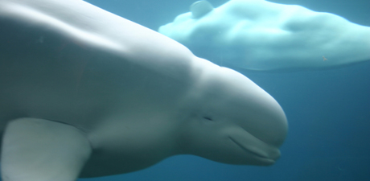
All of us at Whaleman strongly believe that international cooperation is the key to success on these issues. We are committed to capturing the rare and priceless images found in our ocean world in order to continue to preserve and protect it for ourselves and for all future generations, but we can't do it without your help!
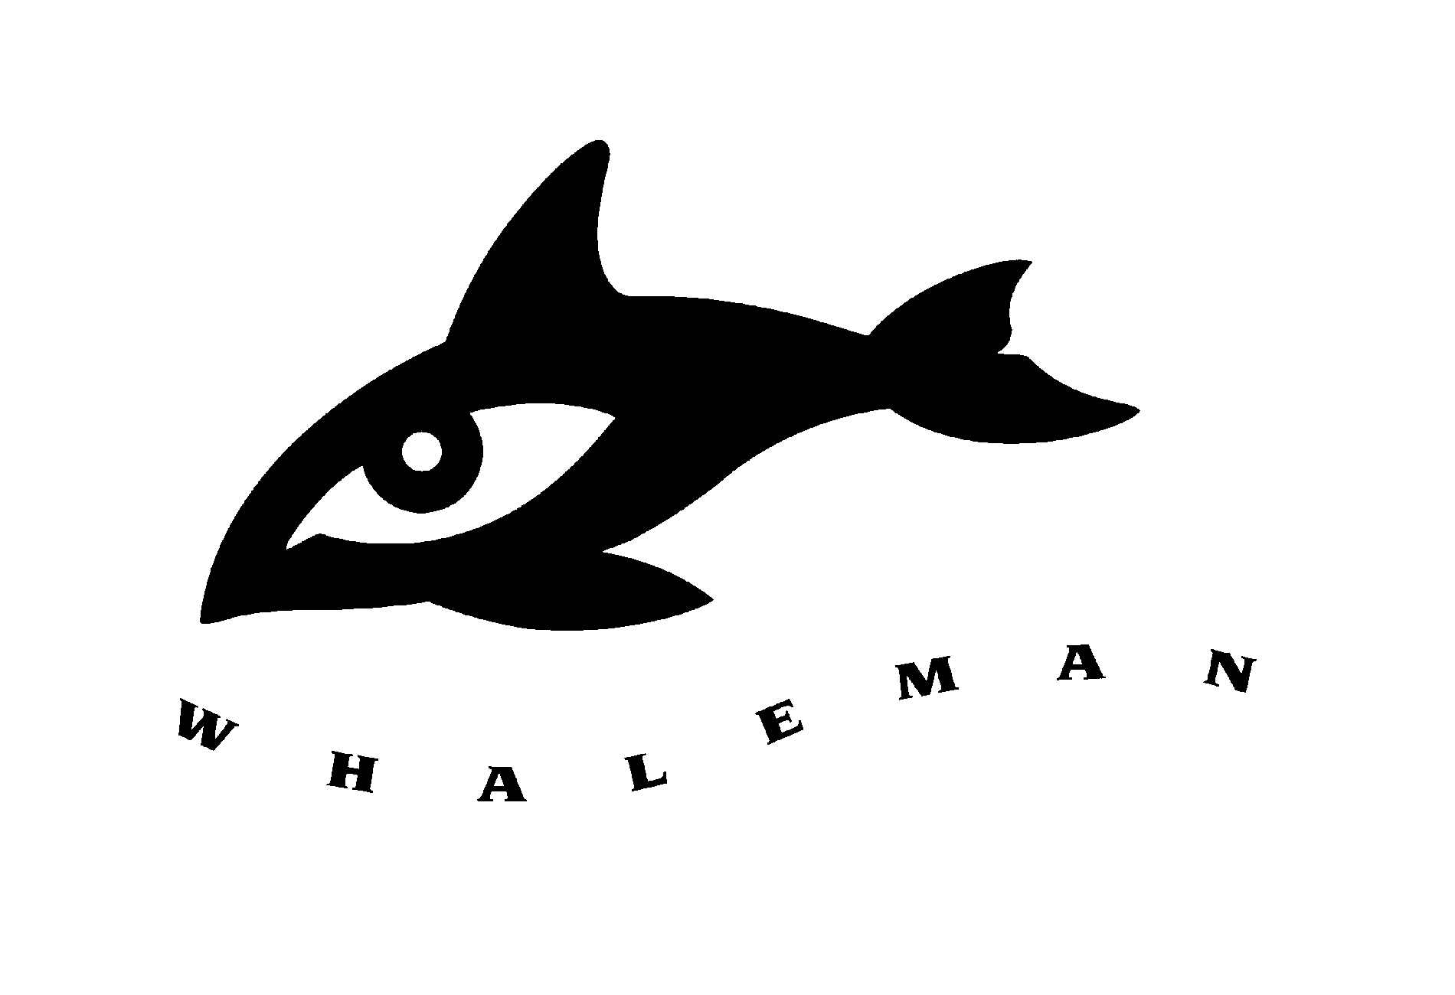

Bringing Whales and Mankind together to Preserve and
Protect our World…

