Success Story
Kumi CYDC is among the 12 FCPs in Kumi-Soroti cluster located in Kumi district in Eastern Uganda with the currently ministering to participants of 443. The community is characterized by low education standards, poor housing, early marriages, domestic violence, drunkenness, high HIV and AIDS prevalence, and malaria incidences. This is as a result of low income and high illiteracy rates and over dependency on subsistence agriculture. The skills CIV was meant to address the skills training gap through setting up a skills Development Center which can be accessed by the participants and the caregivers.
Teso is primarily a non-vegetable growing region and households depend on the vegetables from other regions especially Bugisu /Elgon region and therefore vegetable production was seen as very difficult venture but the church Purchased the green housed from Agrifarm Uganda limited and was installed in March in 2022 in the church premises. The greenhouse is now our demonstration/experimental site of training on Horticulture i.e. vegetable production.
Management of the green house.
The church formed an integrated management 7 member committee including church 02 church leaders,02 caregivers,02 cpc members and 01 staff member. These have steered the operations, procurement and management of the green house. Their clear headed leadership supported by the overseer have thus led to the sustainable production of vegetables in the green house.
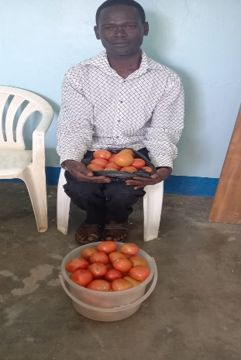
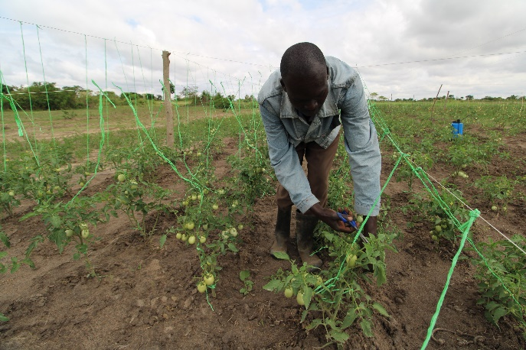
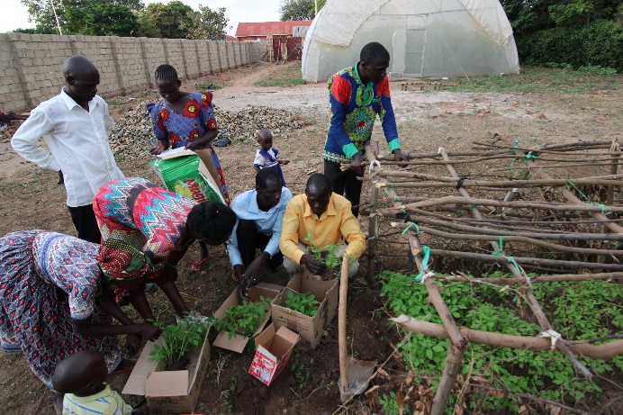
A total of 20 caregivers i.e. 15 males and 5 females, 70 project participants, 5 community members have been trained on vegetable production and this has led to increased number of people engaging in vegetable production as a family business, vegetables ranging from tomatoes, cabbage, onions and eggplant
05 out 20 caregivers have already sold their vegetables and were able to earn minimum average of UGX 200,000 while others are transplanting, others are still having theirs on nursery beds are in different stages of growth. This has helped families to meet basic needs and improved diet.
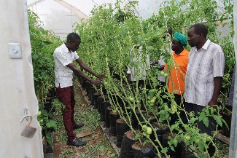
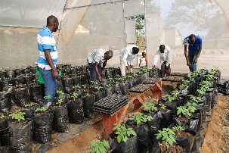
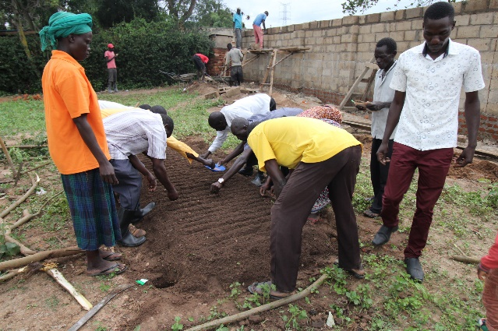
It has also helped the church to bring about transformation within the community through mind set change toward agriculture from subsistence to Commercial farming by enhancing them with knowledge and skills in vegetable production as a holistic ministry approach.
The intervention has benefited the church in establishment of the demo site and income generating activity that generated local resource of 817,000 ug shillings.
As a result of the intervention a total of 16 caregivers have been taken to NASAARI Research station for a study visit where they learnt how to preserve seed for planting and other agronomic practices for different agricultural enterprises.
On the community;
The green house has served as a learning and demonstration centre;
On average more than 500 community members have benefitted through knowledge training or equipping and have adopted the practice of vegetable farming for income generation.
It also served as a unique centre for production of improved tomatoes varieties and centre for modern farming.
The green house has supplied vegetables to more than 500 households in Kumi municipality
The green house has led to improved feeding and nutrition to more than 500 households and mitigated the occurrence of malnutrition among especially infants in the church and community.
In the church, the CIV serves as a knowledge, information dissemination centre for more than 1500 church members in the assembly.
This has complemented government efforts in improving domestic income through increased productivity.
The church is able to earn income from the members who come to
The church plans to do the following;
- The church is planning to conduct more exposure study tours for the caregivers and the participants to trade shows to expose them within the country and in various research stations. The trade shows brings together farmer groups, companies, to promote new appropriate technologies, as Research Institutions come to share new innovations and knowledge with farmers.
- Establish more community demonstration gardens among Caregivers for different Agri-business enterprises
- Start-up VSLA groups among the trained caregivers so as to ease capital acquisition to implement the skills acquired and also to tap government Agribusiness opportunities
- Create links and collaborate with others sister Agencies like NASAARI, SOCADIDO, and District production department to support in capacity building and marketing.
- Dig out a reliable water source (hand dug well) for irrigation in order to scale up the initiative at a reduce cost.
- Recruits skilled personnel (An Agronomist) as the church envision value addition of our products (Post Harvest Handling)
Our appreciation goes to the Godly hearts and families who have laboured to see that we have Funds to support the Participants and the caregivers. May the almighty God prosper them and their families and enrich them beyond borders.
Sustainability
The church plans to expand the production of vegetables, train and equip more participants, church and community and caregivers.
We appreciate compassion international for the support rendered to the church and this is a real time project that is tremendously improving household incomes, church efforts in economic and spiritual transformation as well improving livelihoods. We are grateful to the supporters for meeting the need of the church and caregivers in such a time as this and through this, we are looking forward to achieving the desired outcomes in our child ministry.

