RWANDA RADIO PROJECT FOR ORPHAN FAMILIES

The Freeplay Foundation’s largest and longest running program, has benefitted Rwandese child-headed households since 2000. By February 2009 more than 14,000 Lifeline radios will have been distributed to child families.

We donated 500 Lifeline radios to UNICEF and their report states, “The main objective pursued through the distribution of radios was to encourage vulnerable children to interact and integrate with the community as well as increase their access to information. The donation of the radios has undoubtedly had a positive impact on the lives of the children that benefited from the distribution. UNICEF acknowledges the positive impact that radios may have on the lives of children and is grateful to the Freeplay Foundation for the considerable efforts it deploys to ensure the availability of this product.”

Florentin Manirakiza, a 17-year-old Rwandese youth who heads a household of three children, is quoted: “Before I received the radio, I felt isolated every evening and we all shared sadness with my younger brothers. We now have the radio, which gives us access to interesting broadcasts ever since. We also have opportunities to share listening with the neighbors and enjoy together. The radio also allows me to keep abreast of the happenings inside and outside the country. I am informed about HIV/AIDS and other sexually transmitted diseases and know how to prevent then. I cannot thoroughly say what good the radio has done to me and my family.”

CARE Rwanda is our principal partner at present. The radios are used to support several of their in-country assistance programs including their award winning Nkundabana or ‘godparent’ initiative.

Freeplay Foundation contact in the USA:
Michelle Riley, External Affairs Director and Freeplay Foundation Project Leader for Coffee Lifeline: riley.freeplayfdn@gmail.com

Freeplay Foundation contact in the UK:
Chhavi Sharma, Project Manager, Rwanda: csharma@freeplayfoundation.org

PLEASE SCROLL DOWN FOR MORE INFORMATION ABOUT THE FREEPLAY FOUNDATION, THE LIFELINE RADIO and ACTOR TOM HANKS:

EXECUTIVE SUMMARY

OVERVIEW OF THE FREEPLAY FOUNDATION,

LIFELINE RADIO and LIFELIGHT

Description of the Organization

The Freeplay Foundation’s mission is to transform lives through dependable and clean technologies. We work primarily in sub-Saharan Africa focusing on vulnerable populations - children, women, refugees and people who are ill.

Our key objective is to get solar and self-powered energy solutions – Lifeline radios and Lifelights – into the hands of those who need the poorest and who need them most. Energy poverty is a crucial impediment to progress and to millions of people who strive every day to better their lives.

We work in partnership with governments, international aid organizations, in-country NGOs, local communities, individuals and corporations across seven disciplines:

- Education
- Health
- Agriculture
- Complex emergencies
- Peacemaking
- Economic empowerment for women
- Environment

We build public and private coalitions for the most effective and efficient use of resources. When radio communication is a key component of development success, we can ensure that information is delivered the “last mile” to communities in the most remote, inaccessible locations.

The Freeplay Foundation in radio communications initiatives

Since 1998, the Freeplay Foundation has been creating access to radio information and education for vulnerable and isolated populations via self-powered radios.

The Foundation is committed to promoting the importance of radio as a vital medium in the developing world. In communications projects, the Foundation can ensure that information is delivered the “last mile” to populations in the most inaccessible locations. It can serve as the final point in a seamless line of communication -- from satellite and internet-based information, through television and print material -- all the way to Lifeline self-powered radio access in the remote villages and refugee camps. The Freeplay Foundation works in a dozen African countries and is on the cusp of becoming a major force within the humanitarian development world, because no one else can offer what the Freeplay Foundation can. In a global communications campaign, the Foundation is the final step.

The power of radio remains unrivalled

In developing countries, especially in areas with large, non-literate populations, radio remains the primary means of communication. Roughly 5 % of sub-Saharan Africa is Internet connected and in South Africa its 10%. However, in most of the developing world, electricity is non-existent and the high cost of batteries makes them unaffordable on an ongoing basis, especially to women and children.

Millions of dollars are spent worldwide each year to produce excellent radio programming for development purposes, yet the poor may never hear it. They are unlikely to receive critical information that can help prevent deadly diseases, improve hygiene, raise agricultural productivity, learn English and math through radio distance learning, or enjoy any educational instruction that could help lift them out of extreme poverty and learn about global warming. Lifeline radios solve the problem of access for these audiences.

The Freeplay Foundation is a tax-exempt 501(c)(3) charitable organization in the USA, with its External Affairs Director working from Savannah, Georgia. Additionally, it is a registered charity in the UK and has both Section 21 and 18A charitable status in South Africa. The Foundation’s main office is in London. It has an office in Johannesburg and consultants based in the USA.

Description of our work

Intensive field work in remote areas of Africa to put the radios into the hands of people who needed them most helped establish the Freeplay Foundation’s reputation for speed, flexibility, efficiency and results. As local organizations expressed a tremendous need for wind-up and solar-powered radios, we fostered partnerships among global multilateral and bilateral agencies and national governments.
In 2001, the Freeplay Foundation won the first Tech Museum of Innovation Award. The $50,000 NASDAQ-sponsored grant financed the research and development of the Lifeline radio. Other contributors included Anglo American and the Vodafone Group Foundation. The design brief of the radio was created with extensive input from potential end-users and every aspect was rigorously field-tested. Two years later, 18-year-old Devotte Hafashimana became the world’s first Lifeline radio recipient. A shy Burundian living in the Nduta refugee camp in Tanzania, Devotte was one of 500 mainly female youth listening group leaders who received Lifelines as part of a Voice of America (VOA) youth communications project.

Partners throughout Africa, Europe and the US started including Lifeline radios in their humanitarian projects. Six years later, more than 160,000 Lifeline radios have been distributed, conservatively benefiting over six million people in sub-Saharan Africa alone. Lifeline radios have been integrated into dozens of radio health, education, agricultural and peacemaking communications projects across the continent.

Our move into clean, safe lighting

We recognized that Freeplay’s technology could provide portable, safe, clean lighting for the poor who are dependent on dangerous and inefficient fossil fuels.

After a series of lighting needs assessments with child and granny headed households in rural and peri-urban South Africa, we worked with Freeplay Energy to create a range of lights and lanterns called Lifelights. Like the Lifeline radio, they are charged by either solar energy or by Freeplay’s patented wind-up technology, which is more than twice as efficient as other wind-up mechanisms.

The lights can be safely used for studying, grading papers, home-based micro-enterprises, increased security, night-time sales, night births and other medical emergencies. They can be used as flashlight at night to the toilet or to neighbors. To ensure Lifelights are sustainable and contribute to economic empowerment, we will seek market-based channels to distribute them with an emphasis on the participation of women’s groups.

We continue to explore other energy solutions. A foot-powered generator, the Freeplay Weza (“power” in Swahili), charges a range of low energy devices. The Weza provides up to 12 volts of power for charging phones, lights and other low energy devices. We are piloting income generation projects, training women to establish self-financing Weza micro-enterprises.

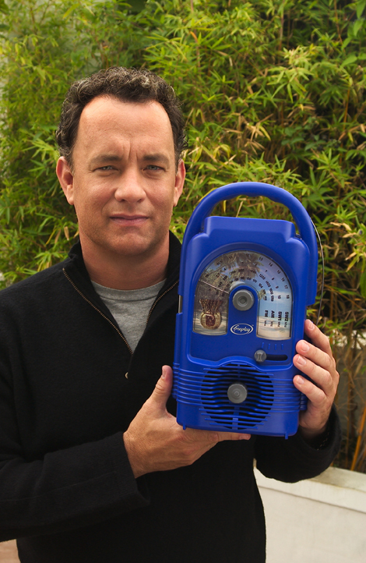

Two-time Academy Award® winner Tom Hanks is the Freeplay Foundation’s Ambassador in the USA. For the past six years Tom has generously funded radio education projects in Tanzania and Rwanda. In addition, he has funded our lighting research and field assessments.

“The extraordinary technology of the Freeplay Foundation’s Lifeline radio can bring vital information to isolated people all over the world,” said Mr. Hanks. “For example, right now there are more than 13 million children orphaned by AIDS. Most can’t attend school and can’t afford batteries or electricity to power a radio. The Freeplay Foundation can hand these children a lifeline to the outside world by giving access to radio programs that teach them how to grow their small garden plots to feed themselves, take care of their chickens or goats, and prevent deadly diseases like malaria and AIDS.”

Mr. Hanks joins humanitarian Terry Waite, who serves as the Foundation’s European ambassador. Mr. Waite is well known in the U.S. as the special envoy to the Archbishop of Canterbury in the 1980s. While negotiating the release of U.S. hostages in Lebanon, Mr. Waite was himself taken hostage, serving most of his five years in captivity in solitary confinement. Mr. Waite is a well-known author, humanitarian and commentator on the BBC and other global media.

Our African Ambassador is Sibusisu Vilane, the first black African to climb Mt. Everest (and he’s done it twice) and to trek to the South Pole. Growing up in rural Swaziland, Mr Vilane knows first-hand what it is like to live without electricity and to be dependent on dangerous kerosene and candles.

###

Key Design Features and Benefits of the Lifeline Radio

Below describes the features and benefits of the Lifeline Radio. Orphaned children in South Africa, Rwanda and Kenya were consulted throughout the design and development process. The size and shape of the Lifeline Radio is a result of focus group research. The more it is wound, the longer it will play.
Children can grip the handle without difficulty. While the Lifeline Radio is large, it is lighter than other Freeplay radios used in development projects.

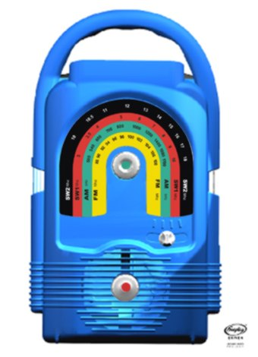
The antenna is an ordinary piece of wire, which can be replaced with any piece of wire. It can be taken off and put back on at will as antennas break easily.

The solar panel is housed in a detachable waterproof casing on a three-meter lead with magnetized clips on top to hold it securely in place. The Lifeline Radio operates in the harshest of conditions in extreme temperatures, rain, moisture, dust, sand and humidity.

The rainbow shaped dial scale has large print making it easy to read even for the visually impaired. As AM/FM/SW is difficult to understand for some, each band is color-coded.

The winding handle (on back) can be turned in either direction to charge the radio. Earlier Freeplay models could only be wound clockwise. Fully charged, the Lifeline Radio can play for many hours.

The dial scale and Lifeline Radio can be custom produced in any combinations of colors, which cannot reflect political parties.

The sound quality is excellent enabling at least 40 people to hear it clearly.

Four-band coverage, AM/FM/SW1/SW2 ensures access to many channels and perspectives. For example, in Zimbabwe where programming is government controlled, SW broadcasts can be received.
Each knob is purposely a different shape.

