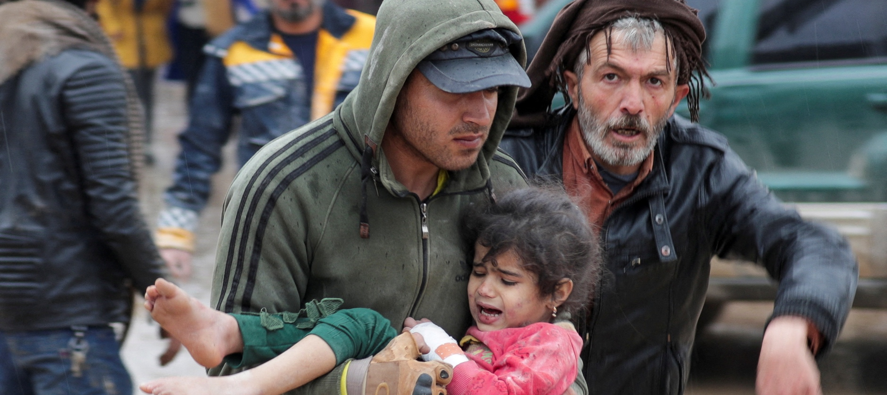
Photo credit: Reuters

TURKEY AND SYRIA

Deadly earthquakes force thousands out into the snow

Background
At 4:17 am on February 6, a 7.8-magnitude earthquake struck southern Turkey and northern Syria, killing at least 2,500 people and injuring nearly 9,000. Buildings began to crumble immediately, forcing people to rush out of their homes as quickly as possible – taking little, if anything, with them. At the height of winter, the streets are covered with snow, and so people are left with the choice between being unsafe inside a compromised structure or outside in freezing temperatures. Hours later, the region experienced a second earthquake with a magnitude of 7.5 in addition to a series of strong aftershocks.

Much of the damage is concentrated in southern Turkey, where the majority of the Syrian refugees in the country are hosted, as well as in northern Syria where approximately 60% of the population is internally displaced. With an impending winter snowstorm expected in the coming days, it is imperative that the international community acts quickly to ensure the health and safety of affected families.
A family makes their way from the rubble of their home in the dark

CARE’s Response
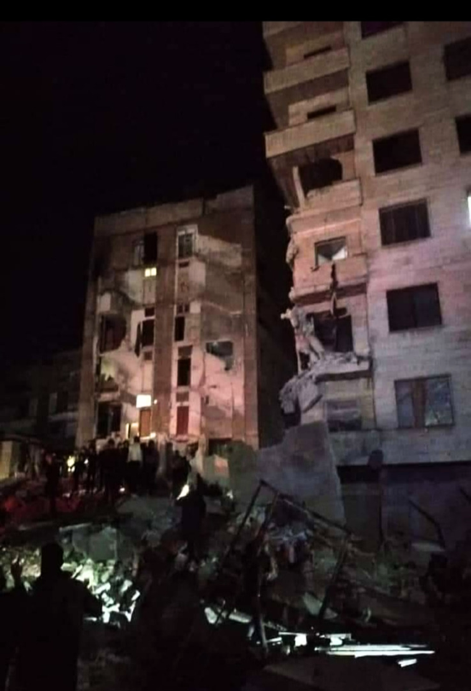
CARE’s team in Turkey (Türkiye) is prepared to launch an initial response with the delivery of essential supplies, like water, sanitation and hygiene (WASH) materials; tents; blankets; food; cash assistance and other emergency items. CARE plans to collaborate with the Turkish Disaster and Emergency Management Presidency to deliver supplies to people in makeshift shelters across Turkey, including schools, mosques and other government-managed shelters. CARE will also continue our existing cross-border operations to respond to the worst affected areas in Northwest Syria, where on-the-ground teams and partners are working to deliver blankets, food, mattresses, tents and other non-food items to people in need amid harsh weather conditions.
Damage caused to residential buildings in Gaziantep, Turkey

CARE has several established partners in the area, as well as established programs and offices. CARE operates four safe spaces for women and girls in the earthquake-affected area, and teams have been sent to ensure that the structures are sound and are ready to provide safe shelter for those in need.

CARE is also preparing to launch a wider assessment of the damage to infrastructure throughout the region. Local partners are requesting our help in conducting search and rescue efforts, including the removal of debris with heavy machinery and waste management at temporary shelters.

Funding Target
CARE seeks to raise $30 million to provide immediate, lifesaving assistance to 90,000 people affected by the earthquakes and to support the medium and long-term recovery of the region. Some examples of how your gift could help families affected by the floods include:
- $35 can provide a family with a set of five blankets;
- $37 can provide a family with a kit of essential hygiene supplies;
- $40 can provide a family with a basic kitchen set so they can continue to prepare their own food;
- $173 can provide a family with warm clothes to survive the winter; and
- $1,035 can provide a displaced family with a temporary shelter.
“Currently, we’re in dire need of immediate support in the form of financial assistance to make sure that those who are out in the cold are able to find warmth, those who are hungry are able to eat, and children who are already suffering from malnutrition are able to survive. Obviously, our priority, at this point, is the people of southeast Turkey and Northwest Syria, who have been hit the hardest by one of the most destructive and wide-reaching earthquakes to impact the region in recent times.”

̶ Sherine Ibrahim, Country Director of CARE Turkey

Conclusion
The earthquakes that have hit southern Turkey and northern Syria have already claimed the lives of at least 2,500 people. With a winter storm expected to strike in the coming days, we must act quickly to ensure that the families that have been displaced have access to shelter, food and other essential items so they can get through the winter. On behalf of the people and communities impacted by CARE’s response, we thank you for your generous contribution to the Turkey and Syria Earthquake Response fund.

February 2023

In order to effectively manage the current emergency response and continue to be able to deploy resources for other emergencies, CARE will reserve 20% of donations to the earthquake response to cover technical support, administration and emergency preparedness expenses, including the rapid deployment of staff to emergencies such as this one.

