EMPOWERING THE UNDERPRIVILAGED

DEAR FRIENDS OF THE HOPE FOUNDATION OF PALESTINE, WE THANK YOU FOR YOUR GENEROUSITY, BUT WE NEED YOUR HELP AND SUPPORT
Few things make me happier than seeing a smile on the face of a child receiving a new school bag for the new school year or receiving a winter package for the cold winter months.
As The Hope Foundation of Palestine supporter, you should know that we are helping further more families by working with other caring nonprofit organizations in the USA, Gaza, and the West Bank to provide support to the poor, needy, and the underprivileged.
We have the following projects that are well-established:
- School bags full of school supplies. Every August. $40 per child. School bags are manufactured locally by single mothers.
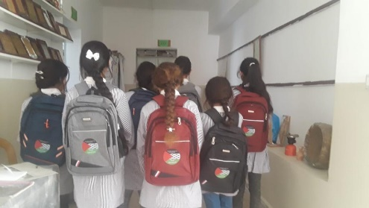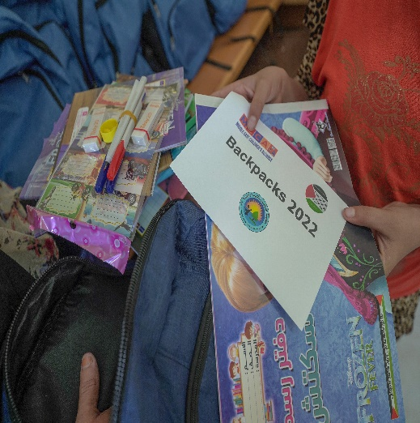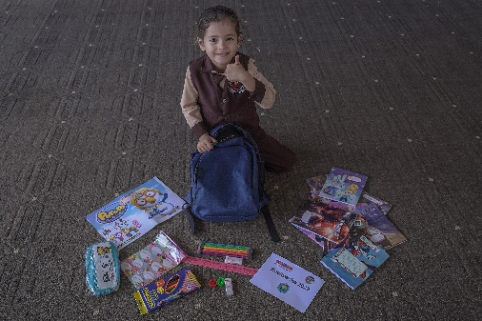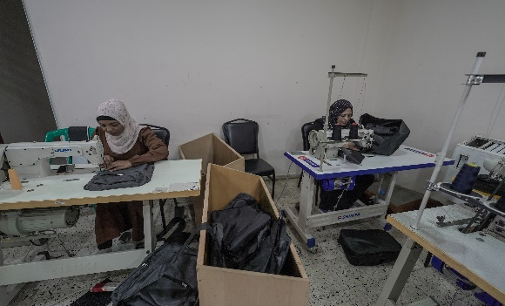
- Winter relief package to children. Every December. $50 per child. Some items are manufactured locally by single mothers.
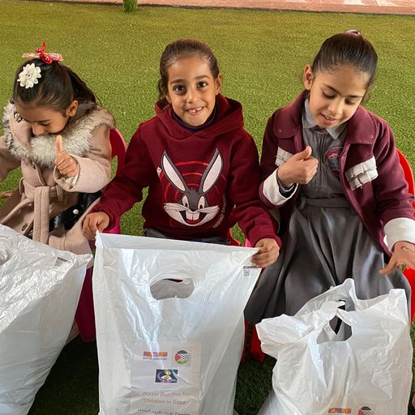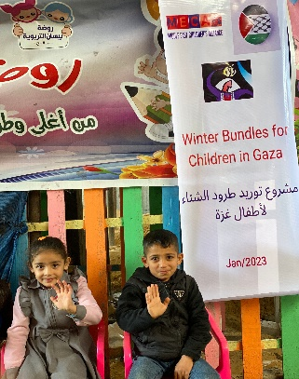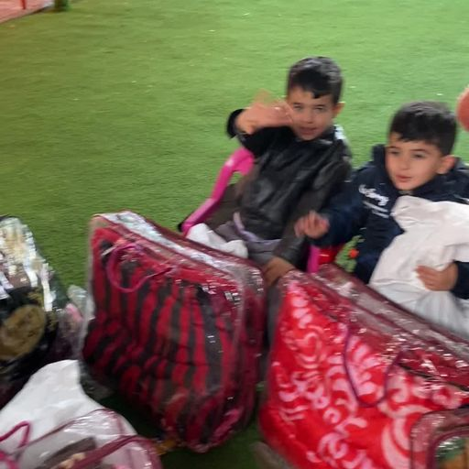
- Food Parcels. Monthly if funds are available but Ramadan is and before Eid Al-Adha. $50 per family in Gaza, and $70 per family in the West Bank. Fresh fruits and vegetables are grown locally by single mothers.
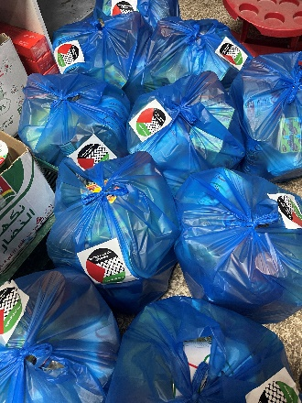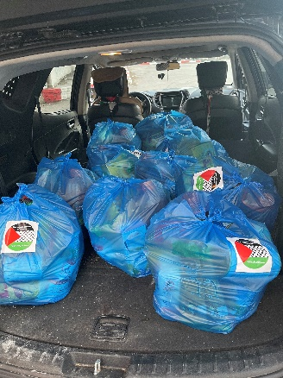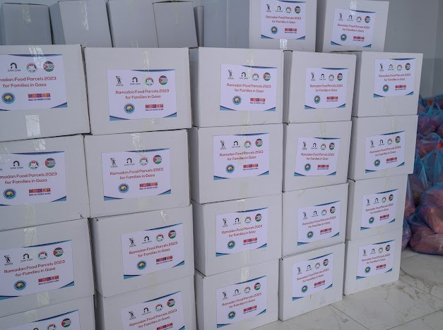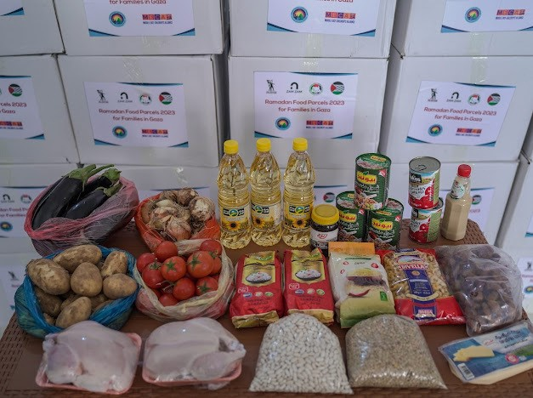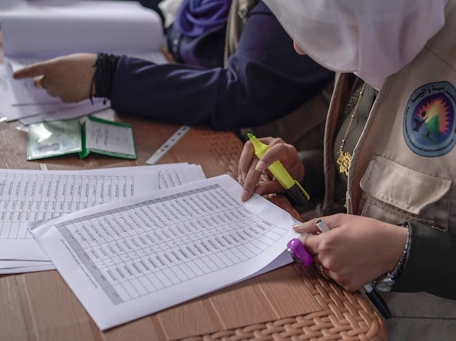
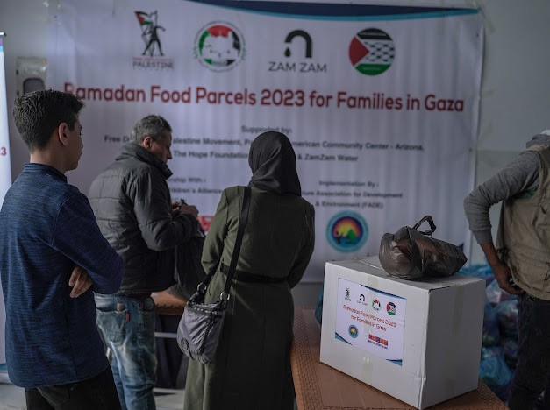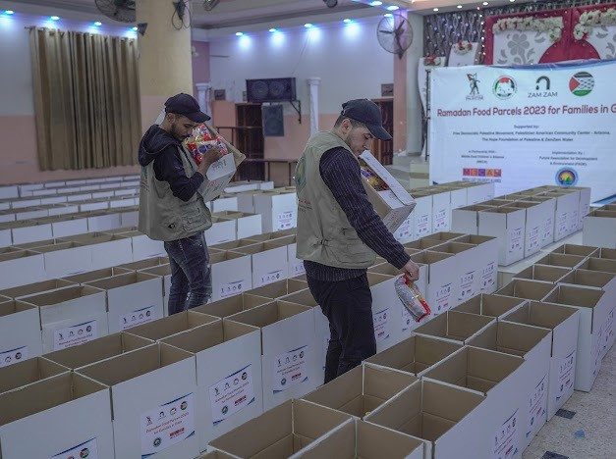

- Safe drinking water in schools in the West Bank and Gaza. This depends heavily on the availability of funds.
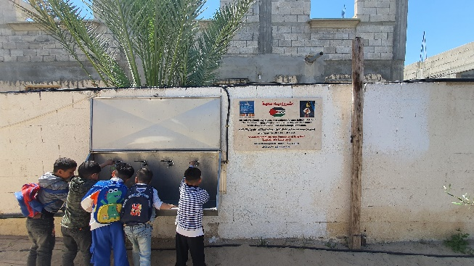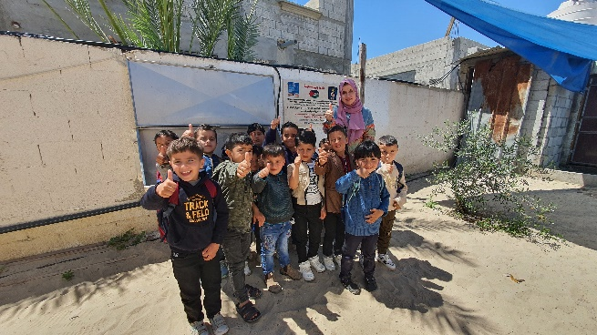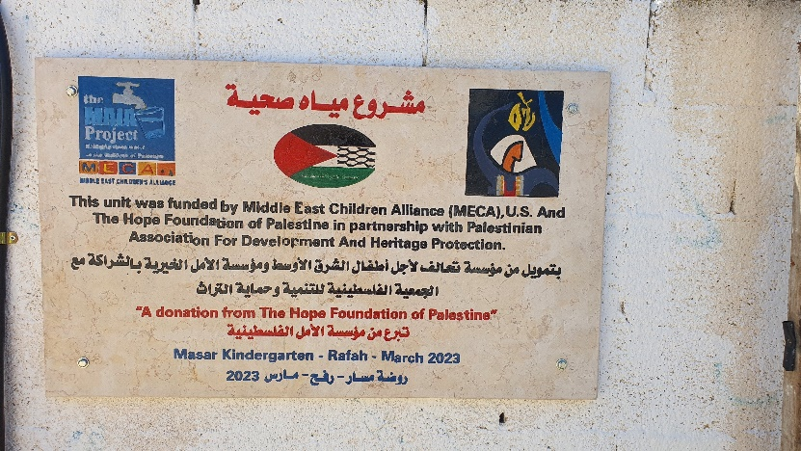
Our work is improving lives and communities little by little.
Thank you for your generosity, without you, our work would be very limited.
For more updates, pictures, and videos, please visit our website.
www.thehopefoundationofpalestine.org
Rest assured; every dollar of your donation goes directly to our causes. Trust in our foundation and transparency to our donors is always our goal.
We have been for the past several years partnering with Global Giving platform for our fundraising, donors can always donate through our website. Donation through our website is less costly to us than through Global Giving.
Below is a link to our campaigns on Global Giving
www.globalgiving.org/donate/95996/the-hope-foundation-of-palestine/
Donate with confidence, see our seals from Global Giving by following the link below,
www.globalgiving.org/dy/v2/pe/dashboard/badges/?organization.id=95996
Yet, the needs are growing and in particular in the education sector.
That is why I’m writing to you today. First to thank you and update you on our work and second to ask for your help and support for the projects below. Project 1) and 2) are on the expensive side and we need all the help to start them. Please spread the word to your friends of our mission.
Several projects that need immediate attention,
1) Educational centers to supplement the loss of time at schools during the school year, free of charge to the whole community. This project is unique to the Hope Foundation of Palestine.
2) Technology supplies to the schools. Computers, smartboards, and doc-cameras. Most public schools have none, which makes teaching at this age a challenge. These educational aids are a must to help teachers and students gain confidence again the educational system in Palestine. This project is unique to the Hope Foundation of Palestine.
3) Of course, all the other projects that we are running are always in need of funds to reach more needy families with children in both the West Bank and Gaza.
Your help did so many good things in the West Bank and Gaza for the past several years, we hope that you will continue supporting us. Monthly donations will help us, allow us to plan for the future and will make a much bigger impact.
To our Muslim Brothers, let your Zakat and Sadaqah make a difference.
We are deeply grateful for your support. Your donation makes a huge impact for today, tomorrow, and all the time!
God Bless
Dr. AbdelNaser Al-Hasan, CEO
The Hope Foundation of Palestine
501(c)(3) Registered in the USA
EIN# 85-3866495

