PROJECT REPORT
Provide Basic Healthcare for a Community in Bauchi (#58340)
Brief on project at identified PHC
Dabarbaga Health Clinic, located along the Burra-Kano Road in Ningi Local Government area of Bauchi state is the Primary Health Centre selected for revitalization. With a catchment area population of about 17,500 people, the average monthly clinic attendance is very low, at about 11 people. Health care services offered at Dabarbaga Health Clinic include Malaria Treatment, antenatal care, and immunization. The facilities at the Dabarbaga Health Clinic such as water and power supply are in poor condition and extremely dilapidated. Additionally, health workers are in acutely short supply. There are also no known health intervention programs available at the Primary Health Centre.
The pictures below show the existing condition of the Health Clinic.
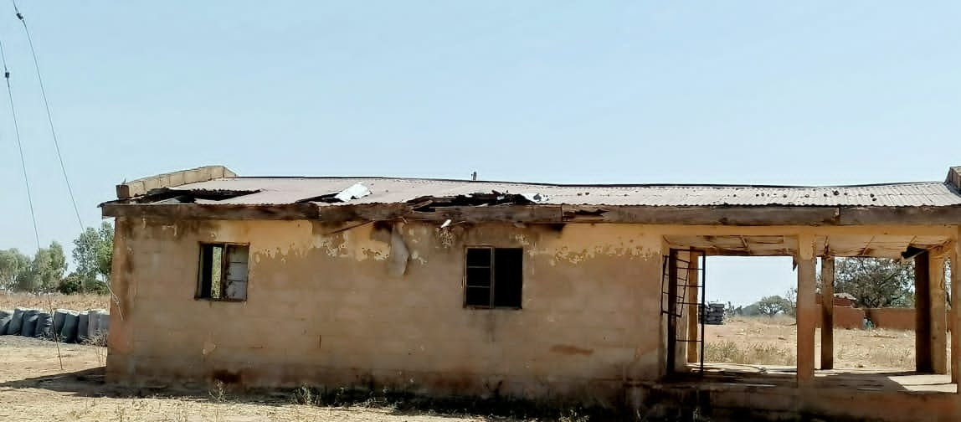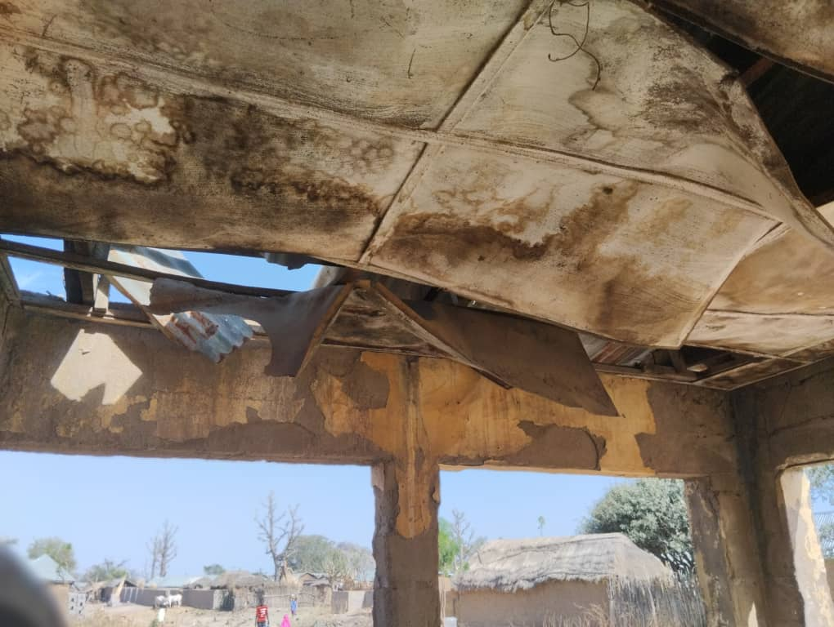
Side view of abandoned Dabarbaga Primary Health Center Image of dilapidated Maternity ward at Dabarbaga PHC

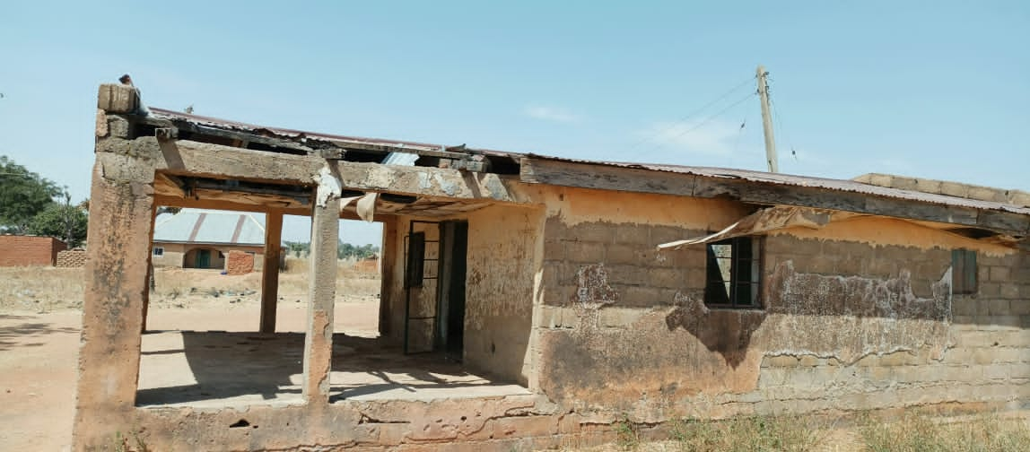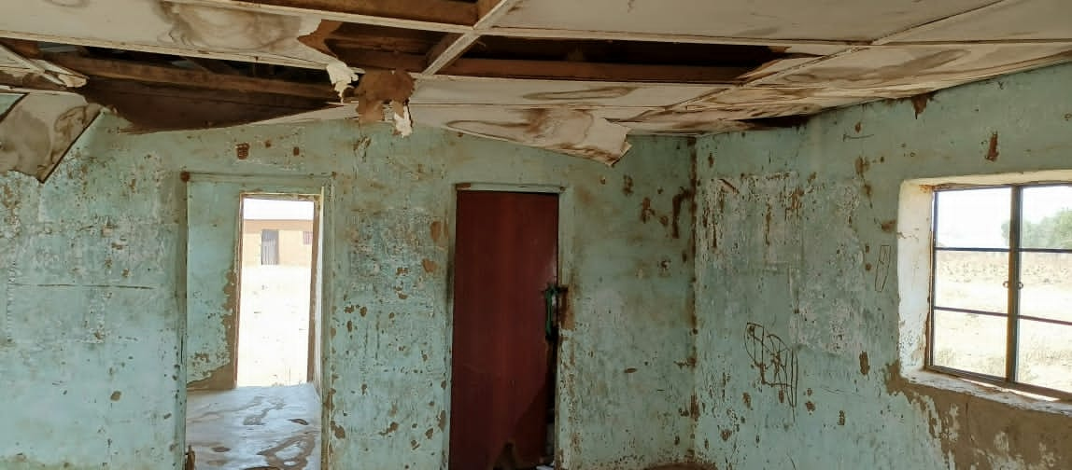
Front View of abandoned Dabarbaga Primary Health Center Image of the entrance into the Maternity ward at Dabarbaga PHC

Summary of activities
Engagement of the Bauchi State Government on the intended revitalisation project at Dabarbaga Health Clinic, Ningi Local Government is still in progress, and the key milestones achieved thus far includes, signing of the memorandum of understanding between our organization and the Bauchi State Government, and approval of renovation plan on the physical structure of the primary health center by the State Primary Health Care Development Agency (SPHCDA).
An Infrastructure Preliminary Survey on the Dabarbaga Primary Health Center has been completed.
The constitution of the community governance committee composed of key representatives from the community who will be charged with supervising the revitalisation project on behalf of the community has just been completed. The community governance committee have commenced background work ahead of the revitalization kick-off, indicative of a high level of reception and expectation by the direct beneficiaries of this revitalization effort at Dabarbaga.
Detailed assessment of the Health Clinic and the compilation of the assets list including medical equipment has commenced.
Conclusion – The quality of care at Darbarbaga Health Clinic, Ningi Local Government remains at a critically poor level. In addition to the poor quality of care, access to quality health care at Dabarbaga has also been challenging and very tedious as community members in need of health care are required to travel to the neighbouring community to access any form of health intervention.
There is a need for more awareness to raise significant donor funding to provide the constituents of Ningi community in Bauchi State with access to basic healthcare and potable water. This will promote healthy living and reduce the occurrence of common ailments like Malaria, Cholera, and Diarrhea, among children. At the end of this campaign, the following are expected as outcomes:
- Raise 20,000 USD.
- Improved healthcare in the community.
- Reduction in cases of child morbidity and mortality due to preventable diseases.
- Better skilled healthcare workers.
- Provision of basic hospital equipment to improve health services.
- To set up a functional Community Health Committee to ensure accountability and sustainability of quality healthcare.

