PROJECT REPORT
Provide Basic Healthcare for a Community in Bauchi (#58340)
Brief on project at identified PHC
Dabarbaga Health Clinic, located along the Burra-Kano Road in Ningi Local Government area of Bauchi state is the primary health care selected for revitalization. With catchment area population of about 17,500 people, the average monthly clinic attendance is very low, at about 11 people. Health care services offered at Dabarbaga Health Clinic includes, Malaria Treatment, Ante-Natal Care, and immunization. The facilities at the Dabarbaga Health Clinic such as water supply and power supply are in poor conditions and extremely dilapidated. Additionally, health workers are in acutely short supply. There are also no known health intervention programs available at primary health care centre.
The pictures below show the existing condition of the Health Clinic.

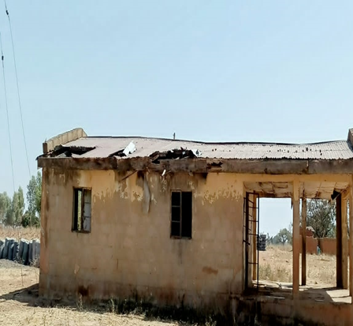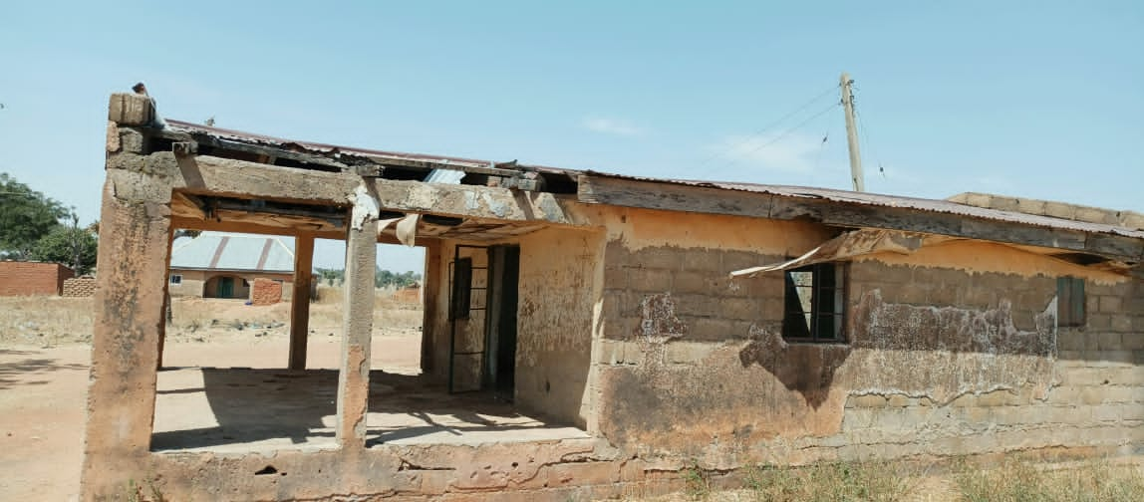

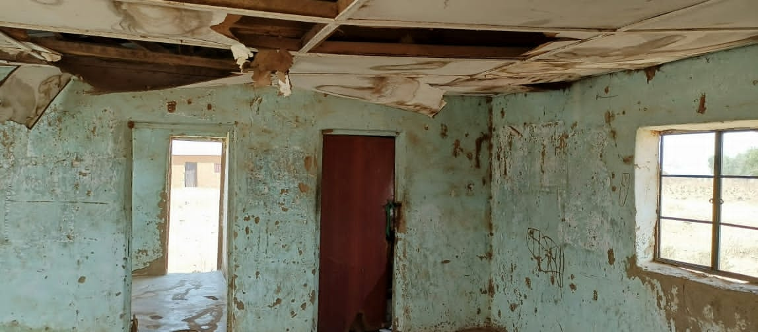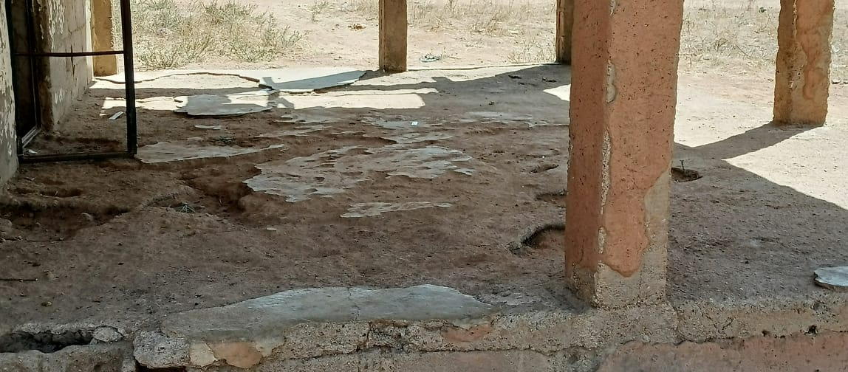

Summary of activities– Engagement of the Bauchi State Government on the intended revitalisation project at Dabarbaga Health Clinic, Ningi Local Government has commenced. Primary Health Care Infrastructure Preliminary Survey has been completed, detailed assessment of the Health Clinic and the compilation of assets list commences next.
Conclusion – There is a need for more awareness to raise more donor funding to provide the constituents of Ningi community in Bauchi State with access to basic healthcare and potable water. This will promote healthy living and reduce the occurrence of common ailments like Malaria, Cholera, and Diarrhea, among children. At the end of this campaign, the following are expected as outcomes:
- Raise 20,000 USD.
- Improved healthcare in the community.
- Reduction in cases of child and female morbidity and mortality due to preventable diseases.
- Better skilled healthcare workers.
- Provision of basic hospital equipment to improve health services.
- To set up a functional Community Health Committee to ensure accountability and sustainability of quality healthcare.

