Living in Paradise
By: Will Bullard, Director of Development
March 2005

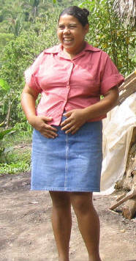
Milagro Esperanza Martinez Solis and I had made an appointment to meet last Thursday at 10:30 AM at the foot bridge in Toncontin so she could take me to see her home. It had been a week since we had made the appointment, and in a part of the world notorious for a lax attitude toward punctuality it seemed unlikely that she would show up on time, but sure enough there she was. As Director of Development for the Adelante Foundation visiting with clients in their homes and being inspired by their accomplishments is one of the perks of the job.
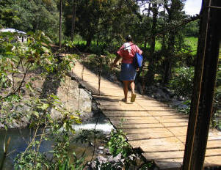
There are no roads to Milagro's beautiful mountainous hamlet of Paraiso (Paradise in English). To get there you have to walk one and a half hours, maneuver over two swinging foot bridges (one of which is frighteningly similar to a thrill ride at an amusement park), cross eleven creeks and hike up various hills. Definitely "off the grid," electricity and running water are miles away. When we arrived at her home Milagro pointed out that my shirt was soaking wet while she hadn't sweated a drop. Milagro makes this hike several times a week to sell her hand-made clothing, to shop and to attend Adelante's bi-weekly Assembly meetings.
The responsibility to remain on the homestead to care for their aging parents fell on Milagro, the second youngest of eleven children, but scratching out an existence in this rugged remoteness is nearly impossible. Milagro and her husband work hard from dawn to dusk, but together they earn no more than $40 per month for their family of five. Subsistence farming helps ensure that they usually have something to eat. As you can see in the first photo Milagro doesn't appear to lack for food, but here many women look that way because they eat an unbalanced diet consisting almost exclusively of starches. The day I visited, the bags that usually held beans and rice were empty. I didn't have the courage to ask how long they'd been that way. It would be homegrown plantains with salt for that day's lunch and dinner.
Since childhood Milagro has enjoyed selling things and making money, but it frustrated her to only have ten or fifteen dollars in local currency to work with. When she heard about Adelante’s loan program she naturally rushed to sign up. At 32 years of age she was thrilled to finally have the chance to start building a business that could mean a tremendous change to the quality of her life and that of her family.
With her first Adelante loan of $60 Milagro bought a donkey. Owning a donkey in Paraiso is akin to owning a pickup in the US - everybody wants to borrow it to ferry things so she rents it out as a business. So far the investment has paid off and will continue to do as long as the animal remains healthy.
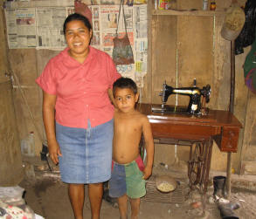
With her second loan of $125, Milagro purchased a used sewing machine, operated by a foot pedal, so she could make clothes to sell. She proudly displayed a shirt she had sewn that had a good deal of intricate detail. I purchased a skirt for my daughters that was surprisingly hip considering its origins. In her tiny mud and thatch roof house the walls were covered with newspapers to provide a splash of color. The relatively high tech sewing machine stood out. It and the donkey are the family’s only possessions of value and Milagro is justifiably proud of them. She also takes pride in a mirror that hangs on a wall. At $30 it was an extravagant purchase she could have easily have done without, but a store owner allowed her to pay in installments, and Milagro understood how important it was for her ten year old daughter. As the father of two young girls, I completely understood her rationale and was profoundly touched by the sacrifice it must have required.
To provide as good a life as possible for her three children, Milagro made the rare decision to have a hysterectomy (a government agency performs the surgery for free for those who can't afford to pay for it). She was open and quite proud about this decision even though others in her community might question her reasoning since the prevailing logic is that the more children you have the better you'll be provided for in old age. Listening to her you can't help but sense that she is a strong woman with a passionate belief in a better future.
The day before my visit, Milagro’s mother-in-law had to be rushed to the hospital. The cost for the emergency operation required everything Milagro and her husband had managed to save over the previous two months: $31.50. It was the all the money they possessed. As tragic as this may sound, Milagro took it in stride because her life has consisted of hardship intermingled with crises. There was even a bright spot: for the first time in her life Milagro had some savings with Adelante she could withdraw to help make ends meet. We require our clients to save a small amount each loan period in part so they can better cope with these types of emergencies.
Milagro Esperanza's name translates into Hopeful Miracle. A person named Hopeful Miracle living in Paradise might sound like the basis for a surreal Latin American novel. Unfortunately Milagro's life is all too real and, for a multitude of reasons, it will continue to be a struggle for the near term. But with her energy and Adelante's loans, savings and education programs, she has the opportunity to work her way toward that brighter future she envisions. It might take years and heroic levels of determination, but I left her village confident that Milagro is up to the challenge.
