Feminist lawyers are the tool to dismantling the master’s house
This year, AdvocAid welcomed a new partner on board - Clooney Foundation for Justice, a human rights institution that advocates for justice through accountability for human rights abuses throughout the world. With AdvocAid’s vision being - that women and girls in Sierra Leone have their human rights respected and protected by a gender-responsive justice system and are empowered to secure their rights and hold the system to account, a partnership such as this that recognises that the justice system is supposed to protect women, but all too often courts perpetuate discrimination shows how important it is to build a justice systems that protect the vulnerable in society such as women and girls who experience violence simply because they are simply women.
With this partnership, AdvocAid was selected as one of the organisations in Africa to host one of the fellows from the inaugural Waging Justice for Women (WJW) fellowship. The aim of this initiative is to fight injustice against women through strategic litigation to reform discriminatory laws and increase accountability for gender-based abuse. As AdvocAid sets out to strengthen the feminist legal base in Sierra Leone, a fellowship like this gives us an opportunity for us to achieve what is set out in our 5 year feminist strategic plan. In July, 2023, I, Ms. Willietta V. J. C. Hughes, a Barrister & Solicitor of Sierra Leone joined AdvocAid as a Legal Fellow to not only strengthen AdvocAid’s work but also to wage justice to create a Sierra Leone where the human rights of girls and women are protected. Throughout the period that I have been at AdvocAid, I am delighted to be part of an organisation that is dedicated to pursuing access to justice for women and girls while fostering a feminist law and policy reform.
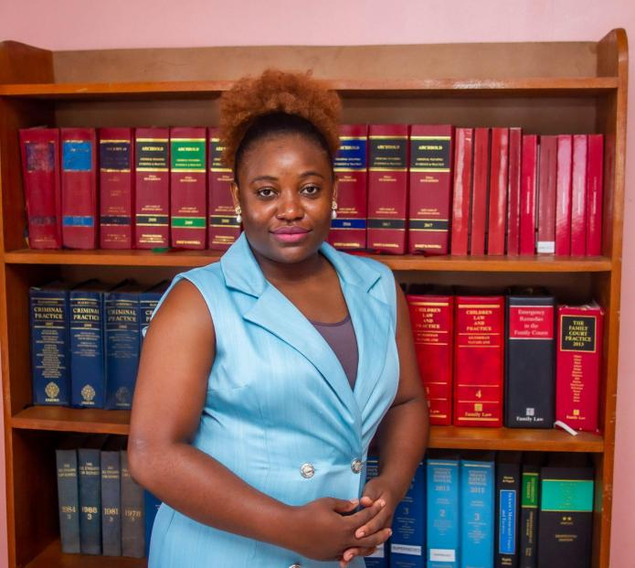
The Waging Justice for Women fellowship has provided me with an environment that supports early career female lawyers like me that are committed to championing issues affecting women and girls. Being a woman myself, a feminist and a lawyer as well that is aware of the injustices that women and girls experience, my lawyering is informed by the experiences of African women. As Simone de Beauvoir once said: "It is in the knowledge of the genuine conditions of our lives that we must draw our strength to live and our reasons for acting. So a fellowship like this that nurtures more feminist lawyers across Africa only means that securing women’s rights and the rights of girls is a global effort that we should all invest in if we want justice for our women and girls.
Between the 23-27th July 2023, we held an engagement in Nairobi, Kenya and I was honoured to meet other fellows and the Clooney Foundation for Justice team. My experience from this convening is that without community, there is no liberation and I am glad I found this community in the WJW fellowship.

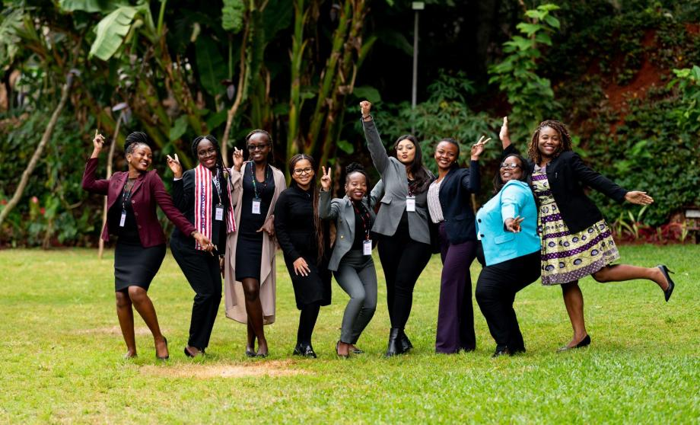

One of the key highlights of this convening were the simulations and training that included - strategic litigation, feminist lawyering, how to conduct trauma informed interviews and reflections through yoga sessions e.t.c. One key takeaway from all these sessions is that feminist lawyering goes beyond legal analysis and personal belief systems. It involves an alertness to the ways we work and commune with others, especially the most vulnerable in society. Being part of this inaugural fellowship of WJW has given me an opportunity as an early career female lawyer to strengthen my legal career and having and still experiencing this, I look forward to seeing more young women experience a fellowship like this. With Sierra Leone having a low proportion of women lawyers and paralegals that will contribute to a more gender-responsive justice system, I believe this can be changed through such programs as they provide tailored mentorship and training to young women lawyers like me that are committed to waging justice for women and girls.
“For the master’s tool will never dismantle the master’s house. They may allow us temporarily to beat him at his own game, but they will never enable us to bring about genuine change.” - Audre Lorde. I have reflected on this statement and I ask myself…Is there hope to dismantle the master’s house? Yes! I believe we feminist lawyers are the tool to dismantling the master’s house and a partnership like this between two human rights organisations is the vehicle to achieving this.
At AdvocAid, we are truly grateful for every donation as your donation signifies your belief in our cause and willingness to move on this journey with us. Thank you for your continued support and we encourage you to keep contributing to this cause.

Developed by:
AdvocAid’s Legal Fellow Willietta V. J. C. Hughes Esq. (ACIArb)
Barrister & Solicitor- Sierra Leone
Waging Justice for Women (WJW) Fellow

