 Monthly Report

|  |  |
| --- | --- |
| Center Name | Alzahraa Medical Center (AMC) |
| Prepared by: | Youssef K. Aouli |
| Name of Coordinator / Manager:  *Name, email, and phone* | Name: Youssef K. Aouli  Phone Number: +961 3041125 Email: health.pm@aica-lb.org |
| Reporting period  *From – To* | 1st September 2024 to 30th September 2024 |

# Management Update:

)Administrative decisions , new projects…)

* We are expecting to sign a new project with the World Bank in collaboration with the Ministry of Public Health. This project encompasses medical packages tailored for low-income individuals registered with the Ministry of Social Affairs.

# Department Update:

(numb of ben, services, activity implemented on filed ….)

AMC is a Primary health care center located between Mankoubin& Jabal Mohsen- Tripoli operating under AICA. In partnership with MoPH, the center was established in November 2008 as a dispensary based on the gap in healthcare provision within the community and has evolved since then into a Primary Health Care Center in late 2016.The center has established a partnership with MoSA as of 2011 and has undergone several partnerships with Médecins Sans Frontières (2012 – 2017 and from April 2024 till present), Relief International (2017), and other two active partnerships with YMCA(2008)&Première Urgence – Aide Médicale Internationale(PU-AMI 2019 - 2023). AMC receives patients without any discrimination in gender, color, race, or religion providing general and specialist examination for minimal fees as well as free medicines, chronic medications and vaccination in addition to a bundle of health services. The center receives an average of 7000 beneficiaries / month visiting from different areas within the North governorate. Since the pandemic, AMC developed an emergency plan partnering with CRS to serve better the community.

* Subsidized Services: All medical services were supported with subsidized prices in collaboration with AICA and the Ministry of Public Health (MoPH). General practitioner consultations are priced at 400,000 LBP, and specialist consultations at 600,000 LBP. Vaccines and medications are provided free of charge.
* Partnership with Médecins Sans Frontières (MSF): A project was launched to provide services for non-communicable diseases and mental health. The cost for renewing chronic medications was reduced to 50,000 LBP per patient, leading to increased interest among patients. Psychological treatment services were initiated on May 1st, 2024.
* Medication Distribution: Medications prescribed by the center's physicians are distributed immediately by the pharmacist with detailed usage instructions. Additionally, applications were submitted for chronic disease patients to benefit from the Young Men’s Christian Program in cooperation with the Ministry of Health for free medication.
* World Bank Project: The center is expected to begin a project with the World Bank from September 1st, 2024, which involves distributing medical packages to low-income individuals registered with the Ministry of Social Affairs.
* UNICEF "Aa Salame" Project: A 12-person team began conducting house-to-house visits in regions such as Jabal Mohsen, Al Kobbeh, Al Badawi, and Al Mankoubin, focusing on child health.
* Response to Displacement Crisis: The center has been linked to four shelters in Jabal Mohsen and responded swiftly by providing free services to displaced Lebanese, coordinating with Médecins Sans Frontières to distribute hygiene kits, and conducting mobile clinic visits funded by UNICEF to offer medical examinations, vaccines, medications, and midwifery services in these shelters

# Finance Update:

(Finance request – donation …. Payments)

Action plan for next Month:

|  |  |  |  |  |
| --- | --- | --- | --- | --- |
| Activities | Description of the activity | Modality (value, frequency…) | Location of activities | Number of Target Group |
| General Practitioner Consultations | Medical consultations by general practitioners at subsidized prices | 400,000 LBP per consultation | Center | All patients |
| Specialist Consultations | Specialist medical consultations for various health issues | 600,000 LBP per consultation | Center | All patients |
| Vaccination Program | Vaccines provided to patients | Free of charge | Center | All patients |
| MSF Non-Communicable Diseases & Mental Health Services | Services addressing chronic diseases and mental health | Support for chronic medication renewal at 50,000 LBP per patient | Center | Patients with chronic diseases |
| Psychological Treatment Services | Psychotherapy services for mental health support | Began on May 1st; ongoing service | Center | Patients requiring therapy |
| Medication Distribution | Dispensing prescribed medications with detailed instructions | Free of charge for chronic patients (via Young Men’s Christian Program) | Center | Patients with chronic diseases |
| World Bank Medical Package Distribution | Distribution of medical packages to low-income individuals | Starting September 1, 2024 | Center | Low-income individuals |
| Home Visits ("Aa Salame" Project) | House-to-house visits focusing on child health in regions like Jabal Mohsen, Al Kobbeh, Al Badawi, and Al Mankoubin. | 12-person team, House visits | Jabal Mohsen, Al Kobbeh, Al Badawi, Al Mankoubin | Children aged 2-4 |
| Response to Displacement Crisis | Free services for displaced Lebanese in shelters. Distribution of hygiene kits and mobile clinic visits for medical exams, vaccines, and midwifery services. | Mobile clinic visits, hygiene kits distribution, Free services | Shelters in Jabal Mohsen | Displaced Lebanese families |

## Challenges

*Overview of any challenges encountered during the reporting period and how they were tackled*

|  |  |
| --- | --- |
| Challenge(s) | Response(s) |
| High cost of medical services for patients | Subsidized pricing for general and specialist consultations; vaccines and medications provided free of charge. |
| Increasing need for non-communicable disease and mental health services | Partnership with Médecins Sans Frontières (MSF) to offer affordable chronic medication renewals and psychological treatment services. |
| Difficulty accessing medications for chronic disease patients | Immediate distribution of prescribed medications by the pharmacist, with applications submitted for free chronic medication via the Young Men’s Christian Program. |
| Low-income individuals lacking access to medical resources | Launch of the World Bank project to distribute free medical packages to those registered with the Ministry of Social Affairs. |
| Ensuring child health in underserved regions | UNICEF's "Aa Salame" project conducting house-to-house visits in targeted regions, focusing on children's health. |
| Displacement crisis leading to increased demand for medical services | Free medical services for displaced Lebanese in shelters, hygiene kit distribution, and mobile clinic visits funded by UNICEF. |

## Monitoring

|  |  |  |  |
| --- | --- | --- | --- |
| Indicators | Number achieved during the reporting period | Overall target | Progress towards target |
| **Health activity 1:** Services | 4,730 | 6,000 | 78.83 % |
| **Health activity 2:** Individuals (with duplication) who benefited from services, disaggregation between male and female. | Female: 2,560  Male: 2,170 | Female: 3,000  Male: 3,000 | Female: 85.33 %  Male: 72.33 % |
| **Health activity 3:** Individuals who benefited from medication chronic. | 600 | 1386 | 43.29 % |

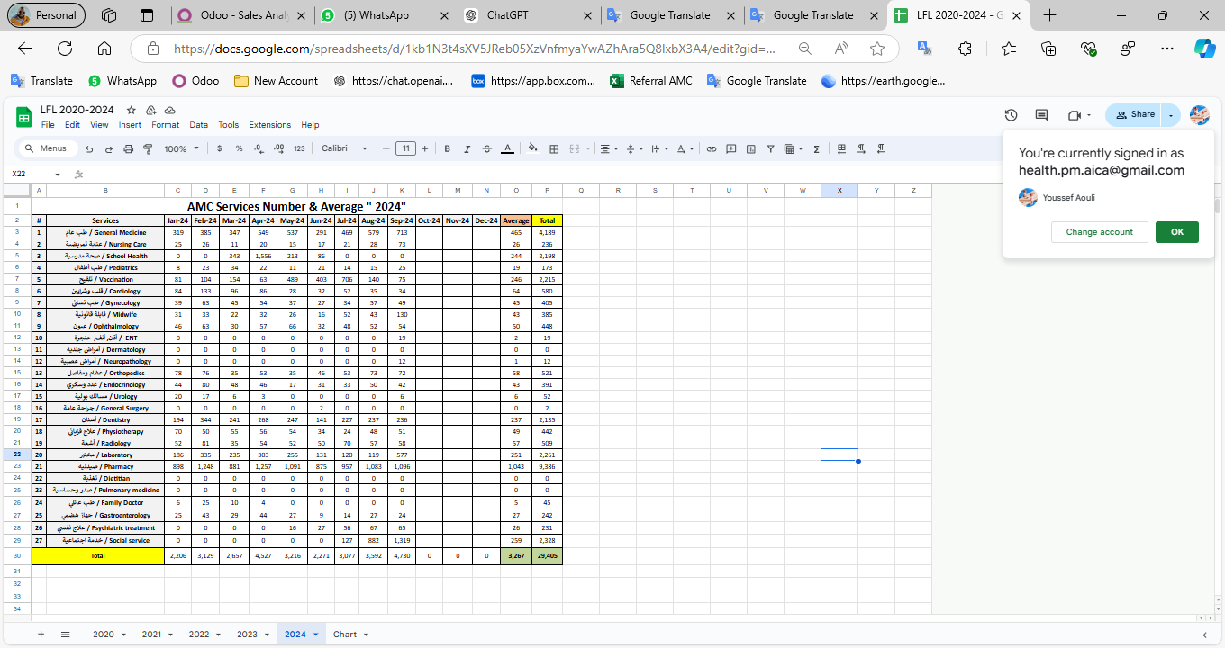

|  |  |  |  |
| --- | --- | --- | --- |
| Monitoring tools used (satisfaction surveys, discussions with beneficiaries…) | Sample size | Primary findings from these tools | Actions taken/to be taken in response to these findings |
| Complaints Box | 0 | N/A | N/A |
| Hot line | 0 | N/A | N/A |
| Individual interviews. | 22 | - Lack of availability of medicines  - No Electricity  - High cost of Consultation | - Agree with MSF to replenishment the missing medicine - Installed a solar energy system  - Review pricing structure of specialized services |
| Beneficiaries Satisfactory | 8 | N/A | N/A |

## Annex II: Success Story

(About your team activity, or may be from beneficiary or good implementation for activity …)

One of the most rewarding aspects of our work has been the opportunity to follow up with our beneficiaries and ensure they receive the care they need, even amidst challenging circumstances. Through regular phone calls and appointment bookings, we've been able to check on their health and well-being, providing a sense of reassurance and support.

The feedback from beneficiaries has been overwhelmingly positive, with many expressing gratitude for the attention and care they've received. Despite facing various adversities, our commitment to improving their lives remains unwavering.

This success story serves as a reminder of the importance of our work and motivates us to continue striving for excellence in everything we do.