 Monthly Report

|  |  |
| --- | --- |
| Center Name | Alzahraa Medical Center (AMC) |
| Prepared by: | Youssef K. Aouli |
| Name of Coordinator / Manager:  *Name, email, and phone* | Name: Youssef K. Aouli  Phone Number: +961 3041125 Email: health.pm@aica-lb.org |
| Reporting period  *From – To* | From 1st October 2024 to 31st October 2024 |

# Management Update:

)Administrative decisions , new projects…)

* We are expecting to sign a new project with the World Bank in collaboration with the Ministry of Public Health. This project encompasses medical packages tailored for low-income individuals registered with the Ministry of Social Affairs.

# Department Update:

(numb of ben, services, activity implemented on filed ….)

AMC is a Primary health care center located between Mankoubin& Jabal Mohsen- Tripoli operating under AICA. In partnership with MoPH, the center was established in November 2008 as a dispensary based on the gap in healthcare provision within the community and has evolved since then into a Primary Health Care Center in late 2016.The center has established a partnership with MoSA as of 2011 and has undergone several partnerships with Médecins Sans Frontières (2012 – 2017 and from April 2024 till present), Relief International (2017), and other two active partnerships with YMCA(2008)&Première Urgence – Aide Médicale Internationale(PU-AMI 2019 - 2023). AMC receives patients without any discrimination in gender, color, race, or religion providing general and specialist examination for minimal fees as well as free medicines, chronic medications and vaccination in addition to a bundle of health services. The center receives an average of 7000 beneficiaries / month visiting from different areas within the North governorate. Since the pandemic, AMC developed an emergency plan partnering with CRS to serve better the community.

S**upported Services**: All medical services are now available at subsidized rates in collaboration with AICA and the Ministry of Public Health. General consultations are priced at 400,000 Lebanese pounds, and specialist consultations at 600,000 pounds. Vaccinations and medications are provided free of charge.

**Response to the Displacement Crisis**: The center is connected to four shelters in Jabal Mohsen, rapidly responding with free services for displaced Lebanese. In coordination with Doctors Without Borders, hygiene kits were distributed, and mobile clinics funded by UNICEF offer medical check-ups, vaccinations, and medications. All center services are also offered for free to displaced individuals on-site.

**Partnership with MSF**: A project for non-communicable disease management and mental health services was launched, reducing the cost of chronic medication renewal to 50,000 Lebanese pounds per patient, increasing interest among patients. Mental health services began on May 1, 2024, with the contract set to last until the end of May 2025.

**Medication Distribution**: Medications prescribed by the center’s doctors are dispensed immediately by the pharmacist, along with detailed usage instructions. Additionally, requests were made for chronic disease patients to benefit from the Young Men's Christian Association (YMCA) program in cooperation with the Ministry of Health for free medications. For displaced individuals, an additional supply of chronic and acute medications was received from the Ministry of Health and is provided free of charge per ministry protocols.

**World Bank Project**: Starting on September 1, 2024, the center began a project with the World Bank to distribute medical packages to low-income individuals registered with the Ministry of Social Affairs. To date, approximately 1,000 individuals have been registered, representing about 200 families, with ongoing efforts to meet the targeted goal.

**UNICEF "Aa slama" Project**: A team of 12 began conducting home visits in areas like Jabal Mohsen, Qobbeh, Baddawi, and Mankoubin, focusing on child health.

**Global Giving:** Covering IDPs consultations from 14 October to 31 October

# Finance Update:

(Finance request – donation …. Payments)

Action plan for next Month:

|  |  |  |  |  |
| --- | --- | --- | --- | --- |
| Activities | Description of the activity | Modality (value, frequency…) | Location of activities | Number of Target Group |
| Supported Medical Services | Subsidized medical consultations and free medications and vaccines | General consultation: 400,000 LBP Specialist consultation: 600,000 LBP | AMC | General public |
| Displacement Crisis Response | Free healthcare services, hygiene kits distribution, mobile clinics with UNICEF funding | Free services and hygiene kits for displaced Lebanese; mobile clinic visits | Jabal Mohsen shelters, Health Center | Displaced Lebanese families |
| Partnership with MSF | Chronic disease management, mental health services | Chronic medication renewal: 50,000 LBP Mental health services (May 2024 - May 2025) | AMC | Patients with chronic illness, mental health needs |
| Medication Distribution | On-site pharmacy distribution with instructions; free medications for displaced individuals | Chronic medication via YMCA, free of charge for displaced according to ministry protocol | AMC | Chronic illness patients, displaced individuals |
| World Bank Project | Distribution of medical packages to low-income individuals | Ongoing distribution, began Sep 1, 2024 | AMC | 1,000 individuals (200 families) |
| UNICEF "Aslama" Project | Home visits focused on child health in vulnerable areas | Visits by 12-person team, ongoing | Jabal Mohsen, Qobbeh, Baddawi, Mankoubin | Children and families in target areas |

## Challenges

*Overview of any challenges encountered during the reporting period and how they were tackled*

|  |  |
| --- | --- |
| Challenge(s) | Response(s) |
| High demand for subsidized healthcare services | Collaborated with AICA and Ministry of Health to support all medical services at subsidized rates; prioritized service efficiency and access. |
| Increased healthcare needs due to displacement | Established connections with four shelters, providing free medical services, mobile clinics, and essential hygiene kits with UNICEF support. |
| Cost barrier to chronic disease management | Partnered with Doctors Without Borders to lower the cost of chronic medication renewal to 50,000 LBP, enhancing accessibility. |
| Limited access to medication for vulnerable groups | Distributed medications on-site; coordinated with YMCA and Ministry of Health for free medications for chronic illness and displaced people. |
| Supporting low-income households | Launched World Bank-funded project to distribute medical packages to 1,000 low-income individuals, ongoing registration and distribution. |
| Need for targeted child health support | Initiated the UNICEF "Aslama" Project, a home-visit program focusing on child health in high-need areas like Jabal Mohsen and Qobbeh. |

## Monitoring

|  |  |  |  |
| --- | --- | --- | --- |
| Indicators | Number achieved during the reporting period | Overall target | Progress towards target |
| **Health activity 1:** Services | 8,121 | 6,000 | 135.35 % |
| **Health activity 2:** Individuals (with duplication) who benefited from services, disaggregation between male and female. | Female: 4,569  Male: 3,552 | Female: 3,000  Male: 3,000 | Female: 152.3%  Male: 118.4 % |
| **Health activity 3:** Individuals who benefited from medication chronic. | 600 | 1386 | 43.29 % |
| **IDP’s by Global Giving:** Services | 721 GP 296 SP | AMC: 823 | AMC: 100% |

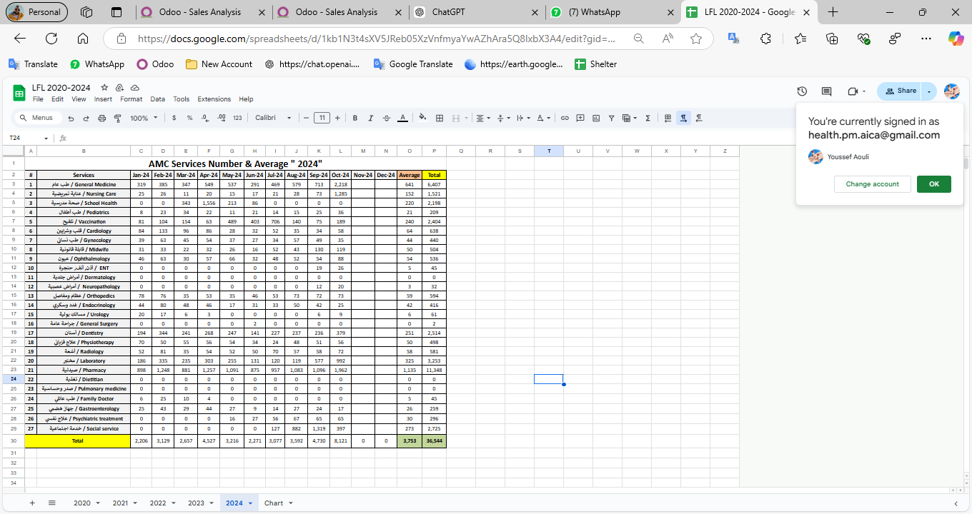

|  |  |  |  |
| --- | --- | --- | --- |
| Monitoring tools used (satisfaction surveys, discussions with beneficiaries…) | Sample size | Primary findings from these tools | Actions taken/to be taken in response to these findings |
| Complaints Box | 0 | N/A | N/A |
| Hot line | 0 | N/A | N/A |
| Individual interviews. | 22 | - Lack of availability of medicines  - No Electricity  - High cost of Consultation | - Agree with MSF to replenishment the missing medicine - Installed a solar energy system  - Review pricing structure of specialized services |
| Beneficiaries Satisfactory | 8 | N/A | N/A |

## Annex II: Success Story

(About your team activity, or may be from beneficiary or good implementation for activity …)

One of the most rewarding aspects of our work has been the opportunity to follow up with our beneficiaries and ensure they receive the care they need, even amidst challenging circumstances. Through regular phone calls and appointment bookings, we've been able to check on their health and well-being, providing a sense of reassurance and support.

The feedback from beneficiaries has been overwhelmingly positive, with many expressing gratitude for the attention and care they've received. Despite facing various adversities, our commitment to improving their lives remains unwavering.

This success story serves as a reminder of the importance of our work and motivates us to continue striving for excellence in everything we do.