 Monthly Report

|  |  |
| --- | --- |
| Center Name | Alzahraa Medical Center (AMC) |
| Prepared by: | Youssef K. Aouli |
| Name of Coordinator / Manager:  *Name, email, and phone* | Name: Youssef K. Aouli  Phone Number: +961 3041125 Email: health.pm@aica-lb.org |
| Reporting period  *From – To* | From 1st November 2024 to 30th November 2024 |

# Management Update:

)Administrative decisions , new projects…)

* We are expecting to sign a new project with the World Bank in collaboration with the Ministry of Public Health. This project encompasses medical packages tailored for low-income individuals registered with the Ministry of Social Affairs.

# Department Update:

(numb of ben, services, activity implemented on filed ….)

AMC is a Primary health care center located between Mankoubin& Jabal Mohsen- Tripoli operating under AICA. In partnership with MoPH, the center was established in November 2008 as a dispensary based on the gap in healthcare provision within the community and has evolved since then into a Primary Health Care Center in late 2016.The center has established a partnership with MoSA as of 2011 and has undergone several partnerships with Médecins Sans Frontières (2012 – 2017 and from April 2024 till present), Relief International (2017), and other two active partnerships with YMCA(2008)&Première Urgence – Aide Médicale Internationale(PU-AMI 2019 - 2023). AMC receives patients without any discrimination in gender, color, race, or religion providing general and specialist examination for minimal fees as well as free medicines, chronic medications and vaccination in addition to a bundle of health services. The center receives an average of 7000 beneficiaries / month visiting from different areas within the North governorate. Since the pandemic, AMC developed an emergency plan partnering with CRS to serve better the community.

**Subsidized Medical Services:**  
In collaboration with AICA and the Ministry of Public Health, the center offers all medical services at subsidized rates. General consultations are priced at 400,000 Lebanese pounds, and specialist consultations at 600,000 pounds. Vaccinations and medications are provided free of charge.

**Response to the Displacement Crisis:**  
The center works with four shelters in Jabal Mohsen to provide free and rapid services to displaced Lebanese. Hygiene kits were distributed in coordination with Doctors Without Borders, and mobile clinics funded by UNICEF offer medical check-ups, vaccinations, and medications. All center services are also provided free of charge to displaced individuals, both on-site and in the shelters.

**Partnership with Doctors Without Borders (MSF):**  
A project focusing on non-communicable disease management and mental health services has been launched, reducing the cost of chronic medication renewals to 50,000 Lebanese pounds per patient, which has increased patient engagement. Mental health services began on May 1, 2024, and are planned to continue until the end of March 2025.

**Medication Distribution:**  
Medications prescribed by the center’s doctors are dispensed immediately at the pharmacy, along with detailed usage instructions. Additionally, requests have been made for chronic disease patients to benefit from the Young Men’s Christian Association (YMCA) program, in cooperation with the Ministry of Health, to access free medications. For displaced individuals, an additional supply of chronic and acute medications was received from the Ministry of Health and is distributed free of charge following ministry protocols.

**World Bank Project:**  
Starting on September 1, 2024, the center began a project with the World Bank to distribute medical packages to low-income individuals registered with the Ministry of Social Affairs. To date, approximately 1,960 individuals have been registered, representing about 380 families.

**UNICEF "Aa Slama" Project:**  
A team of 12 has started conducting home visits in areas such as Jabal Mohsen, Qobbeh, Baddawi, and Mankoubin, focusing on child health.

# Finance Update:

(Finance request – donation …. Payments)

Action plan for next Month:

|  |  |  |  |  |
| --- | --- | --- | --- | --- |
| Activities | Description of the activity | Modality (value, frequency…) | Location of activities | Number of Target Group |
| Subsidized Medical Services | Provision of medical consultations and free medications and vaccinations | General consultations: 400,000 LBP; specialist consultations: 600,000 LBP; free vaccinations and meds | AMC | Not specified |
| Response to Displacement Crisis | Free services, hygiene kits, and mobile clinics for displaced individuals | Free; supported by MSF and UNICEF; regular distribution and check-ups | Jabal Mohsen, shelters | Not specified |
| Partnership with MSF | Chronic disease management and mental health services | Chronic meds: 50,000 LBP/patient; mental health services ongoing until March 2025 | AMC | Not specified |
| Medication Distribution | Dispensing prescribed medications and chronic meds for displaced individuals | Free for displaced individuals; YMCA program for chronic meds | AMC | Not specified |
| World Bank Project | Distribution of medical packages to low-income individuals | Free packages; initiated September 2024 | Center; registered with Social Affairs Ministry | 1,960 individuals (380 families) |
| UNICEF "Aa Slama" Project | Home visits focusing on child health | Regular visits by a team of 12 | Jabal Mohsen, Qobbeh, Baddawi, Mankoubin | Not specified |

## Challenges

*Overview of any challenges encountered during the reporting period and how they were tackled*

|  |  |
| --- | --- |
| Challenge(s) | Response(s) |
| High cost of medical consultations and medications | Offering subsidized consultations (400,000 LBP for general, 600,000 LBP for specialists) and free meds/vaccinations |
| Lack of access to healthcare for displaced individuals | Providing free medical services, mobile clinics, and hygiene kits in coordination with MSF and UNICEF |
| Limited resources for chronic disease management | Partnership with MSF to reduce the cost of chronic medication renewals to 50,000 LBP and provide mental health services |
| Insufficient supply of medications for displaced persons | Additional medication supplies received from the Ministry of Health, distributed free of charge |
| Limited access to medical aid for low-income families | Collaboration with the World Bank to distribute free medical packages to registered individuals |
| Health risks for children in vulnerable areas | Conducting home visits through the UNICEF "Aa Slama" project to focus on child health |

## Monitoring

|  |  |  |  |
| --- | --- | --- | --- |
| Indicators | Number achieved during the reporting period | Overall target | Progress towards target |
| **Health activity 1:** Services | 6,837 | 6,000 | 113.95 % |
| **Health activity 2:** Individuals (with duplication) who benefited from services, disaggregation between male and female. | Female: 3,381  Male: 3,456 | Female: 3,000  Male: 3,000 | Female: 112.7%  Male: 115.2 % |
| **Health activity 3:** Individuals who benefited from medication chronic. | 605 | 1386 | 43.65 % |
| **IDP’s:** Services | 532 132 | AMC: 1000 Shelter: 300 | AMC: 53.2 % Shelter: 44 % |

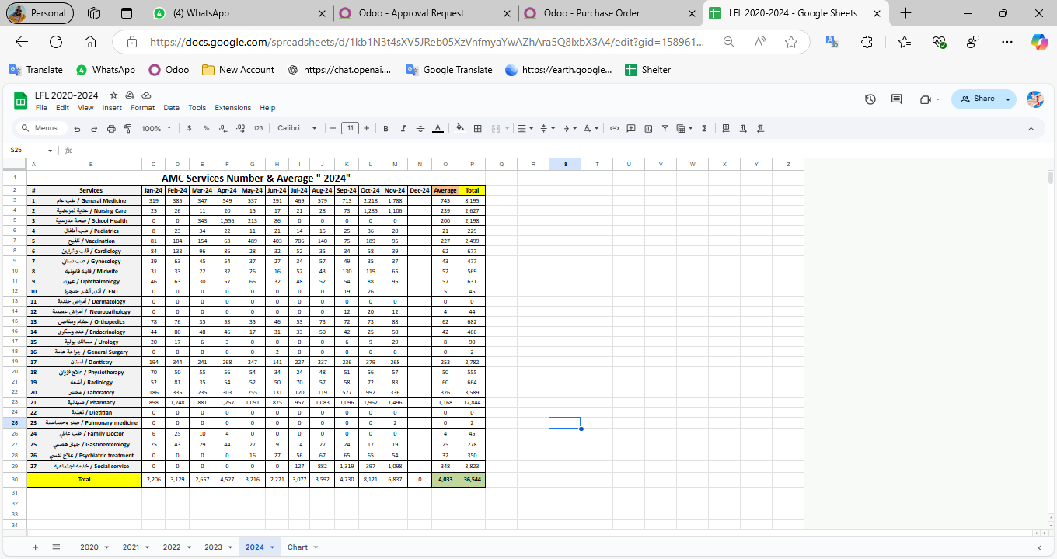

|  |  |  |  |
| --- | --- | --- | --- |
| Monitoring tools used (satisfaction surveys, discussions with beneficiaries…) | Sample size | Primary findings from these tools | Actions taken/to be taken in response to these findings |
| Complaints Box | 0 | N/A | N/A |
| Hot line | 0 | N/A | N/A |
| Individual interviews. | 22 | - Lack of availability of medicines  - No Electricity  - High cost of Consultation | - Agree with MSF to replenishment the missing medicine - Installed a solar energy system  - Review pricing structure of specialized services |
| Beneficiaries Satisfactory | 8 | N/A | N/A |

## Annex II: Success Story

(About your team activity, or may be from beneficiary or good implementation for activity …)

One of the most rewarding aspects of our work has been the opportunity to follow up with our beneficiaries and ensure they receive the care they need, even amidst challenging circumstances. Through regular phone calls and appointment bookings, we've been able to check on their health and well-being, providing a sense of reassurance and support.

The feedback from beneficiaries has been overwhelmingly positive, with many expressing gratitude for the attention and care they've received. Despite facing various adversities, our commitment to improving their lives remains unwavering.

This success story serves as a reminder of the importance of our work and motivates us to continue striving for excellence in everything we do.  
  
