 Monthly Report

|  |  |
| --- | --- |
| Center Name | Alzahraa Medical Center (AMC) |
| Prepared by: | Youssef K. Aouli |
| Name of Coordinator / Manager:  *Name, email, and phone* | Name: Youssef K. Aouli  Phone Number : +961 3 041125 Email : health.pm@aica-lb.org |
| Reporting period  *From – To* | From 1st July 2024 to 31st July 2024 |

# Management Update:

)Administrative decisions , new projects…)

* We are expecting to sign a new project with the World Bank in collaboration with the Ministry of Public Health. This project encompasses medical packages tailored for low-income individuals registered with the Ministry of Social Affairs.

# Department Update:

(numb of ben, services, activity implemented on filed ….)

AMC is a Primary health care center located between Mankoubin& Jabal Mohsen- Tripoli operating under AICA. In partnership with MoPH, the center was established in November 2008 as a dispensary based on the gap in healthcare provision within the community and has evolved since then into a Primary Health Care Center in late 2016.The center has established a partnership with MoSA as of 2011 and has undergone several partnerships with Médecins Sans Frontières (2012 – 2017 and from 2024 till present), Relief International (2017), and other two active partnerships with YMCA(2008)&Première Urgence – Aide Médicale Internationale(PU-AMI 2019 - 2023). AMC receives patients without any discrimination in gender, color, race, or religion providing general and specialist examination for minimal fees as well as free medicines, chronic medications and vaccination in addition to a bundle of health services. The center receives an average of 7000 beneficiaries / month visiting from different areas within the North governorate. Since the pandemic, AMC developed an emergency plan partnering with CRS to serve better the community.

**Subsidized Services:** All services were maintained at subsidized prices in partnership with AICA and the Ministry of Public Health. General practitioner consultations were set at 400,000 LBP, and specialist consultations at 600,000 LBP. Vaccines and medications were provided free of charge.

**MSF Project Implementation:** The project with MSF was launched, offering services for non-communicable diseases and mental health. Support for renewing chronic medications was reduced to 50,000 LBP per patient, increasing patient interest. A new pharmacist was contracted, and the center was equipped with a pharmacist and assistants. Psychological treatment services began on May 1st.

**Medication Distribution:** Medications prescribed by the center’s physician were immediately distributed by the pharmacist, with labels providing detailed usage instructions. Applications were also submitted for patients with chronic diseases to benefit from the Young Men’s Christian Program, in cooperation with the Ministry of Health, to receive free chronic medications.

**Service Demand Challenge:** The center faces challenges due to the high volume of services and patients, which requires providing care to all.

**Quality Standards:** The center adheres to high-quality standards in all its operations.

**World Bank Project:** The center is awaiting the start of a project with the World Bank, which includes distributing medical packages to low-income individuals registered with the Ministry of Social Affairs.

**Solar Energy Installation:** A solar energy system provided by the Norwegian Association was installed, reducing operating costs and improving the quality of service by enabling the use of air conditioners for staff and patient comfort.

**Accreditation Test:** The center passed the mock Canadian accreditation quality standards test with a score of 80% after more than 10 months of preparation.

# Finance Update:

(Finance request – donation …. Payments)

Action plan for next Month:

|  |  |  |  |  |
| --- | --- | --- | --- | --- |
| Activities | Description of the activity | Modality (value, frequency…) | Location of activities | Number of Target Group |
| Subsidized Services | Maintained all services at subsidized prices in collaboration with AICA and the Ministry of Public Health. | General practitioner consultations at 400,000 LBP, specialist consultations at 600,000 LBP; Free vaccines and medications provided | Center | All patients |
| MSF Project Implementation**:** | Implemented the project with MSF, providing services for non-communicable diseases and mental health | Chronic medication renewal support reduced to 50,000 LBP per patient; Psychological treatment started on May 1st | Center | Populations in need |
| Medication Distribution: | Distributed prescribed medications by the center’s physician with proper labeling, submitted applications for patients with chronic diseases to benefit from the Young Men’s Christian Program. | Immediate distribution of medications; Applications for chronic medications submitted | Center | Patients with chronic diseases |
| Service Demand Challenge: | Faced challenges due to the high volume of services and patients. | Continuous service provision despite high demand | Center | All patients |
| Quality Standards | Adhered to high-quality standards in all operations. | Continuous quality improvement | Center | All patients |
| World Bank Project: | Awaited the project with the World Bank to distribute medical packages for low-income individuals. | Pending project approval | Center | People with limited income |
| Solar Energy Installation: | Installed a solar energy system provided by the Norwegian Association, reducing operating costs and improving service | Solar system installation; Continuous operation of air conditioning | Center | All patients and employees |
| Accreditation Test: | Passed the mock Canadian accreditation Quality Standards test. | Scored 80% after 10+ months of preparation | Center | All operations subject to accreditation standards |

## Challenges

*Overview of any challenges encountered during the reporting period and how they were tackled*

|  |  |
| --- | --- |
| Challenge(s) | Response(s) |
| High volume of services and patients. | Continuously providing services to all patients despite high demand. |
| Need to maintain high-quality standards | Adhered strictly to high-quality standards, passed the mock Canadian accreditation Quality Standards test with a score of 80% after extensive preparation. |
| Financial constraints on patients for medication renewal | Reduced the cost of renewing chronic medications from 100,000 LBP to 50,000 LBP per patient, making it more accessible. |
| Energy costs and operational efficiency | Installed a solar energy system provided by the Norwegian Association, which reduced operating costs and improved the quality of services by ensuring continuous operation of air conditioning. |
| Waiting for the World Bank project approval | Continued providing existing services while preparing for the anticipated project, ensuring readiness to distribute medical packages as soon as the project is approved. |

## Monitoring

|  |  |  |  |
| --- | --- | --- | --- |
| Indicators | Number achieved during the reporting period | Overall target | Progress towards target |
| **Health activity 1:** Services | 3,077 | 6,000 | 52% |
| **Health activity 2:** Individuals (with duplication) who benefited from services, disaggregation between male and female. | Female: 1,965  Male: 1,112 | Female: 3,000  Male: 3,000 | Female: 66%  Male: 37% |
| **Health activity 3:** Individuals who benefited from medication chronic. | 531 | 1386 | 39% |

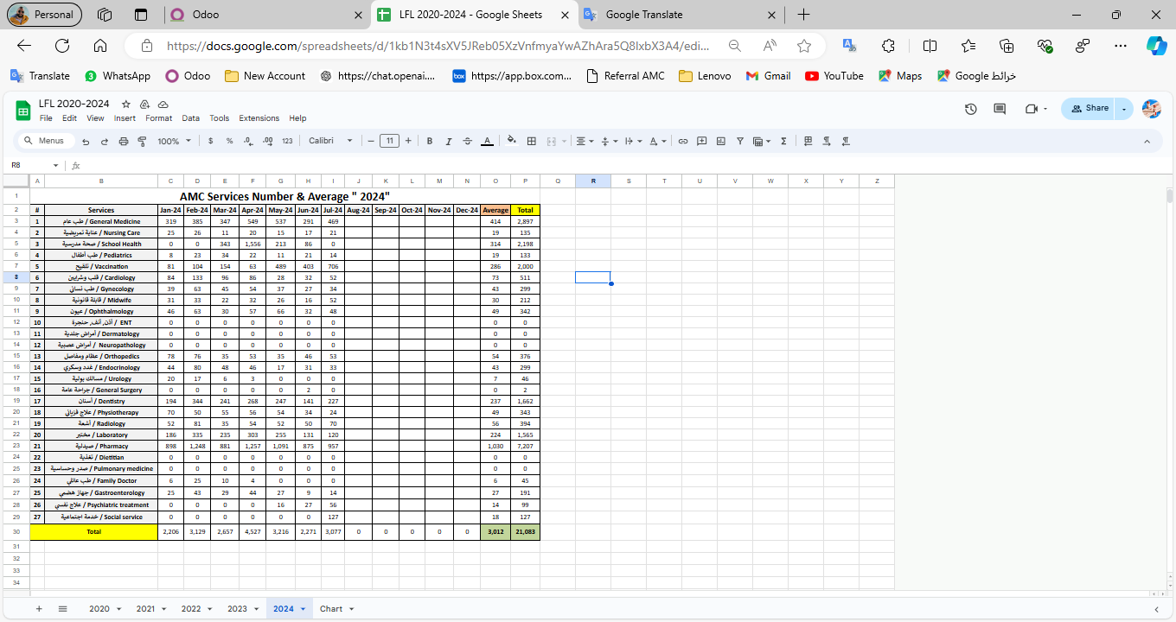

|  |  |  |  |
| --- | --- | --- | --- |
| Monitoring tools used (satisfaction surveys, discussions with beneficiaries…) | Sample size | Primary findings from these tools | Actions taken/to be taken in response to these findings |
| Complaints Box | 0 | N/A | N/A |
| Hot line | 0 | N/A | N/A |
| Individual interviews. | 22 | - Lack of availability of medicines  - No Electricity  - High cost of Consultation | - Agree with MSF to replenishment the missing medicine - Installed a solar energy system  - Review pricing structure of specialized services |
| Beneficiaries Satisfactory | 8 | N/A | N/A |

## Annex II: Success Story

(About your team activity, or may be from beneficiary or good implementation for activity …)

One of the most rewarding aspects of our work has been the opportunity to follow up with our beneficiaries and ensure they receive the care they need, even amidst challenging circumstances. Through regular phone calls and appointment bookings, we've been able to check on their health and well-being, providing a sense of reassurance and support.

The feedback from beneficiaries has been overwhelmingly positive, with many expressing gratitude for the attention and care they've received. Despite facing various adversities, our commitment to improving their lives remains unwavering.

This success story serves as a reminder of the importance of our work and motivates us to continue striving for excellence in everything we do.